2-a

In this section, parameters are chosen according to the designed controller in part c.

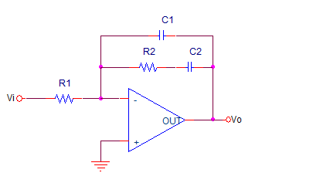

**Figure1.** Type 2 controller.

Transfer function is C1

Let’s equate this transfer function to the our controller in part c.

$$\frac{Vo}{Vi}=Gc\left(s\right)= \frac{11\left(s+909\right)}{s+110000}*21*\frac{1}{s}=\frac{s+909}{s^{2}*4.33*{10}^{-3}+476.2s}=\frac{1.1*{10}^{-3}s+1}{4.76*{10}^{-6}s^{2}+0.52s}$$

$$C2R2=1.1*{10}^{-3}$$

Let’s

$$C2={10}^{-6}F$$

R2=1.1Kohm

$$C1R1=4.33*{10}^{-3}$$

Lets R1=500Kohm

C1= $9*{10}^{-9}$ F

In this system we have 2 poles and 1 zero. In addition, one of the poles is on the center of coordinate system other one is on the left side of the imaginary axis. This means open loop system is not stable. However, in order to ensure the stability, we need to use this topology on closed loop systems.

Bode plot of the controller is on following figure.

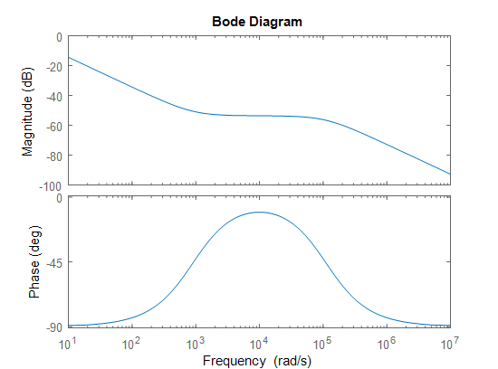

**Figure 1.** Bode plot of the system with given values.

In this bode plot, cut of frequency is almost equal to 1 and phase margin is 90 degrees. When we use this controller with a system, the system’s phase will increase around 10^4rad/s and the system’s gain will decreases gradually as frequency increase.

2b)

Type 2 controller circuit is designed via using PSIM and in the following figure 2.

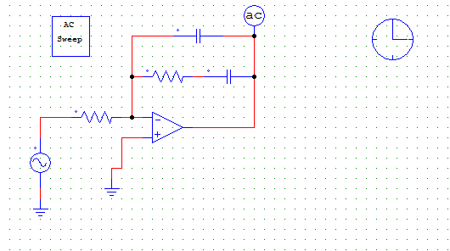

**Figure2.** Type 2 controller

Bode plot characteristic of the controller is on figure 3.

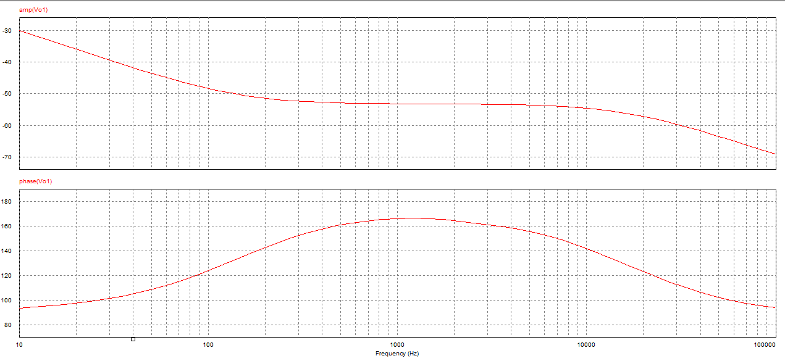

**Figure 3**. Bode plot of the controller via using PSIM.