2-c

State equations are as follows:

On state Off state

ẋ = A1 + B1u ẋ = A2x + B2u

y= C1x y= C2x

where u is input.

Averaging them:

ẋ = [A1d +A2(1-d)] x + [B1d+B2(1-d)] u

y=C1d+C2(1-d)] x

Introducing small perturbations as follows (assuming perturbations in input is equal to zero):

x=X+x y=Y+y d=D+d

in steady state ẋ=0 and neglecting products of x and d;

ẋ=AX+Bu+Ax+[ (A1 – A2 ) X+(B1 -B2 )u]d (10-50) in text book Mohan

A = A1D + A2(1-D)

B= B1D + B2(1-D)

In steady state

AX+Bu= 0

Equation 10-50 becomes

ẋ= Ax+[ (A1 – A2 ) X+(B1 -B2 )u]d and

Y+y=CX+Cx+[(C1-C2)X]d (10-58) in text book Mohan

Where C=C1D+C2(1-D)

Y=CX

y=Cx+[(C1-C2)X]d

Y/U=-CA-1B

Taking lap lace transform of small signal eqn. (10-58)

Y(s)/d(s)=C[sI-A]-1 [(A1-A2)X + (B1-B2)U] + (C1-C2)X

Let’s apply the formula to the buck converter state variables are defined as inductor current and capacitor voltage.

A1= [ -(R*rc + R*rl + rc*rl)/(L*(R + rc)), -R/(L*(R + rc))]

[ R/(C*(R + rc)) , -1/(C*(R + rc))]

A1=A2=A;

B1= [ 1/L ]

[ 0 ]

B2=0;

B=B1*D

For the sake of simplicity assuming R is much greater than (rc+rl);

A=A1=A2= [ -(rc + rl)/L, -1/L ]

[ 1/C , -1/(C*R)]

C=C1=C2=[rc 1];

B remains same.

A-1=1/det(A)* [-1/(C*R ) , 1/L ]

[ -1/C , -(rc + rl)/L]

Finally steady state transfer function is

$\frac{Y}{U}$ = $\frac{R+rc}{R+rc+rl}D$ =D

Small signal transfer function is as follows

$\frac{u(s)}{d(s)}$ = $\frac{1+sCrc}{LC[s^{2}+s\left[\frac{1}{CR}+\frac{rc+rl}{L}\right]+\frac{1}{LC}]}U$

Lets choose ;

Vd=48V

Vo=23.6V

rl=0.002ohm

L=10uH

rc=0.001ohm

C=1000uF

R=5ohm

Fs=150kHz

For finding gain crossover frequency: $\frac{u(s)}{d(s)}$ = $\frac{1+sCrc}{LC[s^{2}+s\left[\frac{1}{CR}+\frac{rc+rl}{L}\right]+\frac{1}{LC}]}U$ =1;

wc=7.01*104

Bode plot characteristic of buck converter without controller can be seen on figure 1.

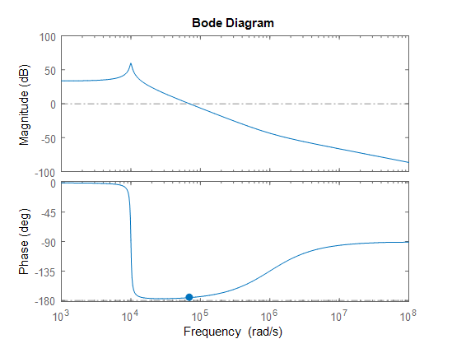

**Figure1**. Bode plot characteristic of open loop system without controller.

This system is stable however we have very low phase margin in this system. Lets design a lead compensator with integral term (type 2) controller for increasing the phase margin and better system characteristics. Overall open loop characteristic is as follows.

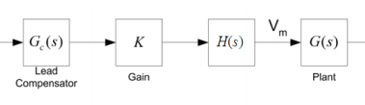

**Figure 2.** Planned open loop characteristics.

**Step1.** Satisfying the steady state error:

By choosing H(s)=1/s. This term is for eliminating the steady state error. New bode plot diagram is as follows.

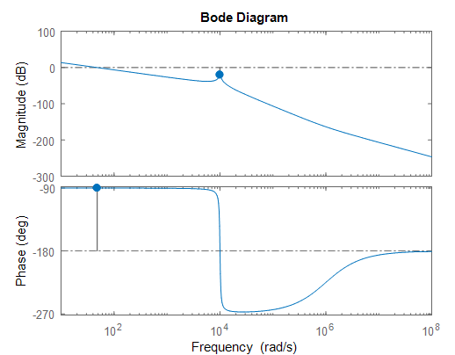

**Figure3.** Bode plot with only integral term.

**Step2.** Increasing bandwidth

By adding K term to the system. Let’s say we want wc=104 rad/s.

20*log(K*G(s)*H(s))=0

K=21;

**Step4.** Adjusting phase margin.

Now we have -57 degrees of phase margin which makes our system unstable. Let’s try to obtain 23 degrees of phase margin. Extra phase required to the compensate by compensator is 80 degrees. For compensator let’s choose a lead compensator which has unity DC gain. Transfer function of compensator is as follows:

Gc(s)= $\frac{a(s+\frac{w}{a})}{s+wa}$

where

w= wc =10000

tan(a)-tan(1/a)=80

a=11

Gc(s)= $\frac{11(s+909)}{s+110000}$

Finally, we have 21 degrees of phase margin. Final open loop bode plot characteristic is as follows:

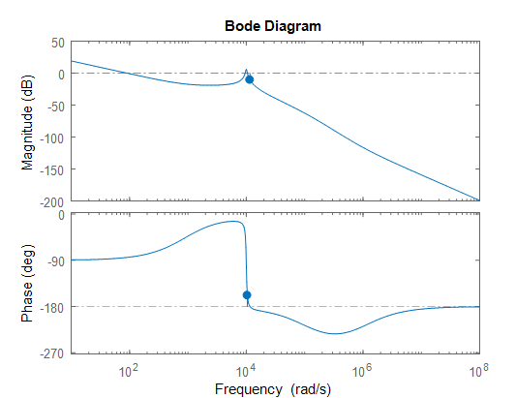

**Figure 4.** Final bode plot of the system.

d)i) case 1 load is increased, corresponding circuit is on the following figure5.

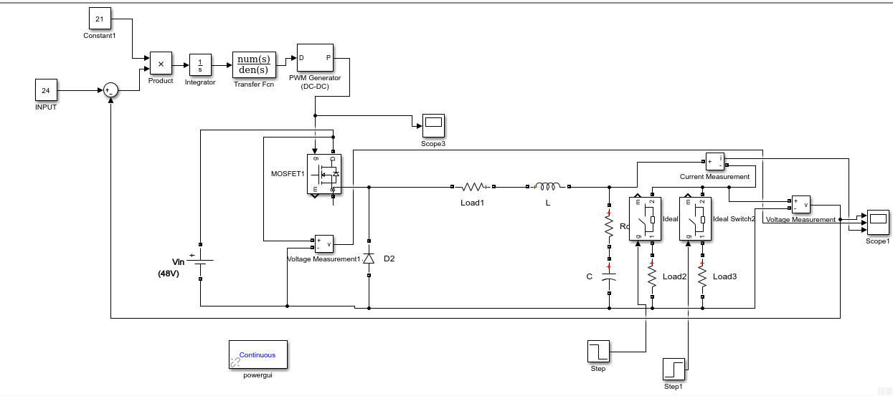

**Figure 5.** load is increased.

Simulation results are on the following figure6.

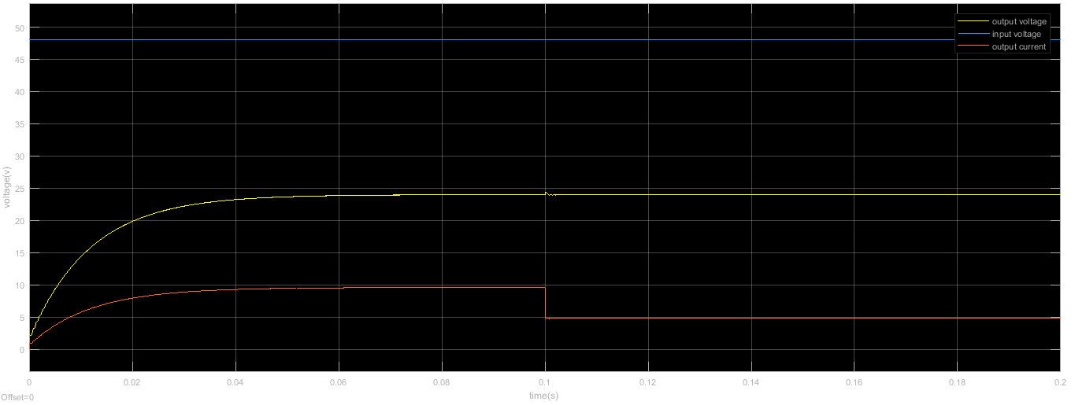

**Figure 6.** Step change from half load to full load case

d)ii) Overall circuit schematic is on the following figure 7.

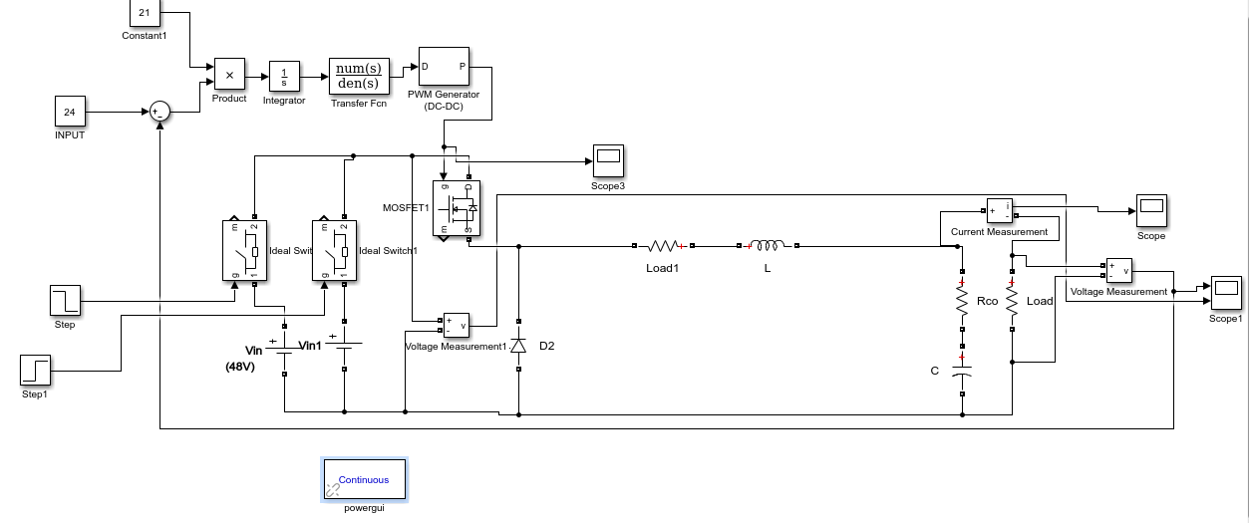

**Figure7.** overall system circuit

Output voltage waveform is on the following figure8.

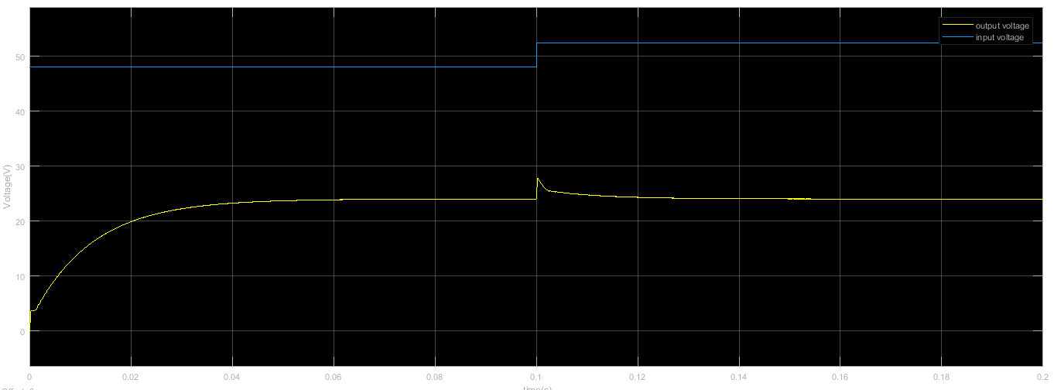

**Figure 8.** input voltage is increased %10 and corresponding output voltage.

e) Transient performance is good enough. However, the controller is working on close to the unstable region which causes real implements may not worked.