

MIDDLE EAST TECHNICAL UNIVERSITY

DEPARTMENT OF

ELECTRICAL AND ELECTRONICS

ENGINEERING

EE568 - Special Topics on Electrical Machines

Project #2

Motor Winding Design and Analysis

31/03/2020

Raşit GÖKMEN - 2339760

# Contents

1. Contents 2

2. Introduction 3

3. Integral-Slot Winding Design 3

4. Fractional-Slot Winding Design 5

4.1. 20-pole and 24-slot Machine 5

4.2. 20-pole and 30-slot Machine 8

4.3. Comment and comparison of machines: 11

# Introduction

In this project, the aim is to design windings of motors with integral slot winding and fractional slot winding. In the first part, the windings of integral slot winding motor which has 120 slots, 20 pole and 3 phase are designed. After that, the distribution factor and pitch factor are calculated for the fundamental, 3rd and 5th harmonic components and results are compared.

In the second part, fractional slot winding machine is considered. Same calculations with the previous part are obtained.

In the final part, 2D model of our motor is modeled and some results including airgap flux density distribution, induced voltage waveforms and cogging torque are given.

# Integral-Slot Winding Design

In this part, a motor which has 120 slots, 20 poles and 3 phases is considered. It is assumed that the winding is full-pitched and winding diagram for one pole pair is designed and given in below.

q is defined as number of slot per poles per phases is calculated as follow;

(1)

where, Q is the number of slots : 120

p is the number of poles: 20

m is the number of phases: 3

One pole pair has = = 12 slots.

The electrical angle between each slot, is defined as

(2)

Table 1: Winding diagram of the given integral slot machine for one pole pair for the full-pitched coils

|  |  |  |  |  |  |  |  |  |  |  |  |  |
| --- | --- | --- | --- | --- | --- | --- | --- | --- | --- | --- | --- | --- |
| Slot number | 1 | 2 | 3 | 4 | 5 | 6 | 7 | 8 | 9 | 10 | 11 | 12 |
| Coil Distributions | A1 | A2 | -C1 | -C2 | B1 | B2 | -A1 | -A2 | C1 | C2 | -B1 | -B2 |

Distribution factor, kd is defined as

(3)

where, q is no. of slots per no. of poles per no. of phases: 2

n is the number of order of the harmonic

: is the angle between slots in electrical : 30⁰

Pitch factor, kp is defined as

(4)

where, n is the number of order of harmonic

is the pitch angle : 180⁰ for the full-pitched coils

Winding factor is defined as

(5)

For the fundamental harmonic component kd, kp and kw is calculated by using equations 3, 4 and 5, respectively.

0.966

0.966

For the third harmonic component kd, kp and kw is calculated by using equations 3, 4 and 5, respectively.

For the third harmonic component kd, kp and kw is calculated by using equations 3, 4 and 5, respectively.

As can be seen from the results, fundamental harmonic component has the larger winding factor value than the others. However, the other harmonic components have larger winding factor value especially the third harmonic component. Therefore, these harmonic components have unwanted effects on the resultant induced voltage waveform. Morevor, their effects could be worsen even though their winding factors are smaller. Because, the other factor which is frequency that has effect on the induced voltage and frequency increases as the harmonic order increases.

As a result, the full-pitched winding design or concentrated winding design is not a very good approach due to the higher THD in the induced voltage waveform. Winding factor of harmonics apart from fundamental harmonic should kept small in order to achieve lower THD and more likely sinusoidal induced voltage waveform. This can be achieved by using fractional winding design or in an other words distributed winding design. For example if the pitch factor is choosen as 2/3, the resultant winding factor of the third harmonic will be 0. Moreover, winding factor of fifth and consecutive odd harmonics will be smaller.

# Fractional-Slot Winding Design

## 20-pole and 24-slot Machine

In this part, a fractional slot winding machine with 20-pole, 24-slot and 3-phase is selected. Because, by using e-motor winding design tool it is clear that with this pole and slot number configuration maximum fundamental winding factor can be obtained.

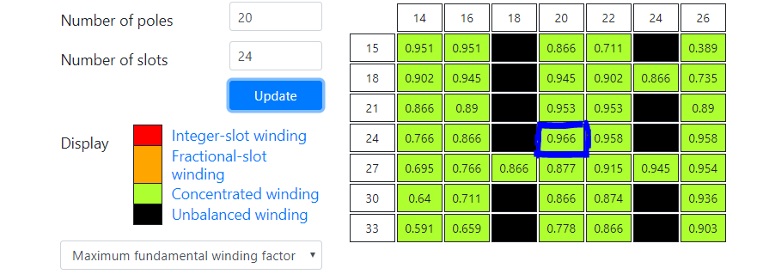

Figure 1. Emotor winding design tool

The number of slots per pole per phase, q

The electrical angle between each slot,

Table 2: Winding diagram of the given fractional slot machine with 20-pole 24-slot under-pitched coils

|  |  |  |  |  |  |  |  |  |  |  |  |  |
| --- | --- | --- | --- | --- | --- | --- | --- | --- | --- | --- | --- | --- |
| Slot Number | 1 | 2 | 3 | 4 | 5 | 6 | 7 | 8 | 9 | 10 | 11 | 12 |
| Electrical Angle | 0° | 150° | 300° | 450° | 600° | 750° | 900° | 1050° | 1200° | 1350° | 1500° | 1650° |
| Phase Angle of Fundamental Harmonic  Component | 0° | 150° | 300° | 90° | 240° | 30° | 180° | 330° | 120° | 270° | 60° | 210° |
| Phase Angle of Third Harmonic  Component | 0° | 90° | 180° | 270° | 0° | 90° | 180° | 270° | 0° | 90° | 180° | 270° |
| Phase Angle of Fifth Harmonic  Component | 0° | 30° | 60° | 90° | 120° | 150° | 180° | 210° | 240° | 270° | 300° | 330° |
| Coil distribution | A1 | -A1 | -B1 | B1 | C1 | -C1 | -A3 | A3 | B3 | -B3 | -C3 | C3 |
|  |  |  |  |  |  |  |  |  |  |  |  |  |
| Slot Number | 13 | 14 | 15 | 16 | 17 | 18 | 19 | 20 | 21 | 22 | 23 | 24 |
| Electrical Angle | 1800° | 1950° | 2100° | 2350° | 2500° | 2650° | 2800° | 2950° | 3100° | 3250° | 3400° | 3550° |
| Phase Angle of Fundamental Harmonic  Component | 0° | 150° | 300° | 90° | 240° | 30° | 180° | 330° | 120° | 270° | 60° | 210° |
| Phase Angle of Third Harmonic  Component | 0° | 90° | 180° | 270° | 0° | 90° | 180° | 270° | 0° | 90° | 180° | 270° |
| Phase Angle of Fifth Harmonic  Component | 0° | 30° | 60° | 90° | 120° | 150° | 180° | 210° | 240° | 270° | 300° | 330° |
| Coil distribution | A2 | -A2 | -B2 | B2 | C2 | -C2 | -A4 | A4 | B4 | -B4 | -C4 | C4 |
|  |  |  |  |  |  |  |  |  |  |  |  |  |

For the fundamental harmonic component, the phasor diagram, distribution, pitch and winding factor;

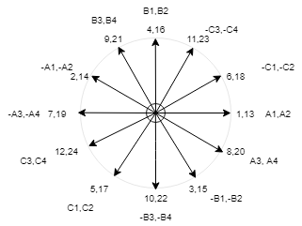

Figure 2: Phasor diagram of the machine with 20 poles and 24 slots for the fundamental harmonic component

For the third harmonic component, the phasor diagram, distribution, pitch and winding factor;

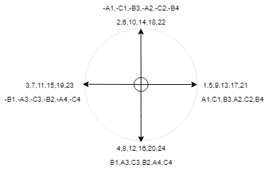

Figure 3: Phasor diagram of the machine with 20 poles and 24 slots for the third harmonic component

For the fifth harmonic component, the phasor diagram, distribution, pitch and winding factor;

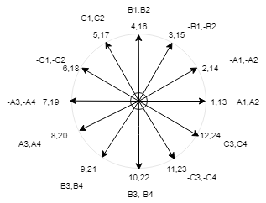

Figure 4: Phasor diagram of the machine with 20 poles and 24 slots for the fifth harmonic component

## 20-pole and 30-slot Machine

Now, let's increase the slot number while keeping the pole number constant. A machine with 20 poles and 30 slots is selected for this purpose.

The number of slots per pole per phase, q

The electrical angle between each slot,

Table 3: Winding diagram of the given fractional slot machine with 20-pole 30-slot under-pitched coils

|  |  |  |  |  |  |  |  |  |  |  |  |  |  |  |  |
| --- | --- | --- | --- | --- | --- | --- | --- | --- | --- | --- | --- | --- | --- | --- | --- |
| Slot Number | 1 | 2 | 3 | 4 | 5 | 6 | 7 | 8 | 9 | 10 | 11 | 12 | 13 | 14 | 15 |
| Electrical Angle | 0° | 120° | 240° | 360° | 480° | 600° | 720° | 840° | 960° | 1080° | 1200° | 1320° | 1440° | 1560° | 1680° |
| Phase Angle of Fundamental Harmonic  Component | 0° | 120° | 240° | 0° | 120° | 240° | 0° | 120° | 240° | 0° | 120° | 240° | 0° | 120° | 240° |
| Phase Angle of Third Harmonic  Component | 0° | 0° | 0° | 0° | 0° | 0° | 0° | 0° | 0° | 0° | 0° | 0° | 0° | 0° | 0° |
| Phase Angle of Fifth Harmonic  Component | 0° | 240° | 120° | 0° | 240° | 120° | 0° | 240° | 120° | 0° | 240° | 120° | 0° | 240° | 120° |
| Coil distribution | A1 | -A1 | C1 | -C1 | B1 | -B1 | -A2 | A2 | C2 | -C2 | B2 | -B2 | A3 | -A3 | C3 |
|  |  |  |  |  |  |  |  |  |  |  |  |  |  |  |  |
| Slot Number | 16 | 17 | 18 | 19 | 20 | 21 | 22 | 23 | 24 | 25 | 26 | 27 | 28 | 29 | 30 |
| Electrical Angle | 1800° | 1920° | 2040° | 2160° | 2280° | 2400° | 2520° | 2640° | 2760° | 2880° | 3000° | 3120° | 3240° | 3360° | 3480° |
| Phase Angle of Fundamental Harmonic  Component | 0° | 120° | 240° | 0° | 120° | 240° | 0° | 120° | 240° | 0° | 120° | 240° | 0° | 120° | 240° |
| Phase Angle of Third Harmonic  Component | 0° | 0° | 0° | 0° | 0° | 0° | 0° | 0° | 0° | 0° | 0° | 0° | 0° | 0° | 0° |
| Phase Angle of Fifth Harmonic  Component | 0° | 240° | 120° | 0° | 240° | 120° | 0° | 240° | 120° | 0° | 240° | 120° | 0° | 240° | 120° |
| Coil distribution | -C3 | B3 | -B3 | A4 | -A4 | C4 | -C4 | B4 | -B4 | A5 | -A5 | C5 | -C5 | B5 | -B5 |
|  |  |  |  |  |  |  |  |  |  |  |  |  |  |  |  |

For the fundamental harmonic component, the phasor diagram, distribution, pitch and winding factor;

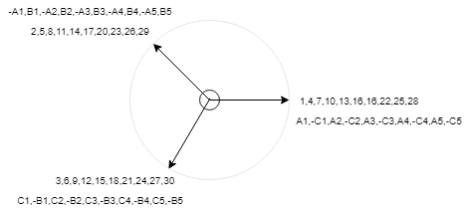

Figure 5: Phasor diagram of the machine with 20 poles and 30 slots for the fundamental harmonic component

For the third harmonic component, the phasor diagram, distribution, pitch and winding factor;

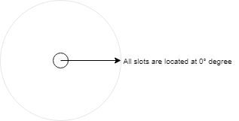

Figure 6: Phasor diagram of the machine with 20 poles and 30 slots for the third harmonic component

For the fifth harmonic component, the phasor diagram, distribution, pitch and winding factor;

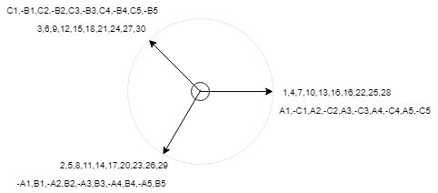

Figure 7: Phasor diagram of the machine with 20 poles and 30 slots for the fifth harmonic component

## Comment and comparison of machines:

Comparison of winding factor values of two different machine is given in below in Table 4.

Table 4: Winding factors of harmonics of two different machine

|  |  |  |
| --- | --- | --- |
|  | **20 poles and 24 slots** | **20 poles and 30 slots** |
| **Fundamental harmonic component** | 0.933 | 0.866 |
| **Third harmonic component** | -0.5 | 0 |
| **Fifth harmonic component** | 0.067 | -0.866 |

As can be seen from Table 4, the first design which is 20poles and 24 slots has better winding factor for fundamental harmonic component. The second design has no third harmonic component in the induced voltage but it has fifth harmonic component with very large, value of winding factor same with fundamental component. Also it has negative value which means it will rotate in the reverse direction. This is resulting in very large THD in the induced voltage. When compared with the first design, fifth harmonic component of second design has larger winding factor value than the third harmonic's of first design. Moreover, fitfth harmonic has larger f, resulting in larger induced voltage at that harmonic. Resulting in more distorted induced voltage waveform compared with the first design. Therefore, first design seems better choose when considering these factors.