

MIDDLE EAST TECHNICAL UNIVERSITY

DEPARTMENT OF

ELECTRICAL AND ELECTRONICS

ENGINEERING

EE568 - Special Topics on Electrical Machines

Project #3

PM Motor Comparison Analysis

03/05/2020

Raşit GÖKMEN - 2339760

# Contents

1. Contents 2

2. Introduction 3

3. Magnetic Loading 3

4. Electrical Loading and Machine Sizing 6

4.1. Selecting number of slots 6

4.2. Selection of suitable wire cable 6

4.3. Calculation of slot height, number of coils per slot and back-core thickness 7

4.4. Electric loading calculation 8

4.5. Calculation of force and tangential stress 8

4.6. Calculation of output power of the machine 8

5. Comparison and Optimization 9

# Introduction

In this assignment, several surface-mount PM machines are designed and compared. All machines have constant parameters as given below.

* Number of phases: 3
* Number of poles: 4
* Motor Axial Length: 100 mm
* Air-gap clearance: 1 mm
* Magnet to Pole Pitch Ratio: 0.8

# Magnetic Loading

In this part, a surface-mount PM machine with NdFeB magnet with following parameters and constant parameters given in introduction section is designed. For one pole-pair equivalent magnetic circuit is drawn. By using machine parameters, reluctances of magnet and air gap are calculated. After that, operating magnetic flux density is calculated and load line of magnet is drawn. On this load line operating point of magnet is given. For this operating point, magnetic loading of this machine is calculated. Finally, air gap flux density is obtained by using FEA. FEA result is compared with the analytical result and some comments on this comparison are given.

* Magnet Type: NdFeB N42 grade (=1.05), radial shaped
* Rotor Diameter: 100 mm
* Magnet Radial Thickness: 4 mm

The equivalent magnetic circuit for one pole-pair is given in Figure 1.

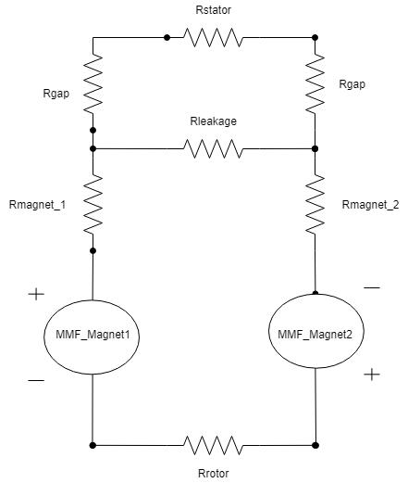

Figure 1. Equivalent magnetic circuit for one pole-pair

Area of magnet, is given as,

(1)

where, Di: rotor diamater

L: axial length of the motor

p: number of poles

Then, reluctances of magnet and airgap are given as,

(2)

(3)

MMF of magnet is calculated as,

(4)

(5)

where,

(6)

if we ignore leakage flux and assume that rotor and stator are infinitely permeable.

+ (7)

By substituting (6) and (7) into equation (5)

is obtained as,

.387 * (Weber) (8)

Magnetic flux density is calculated as,

(9)

(10)

where, : residual flux density of N42 NdFeB material which is 1.28

In Fig. 2, load line and operating point of N42 NdFeB is given. As can be seen from appendix A, the residual magnetic flux density is 1.28 and intrisintic coercive force is -955 for N42 NdFeB material. At the operating point, is calculated as in equation (9) and is calculated as -201.59in equation (10).

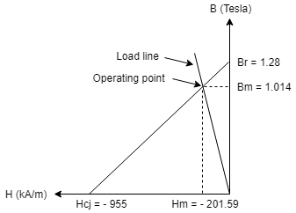

Figure 2. Load line and operating point on B-H curve of N42 NdFeB material

The magnetic loading of the machine is given as,

(11)

# Electrical Loading and Machine Sizing

## Selecting number of slots

In this part, the number of slots is choosen by considering better mmf distribution, cost and mechanical limits. The number of slots is generally choosento give a well distributed winding producing a mmf waveform with low harmonic content. The number of slots is defined as,

(12)

where, q: number of slots per phase per pole

p: number of poles

m: number of phases

If q is choosen as 1, it means the windings are concentared which is not prefable for harmonic content of mmf distribution and resultant induced voltages. Therefore, q has to be at least 2. As the q increases, the harmonic content of mmf waveform reduces but on the other hand the cost of manufacturing these slots on the core increases due to increased insulation need and stamping operation. Also, as the number of slots increases, for constant stator inner diameter, the width of teeth and slot decreases and they should not be smaller than the mechanical limits otherwise there will be a tooth bending and/or breakage. Lets choose, q as 2. This will yields number of slots as 24. For this slot number tooth thickness is found as,

= = 13.75mm (13)

where, slot width ratio is assumed as 0.5.

stator circumference:

Let’s increase q, for q equal to 3, the number of slot becomes 36 and tooth thickness is now equal to 9.16mm.

For q = 4, the number of slots becomes 48 and tooth thickness is 6.875mm.

To not close the mechanical limits and not increase the cost at the same time reducing the harmonic content of mmf waveform, q is choosen as 3 which yields number of slots is equal to 36.

## Selection of suitable wire cable

In this part, diameter of wire is choosen by considering maximum current density,J, as 5 A/mm2 and maximum fill factor as 0.6. The coil current is given as 2.5A. The minimum wire diameter can be calculated as,

(14)

So, AWG#20 wire cable with 0.518 mm2 area can be choosen as a wire cable.

## Calculation of slot height, number of coils per slot and back-core thickness

In this part, slot height, number of coils per slot and back-core thickness are calculated. To calculate slot height, slot ratio is choosen. Slot ratio(d) is the ratio of inner stator slot diameter to outer stator slot diamater. Larger slot ratio means smaller slot height and as the slot ratio reduces slot height increases and hence electrical loading increases for the same diameter. It is assumed that we have parallel teeth in our design which is most common design of stator tooth. By the help of parallel teeth slot gets wider with diameter which enables us to use put more coils into the slot. In the class it was shown that for thick parallel teeth slot ratio, d has the optimum value of 0.7. Therefore, slot ratio is choosen as 0.7.

Outer stator slot diamater, Do can be calculated as,

(15)

where, Di is the inner stator slot diamater which is the sum of rotor diameter, magnet radial thickness and air-gap clearance.

Slot height, hs can be calculated as,

(16)

As stated in section 4.1, slot width ratio was assumed as 0.5. Teeth thickness was found as 9.16 mm for 36 slots. Therefore, slot width, hw is also equals to 9.16mm.

For the open slot type, slot area, Aslot can be calculated as,

(17)

Then, number of coils per slot can be calculated as,

(18)

The back-core flux is equal to half of the flux per pole.

(19)

where, is assumed as the saturation flux density for the stator iron Bsat of 1.5 T.

can be written as,

(20)

where, is the back-core thickness

is the stacking factor of the core which is assumed 0.95.

is the axial core length which is 100mm.

The back-core thickness for the maximum flux density at the stator back-core be calculated as,

(21)

## Electric loading calculation

Electric loading of the machine can be calculated as,

(22)

where, : the number of coils per slot

Di: stator slot inner diameter

: rms coil current

: number of stator slots

If we substitute the values of the parameters in the equation 22, electric loading is found as,

(23)

In the lecture, usual values of electrical loading for PMSM is presented as 35-65 kA/m. The value that was found in equation 23. above is literally the limit value for this range. It can be said that this design has very good electric loading value.

## Calculation of force and tangential stress

Average tangential stress in the rotor surface of the machine can be calculated as,

(24)

cosφ is taken 1 since it was taken 1 for PMSM in the lecture.

Then, corresponding total force can be calculated as,

(25)

where, is the rotor surface area which is defined as,

(26)

(27)

By substituting the value found in equation 27 into the equation 25,total force that the machine can produce found as,

(28)

## Calculation of output power of the machine

The power output of the machine can be calculated by using following formula:

(29)

Torque output of the machine can be calculated from the force value that was found in equation 28.

(30)

The rotor speed is assumed as 1500 rpm. It should be converted to mech. rad/s before calculating the power.

(31)

Then, output power of the machine can be calculated by substituting the values of torque and w found in equation 30 and 31, respectively into the equation 29.

(32)

# Comparison and Optimization