WP5.3 PROCESS TWIN & HMI
Software Architecture and Technical Design Specification
Work Package: WP5.3 Process Optimization
Architecture style: arc42-aligned
Version 1.0 | July 2026

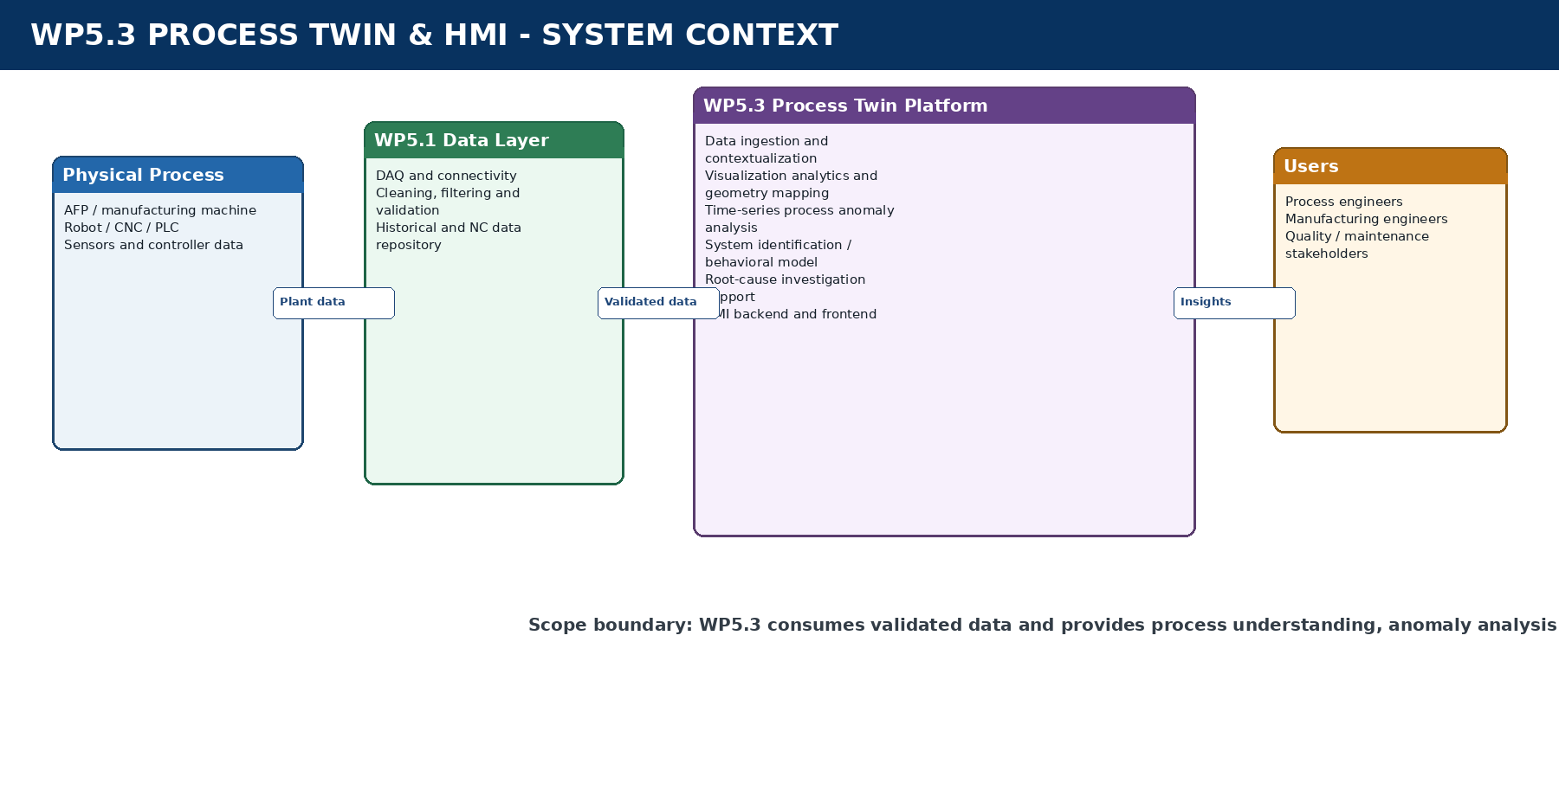
Architecture scope overview

Document Control
Document title | WP5.3 Process Twin & HMI - Software Architecture and Technical Design Specification
Version | 1.0
Status | Architecture baseline for review
Work package | WP5.3 Process Optimization
Primary audience | Process engineers, software architects, HMI developers, data engineers, analytics engineers and project stakeholders
Scope baseline | Process data analysis, time-series anomaly analysis, system identification, root-cause investigation support and HMI visualization

Revision History
Version | Date | Author/Owner | Description
1.0 | July 2026 | WP5.3 Team | Initial formal architecture and design baseline

Approval
Role | Name | Approval/Date
WP5.3 Work Package Owner
Software Architecture Reviewer
Industrial Process Stakeholder

Table of Contents
1. Introduction and Goals
2. Architecture Constraints
3. System Scope and Context
4. Solution Strategy
5. Building Block View
6. Runtime View
7. Deployment View
8. Cross-Cutting Concepts
9. Architectural Decisions
10. Quality Requirements
11. Risks and Technical Debt
12. Detailed Backend Architecture
13. Detailed Frontend Architecture
14. Analytics and Process Twin Services
15. Data and Interface Architecture
16. Testing and Validation Strategy
17. Release and Evolution Plan
18. Glossary
Appendix A. Reference Architecture Diagrams
Appendix B. Example API and Message Contracts

1. Introduction and Goals

1.1 Purpose of the Document
This document defines the software architecture and detailed technical design of the WP5.3 Process Twin and HMI platform. It establishes a common engineering baseline for implementation, integration, verification and long-term maintenance. The specification follows the structure and intent of the arc42 architecture template while extending it with implementation-level descriptions of the backend, frontend, analytics, data contracts and deployment model.
The platform is intended to transform validated process data into actionable process understanding. It combines engineering data analysis, spatial mapping, time-series process anomaly analysis, data-driven system identification, root-cause investigation support and interactive visualization. The term Process Twin is used to describe this integrated digital representation of process execution and behavior; it does not imply a physics-based simulation of the robot, machine or aircraft structure.

1.2 Business and Engineering Goals
The principal engineering goal is to provide a coherent view of process execution using data acquired by WP5.1. Engineers shall be able to inspect KPI evolution, reconstruct actual TCP trajectories, compare programmed and executed paths, superimpose process variables on part geometry, identify abnormal temporal behavior and compare actual process response with expected behavior derived from empirical models.
The platform shall shorten the time required to understand process variation and investigate abnormal conditions. It shall make process information accessible through a unified HMI rather than through disconnected logs, database queries and offline scripts. It shall also provide a reusable architecture in which basic visualization can be released before advanced time-series and system-identification modules are completed.

1.3 Scope
The architecture includes the WP5.3 data-consumption interfaces, data-ingestion adapters, contextualization services, visualization analytics, geometry mapping, time-series anomaly-analysis services, behavioral-model services, root-cause investigation support, orchestration, HMI backend APIs and HMI frontend application. Historical and NC-program data are obtained through RXU.Data or the WP5.1 repository, while live process data are consumed through RXU Connectivity topics or services.
The architecture excludes direct machine control, robot motion control, raw sensor-driver development, primary DAQ filtering owned by WP5.1, closed-loop parameter adjustment, runtime autonomous learning, virtual commissioning and physics-based environment simulation. Root-cause functionality is defined as engineering investigation support unless its diagnostic accuracy is separately validated.

1.4 Stakeholders
Stakeholder | Primary concern
Process and manufacturing engineers | Understanding KPI variation, process events, spatial behavior and potential contributors to abnormal conditions.
HMI users | Clear navigation, responsive dashboards, reliable 3D visualization and traceable investigation workflows.
WP5.1 data team | Stable data contracts, clear ownership boundaries and controlled data-consumption interfaces.
Software developers | Modular components, testable interfaces, versioned APIs and maintainable deployment.
Data and analytics engineers | Reproducible datasets, model lifecycle separation and traceable analysis outputs.
Project management | Incremental releases, visible value, bounded scope and measurable acceptance criteria.

2. Architecture Constraints
The platform is constrained by the availability and maturity of production data. Actual WP5.1 laying data is expected later than the initial WP5.3 development start; therefore the architecture must support sample mTorres data for early development and actual production data for later refinement. Data contracts shall be stable enough to avoid rebuilding the platform when the data source changes.
Constraint | Architectural consequence
WP5.1 owns acquisition, cleaning, filtering and validation | WP5.3 consumes validated data and performs contextualization, mapping, analysis and visualization without duplicating primary DAQ processing.
No physics-based 3D process model | The Process Twin is empirical and data-centric; geometry is used for visualization and spatial association, not for physical simulation.
No closed-loop control in the current scope | The platform provides insights and investigation context but does not command machine parameters.
Incremental HMI releases are required | Frontend, backend and visualization services must operate with mock or basic data before advanced analytics are available.
IPC/edge deployment | Services must run reliably within industrial-PC resource, security and network constraints.
RXU-based integration | Internal services shall use established RXU topics/services or compatible adapters where practical.

3. System Scope and Context

Figure 1 - WP5.3 system context
The physical process, machine controllers, robot controllers and sensors are outside the WP5.3 software boundary. Their data are acquired and validated by WP5.1 and made available through RXU.Data and RXU Connectivity. WP5.3 consumes this information, applies process-specific analysis, produces visualization-ready outputs and exposes them through an HMI hosted on an industrial PC or accessed from an authorized engineering workstation.

3.1 External Interfaces
External system | Direction | Information exchanged | Interface
RXU.Data / WP5.1 repository | Inbound | Historical KPI, TCP, events, NC program, run and part metadata | Repository API, database adapter or RXU service
RXU Connectivity | Inbound | Live KPI, machine state, TCP pose and process events | RXU topics/services
Part geometry repository | Inbound | CAD or mesh representation and coordinate metadata | File or geometry service
HMI users | Bidirectional | Queries, filters, visualization payloads and job status | HTTPS REST and secure WebSocket
Optional enterprise systems | Bidirectional/optional | Reports, data export or integration status | Controlled IT interface

4. Solution Strategy
The solution is decomposed into data services, visualization analytics, advanced analytics, orchestration, backend APIs and frontend modules. This separation prevents the HMI from becoming tightly coupled to databases or analytical algorithms. It also allows each service to evolve independently and enables an early HMI release using mock or basic datasets.
The architecture uses request-response communication for historical queries and analysis jobs, publish-subscribe communication for live process updates, and standardized JSON contracts between the backend and frontend. The orchestration layer coordinates multi-service workflows and protects the frontend from internal service sequencing and failure-handling complexity.
The implementation shall prefer explicit service contracts, versioned schemas, traceable job identifiers and deterministic historical analysis. Advanced analytics modules are independently deployable and are integrated through adapters so that a statistical or machine-learning implementation can be changed without redesigning the HMI.

5. Building Block View
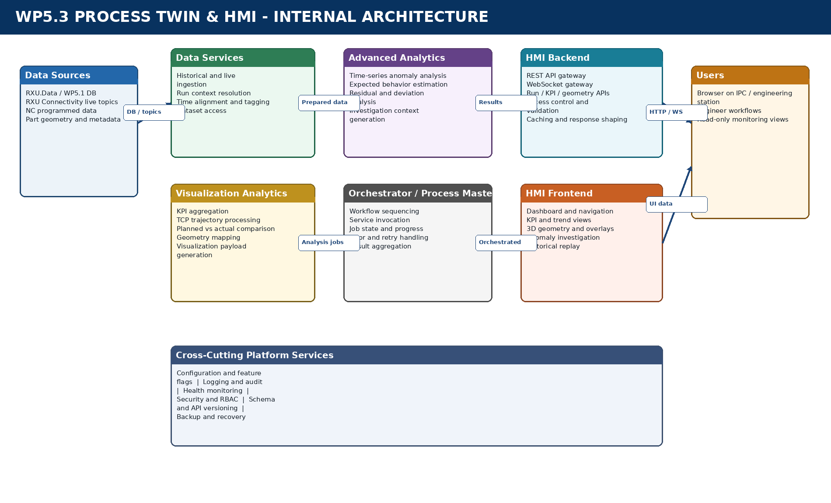
Figure 2 - Internal building-block architecture

5.1 Level 1 Building Blocks
Building block | Responsibility
Data Services | Retrieve historical and live data, resolve run context, align timestamps and expose normalized records.
Visualization Analytics | Compute dashboard KPIs, TCP paths, planned-versus-actual deviations, geometry associations and visualization payloads.
Advanced Analytics | Perform time-series anomaly analysis, expected-behavior estimation, residual analysis and investigation-context generation.
Orchestrator / Process Master | Sequence workflows, manage service dependencies, monitor jobs, handle errors and aggregate results.
HMI Backend | Expose APIs, validate requests, shape responses, manage live subscriptions and enforce access policies.
HMI Frontend | Provide dashboards, trends, 3D visualization, overlays, investigation views and historical replay.
Cross-Cutting Services | Provide configuration, logging, monitoring, security, schema versioning and recovery capabilities.

6. Runtime View
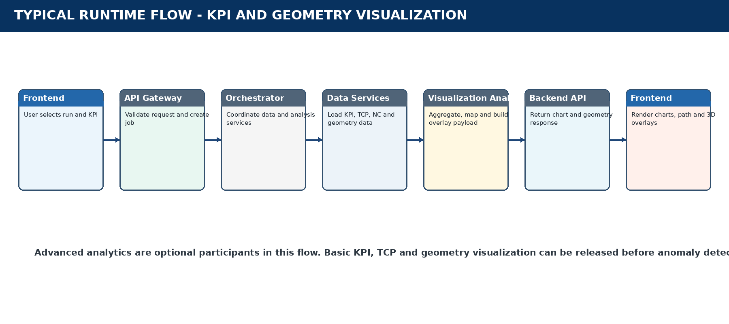
Figure 3 - Typical KPI and geometry visualization runtime flow

6.1 Historical Run Visualization
When a user selects a historical run, the frontend requests the run summary and available signals from the backend. The API gateway validates the request and delegates it to the orchestrator. The orchestrator retrieves historical KPI, TCP, event, NC and geometry information through the data services. Visualization analytics calculate summaries, prepare the trajectory, perform spatial association and build the chart and overlay payloads. The backend returns a normalized response, after which the frontend updates its state and renders the selected views.

6.2 Live Process Visualization
RXU Connectivity publishes live process values and state changes. The live-data adapter subscribes to the configured topics, associates each message with the active run and forwards normalized updates to the backend streaming gateway. Authorized frontend clients receive the updates through WebSocket subscriptions. The frontend updates KPI cards, trend windows, process state and TCP indicators without reloading the entire page.

6.3 Process Anomaly Investigation
The time-series service detects or evaluates an abnormal condition and returns an anomaly event containing the signal, time interval, score, severity and process context. The orchestrator requests related signal windows, event history and geometry mapping. The investigation service then generates associated variables and contextual evidence. The backend returns a consolidated payload that allows the frontend to show the anomaly on the timeline, highlight its spatial location and display the relevant before-and-after trends.

6.4 Expected-versus-Actual Analysis
For a selected run or interval, the system-identification service evaluates the empirical behavioral model using the relevant process inputs and state. It produces expected response values or an expected envelope. The actual measurements are aligned to these results and residuals are calculated. The frontend receives actual, expected, envelope and deviation series and presents them as a comparison rather than as a claim of defect prediction.

7. Deployment View
The target deployment is an industrial PC located at the edge of the production network. The IPC hosts the frontend web application, backend interface, orchestration process and WP5.3 analysis services. RXU Connectivity may run on the same IPC or on an adjacent edge node depending on the established plant architecture. Historical data may reside locally or in a WP5.1-managed repository accessible over the OT network.
Deployment unit | Typical content | Communication
Frontend container or static web server | Compiled web application and assets | HTTPS/WSS to backend
Backend/API container | REST API, WebSocket gateway, authentication and response shaping | Internal service calls and repository access
Orchestrator process | Workflow and behavior-tree logic | RXU services/topics or internal RPC
Data-service container | Repository adapters, live subscribers and context services | RXU.Data and RXU Connectivity
Analytics containers | Visualization analytics, time-series, system identification and investigation services | Internal APIs or RXU services
Local infrastructure | Cache, logs, configuration and optional local database | Local IPC communication

Containerization is recommended to isolate dependencies and simplify versioned deployment. A reverse proxy shall terminate HTTPS, serve the frontend and route API and WebSocket traffic. Health checks shall be exposed for all critical services. The IPC shall use a controlled dual-network or segmented-network design when both OT and IT connectivity are present.

8. Cross-Cutting Concepts

8.1 Configuration Management
Configuration includes topic names, repository endpoints, KPI definitions, units, geometry references, feature flags, access roles and analysis parameters. Configuration shall be externalized from application binaries and version controlled.

8.2 Logging and Traceability
Every frontend request that initiates a multi-service workflow shall receive a job identifier. Logs from the API gateway, orchestrator and analysis services shall include this identifier so that a complete execution path can be reconstructed.

8.3 Health Monitoring
Health checks shall cover API availability, RXU.Data connectivity, RXU Connectivity subscriptions, orchestrator status, analysis-service readiness, cache status and storage availability.

8.4 Security
The platform shall use authenticated HTTPS and secure WebSocket communication where required. Role-based access shall separate viewer, engineering and administrative capabilities. Critical user actions and configuration changes shall be auditable.

8.5 Schema and API Versioning
Data schemas, RXU messages and frontend APIs shall be explicitly versioned. Backward-compatible changes shall be preferred, while incompatible changes shall be introduced through a new versioned endpoint or topic.

8.6 Error Handling
Services shall return structured status, error code, human-readable message, source component and job identifier. The orchestrator shall distinguish retryable connectivity failures from invalid input and deterministic analysis failures.

9. Architectural Decisions
Decision | Rationale | Consequence
Frontend communicates only through backend APIs | Prevents direct coupling to databases and RXU internals. | All visualization data must be exposed through controlled contracts.
REST for queries and WebSocket for live updates | Matches historical request-response and live publish-subscribe patterns. | Backend must manage subscriptions and connection recovery.
Analytics services remain independent | Allows statistical, SI and ML implementations to evolve separately. | Adapters and stable result schemas are required.
Orchestrator coordinates multi-step workflows | Centralizes sequencing, progress and failure handling. | Orchestrator becomes a critical monitored component.
Geometry is used for spatial visualization, not physical simulation | Aligns with scope and avoids misleading digital-twin claims. | No dynamic robot or environment simulation is required.
Root-cause capability is investigation support | Reflects limited labeled causal evidence. | UI wording must avoid claiming confirmed automatic diagnosis.

10. Quality Requirements
Quality attribute | Requirement intent | Verification approach
Performance | Dashboard and historical-query response shall be suitable for interactive engineering use; large geometry and time-series data shall be paged, aggregated or streamed. | Load tests and representative dataset benchmarks.
Reliability | Temporary loss of live connectivity shall not crash the HMI; the system shall reconnect and expose status. | Fault-injection and reconnect tests.
Maintainability | Services shall be modular, documented and independently testable. | Code review, interface tests and dependency checks.
Extensibility | New KPIs, overlays and analytics outputs shall be added through configuration and versioned schemas. | Change-impact demonstration.
Usability | Users shall navigate from summary to detailed evidence with consistent filters and context. | User acceptance testing.
Traceability | Every displayed analysis result shall be traceable to run, timestamp, source data and analysis version. | Audit and data-lineage tests.
Security | Only authorized users and systems shall access data and configuration. | Authentication, authorization and penetration checks as applicable.

11. Risks and Technical Debt
Risk | Impact | Mitigation
Late or incomplete WP5.1 data | Delays analytics validation and actual-data integration. | Use sample data, synthetic interface tests and explicit data contracts.
Timestamp misalignment | Incorrect KPI-to-TCP or anomaly-to-geometry mapping. | Define clock source, tolerances and synchronization quality indicators.
Large CAD/mesh files | Slow startup and poor frontend rendering. | Preprocess meshes, use level of detail and cache geometry.
Unclear process states | Incorrect comparisons and false anomaly interpretation. | Validate state semantics with process experts and store state provenance.
Root-cause overclaim | Loss of stakeholder trust. | Present evidence and possible contributors; retain human validation.
Architecture drift between RXU and HMI teams | Integration rework. | Maintain interface control documents and automated contract tests.

12. Detailed Backend Architecture
The backend is the controlled integration boundary between the frontend, RXU platform, data repositories and analysis services. It contains no rendering logic and shall not expose internal database structures directly to the user interface.

12.1 Backend Interface and API Gateway
Receives HTTPS and WebSocket traffic from the frontend. It validates authentication, request syntax, run identifiers, filter parameters and payload size. Historical queries are routed to data services, while analysis requests are converted into orchestrated jobs. Responses are normalized so the frontend does not depend on the internal representation of RXU messages or database records.

12.2 Run Management Service
Maintains the identity and metadata of production runs, including part, program, layer, course, start and end time, available signals and geometry reference. It provides the anchor used to correlate historical records, live messages and analysis outputs.

12.3 Historical Data Service
Retrieves validated process data from RXU.Data or the WP5.1 repository through a repository abstraction. It supports run-, time-, signal-, layer- and course-based queries and returns normalized records to other services.

12.4 Live Data Service
Subscribes to RXU Connectivity topics, manages reconnect behavior and converts incoming messages into the internal canonical schema. It tracks the active run context and forwards live updates to subscribed clients through the backend streaming gateway.

12.5 Data Context and Synchronization Service
Associates KPI, TCP, events and NC records through timestamp, run and process-state context. It performs WP5.3-specific alignment and enrichment but does not duplicate the primary cleaning and validation already performed by WP5.1.

12.6 Visualization Analytics Service
Calculates KPI summaries, resampling for charts, TCP trajectories, run summaries and planned-versus-actual differences. It also produces compact payloads for charts, tables, timelines and geometry overlays.

12.7 Geometry Mapping Service
Loads or references the approved part representation, resolves coordinate-system metadata and associates TCP points, KPI values and analysis events with spatial locations. It exposes geometry, overlay and point-inspection data through backend APIs.

12.8 Analytics Integration Service
Adapts time-series anomaly, system-identification and root-cause investigation outputs to the common HMI schema. It allows algorithms to evolve without requiring frontend changes.

12.9 Orchestrator / Process Master
Coordinates workflows spanning multiple services. It manages prerequisites, job state, progress, timeout, retry and partial-failure behavior. A behavior tree or equivalent workflow model is suitable where the RXU architecture already uses this pattern.

12.10 Cache and Storage Adapter
Caches frequently requested run summaries, chart aggregates and geometry overlays. Persistent analysis results may be stored with their model and algorithm version to support traceability.

12.11 Configuration, Logging and Health Services
Provide centralized runtime configuration, structured logging, audit records, service-health reporting, backup information and deployment diagnostics.

13. Detailed Frontend Architecture
The frontend is a browser-based engineering HMI designed for progressive delivery. Version 1 establishes the design system, navigation, screen templates and frontend-to-backend connectivity. Later releases add real KPI and TCP data, geometry overlays, anomaly investigation and behavioral-model views.

13.1 Application Shell and Navigation
Provides the common header, navigation menu, route handling, user context, backend status and consistent screen layout. The shell shall preserve selected run and filter context when the user moves between views.

13.2 Dashboard
Shows run identity, process state, data availability, KPI summary cards, active events and links to detailed views. In early releases, the dashboard may use mock payloads while preserving the final API contract.

13.3 KPI Trends and Comparison
Displays one or more KPI series with units, time range, cursor inspection, zoom and process-state context. It supports synchronized cursors across multiple charts so related changes can be investigated.

13.4 Process Timeline and Event View
Presents process states, run phases, machine events and analysis events on a common time axis. Selecting an event updates related charts and geometry context.

13.5 Three-Dimensional Geometry Viewer
Displays the approved part mesh with rotate, pan, zoom, reset, layer visibility and selection. It shall render actual TCP paths, programmed paths, KPI overlays, anomaly markers and selected regions without implying physical simulation.

13.6 Overlay Management
Allows the user to select the displayed KPI, color scale, path, anomaly layer and time or run interval. Tooltips shall show the mapped timestamp, TCP pose, signal value and process context.

13.7 Anomaly Investigation View
Combines anomaly metadata, before-and-after trends, process-state events, geometry location and associated variables. It is enabled when time-series analysis results are available.

13.8 Expected-versus-Actual View
Displays expected response, actual response, expected envelope and residual or deviation. It is enabled when a validated behavioral model produces the required output.

13.9 Historical Run Explorer
Supports run selection, replay, comparison and retrieval of historical overlays. The user may move through time while charts, events and TCP position remain synchronized.

13.10 Frontend Communication Layer
Encapsulates REST clients, WebSocket subscriptions, authentication tokens, retry logic, error handling and response conversion. UI components shall not call endpoints directly outside this layer.

14. Analytics and Process Twin Services

14.1 Process Data Analysis for Visualization
This service can be delivered before time-series anomaly analysis and system identification. It consumes the dataset prepared by the preceding data-preparation deliverable and generates engineering and visualization products. Its outputs include KPI aggregates, TCP trajectories, planned-versus-actual path and speed comparisons, process timelines, geometry mappings, heatmap values and HMI-ready payloads.

14.2 Time-Series Process Anomaly Analysis
The time-series service evaluates temporal behavior to identify threshold violations, spikes, drift, oscillation, change points or statistically unusual windows. Its primary subject is process anomaly rather than product defect. The service shall generate traceable anomaly events with signal, time interval, severity, score, method, process state and spatial association where available.

14.3 System Identification and Behavioral Model
The system-identification service learns or applies empirical input-output relationships using process signals and state. It estimates expected process behavior under given conditions and supports expected-versus-actual comparison. It does not require a 3D environment model and shall not be described as a physics-exact digital twin. Candidate methods may include ARX, state-space, regression and other data-driven temporal models selected through validation.

14.4 Root-Cause Investigation Support
The investigation service combines anomaly events, related KPI windows, process-state transitions, planned-versus-actual deviations, behavioral residuals and spatial context. It ranks or presents possible contributing variables and associated evidence. The service must preserve the distinction between correlation, temporal association and confirmed causation.

15. Data and Interface Architecture

15.1 Canonical Data Entities
Entity | Key attributes
Run | runId, partId, programId, startTime, endTime, machineId, geometryId, dataStatus
KPI sample | runId, timestamp, signalId, value, unit, processState, qualityFlag, source
TCP pose | runId, timestamp, position, orientation, coordinateFrame, processState
NC point/path | programId, sequence, plannedPose, plannedSpeed, layer, course
Event | eventId, runId, timestamp, type, severity, state, description
Anomaly | anomalyId, runId, signal, start/end, score, severity, method, context
Behavior result | runId, modelVersion, expectedValue/envelope, actualValue, residual, timestamp
Geometry overlay | geometryId, overlayType, points/regions, values, scale, time range

15.2 API Categories
API category | Representative capability
Run APIs | List runs, retrieve metadata and available signals.
KPI APIs | Retrieve summary cards, trend series and chart aggregates.
Trajectory APIs | Retrieve actual TCP, programmed path and comparison results.
Geometry APIs | Retrieve geometry metadata, overlays and point-inspection information.
Timeline APIs | Retrieve process states and events.
Anomaly APIs | Retrieve anomaly lists, details and investigation context.
Behavior APIs | Retrieve expected-versus-actual data, envelopes and residuals.
Job APIs | Start analysis, query progress and retrieve result status.
Health APIs | Expose backend and dependency status.

15.3 Communication Rules
REST responses shall include schema version, request or job identifier, status, data and structured error information. WebSocket messages shall identify subscription, message type, run, timestamp and sequence where ordering matters. Internal RXU topics and services shall use stable names, explicitly defined units and documented quality flags.

16. Testing and Validation Strategy
Test level | Scope
Unit testing | Parsing, mapping, KPI calculations, API validation, state reducers and UI components.
Contract testing | WP5.1 data contracts, RXU topics/services and frontend-backend APIs.
Integration testing | Historical retrieval, live subscription, orchestration, analytics adapters and geometry mapping.
System testing | End-to-end runs using representative data, including API, charts, timeline and 3D overlays.
Performance testing | Large time-series queries, multi-run history, geometry loading and live update rates.
Usability testing | Navigation, filtering, context preservation and anomaly-investigation workflows.
Acceptance testing | Stakeholder-approved scenarios for each HMI release and analytics version.

Validation shall distinguish software correctness from analytical validity. A correctly displayed anomaly is not necessarily a meaningful process anomaly unless the underlying method and threshold have been validated. Similarly, a system-identification model shall be accepted only after residual, stability and generalization assessment using representative data.

17. Release and Evolution Plan
Release | Content | Dependencies
HMI Version 1 - Framework and navigation prototype | Application shell, landing page, buttons, navigation, placeholder screens, sample KPI cards, mock data, basic 3D placeholder and frontend-backend connectivity. | Architecture and design freeze; mock API contracts.
HMI Version 2 - Process data visualization | Actual KPI trends, run selection, process timeline, TCP trajectory, NC path, basic part geometry and KPI overlays. | WP5.1 data access, visualization analytics and geometry mapping.
HMI Version 3 - Process intelligence integration | Process anomaly views, expected-versus-actual views, investigation context, historical replay and mature overlays. | Validated time-series, system-identification and investigation outputs.

The versioned strategy avoids blocking HMI development on analytics maturity. Each release shall preserve API contracts where possible and introduce advanced functionality as an additional layer rather than rewriting the basic application structure.

18. Glossary
Term | Definition
Process Twin | Data-centric representation of process execution, spatial context, abnormal behavior and expected behavior; not a physics-based environment simulation.
HMI | Human-machine interface used here for process visualization and engineering investigation.
RXU | Application and connectivity framework used for internal services, orchestration and data exchange.
WP5.1 | Work package responsible for acquisition, cleaning, filtering, validation and data availability.
KPI/KPP | Process or performance indicator supplied or calculated for analysis and visualization.
TCP | Tool center point pose recorded from the machine or robot.
Process anomaly | Abnormal signal or process behavior such as spike, drift, oscillation or deviation; not automatically a product defect.
System identification | Data-driven estimation of process input-output behavior.
Residual | Difference between actual and expected model output.
Root-cause investigation support | Contextual evidence and possible contributing variables provided to engineers; not necessarily confirmed diagnosis.

Appendix A. Reference Architecture Diagrams
The following project diagrams were used as references for the formal architecture described in this specification.
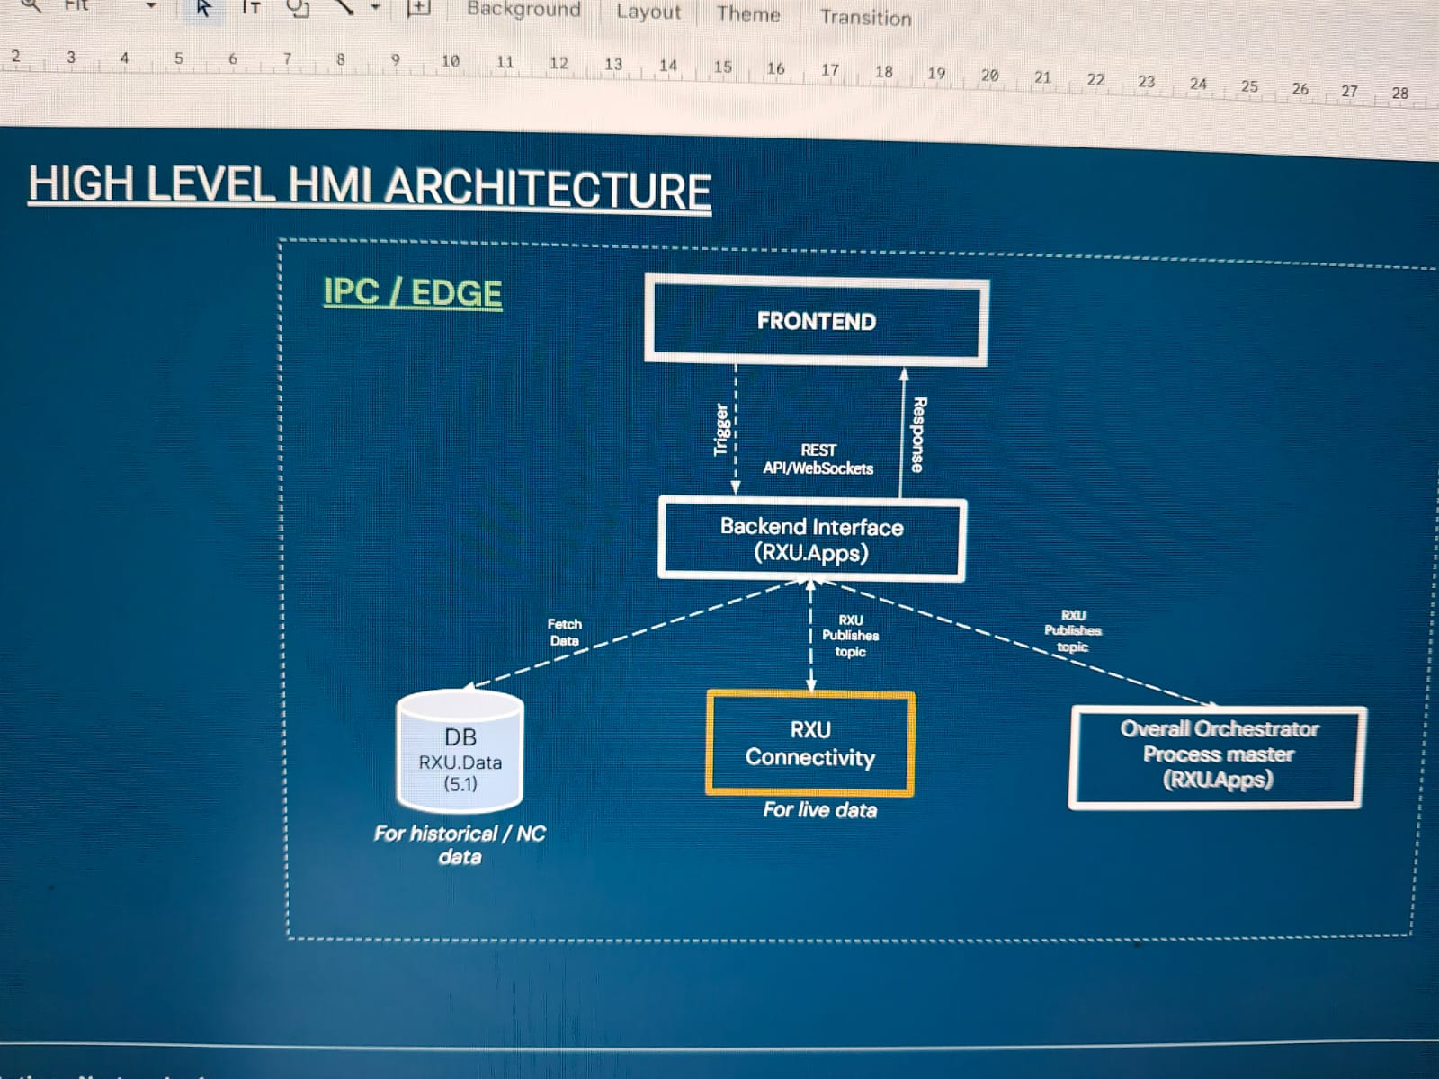
Figure A-1 - Project high-level HMI architecture reference
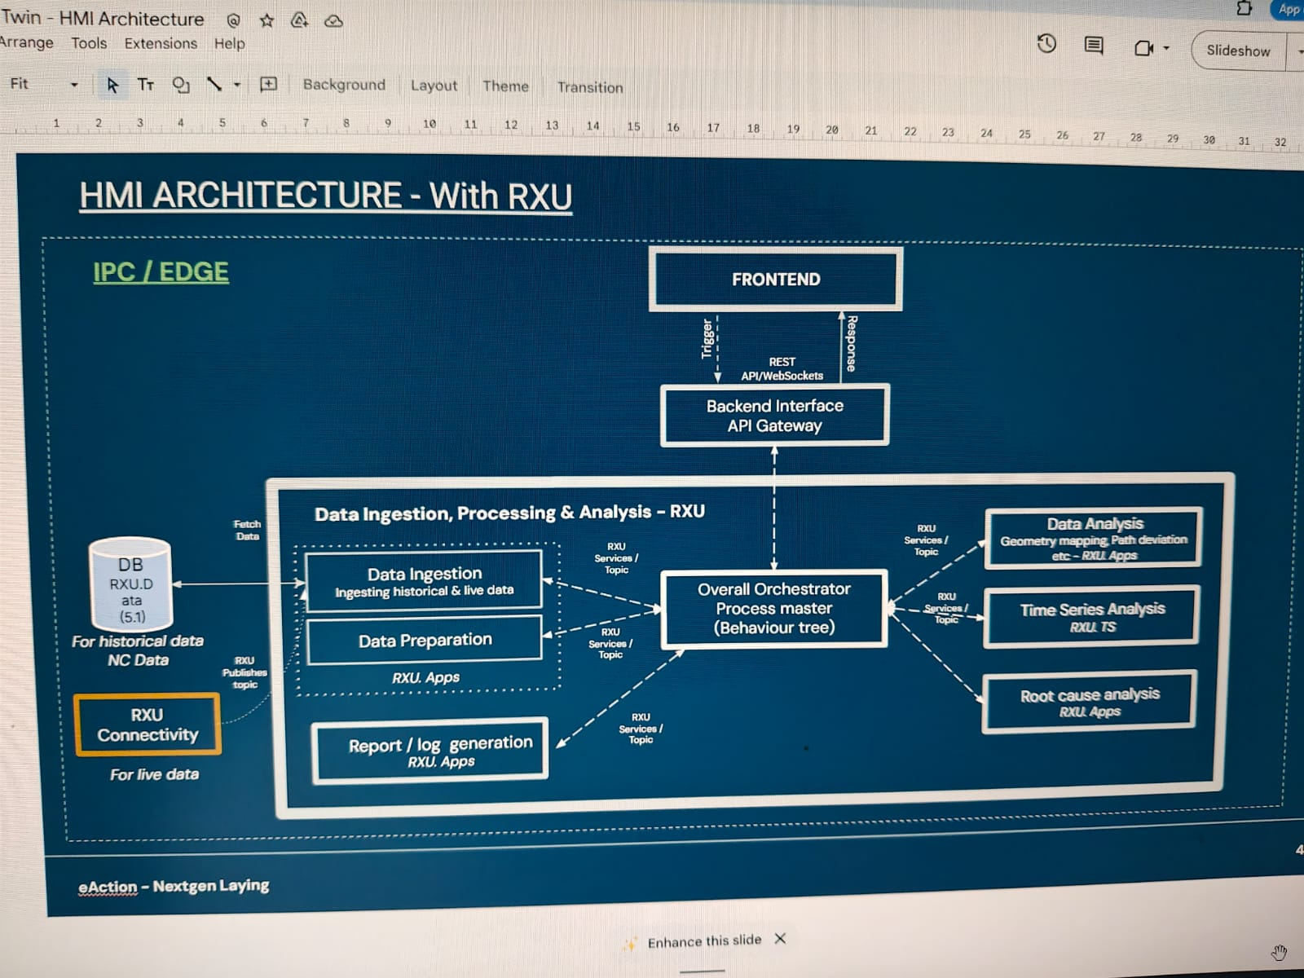
Figure A-2 - Project detailed HMI architecture reference

Appendix B. Example API and Message Contracts

B.1 KPI Trend Response
A KPI trend response shall identify the schema version, run, signal, unit, time range and ordered samples. Optional process-state and quality flags should be included when they are required by the HMI.
{
"schemaVersion": "1.0",
"runId": "RUN-2026-001",
"signal": "tow_tension",
"unit": "N",
"samples": [
{"timestamp": "2026-07-15T10:15:32.125Z", "value": 21.4, "processState": "laying"}
]
}

B.2 Geometry Overlay Response
{
"schemaVersion": "1.0",
"runId": "RUN-2026-001",
"geometryId": "PART-A-MESH-V3",
"overlayType": "kpi_path",
"signal": "tow_tension",
"points": [
{"x": 1.24, "y": 0.42, "z": 2.11, "value": 21.4, "timestamp": "2026-07-15T10:15:32.125Z"}
]
}

