Autonomy in Motion
Interview Script
12 visible slides • 15 minute presentation
This script follows the updated 7 November 2026 deck and excludes hidden slides. It connects your career, contributions and vision for a mixed technical and nontechnical panel.
Target delivery is 14 minutes 15 seconds, including short pauses and slide transitions, leaving a 45 second buffer. The spoken text is approximately 1,530 words. Timing is a rehearsal target; adjust your pace using the checkpoints below.

Timing guide
Slide | Topic | Time | Finish by
1 | Opening | 0:25 | 0:25
2 | Personal foundation | 1:00 | 1:25
3 | Career trajectory | 1:00 | 2:25
4 | Recognition and learning | 0:55 | 3:20
5 | Motion planning explained | 1:00 | 4:20
6 | Value of autonomy | 1:15 | 5:35
7 | Milestones in planning and inspection | 1:20 | 6:55
8 | Milestones in software and process quality | 1:05 | 8:00
9 | Collaboration and technical influence | 0:55 | 8:55
10 | Innovation and shared knowledge | 1:35 | 10:30
11 | Short term vision and common framework | 1:35 | 12:05
12 | Mid and long term vision and closing | 2:10 | 14:15

How to rehearse
Read the main paragraphs aloud. Delivery cues are not spoken. Use the final sentence of each section as the transition. On the vision slides, pause after each reveal rather than reading every label. Aim to reach slide 11 by 10:30.

Slide 1 Autonomy in Motion
0:25 | Presentation clock 0:00 to 0:25
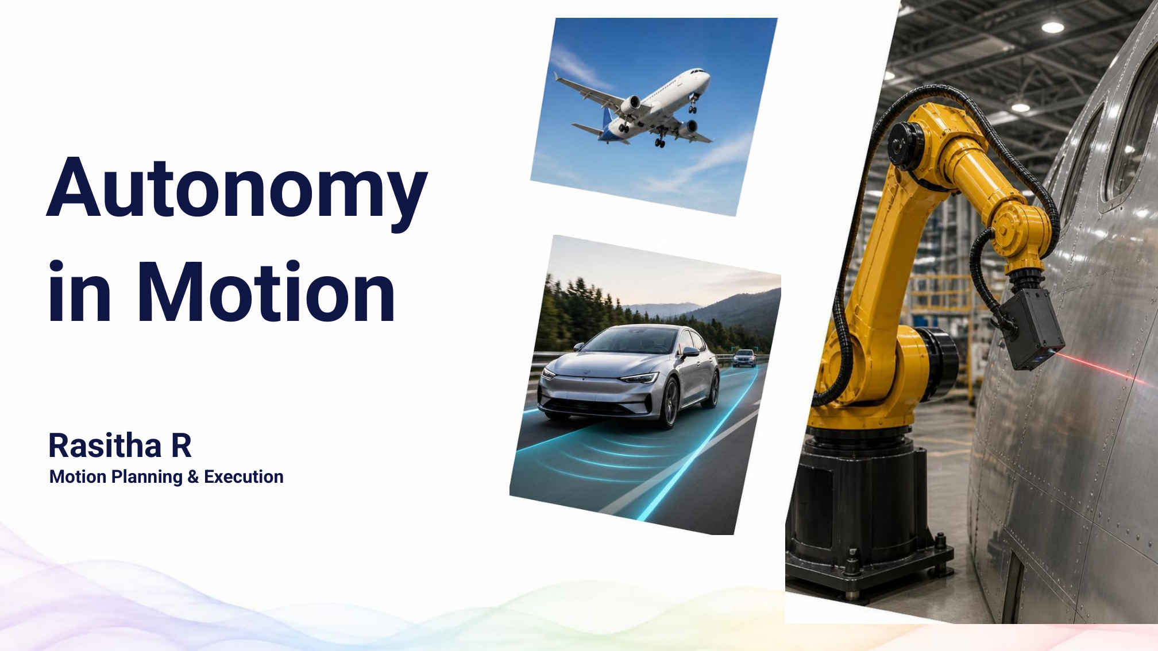
Good morning, and thank you for the opportunity. My journey has taken me from flight control to driver assistance and now robotics, with one continuous interest: helping machines move reliably and adapt to the task.
I’ll share the value I’ve contributed and the direction I want to take next.
Delivery cue Make eye contact before moving to your personal story.

Slide 2 What Shaped My Journey
1:00 | Presentation clock 0:25 to 1:25
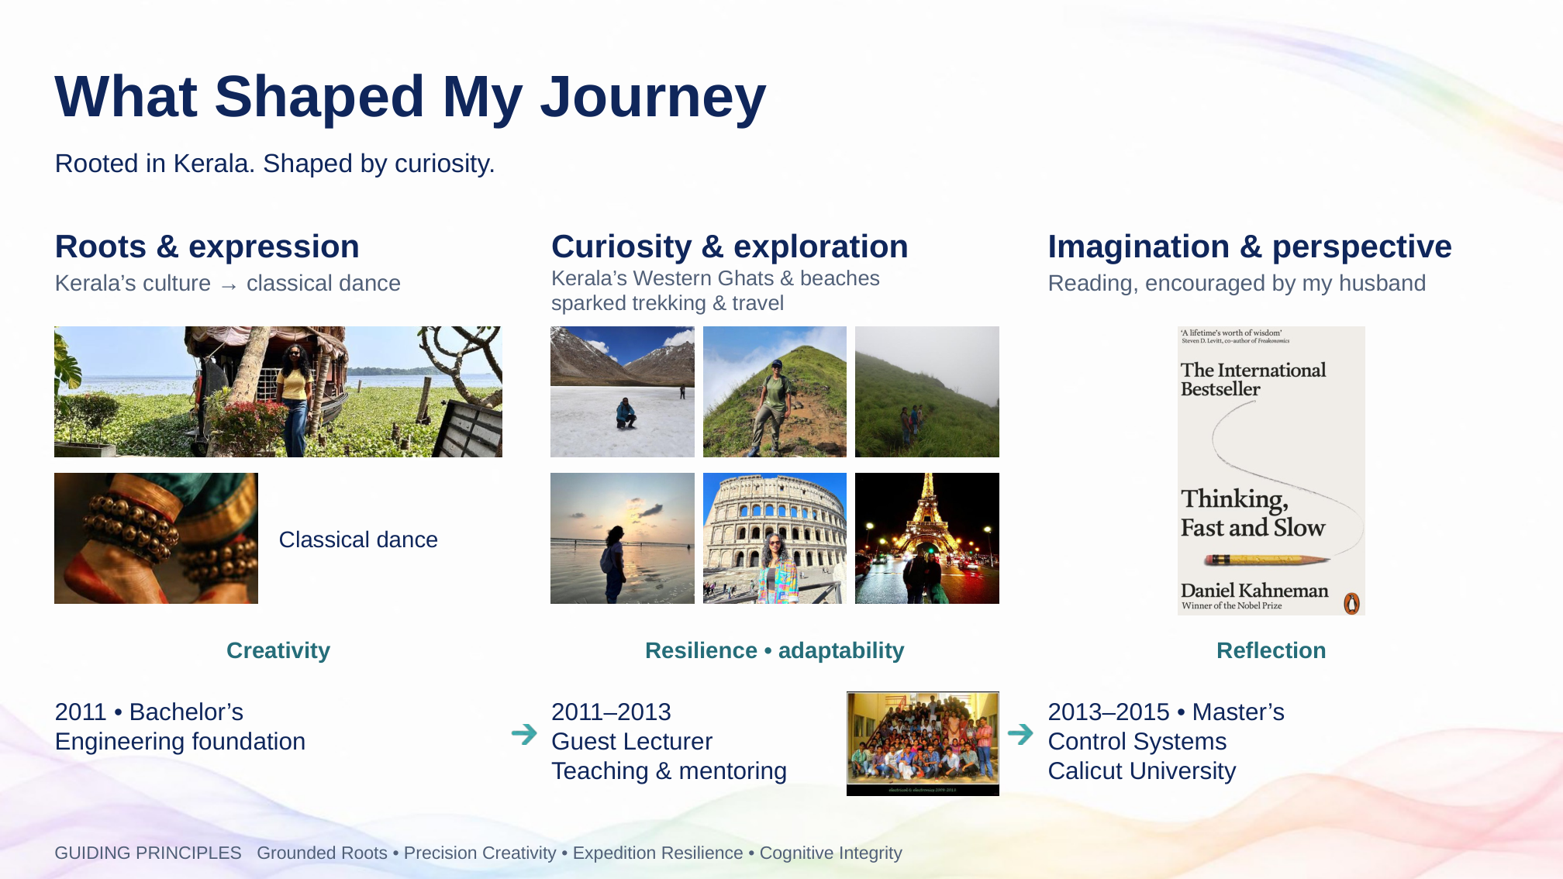
My roots are in Kerala. Its culture introduced me to classical dance, which brings together precision and creativity. Its mountains and coastline sparked my interest in trekking and travel, teaching me to adapt and keep going when plans change.
Reading, encouraged by my husband, has added another way to explore ideas and question my assumptions.
After my bachelor’s in 2011, I worked as a guest lecturer. Teaching taught me to make complex ideas understandable, something I still value when mentoring. My master’s in Control Systems then gave me the technical foundation for my career.
Together, these experiences shape how I work: with curiosity, discipline and a willingness to understand different perspectives.
Delivery cue Follow the images, then the education timeline. Do not read the four guiding principles individually.

Slide 3 Career trajectory
1:00 | Presentation clock 1:25 to 2:25
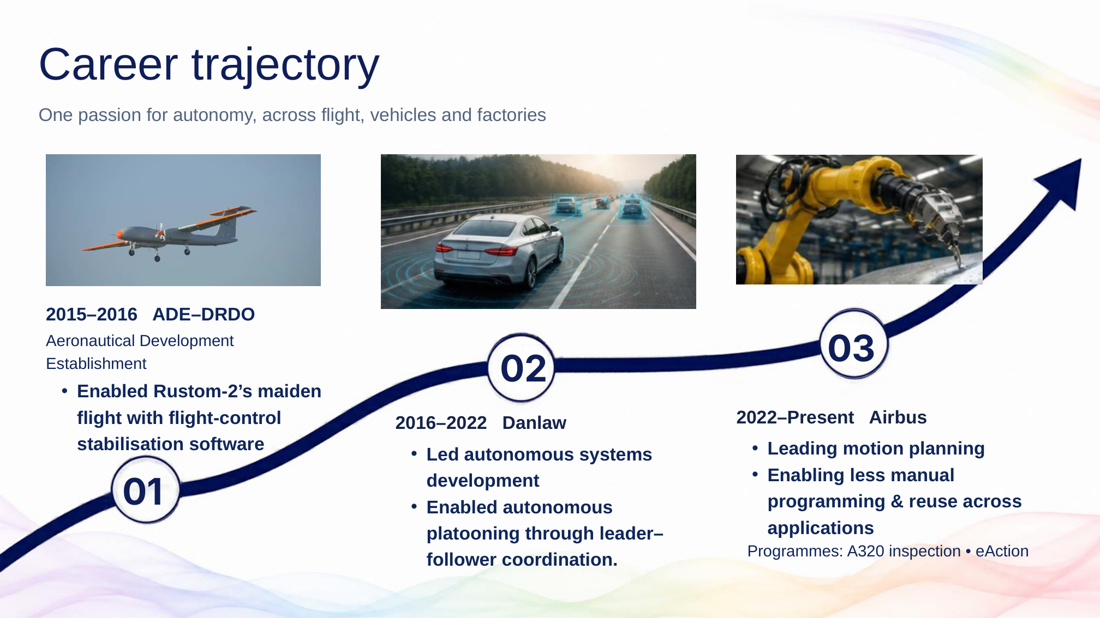
My career has followed the same theme across three environments.
At the Aeronautical Development Establishment, part of DRDO, I contributed flight-control stabilisation software that helped enable Rustom-2’s maiden flight. The focus was reliable movement in the air.
At Danlaw, I led autonomous systems development and enabled autonomous platooning through leader–follower coordination: vehicles coordinating their movement as a group. I also worked on driver-assistance applications.
At Airbus, I lead motion planning to reduce manual robot programming and make solutions reusable across applications, including A320 inspection and eAction.
The setting has changed, but the question remains: how can we make movement reliable while reducing the effort needed to prepare it?
Delivery cue Move along the trajectory. Emphasise your contribution rather than the company dates.

Slide 4 Achievements and recognition
0:55 | Presentation clock 2:25 to 3:20
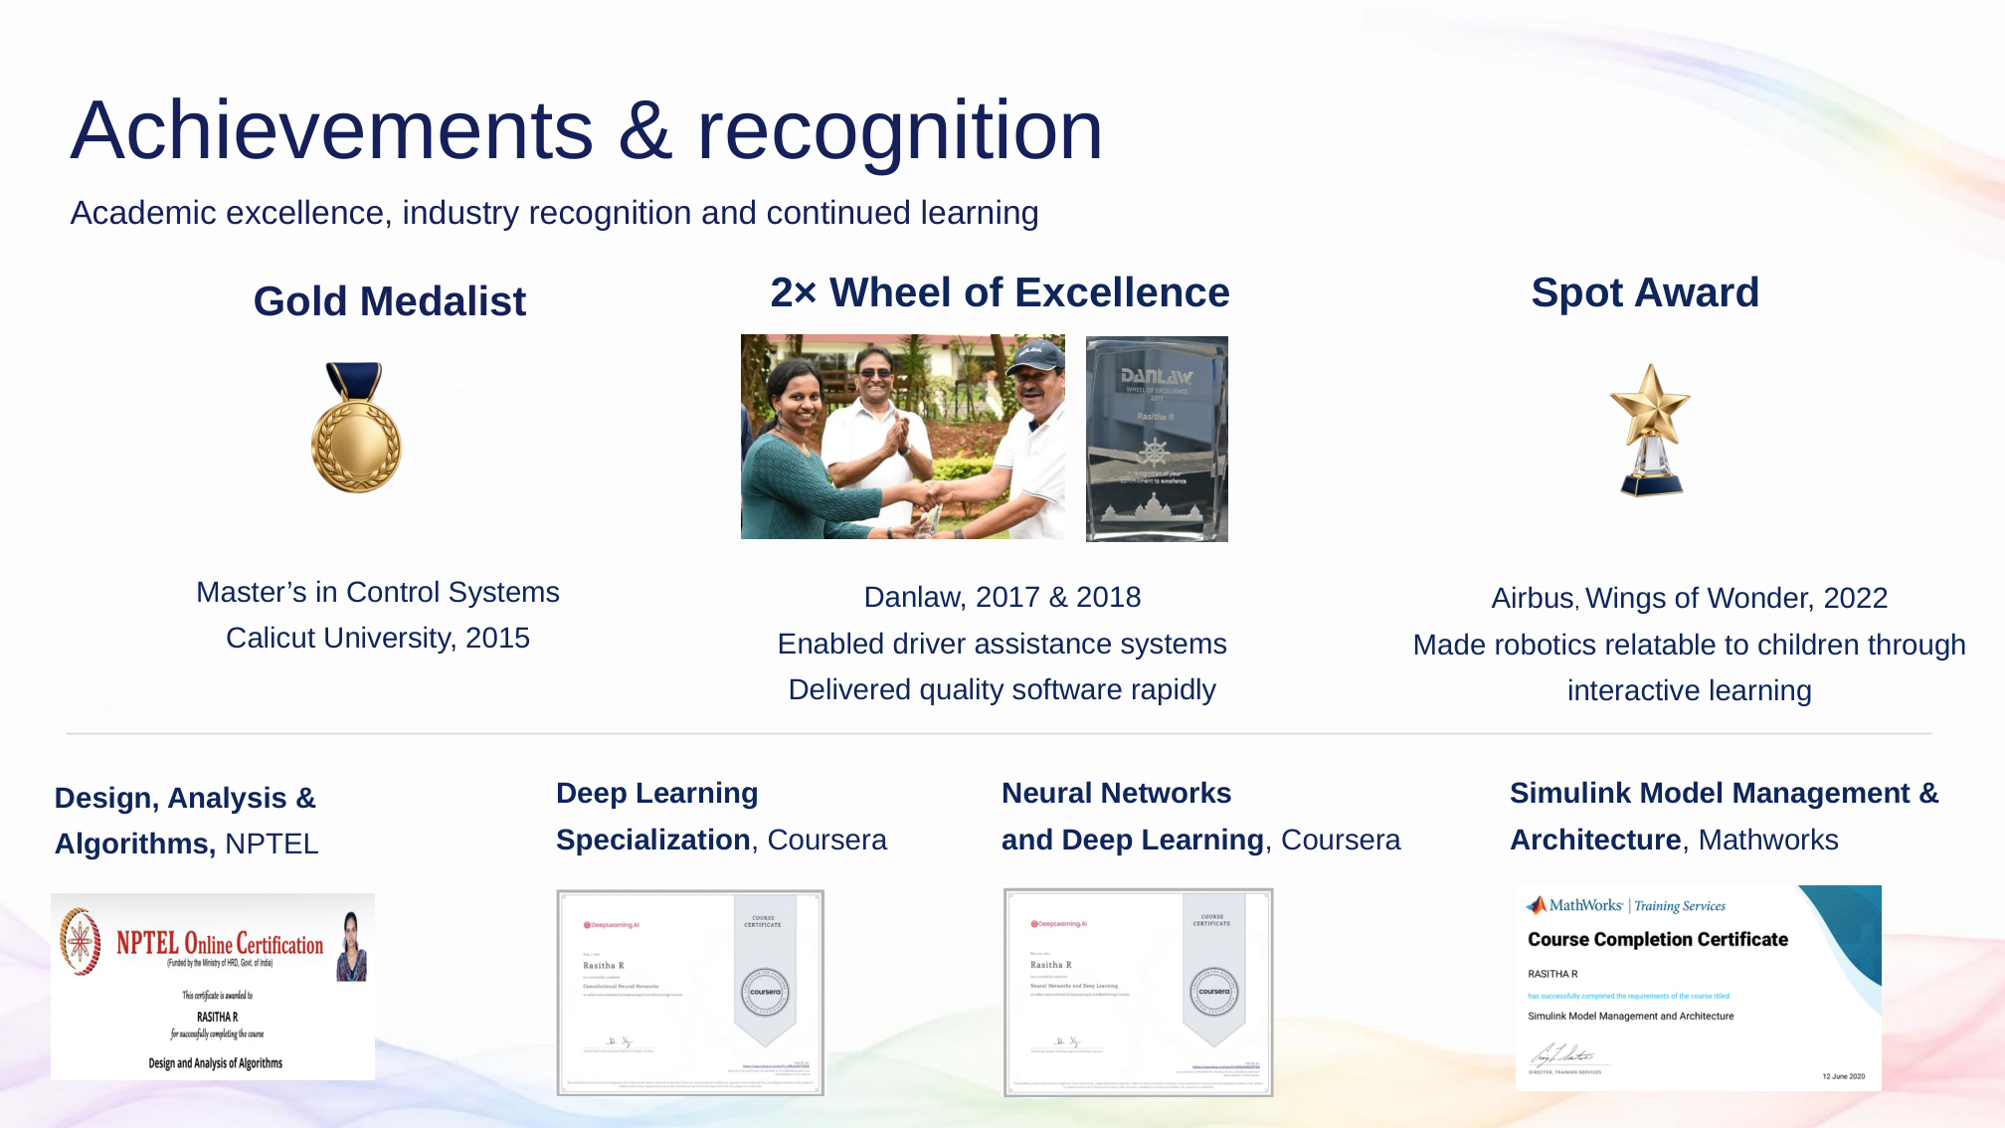
I was a gold medallist in Control Systems in 2015. At Danlaw, I received the Wheel of Excellence twice, for contributions in 2017 and 2018: enabling driver-assistance systems and delivering quality software within short timelines.
At Airbus, my 2022 Spot Award recognised Wings of Wonder, where I made robotics relatable to children through interactive learning. That reflects my approach to mentoring: make ideas accessible and encourage questions.
My algorithms studies support structured problem-solving and planner evaluation. Deep-learning studies help me assess learning-based robotics approaches, while model-management training supports modular software thinking. These foundations help me make informed choices in Airbus projects.
Now, to the focus of my work.
Delivery cue Connect each recognition to contribution. Let the panel read the certificate titles.

Slide 5 Motion planning
1:00 | Presentation clock 3:20 to 4:20
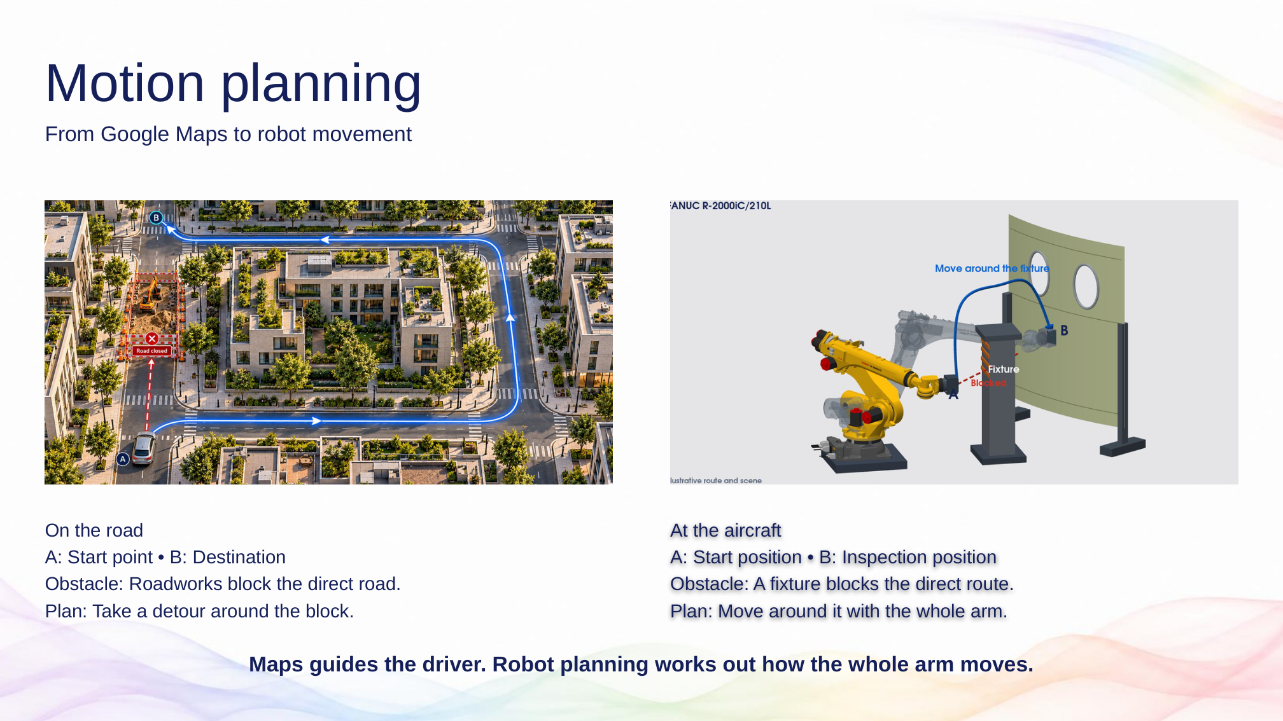
Imagine driving to a destination and finding that roadworks block the direct route. A navigation app helps you choose another way.
A robot inspecting an aircraft panel faces a similar problem. It knows where the sensor needs to go, but a fixture may block the direct movement.
The important difference is that we must consider the whole arm. Even if the sensor clears the fixture, an elbow or another part of the robot could collide with it.
Motion planning works out a feasible movement from the starting position to the inspection position, while respecting the robot’s limits and the surrounding equipment.
The next question is what happens when the panel changes.
Delivery cue Point to the road obstacle first, then the fixture and the robot’s whole arm.

Slide 6 Where autonomous motion adds value
1:15 | Presentation clock 4:20 to 5:35
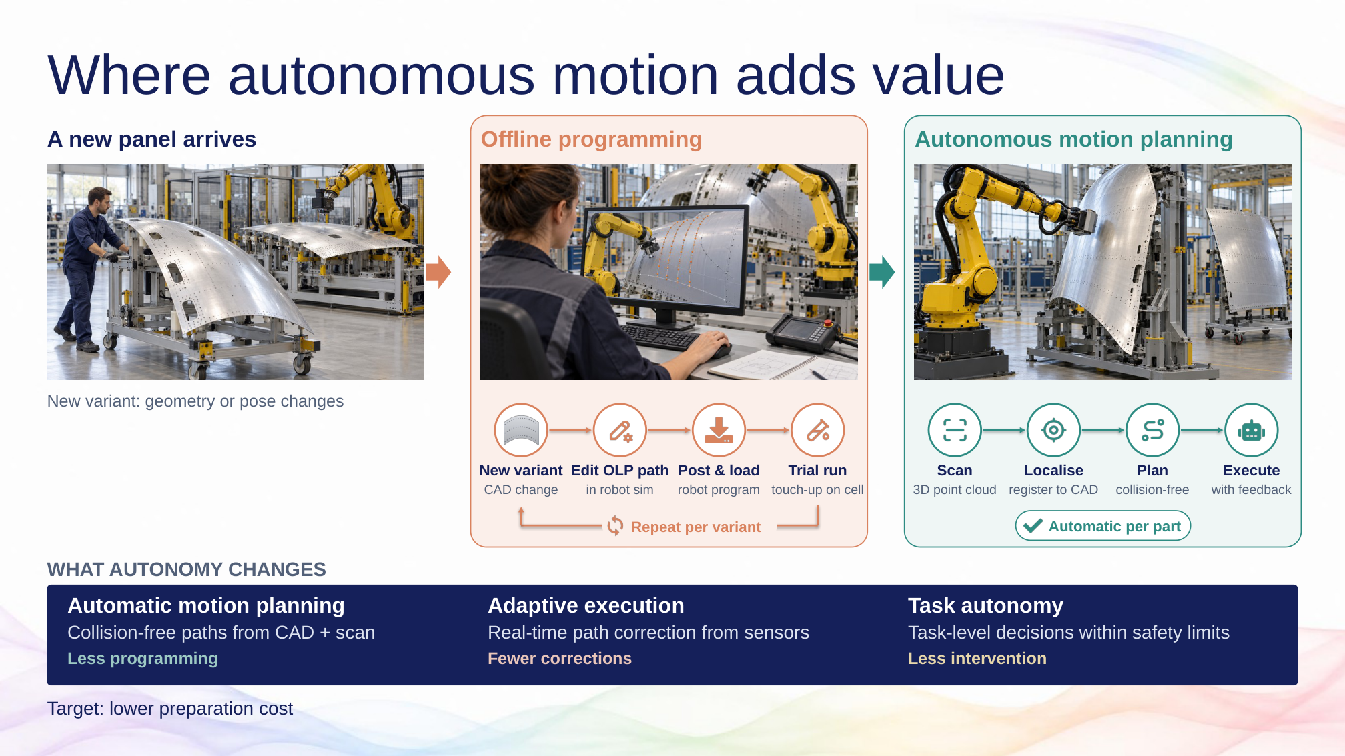
When a new panel arrives, its shape or position may differ from the previous one.
With offline programming, an engineer can need to edit the path in simulation, load the program, test it on the robot and make further adjustments. Repeating that cycle across variants takes preparation time and specialist effort.
With autonomous motion planning, the system uses the panel model and scan data to locate the part and calculate a suitable path. During execution, sensor feedback can support corrections.
Automatic planning reduces path preparation. Adaptive execution responds to measured changes. Task autonomy manages an agreed job within defined limits.
For Airbus, the intended value is less preparation effort for each variant, more consistent execution, and more engineering time for process quality. These benefits need to be demonstrated for each application.
Delivery cue Trace the offline loop, then the scan–localise–plan–execute flow. Pause on the change in preparation effort.

Slide 7 My Airbus milestones
1:20 | Presentation clock 5:35 to 6:55
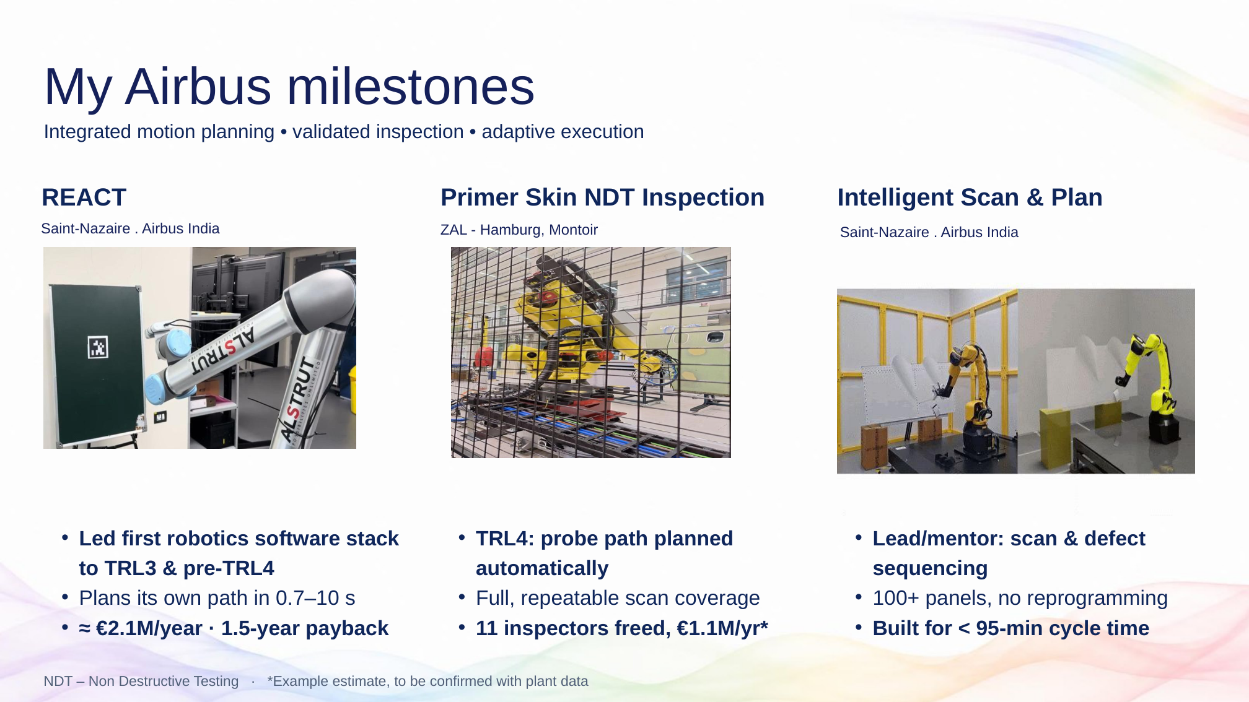
These three projects connect autonomous motion with practical manufacturing value.
In REACT, I led Airbus’ first complete robotics software stack to TRL3 and pre-TRL4, integrating vision, planning and control. Paths are generated in 0.7 to 10 seconds. The indicated business case is approximately 2.1 million euros per year, with a one-and-a-half-year payback.
For Primer Skin NDT, or Non Destructive Testing, I contributed to TRL4 in automatic probe-path planning, with full, repeatable scan coverage. The example estimate is capacity equivalent to eleven inspectors and 1.1 million euros per year, subject to confirmation with plant data.
In Intelligent Scan and Plan, I lead and mentor motion planning for scanning and defect sequencing. The framework is designed for over a hundred panels without reprogramming, with a cycle-time target below 95 minutes.
The value is reducing repeated preparation as the panel or application changes.
Delivery cue Point to each project as you speak. Present the savings as business-case estimates, and the 95-minute cycle as a target.

Slide 8 My Airbus milestones continued
1:05 | Presentation clock 6:55 to 8:00
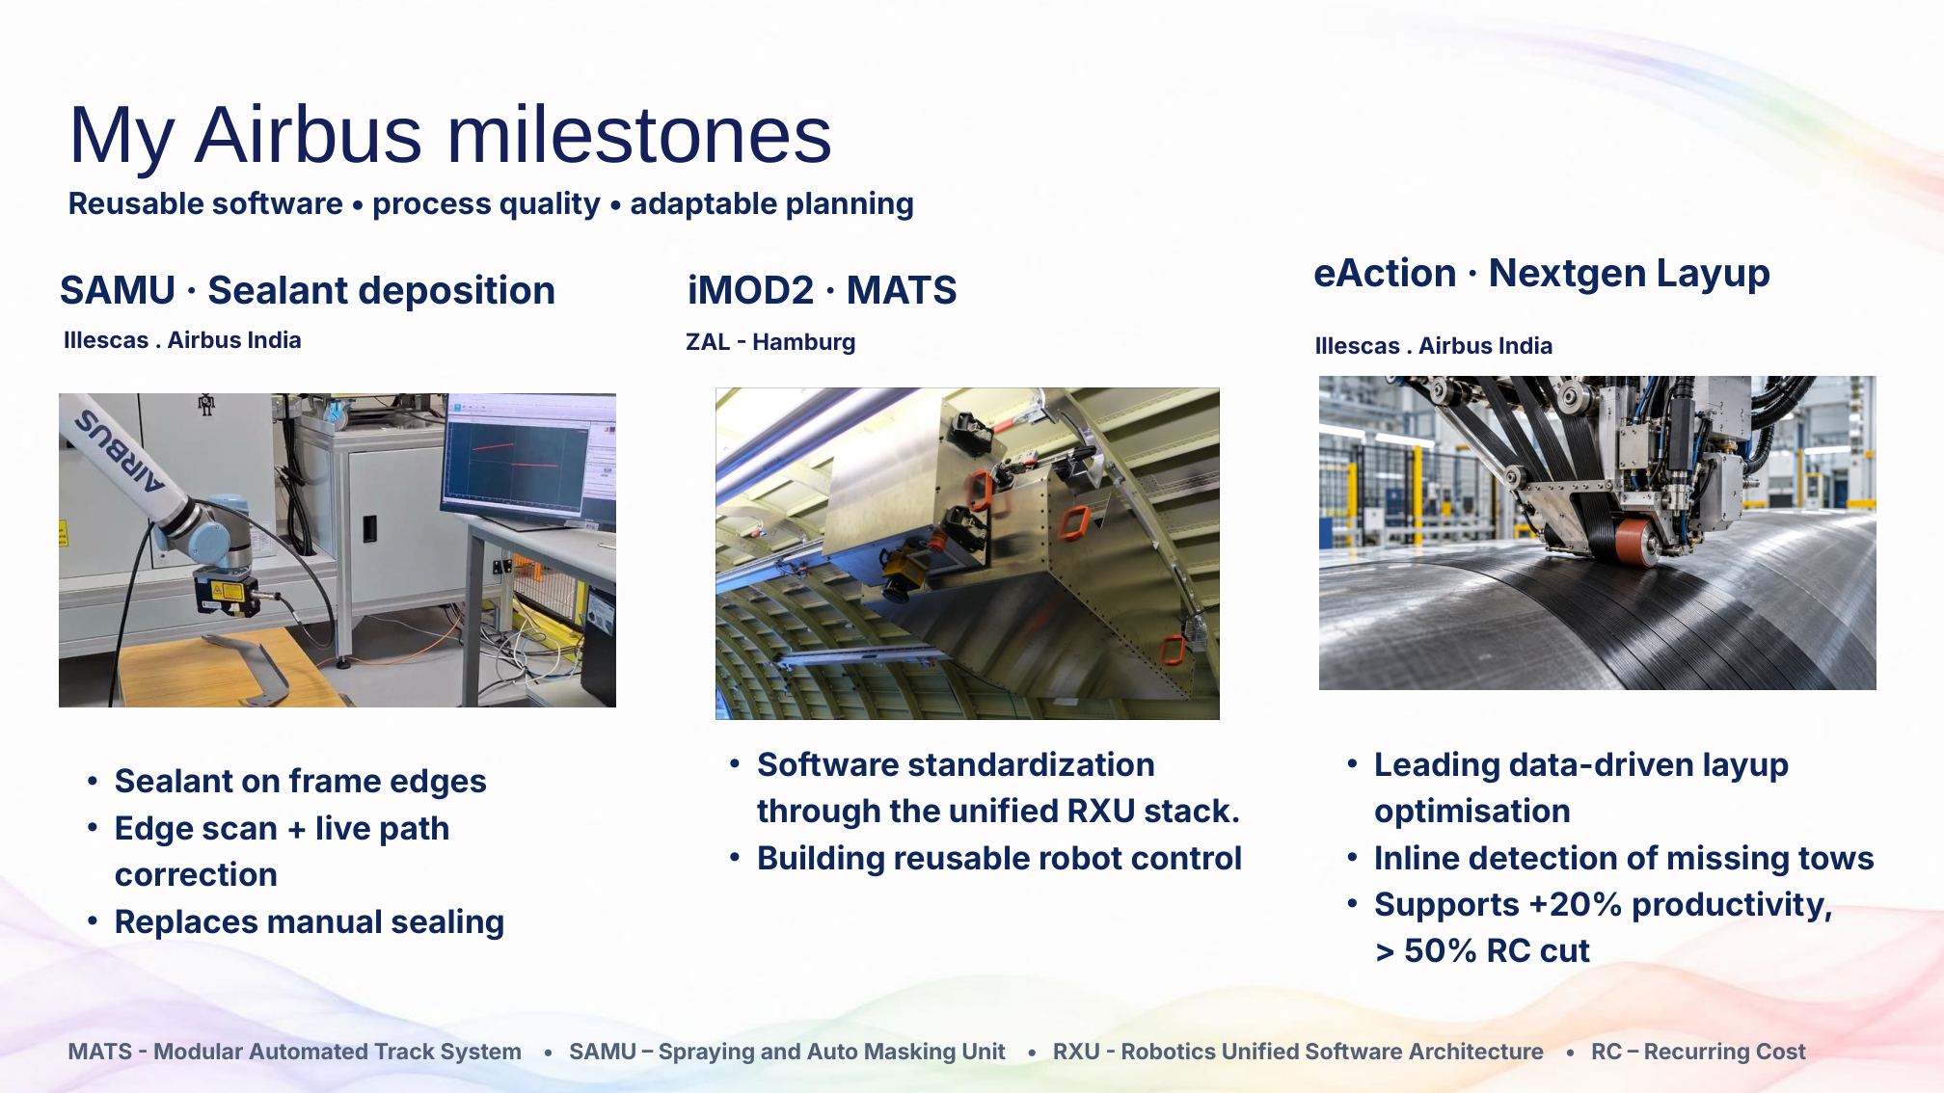
The next three projects extend that value into process automation and reusable software.
In SAMU, I enabled sensor-guided path correction for sealant dispensing along frame edges. An edge scan helps correct the planned movement during execution, supporting the move from manual sealing to automated dispensing.
In iMOD2 MATS, I contribute to standardising the RXU software stack. The value is reusable robot control, so teams can build on a common foundation.
In eAction Nextgen Layup, I lead data-driven process optimisation. Inline detection of missing strips of composite material supports quality and helps reduce rework. This contributes to the wider programme targets of twenty percent higher productivity and more than fifty percent lower recurring cost.
Delivering and sharing these benefits depends on collaboration across teams.
Delivery cue Follow the slide from left to right: SAMU, iMOD2 MATS, then eAction. Describe the eAction figures as wider programme targets supported by this work.

Slide 9 My network and technical influence
0:55 | Presentation clock 8:00 to 8:55
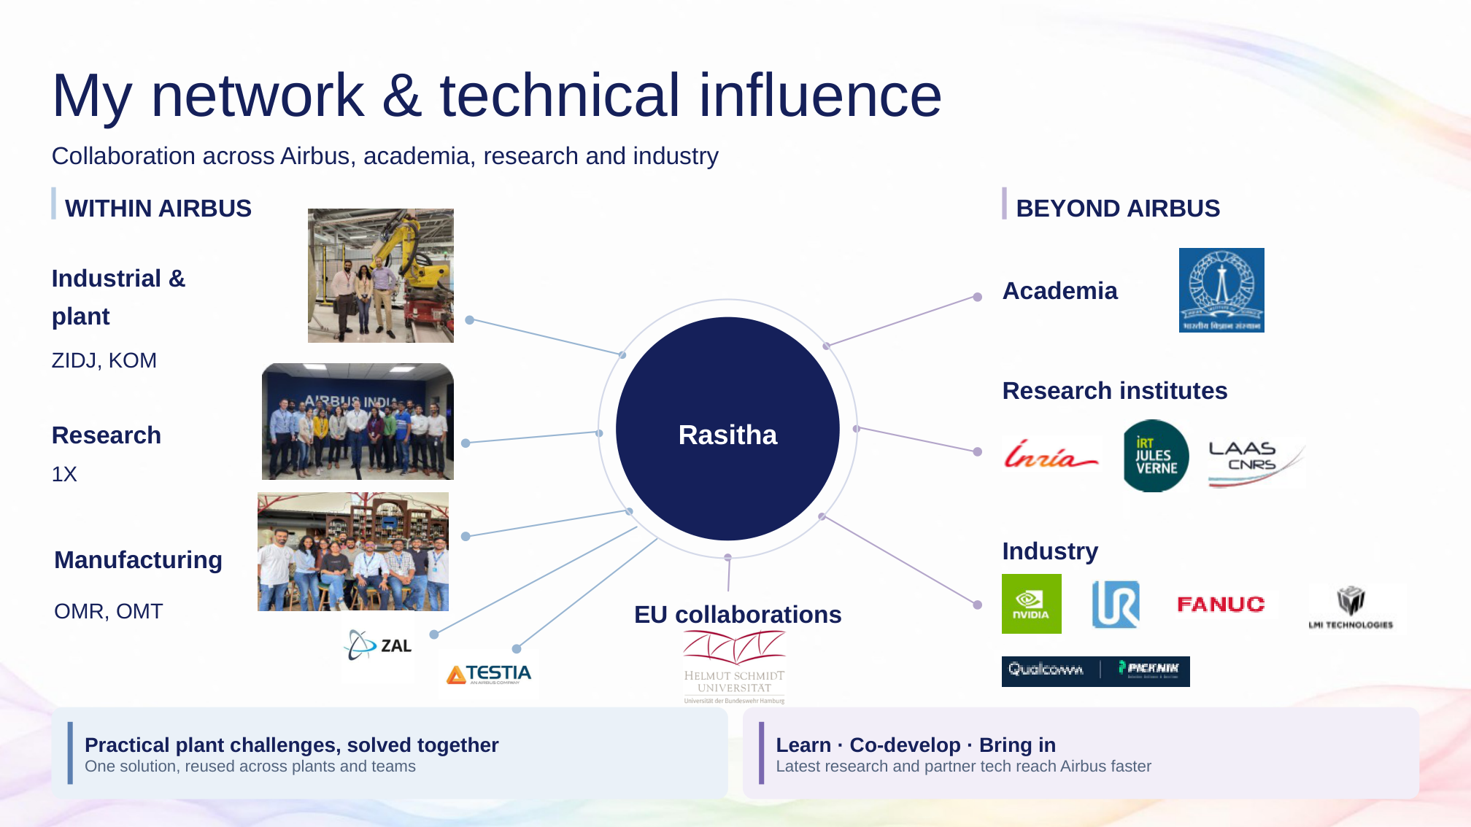
I collaborate across Airbus research, manufacturing and plant teams, and with external research and industry partners, to address practical manufacturing challenges.
Working with Airbus research and external partners also helps me understand emerging trends in robotics and autonomous planning, and assess which are relevant to our needs.
My contribution is to evaluate approaches jointly and share findings across teams, explaining what worked, what did not, and where an approach could be applied again.
This helps teams choose suitable solutions, avoid repeating the same investigations and use proven approaches in other projects.
The next slide shows how this collaboration supports innovation and shared knowledge.
Delivery cue Gesture across the internal and external groups. Focus on two-way collaboration and sharing.

Slide 10 Innovate prove share
1:35 | Presentation clock 8:55 to 10:30
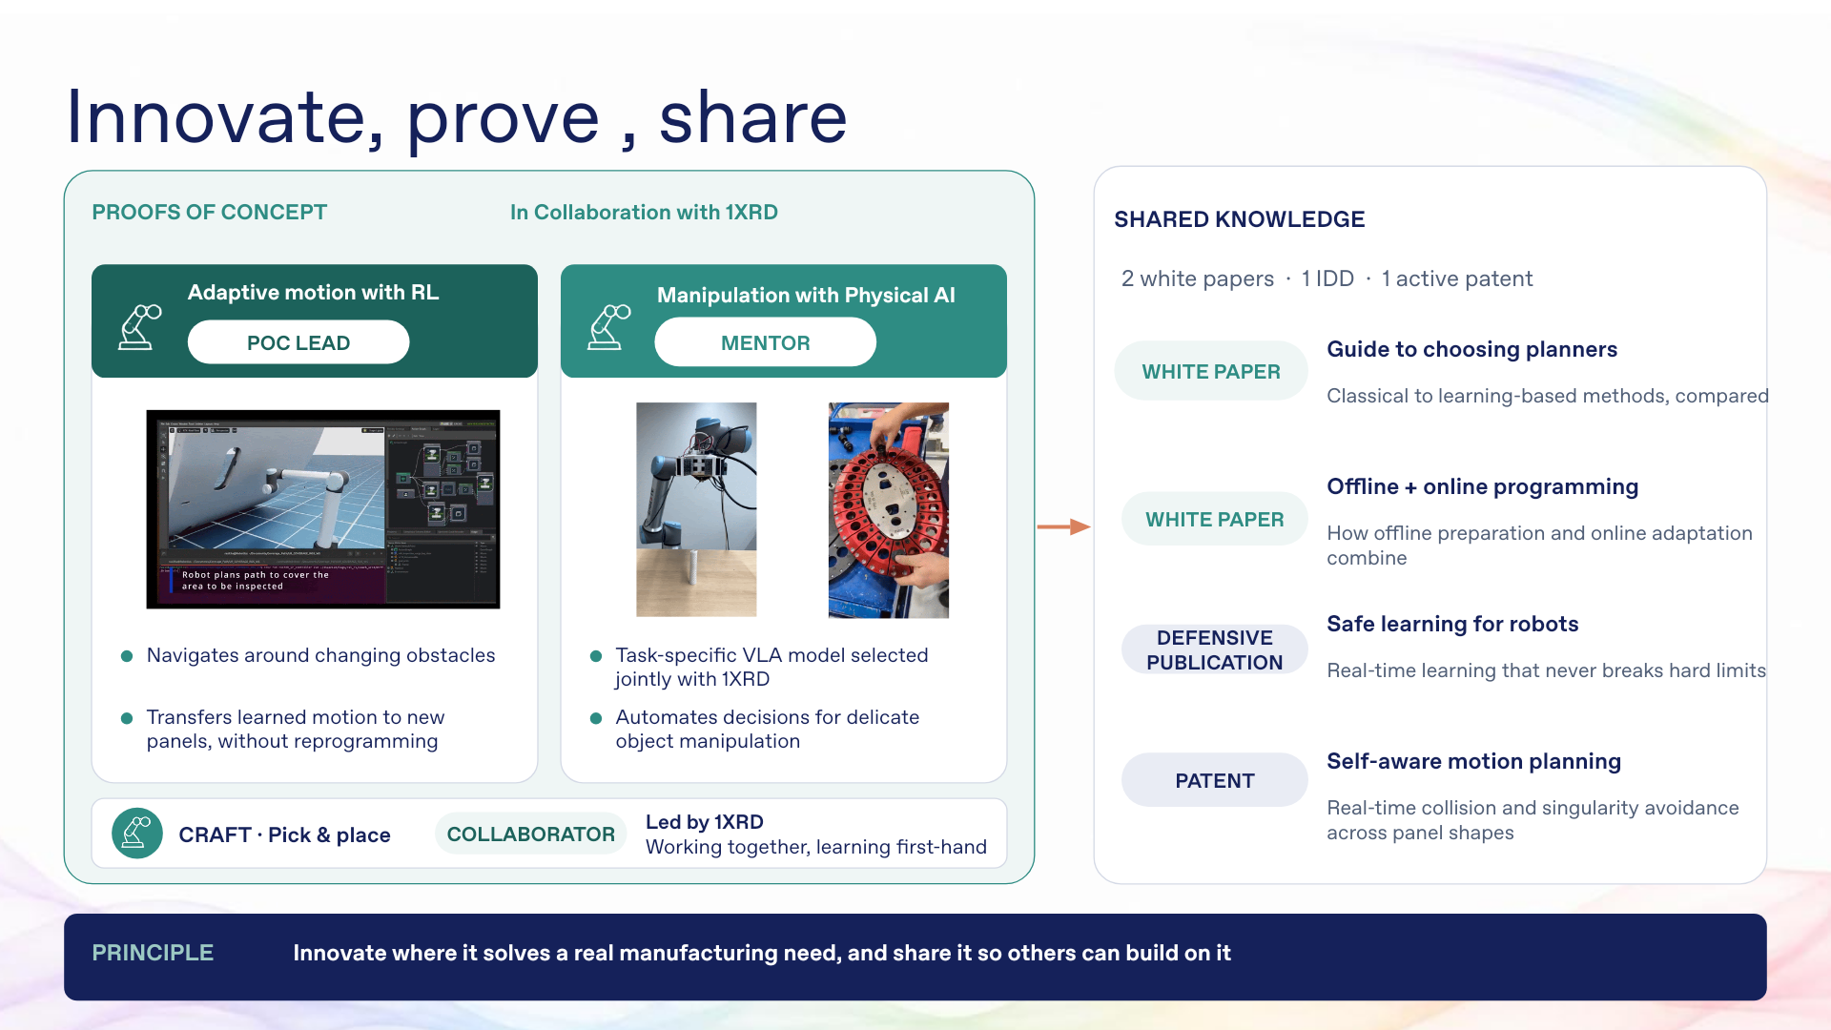
My contribution here is to turn new ideas into practical experiments with others, and make the results useful beyond the original project.
In the reinforcement-learning proof of concept, I led the work, building on 1XRD experience. We explored navigation around changing obstacles and transferring learned motion to new panels, reducing the need to program each case separately.
For manipulation with Physical AI, my role was mentoring. Together with 1XRD, I guided the choice of task-specific vision-language-action models for delicate manipulation, with touch helping guide the movement.
In CRAFT pick and place, I collaborate in work led by 1XRD, gaining first-hand experience and contributing to the shared learning.
I also contribute to two white papers, a defensive publication and active patent work. They capture guidance on planner selection, offline and online programming, constrained learning and self-aware motion planning.
The value is making technical knowledge available for colleagues to assess and apply, so each team does not have to start its investigation from the beginning.
These experiences shape my next steps.
Delivery cue Point to each role label, then the publications. CRAFT is led by 1XRD. Do not read all publication titles.

Slide 11 My vision autonomy across applications short term
1:35 | Presentation clock 10:30 to 12:05
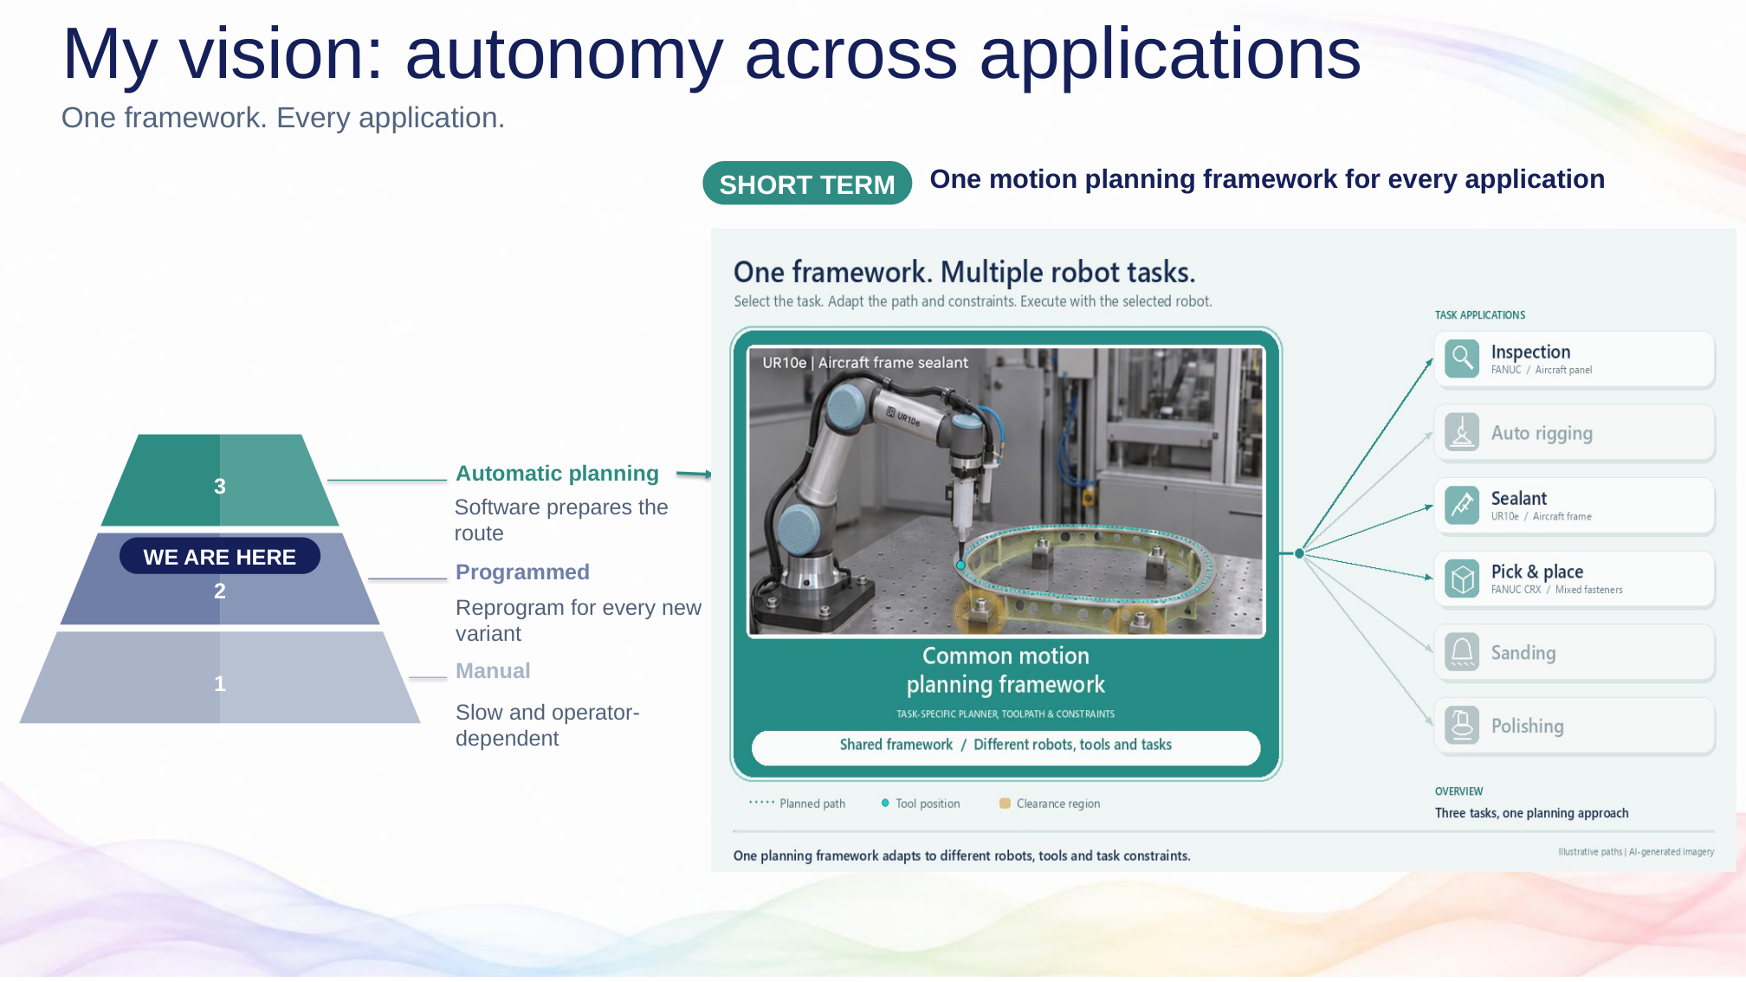
This pyramid connects the progression of autonomy to what I want to build.
At level one, a person guides the work. At level two, a robot follows movements prepared through a teach pendant or offline programming. This is the production starting point I am addressing: changes to the part or process can require more programming.
My short-term focus is level three, where software prepares the movement.
The key is a common motion-planning framework that can serve inspection, sealant application, pick and place, and other manufacturing tasks. Each application still selects its own toolpath, planner and constraints.
For example, inspection needs scan coverage, while sealant application needs a controlled dispensing path. They can share the underlying planning capabilities without having identical requirements.
For Airbus, this means less repeated development and easier introduction of new applications. An improvement to the common foundation can benefit several projects.
To make that foundation work reliably in a production cell, we need the wider robotics platform.
Delivery cue If animated, reveal levels 1 and 2, then level 3 and the common framework. Otherwise point in that order.

Slide 12 My vision autonomy across applications mid and long term
2:10 | Presentation clock 12:05 to 14:15
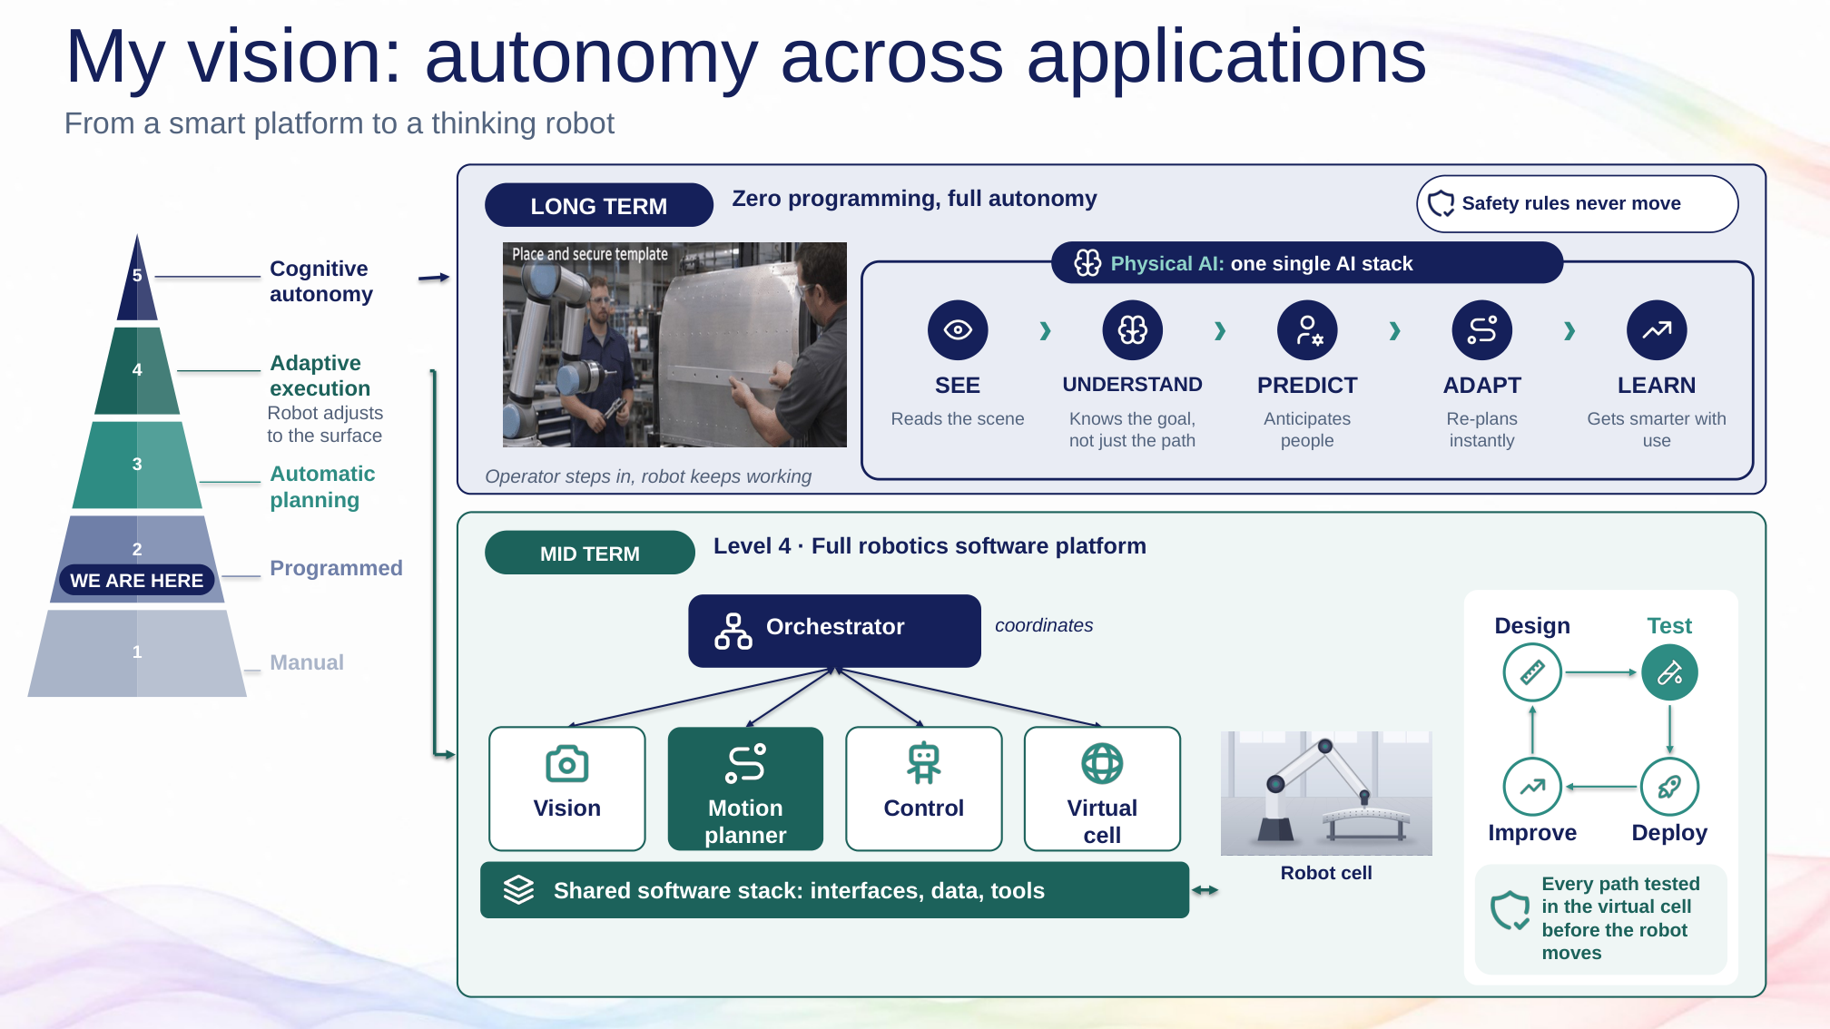
My mid-term goal is a complete robotics platform, developed as a product line: a maintained common foundation configured for different applications.
Vision locates the part and observes changes. The motion planner chooses a feasible movement, and control executes it. Simulation and the digital twin let us test models and software in a virtual cell before physical trials.
A shared software stack connects these components and their data. The orchestrator coordinates the sequence, such as scan, plan, inspect and recover from an exception.
The lifecycle is equally important: design, test, deploy and improve. Validated updates should be reusable across cells, rather than maintained separately in every project.
This level can already provide autonomous execution within defined operating conditions.
Longer term, Physical AI can add value when the situation is less predictable. Imagine an operator positioning a template before drilling. The system needs to recognise the changed task state, wait where necessary and resume when conditions are safe.
My goal is quicker adaptation and fewer avoidable interruptions, demonstrated through testing. Learned capabilities would work with control, orchestration and safety measures.
For Airbus, the direction is less repeated programming and a reusable platform that can respond to greater variation. My contribution would combine motion-planning leadership, practical validation and knowledge shared across teams.
Thank you. I look forward to your questions.
Delivery cue Reveal level 4 with the platform, then the lifecycle, then level 5. Leave a brief pause before the closing line.

