Technical Specialist Interview Script
  - Autonomy in Motion for a 15 minute slot
Rasitha R | 1 November 2026
Target 14 minutes 5 seconds of presentation, with a 55 second buffer. The shorter script keeps the focus on your contribution, manufacturing value and future direction. Timings include transitions and brief pauses; questions are not included.

Recommended route
Present 14 slides: 1, 3, 4, 5, 6, 7, 8, 9, 10, 11, 12, 13, 16, 17.
Use slide 3 for your personal story and slide 16 for the combined vision. Skip slides 2, 14 and 15 in the timed presentation; their short scripts remain available as backup.

Time plan
Slides | Focus | Time | Finish by
1, 3, 4, 5 | Introduction and career | 3:25 | 3:25
6, 7, 8 | Motion planning and its value | 2:50 | 6:15
9, 10, 11 | Airbus contributions and innovation | 3:45 | 10:00
12, 13 | Collaboration and shared knowledge | 1:30 | 11:30
16, 17 | Vision, challenges and close | 2:35 | 14:05

Rehearsal cues
- Use the finish-by times as checkpoints. Reach the main vision slide at about 11 minutes 30 seconds.
- Give your contribution and its value; save algorithms, publication titles and detailed examples for questions.
- If you fall behind, trim an example or transition. Preserve the vision and closing rather than speaking faster.
The main script contains approximately 1,400 spoken words. Delivery cues are notes for you, not part of the spoken script.

Slide 1 Autonomy in Motion
Main presentation | Target 0:30 | Finish by 0:30
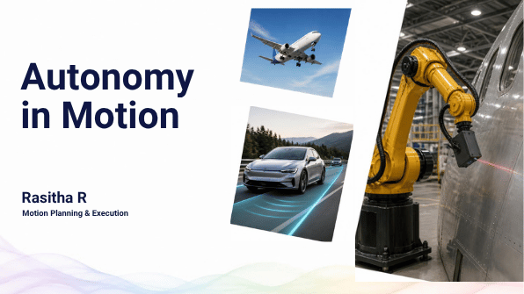
An aircraft, a car and a robot look very different, but they share a need: turning a goal into controlled movement.
I'm Rasitha. My journey from flight control to driver assistance and Airbus robotics has focused on making that movement more autonomous, adaptable and reusable.
Transition First, a little about what shaped me.
Delivery cue Pause after the opening comparison, then move on.

Slide 2 What Shaped My Journey
Backup only | Not included in the 14:05 route | Optional script 0:50
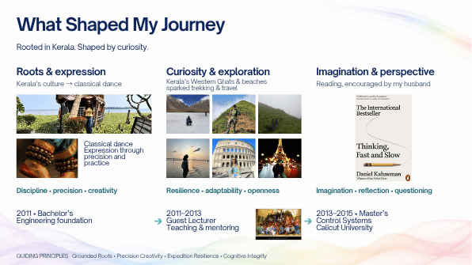
My roots are in Kerala. Its culture drew me towards classical dance, and its landscapes sparked my interest in trekking and travel. Reading, encouraged by my husband, adds imagination and perspective.
After my bachelor's degree, I spent two years teaching before completing my master's in Control Systems.
Together, these experiences shaped how I work: precision and practice, curiosity and adaptability, and explaining ideas so others can use them.
Transition That foundation connects the different stages of my career.
Delivery cue Backup alternative to slide 3. Use one personal slide only.

Slide 3 What Shaped My Journey
Main presentation | Target 0:50 | Finish by 1:20
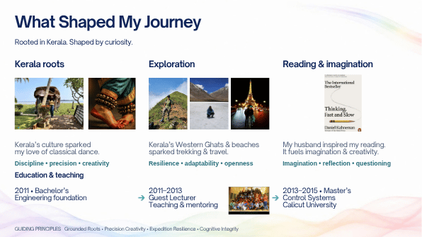
My roots are in Kerala. Its culture drew me towards classical dance, which combines precision with creativity. Its landscapes sparked my interest in trekking and travel, helping me stay curious and adapt to unfamiliar situations.
Reading, encouraged by my husband, brings imagination and reflection.
After my bachelor's degree, I spent two years teaching before completing my master's in Control Systems. Teaching strengthened my ability to make complex ideas understandable.
These experiences underpin how I approach engineering and share knowledge.
Transition That foundation runs through my career.
Delivery cue Follow roots, interests, then education. Keep the individual hobby examples brief.

Slide 4 Career trajectory
Main presentation | Target 1:05 | Finish by 2:25
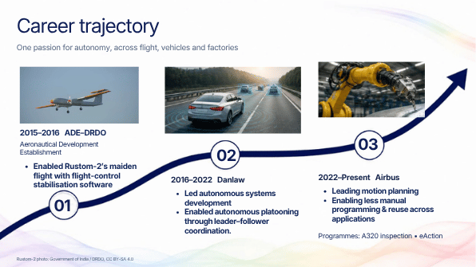
My career connects three domains through one interest: autonomy.
At ADE, the Aeronautical Development Establishment within DRDO, I contributed flight-control stabilisation software supporting Rustom-2's maiden flight.
At Danlaw, I led autonomous-system development across collision warning, cruise control and platooning. I enabled leader-follower coordination, where vehicles coordinate their movement with a lead vehicle.
Since joining Airbus in 2022, I have been leading motion planning for manufacturing robotics, including A320 inspection and eAction-related work.
The value is reducing manual programming and making capabilities reusable across applications. My experience connects control, software integration and real manufacturing needs.
Transition That journey has also brought recognition.
Delivery cue Give each company one clear contribution. Do not explain individual ADAS functions.

Slide 5 Achievements and recognition
Main presentation | Target 1:00 | Finish by 3:25
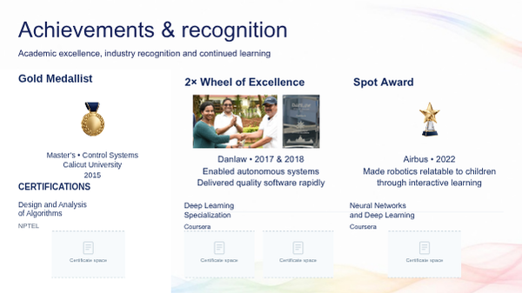
I was a gold medallist in Control Systems in 2015.
At Danlaw, I received the Wheel of Excellence twice, for contributions in 2017 and 2018: enabling autonomous systems and delivering quality software products within tight timelines.
At Airbus, my 2022 Spot Award recognised Wings of Wonder, where I made robotics relatable to children through interactive learning. That reflects how I approach mentoring: make ideas accessible and encourage questions.
My NPTEL certification in algorithms helps me compare efficient ways to plan robot movement. My Coursera certifications in deep learning and neural networks support my reinforcement-learning work and help me guide task-specific AI model selection at Airbus.
Transition Now, to the focus of my work.
Delivery cue Connect each recognition to contribution. Explain how the certifications support planning and AI decisions at Airbus; let the panel read the full certificate titles.

Slide 6 Motion planning
Main presentation | Target 1:00 | Finish by 4:25
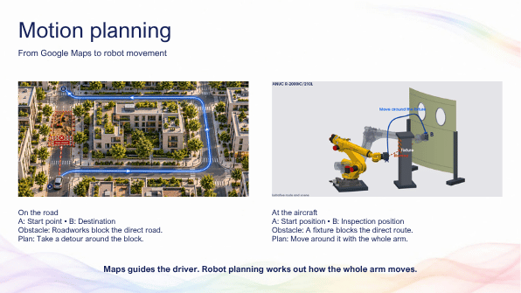
Imagine roadworks blocking your route. A navigation app helps you find another way to your destination.
A robot inspecting an aircraft panel faces a similar problem. It must bring its sensor to the right position, facing the surface, while moving around fixtures.
But the whole arm matters. A clear route for the sensor is not enough if the robot's elbow would hit an obstacle.
Motion planning works out a movement that respects the geometry and motion limits. Execution makes the robot follow it. Together, they turn an inspection goal into a movement the robot can perform.
Transition We can build greater autonomy on that foundation.
Delivery cue Point to the obstacle and route, then the whole robot arm.

Slide 7 A progressive path to autonomy
Main presentation | Target 1:00 | Finish by 5:25
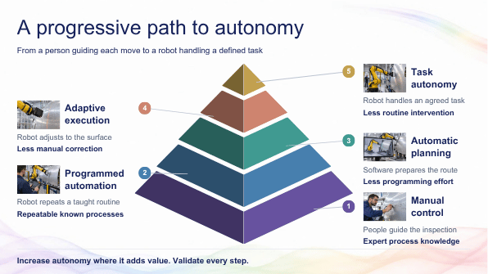
This pyramid shows how the robot takes on more responsibility.
At level one, a person guides the work. At level two, an engineer prepares the robot program, either by teaching it or through offline programming on a computer. The robot follows those prepared instructions.
At level three, software generates movement from the task and part information. At level four, measurements help it adjust during execution. At level five, the system coordinates and completes an agreed task, such as an inspection, within defined limits.
My focus is on these upper three capabilities. Offline preparation can still support them, with people supervising and handling exceptions.
Transition Here is how this reduces repeated programming and manual correction.
Delivery cue Point to layer 2 when explaining offline programming. For layers 3, 4 and 5, emphasise generates movement, adjusts movement and completes the task.

Slide 8 Why autonomous motion matters
Main presentation | Target 0:50 | Finish by 6:15
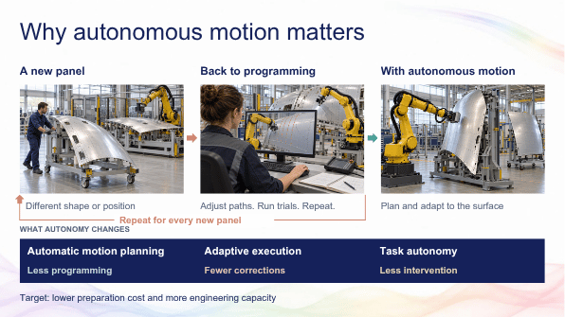
A new panel arrives. The inspection task is familiar, but its shape or position has changed.
With prepared paths, an engineer may need to adjust the program, run trials and repeat. The loop represents that recurring effort.
Automatic planning can prepare the new movement; adaptive execution can handle measured differences; task autonomy can reduce routine intervention.
The value is lower preparation effort and more engineering time for quality and improvement. This operates within configured process requirements and validated limits.
Transition My Airbus projects address these needs.
Delivery cue Explain the reprogramming loop once. Keep cost benefits qualitative.

Slide 9 My Airbus milestones
Main presentation | Target 1:25 | Finish by 7:40
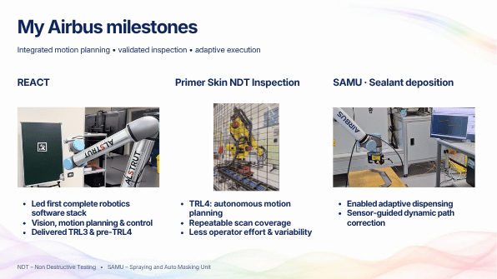
In REACT, I led delivery of our first complete online robotics software stack, integrating vision, motion planning and control. I led the TRL3 demonstration and pre-TRL4 validation. These are technology-readiness checkpoints. The contribution was turning separate components into a working system.
For Primer Skin NDT inspection, I contributed the autonomous motion-planning strategy that achieved TRL4, demonstrated at ZAL Hamburg. NDT means Non Destructive Testing: finding defects without damaging the part. Repeatable scan coverage reduces manual preparation and operator-dependent variation.
In SAMU, I enabled adaptive sealant dispensing through sensor-guided path correction. The robot follows a nominal process path and adjusts for differences in the real part.
These projects connect planning with execution and validation, moving towards more repeatable and adaptable manufacturing.
Transition The next projects extend reuse and adaptability.
Delivery cue Allow most time for REACT and NDT. Keep led and contributed distinct.

Slide 10 My Airbus milestones
Main presentation | Target 1:10 | Finish by 8:50
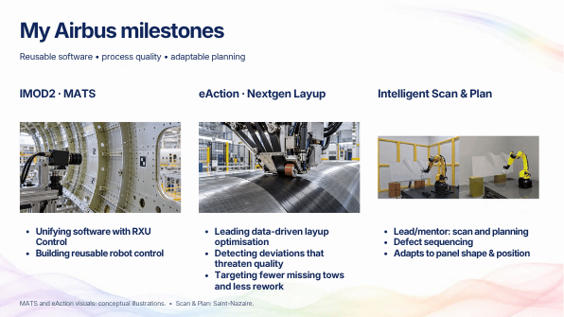
In iMOD2 MATS, I contribute to software standardisation through RXU Control, creating a reusable control foundation.
In eAction Nextgen Layup, I lead data-driven process optimisation: detecting deviations that threaten quality and targeting fewer missing material strips, or tows, and less rework.
In Intelligent Scan and Plan at Saint-Nazaire, I lead and mentor the motion-planning strategy for surface scanning and defect sequencing. The path adapts to changes in panel geometry and position.
Across these projects, the value is reusable engineering, better process insight and less repeated preparation when the part changes.
Transition I also explore where learning-based methods can help.
Delivery cue One contribution and one benefit per project. Missing-tow reduction remains a target.

Slide 11 Innovation at Airbus
Main presentation | Target 1:10 | Finish by 10:00
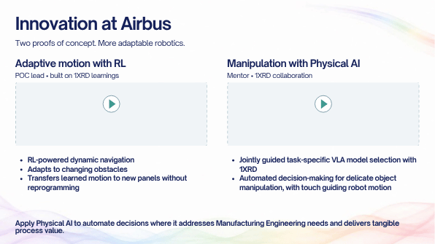
I led the reinforcement-learning motion-planning proof of concept, building on 1XRD learnings. The robot learns behaviour through feedback. We explored adapting to changing obstacles and transferring learned motion to new panels with less repeated programming.
In the Physical AI manipulation work, my role was mentoring. With 1XRD, I jointly guided task-specific VLA model selection. These models connect visual information, instructions and robot actions.
The challenge is deciding how to handle delicate objects, with touch guiding the motion.
My direction is to apply Physical AI where it addresses a clear Manufacturing Engineering need and delivers process value.
Transition Collaboration helps turn those ideas into useful capabilities.
Delivery cue Keep the distinction clear: led the RL POC; mentored the manipulation work.

Slide 12 My network and technical influence
Main presentation | Target 0:40 | Finish by 10:40
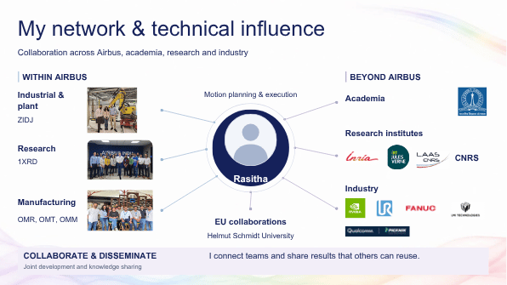
Within Airbus, I connect research, manufacturing and plant teams. Externally, I collaborate with research and industry partners, including LAAS and IRT Jules Verne.
My contribution is to bring manufacturing challenges into these discussions, evaluate approaches jointly and share findings that colleagues can reuse.
That is how I extend my impact beyond an individual project.
Transition Publications make that knowledge available more widely.
Delivery cue Point to representative connections; do not read the logos or siglums.

Slide 13 Turning technical ideas into shared knowledge
Main presentation | Target 0:50 | Finish by 11:30
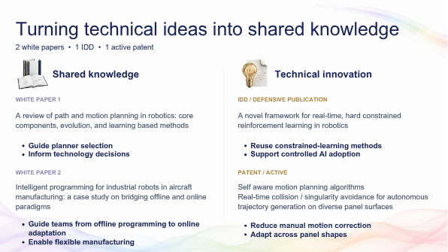
My two white papers, co-authored with Phani Kiran, help teams select motion-planning methods and connect offline programming with online adaptation.
The defensive publication documents constrained reinforcement learning, supporting reuse with explicit operating limits.
My active patent work with Parameswaran S and Alexandre Arnold addresses self-aware motion planning, including collision avoidance and avoiding robot configurations that are difficult to control.
The value is making project knowledge reusable, supporting technology decisions and reducing repeated problem-solving.
Transition This leads to the foundation I want to build.
Delivery cue The full titles are on the slide. Explain their value rather than reading them.

Slide 14 My vision one foundation many applications
Backup only | Not included in the 14:05 route | Optional script 0:40
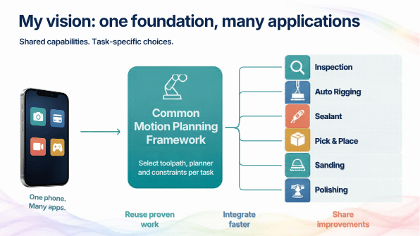
Different phone apps share the same device and software capabilities. My motion-planning vision follows that principle.
Inspection, sealant, auto rigging and other applications can share a common foundation, while selecting their own planner, toolpath and constraints.
This lets teams reuse proven engineering and share improvements across applications, reducing repeated development and integration effort.
Transition That foundation must connect with the full robotics system.
Delivery cue Backup only. Slide 16 already covers this vision in the main presentation.

Slide 15 My vision a complete robotics product
Backup only | Not included in the 14:05 route | Optional script 0:45
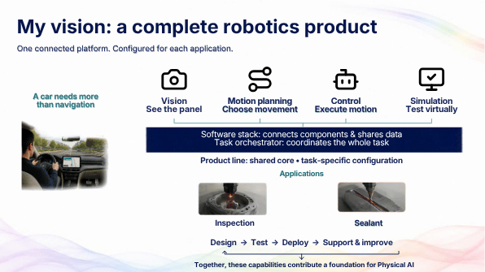
A car needs more than navigation to complete a journey. A robot also needs connected capabilities: vision to understand the situation, planning to choose movement, control to execute it and simulation to test it.
The software stack shares data; the task orchestrator coordinates activities.
My vision is a maintained robotics product with a common core, task-specific configurations and support throughout its lifecycle. This contributes a foundation for Physical AI.
Transition Slide 16 combines that stack with the reusable motion framework.
Delivery cue Backup only. Use this if the panel needs the car analogy or more component detail.

Slide 16 My vision motion planning to a common stack
Main presentation | Target 1:35 | Finish by 13:05
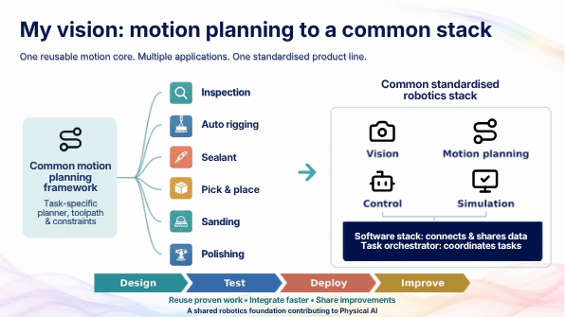
My vision starts with the common motion-planning framework on the left. Inspection, auto rigging, sealant, pick and place, sanding and polishing share that foundation. Each application chooses its planner, toolpath and constraints.
The next step is a common standardised robotics stack. Vision provides information, planning prepares movement, control executes it and simulation supports testing.
The blue software layer connects the components through shared data and interfaces. The task orchestrator coordinates the activities needed to complete the job.
This is a product-line approach: maintain one reusable core and configure it for different applications.
The lifecycle below is equally important: design, test, deploy and improve. Learning from one deployment should benefit the next.
The value is less repeated engineering, faster integration and shared improvements. This provides a foundation for Physical AI and automated decisions where they meet a manufacturing need.
Transition The final slide brings together the challenges ahead.
Delivery cue Trace left framework, right stack, blue software layer and lifecycle. Preserve time for this slide.

Slide 17 Vision and challenges
Main presentation | Target 1:00 | Finish by 14:05
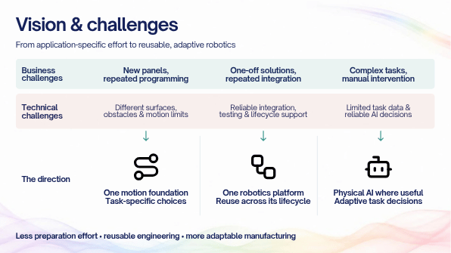
The challenges are repeated programming when panels change, repeated integration for new applications, and reliable decisions in complex tasks.
My response is a reusable motion foundation, a common robotics platform and targeted use of Physical AI.
I would progress with plant teams step by step: choose a useful problem, demonstrate it, validate the results and expand from the evidence.
As a Technical Specialist, I want to combine technical depth with practical adoption: guide engineering choices, mentor colleagues and turn project results into capabilities others can reuse.
From flight control to robotics, that is the contribution I want to continue making. Thank you.
Delivery cue Finish calmly. Do not add another summary after thanking the panel.

