Technical Specialist Interview Script
  - Autonomy in Motion for a 15 minute slot
Rasitha R | 5 November 2026
This script follows slides 1–12 of the updated deck. Slides 13–24 are marked hidden and are excluded. The earlier wording is retained where it still fits. The combined projects, innovation and vision sections follow the new content and order.
Rehearsal target: 14 minutes 10 seconds, with a 50 second buffer. Timings include transitions and brief pauses, but not questions or additional video playback. The spoken script contains approximately 1,400 words.

Time plan
Slide | Focus | Target | Finish by
1 | Autonomy in Motion | 0:30 | 0:30
2 | What Shaped My Journey | 0:50 | 1:20
3 | Career trajectory | 1:05 | 2:25
4 | Achievements and recognition | 1:10 | 3:35
5 | Motion planning | 1:00 | 4:35
6 | Where autonomous motion adds value | 1:05 | 5:40
7 | Milestones: REACT, NDT, Scan and Plan | 1:30 | 7:10
8 | Milestones: SAMU, MATS, Nextgen Layup | 1:15 | 8:25
9 | My network and technical influence | 0:45 | 9:10
10 | Innovate prove share | 1:40 | 10:50
11 | Short term: progression and shared planning | 1:20 | 12:10
12 | Mid and long term: platform, Physical AI, close | 2:00 | 14:10

Rehearsal priorities
Reach slide 10 at about 9:10 and the vision section at about 10:50. If time is tight, shorten a project example. Preserve time for the vision and closing. Delivery cues and the final preparation notes are not spoken text.

Slide 1 Autonomy in Motion
Target 0:30 • Finish by 0:30
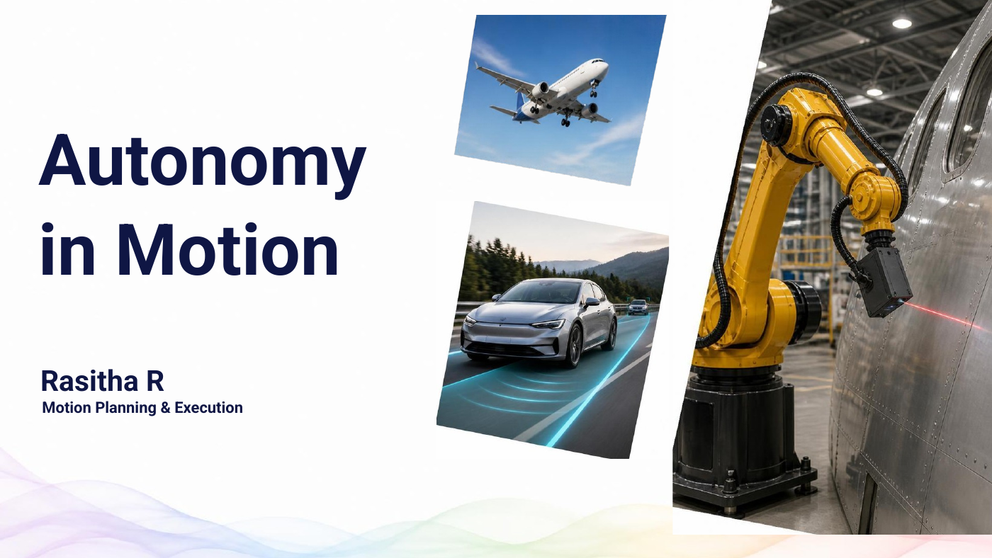
An aircraft, a car and a robot look very different, but they share a need: turning a goal into controlled movement.
I'm Rasitha. My journey from flight control to driver assistance and Airbus robotics has focused on making that movement more autonomous, adaptable and reusable.
Transition First, a little about what shaped me.
Delivery cue Pause after the opening comparison, then move on.

Slide 2 What Shaped My Journey
Target 0:50 • Finish by 1:20
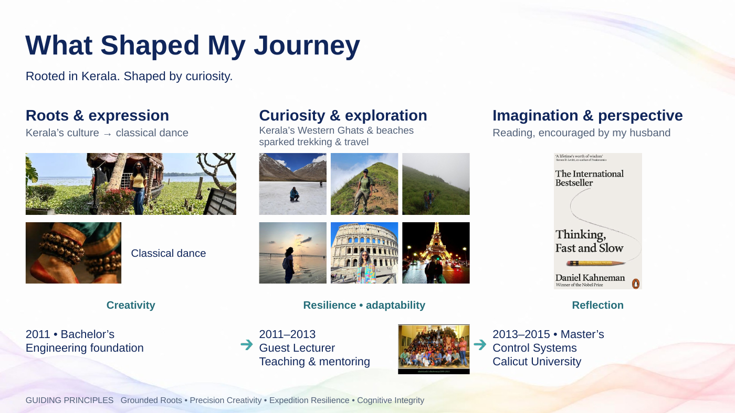
My roots are in Kerala. Its culture drew me towards classical dance, which combines precision with creativity. Its landscapes sparked my interest in trekking and travel, helping me stay curious and adapt to unfamiliar situations.
Reading, encouraged by my husband, brings imagination and reflection.
After my bachelor's degree, I spent two years teaching before completing my master's in Control Systems. Teaching strengthened my ability to make complex ideas understandable.
These experiences underpin how I approach engineering and share knowledge.
Transition That foundation runs through my career.
Delivery cue Follow roots, interests, then education. Keep the individual hobby examples brief.

Slide 3 Career trajectory
Target 1:05 • Finish by 2:25
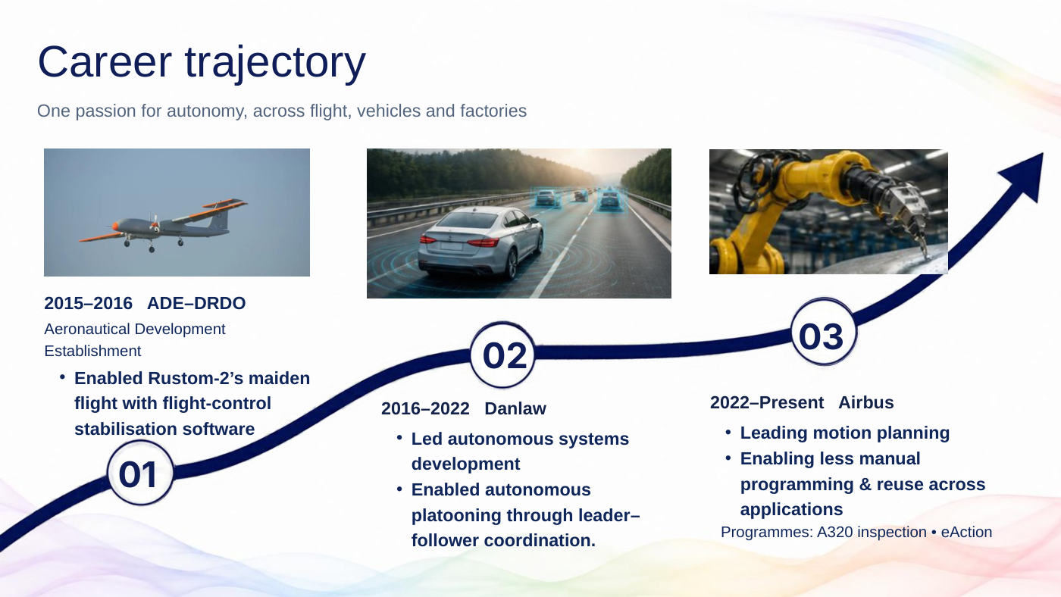
My career connects three domains through one interest: autonomy.
At ADE, the Aeronautical Development Establishment within DRDO, I contributed flight-control stabilisation software supporting Rustom-2's maiden flight.
At Danlaw, I led autonomous-system development across collision warning, cruise control and platooning. I enabled leader-follower coordination, where vehicles coordinate their movement with a lead vehicle.
Since joining Airbus in 2022, I have been leading motion planning for manufacturing robotics, including A320 inspection and eAction-related work.
The value is reducing manual programming and making capabilities reusable across applications. My experience connects control, software integration and real manufacturing needs.
Transition That journey has also brought recognition.
Delivery cue Give each company one clear contribution. Do not explain individual ADAS functions.

Slide 4 Achievements and recognition
Target 1:10 • Finish by 3:35
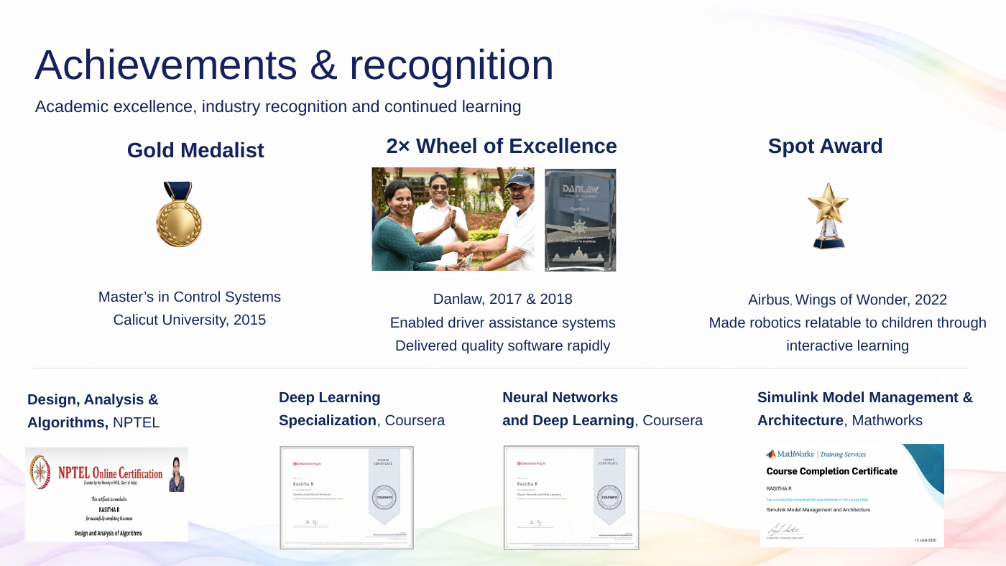
I was a gold medallist in Control Systems in 2015.
At Danlaw, I received the Wheel of Excellence twice, for contributions in 2017 and 2018: enabling driver-assistance systems and delivering quality software products within tight timelines.
At Airbus, my 2022 Spot Award recognised Wings of Wonder, where I made robotics relatable to children through interactive learning. That reflects how I approach mentoring: make ideas accessible and encourage questions.
My NPTEL certification in algorithms helps me compare efficient ways to plan robot movement. My Coursera certifications in deep learning and neural networks support my reinforcement-learning work and help me guide task-specific AI model selection at Airbus.
My Simulink training supports modular model design and clearer software architecture.
Transition Now, to the focus of my work.
Delivery cue Connect recognition to contribution. Explain the relevance of the studies without reading the certificate titles.

Slide 5 Motion planning
Target 1:00 • Finish by 4:35
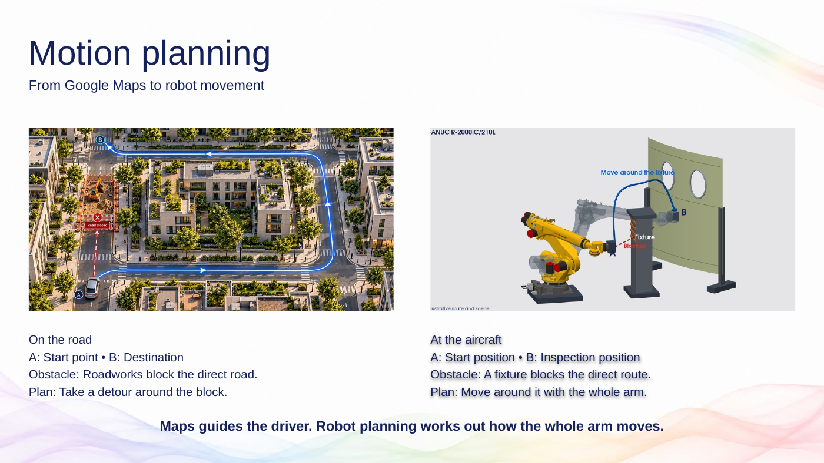
Imagine roadworks blocking your route. A navigation app helps you find another way to your destination.
A robot inspecting an aircraft panel faces a similar problem. It must bring its sensor to the right position, facing the surface, while moving around fixtures.
But the whole arm matters. A clear route for the sensor is not enough if the robot's elbow would hit an obstacle.
Motion planning works out a movement that respects the geometry and motion limits. Execution makes the robot follow it. Together, they turn an inspection goal into a movement the robot can perform.
Transition Now consider what happens when the next panel changes.
Delivery cue Point to the obstacle and route, then the whole robot arm.

Slide 6 Where autonomous motion adds value
Target 1:05 • Finish by 5:40
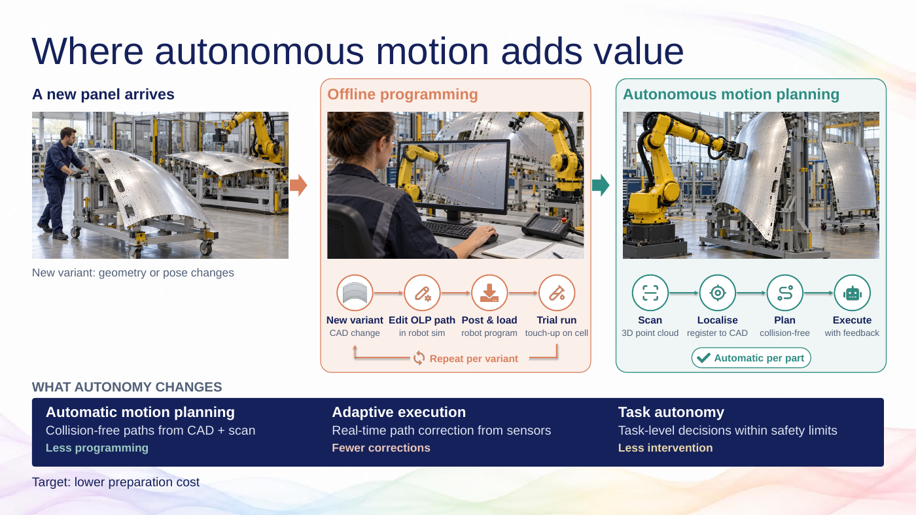
A new panel arrives. The inspection task is familiar, but its shape or position has changed.
With prepared paths, an engineer may need to edit the offline program, load it onto the robot, run trials and correct it on the cell. The loop shows that recurring effort.
On the right, the cell scans the part and identifies where it is. The planner prepares the movement, and the robot executes it with feedback.
Automatic planning reduces repeated programming. Adaptive execution handles measured differences. Task-level decisions reduce routine intervention.
The target is lower preparation cost and more engineering time for quality and improvement. We still configure the process and validate its operating limits.
Transition My Airbus projects address these needs.
Delivery cue Trace the offline loop once, then the scan-to-execution flow. Present cost reduction as a target, not a measured saving.

Slide 7 My Airbus milestones
Target 1:30 • Finish by 7:10
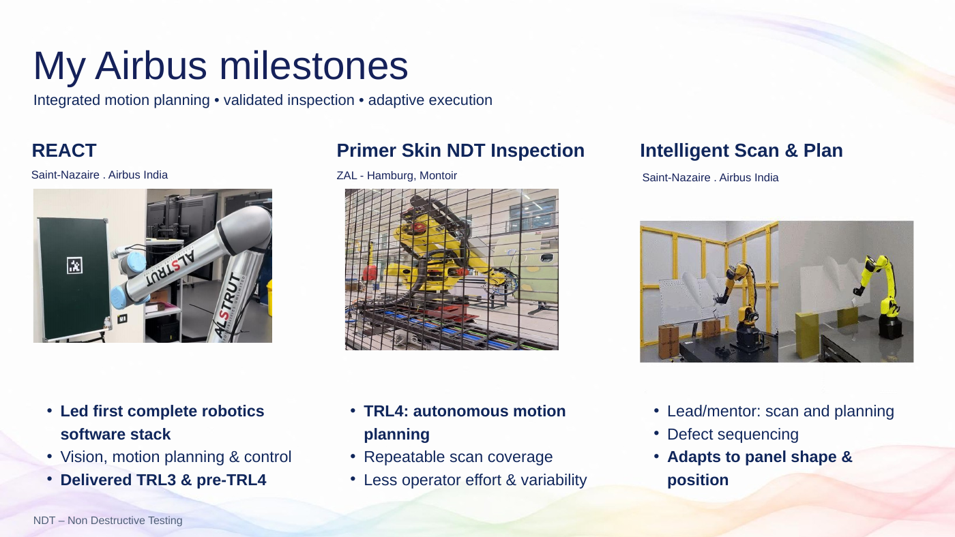
In REACT, I led delivery of our first complete online robotics software stack, integrating vision, motion planning and control. I led the TRL3 demonstration and pre-TRL4 validation. These are technology-readiness checkpoints. The contribution was turning separate components into a working system.
For Primer Skin NDT inspection, I contributed the autonomous motion-planning strategy that achieved TRL4, demonstrated at ZAL Hamburg. NDT means Non Destructive Testing: finding defects without damaging the part. Repeatable scan coverage reduces manual preparation and operator-dependent variation.
In Intelligent Scan and Plan at Saint-Nazaire, I lead and mentor the motion-planning strategy for surface scanning and defect sequencing. This means choosing how to cover the surface and in what order to visit defects. The path adapts to changes in panel geometry and position.
Across these projects, the value is less repeated preparation and more consistent robot motion.
Transition The next projects extend this work into execution, reuse and process quality.
Delivery cue Follow the three columns from left to right. Keep led, contributed and mentored distinct.

Slide 8 My Airbus milestones
Target 1:15 • Finish by 8:25
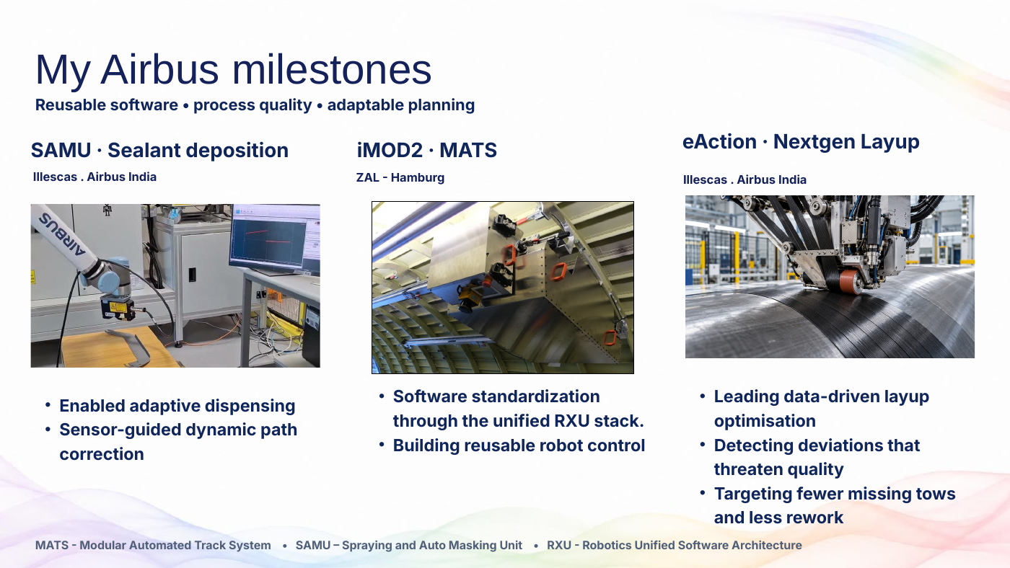
In SAMU, I enabled adaptive sealant dispensing through sensor-guided path correction. The robot follows a nominal process path and adjusts for differences in the real part. This reduces reliance on a perfectly positioned part.
In iMOD2 MATS, I contribute to software standardisation through the unified RXU stack, particularly reusable robot control. That gives teams a common foundation they can build on.
In eAction Nextgen Layup, I lead data-driven process optimisation: detecting deviations that threaten quality and targeting fewer missing material strips, or tows, and less rework.
Across these projects, the value is adaptable execution, reusable engineering and better process insight.
Transition Delivering these projects depends on collaboration.
Delivery cue Follow SAMU, MATS, then layup. Missing-tow reduction and less rework remain targets.

Slide 9 My network and technical influence
Target 0:45 • Finish by 9:10
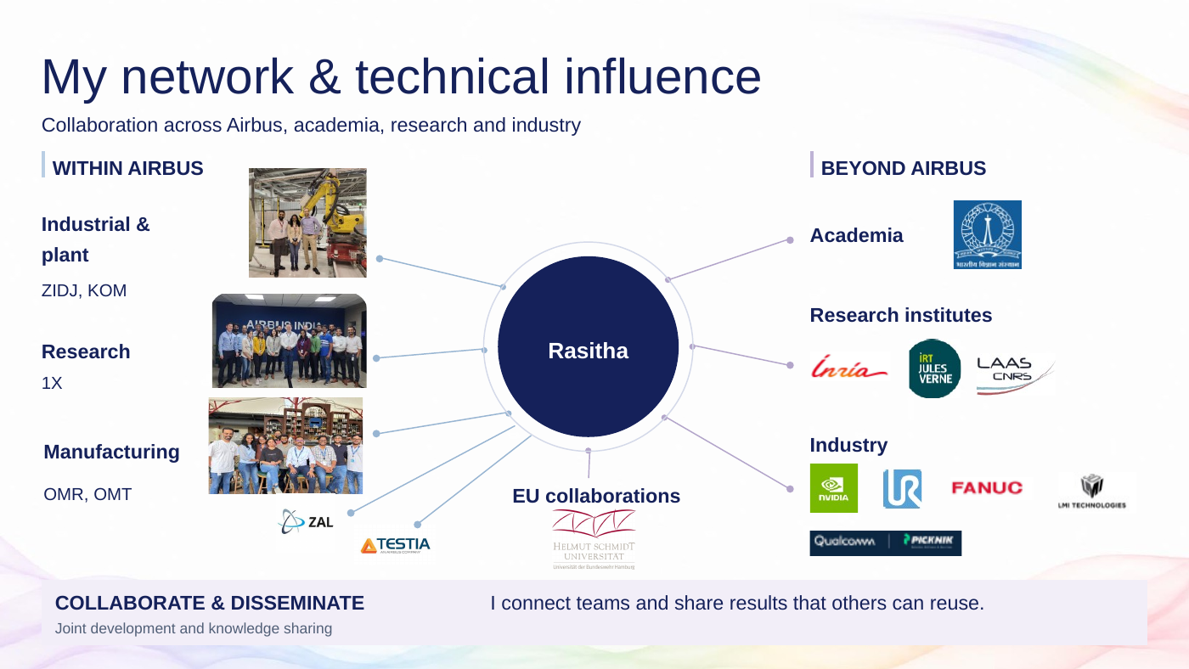
I collaborate across Airbus research, manufacturing and plant teams, and with external research and industry partners, to address practical manufacturing challenges.
I collaborate with Airbus research and external research and industry partners to understand emerging trends in robotics and autonomous planning.
My contribution is to evaluate approaches jointly and share findings and lessons across teams, explaining what worked and where the learning can be reused.
This helps teams make better decisions, avoid repeating work and use what they learn in other projects.
Transition The next slide shows how this collaboration supports innovation and shared knowledge.
Delivery cue Emphasise both purposes: addressing manufacturing challenges and understanding emerging trends. Connect joint evaluation to sharing knowledge across teams. Point to representative partners without listing every logo or siglum. Rehearse to the 45-second target.

Slide 10 Innovate prove share
Target 1:40 • Finish by 10:50
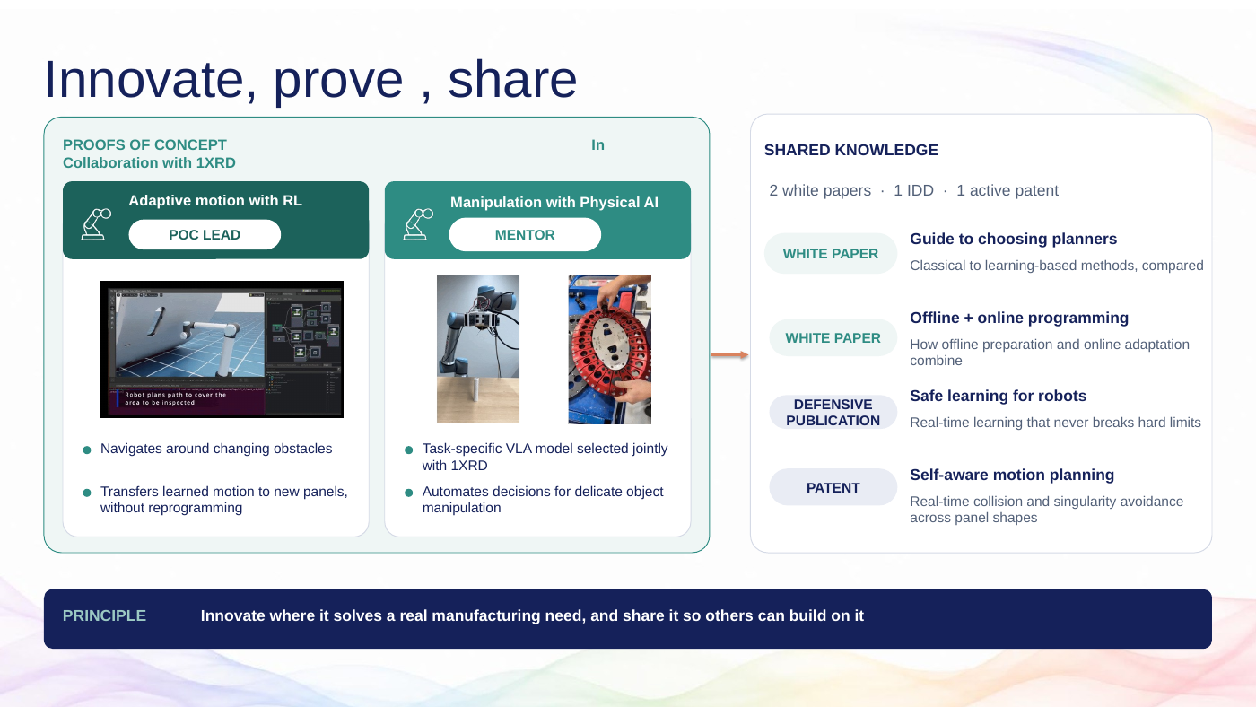
Here, my contribution is to turn new ideas into practical experiments, develop them with others, and share what we learn.
In collaboration with 1XRD, I led the reinforcement-learning motion-planning proof of concept, exploring how robots can adapt to changing obstacles and new panels with less reprogramming.
For Physical AI manipulation, I contributed as a mentor. Together with 1XRD, I guided model selection for handling delicate objects. These collaborations bring research expertise and manufacturing needs into the same discussion.
I also make the learning accessible beyond the project. My two white papers with Phani Kiran help colleagues compare planning approaches and connect offline preparation with online adaptation. The defensive publication and ongoing patent work capture further innovations in constrained learning and self-aware motion planning.
For the team and Airbus, the value is knowledge that others can build on: clearer technical choices, less duplicated effort, and reusable ideas for future applications.
Transition This experience shapes the common foundation I want to build next.
Delivery cue Emphasise innovation, collaboration and knowledge sharing. Use the two POCs as examples; distinguish your lead and mentor roles. Point to the publications as reusable knowledge rather than reading their titles. Keep within 1:40.

Slide 11 My vision autonomy across applications
Target 1:20 • Finish by 12:10
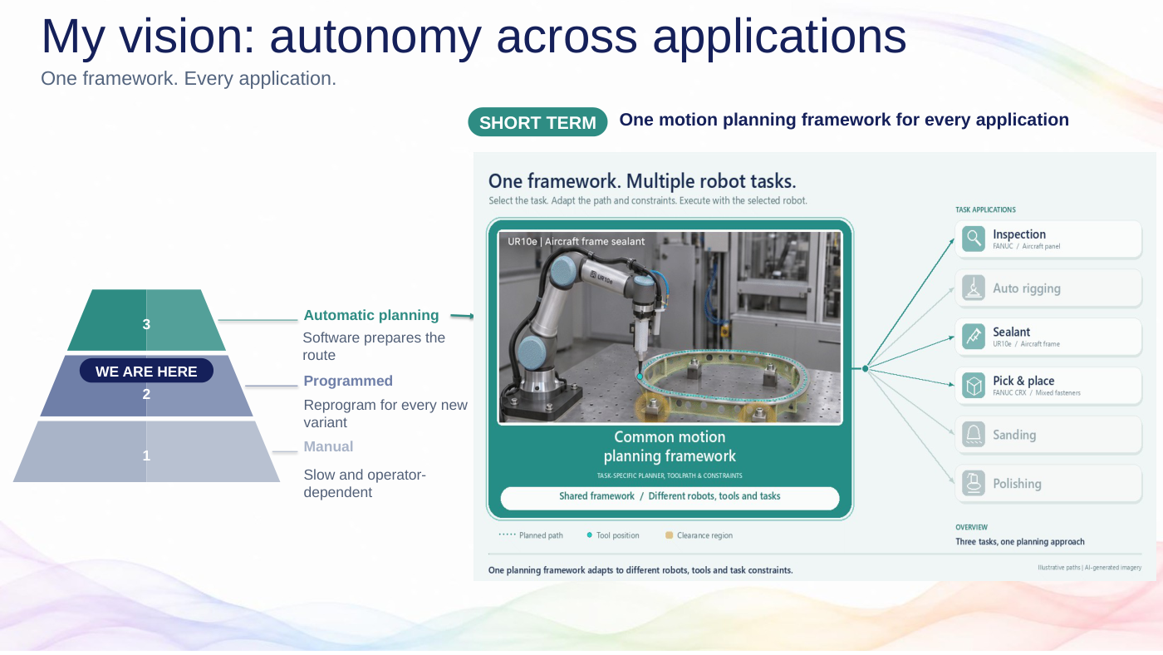
This pyramid shows the progression I am working towards.
At level one, a person guides the work. At level two, an engineer prepares the robot program, either by teaching it with a pendant or through offline programming. This is the baseline I want to advance.
At level three, software generates the movement from the task and part information.
My short-term goal is the common motion-planning framework on the right. Take the sealant example: when the frame changes, the framework would prepare motion for the new geometry and position, using the selected tool and process constraints.
The same foundation would support inspection, pick and place and the other applications shown. Each application selects its planner, toolpath and constraints.
The value is less repeated programming and engineering that different teams can reuse, with validation for each application.
Transition The next step is to connect this framework to a complete robotics platform.
Delivery cue Reveal levels 1, 2 and 3 in sequence, then point to the framework and its applications. Keep Levels 4 and 5 for slide 12. Treat the sealant scene as an illustration of the vision.

Slide 12 My vision autonomy across applications
Target 2:00 • Finish by 14:10
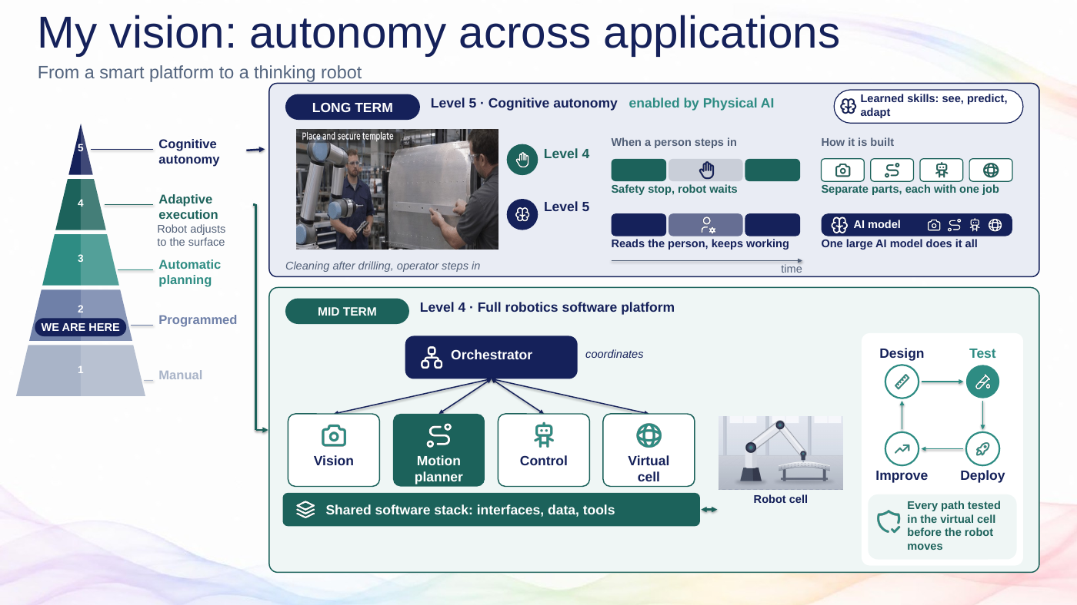
At level four, my goal is a complete robotics product line. Vision identifies the situation, the planner updates movement, and control executes it. The shared software stack connects them, while the orchestrator coordinates the job.
The virtual cell lets us test models and software before deployment, through model-in-the-loop and software-in-the-loop testing. We also check planned movement against robot and cell constraints.
The lifecycle is design, test, deploy and improve, so lessons from one application benefit the others. This level can already perform a defined task autonomously.
At level five, Physical AI adds learned skills where uncertainty makes them useful. Imagine an operator stepping in to inspect drilled holes. Learned models could help interpret the situation and choose an appropriate next action, within the cell's safety rules.
My goal is quicker adaptation and fewer unnecessary interruptions, demonstrated through testing. Those learned skills still work with control, orchestration and safety.
As a Technical Specialist, I want to combine technical depth with practical adoption: guide engineering choices, mentor colleagues and turn project results into capabilities others can reuse.
From flight control to robotics, that is the contribution I want to continue making. Thank you.
Delivery cue Explain the lower Level 4 block first, then the upper Level 5 example. Finish here, because the later slides are hidden. Do not promise that Physical AI removes protective stops.

Preparation notes
These notes are for rehearsal and possible slide wording corrections. They are not part of the 15 minute script. The presentation file has not been edited.

What changed in the script
Slides 1–3 retain the earlier narration. Slide 4 adds the relevance of the Simulink training shown in the updated deck. Slide 5 retains its explanation with a new transition. Slide 6 follows the new offline-versus-autonomous workflow. Slides 7–8 follow the revised project groupings. Slide 9 retains the collaboration message. Slide 10 combines the innovation and shared-knowledge scripts. Slides 11–12 follow the revised roadmap, with the closing now on slide 12.

Claims to keep precise
Slide 10: “Real-time learning that never breaks hard limits” is stronger than the evidence supplied. The script says “constrained reinforcement learning.” Suggested slide wording: “Real-time learning with explicitly enforced constraints.”
Slide 12: a person entering the cell does not automatically mean that Level 4 must stop or that Level 5 may keep working. The required response depends on the validated application and protective measures. Suggested wording: “Adapts to change within validated safety limits.” [1]
Slide 12: “One large AI model does it all” describes one possible direction, not a requirement for Physical AI. Learned skills can work with planning, control and orchestration. Suggested wording: “Learned skills integrated with the robotics stack.” [2]
Slide 12: distinguish virtual testing during development from checking each planned movement. MIL and SIL test models and software; they do not establish that every real-time path undergoes a full simulation before execution. Suggested wording: “Validate virtually and check motion before execution.” [3]
The five levels are a presentation roadmap, not a formal autonomy classification. Level 2 is the stated baseline for the workflow under discussion. Faster adaptation and reduced effort remain intended benefits unless supported by measured results.

Technical references
[1] Universal Robots. Risk Assessment. Application-specific safeguarding and safety settings. Accessed 5 November 2026.
https://www.universal-robots.com/manuals/EN/HTML/SW5_26/Content/prod-usr-man/complianceUR10e/H_g5_sections/safety_g5/risk_assessment.htm
[2] NVIDIA Seattle Robotics Lab. Research across perception, task and motion planning, control and robot learning. Accessed 5 November 2026.
https://research.nvidia.com/labs/srl/
[3] MathWorks. SIL and PIL Simulations. Model and code verification. Accessed 5 November 2026.
https://www.mathworks.com/help/ecoder/ug/about-sil-and-pil-simulations.html

