Kubernetes is an open-source container orchestration platform that automates:
- Deployment of applications
- Scaling (adding/removing containers automatically)
- Load balancing
- Self-healing (restarting crashed containers)
Think of it as a manager for Docker containers — it ensures your app is always running, balanced, and scalable across multiple machines.

Minikube
Minikube is a lightweight tool that allows you to run Kubernetes locally on your computer.
It sets up a single-node Kubernetes cluster (a small version of a real K8s cluster) for learning, testing, and development.

Install Minikube
Step 1: Update System
sudo apt update && sudo apt upgrade -y
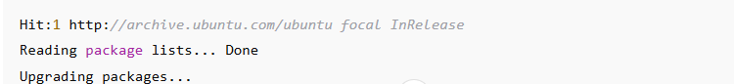

Step 2: Install Dependencies
sudo apt install curl apt-transport-https virtualbox virtualbox-ext-pack -y
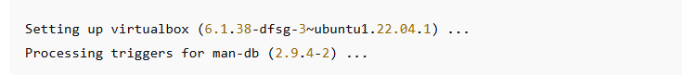

Step 3: Download Minikube Binary
curl -LO https://storage.googleapis.com/minikube/releases/latest/minikube-linux-amd64
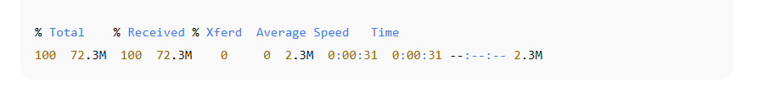

Step 4: Install Minikube
sudo install minikube-linux-amd64 /usr/local/bin/minikube

Step 5: Verify Installation
minikube version
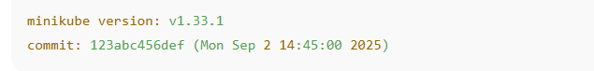

Start Minikube Cluster
Step 1: Start the Cluster
minikube start --driver=virtualbox
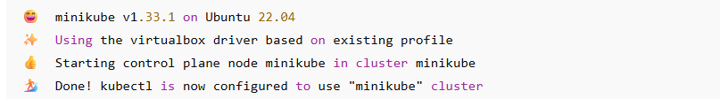

Step 2: Check Status
minikube status
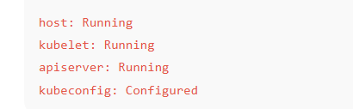

Step 3: Access Dashboard
minikube dashboard

Deploy a Simple Application
Step 1: Create a Deployment
kubectl create deployment hello-minikube --image=k8s.gcr.io/echoserver:1.4

Step 2: Expose the Deployment

kubectl expose deployment hello-minikube --type=NodePort --port=8080

Step 3: Check Pods
kubectl get pods
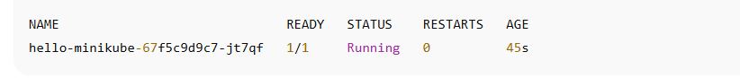

Step 4: Get Service URL
minikube service hello-minikube –url
Open this URL in your browser, and you’ll see:

Stop & Delete Cluster
Step 1: Stop the Cluster
minikube stop
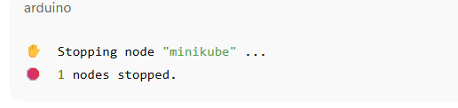

Step 2: Delete the Cluster
minikube delete
