**COVID VACCINES ANALYSIS**

**TEAM MEMBER**

# 962221106086 : RASKIN RAJ S

**Phase – 4 Document Submission**

**Project : COVID VACCINES ANALYSIS**



**OBJECTIVE :** The objectives of COVID-19 vaccine analysis can vary

depending on the specific purpose of the analysis. However, some common objectives include:

* To assess the safety and effectiveness of COVID-19 vaccines. This includes evaluating the vaccines' ability to prevent infection, serious illness, hospitalization, and death.
* To identify the optimal vaccination schedule. This includes determining the number of doses needed and the ideal time interval between doses.
* To understand how COVID-19 vaccines work and how they interact with the immune system. This information can be used to develop new and more effective vaccines.
* To identify and monitor the emergence of vaccine-resistant variants of the SARS-CoV-2 virus. This information can be used to update vaccines and develop new booster shots

Covid-19 vaccines analysis by performing: Exploratory data analysis Statistical analysis Visualization

__________________________________________________________________________________ **Introduction:**

The development and distribution of COVID-19 vaccines have been pivotal in the global fight against the pandemic. As vaccination campaigns progress, it becomes essential to assess their efficacy and identify trends in vaccine administration and their impact on the spread of the virus. To achieve these goals, we will perform the following analyses :

1.Exploratory Data Analysis (EDA)

2.Statistical analysis

3.Visualization

*Exploratory Data Analysis (EDA):*

EDA is the initial step in understanding the dataset and uncovering its inherent patterns and structures. We will explore summary statistics, data distributions, correlations, time series trends, and geographical aspects of COVID-19 vaccine data. This will provide a foundation for further analysis and highlight areas of interest within the data.

**Data Collection and Preparation:**

* Collect the dataset with information on COVID-19 vaccinations, which should include variables like date, location, type of vaccine, doses administered, and demographics.

* Clean the data by addressing missing values, outliers, and data inconsistencies.

* Ensure data types are appropriate for analysis.

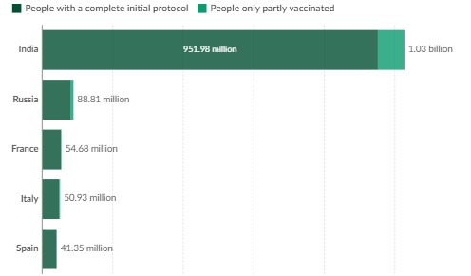

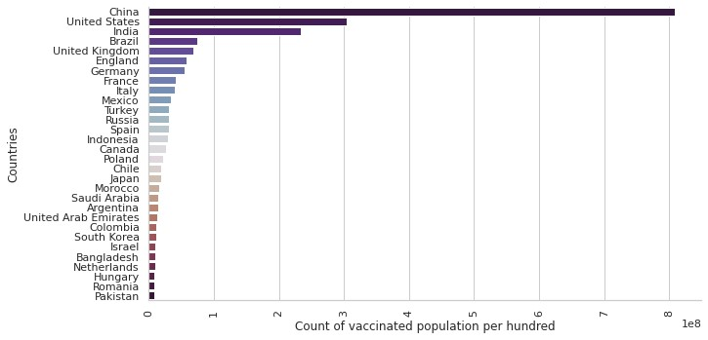

**Summary Statistics:**

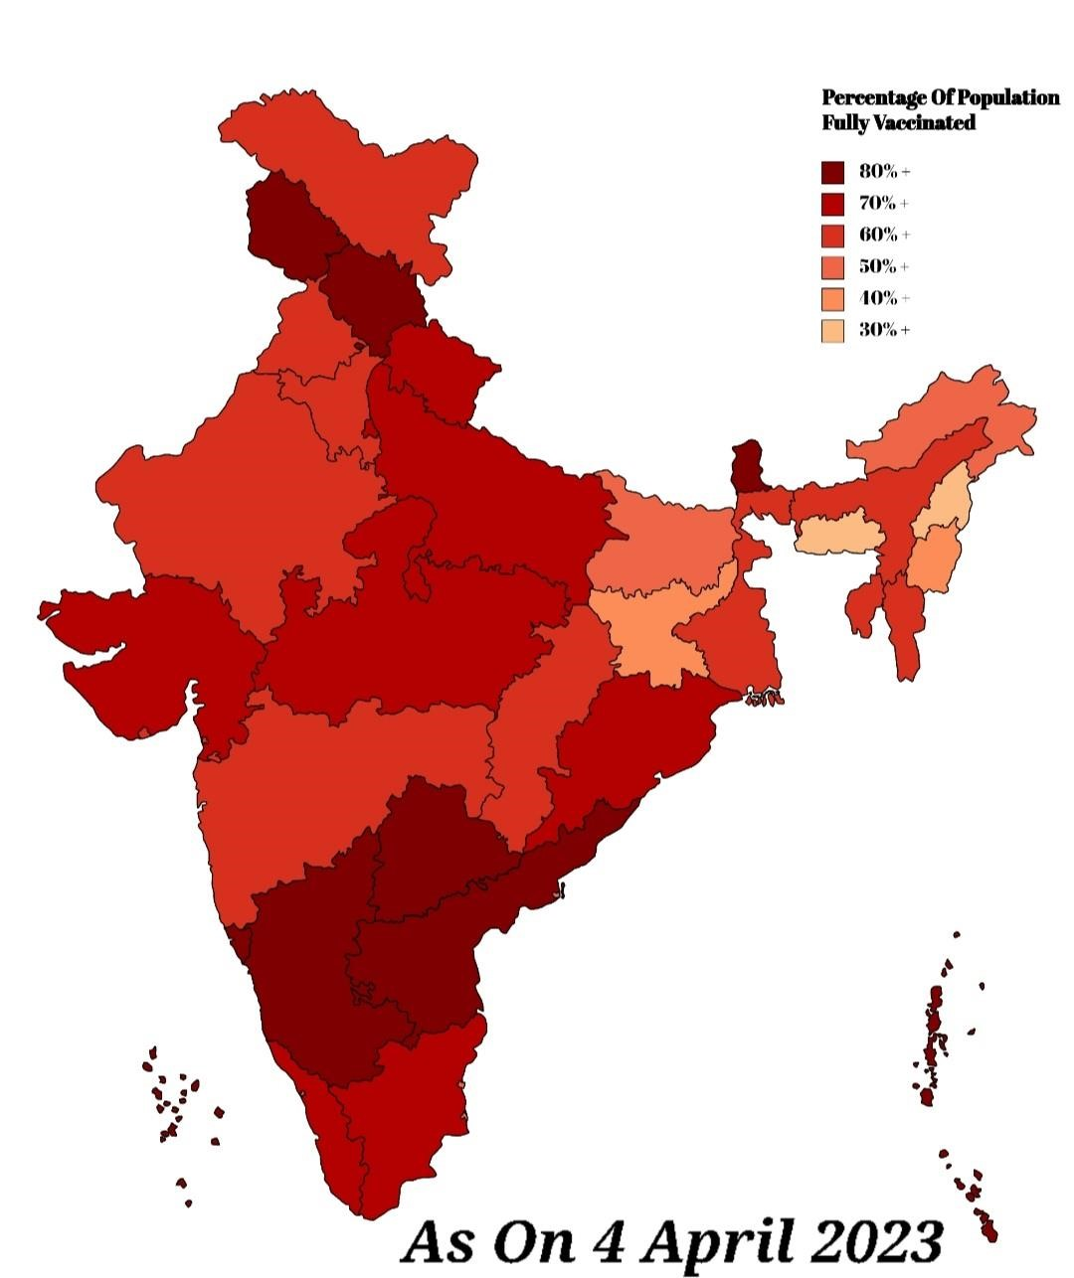

**Time series analysis:**

Time series forecasting is a powerful tool for predicting future trends based on historical data. In this presentation, we will explore how it can be applied to vaccine distribution and adverse effects data to unlock insights that can help improve public health

**Demographic Analysis:**

* Explore the distribution of vaccine doses by age group, gender, or other demographic factors.
* Identify any disparities in vaccine distribution.

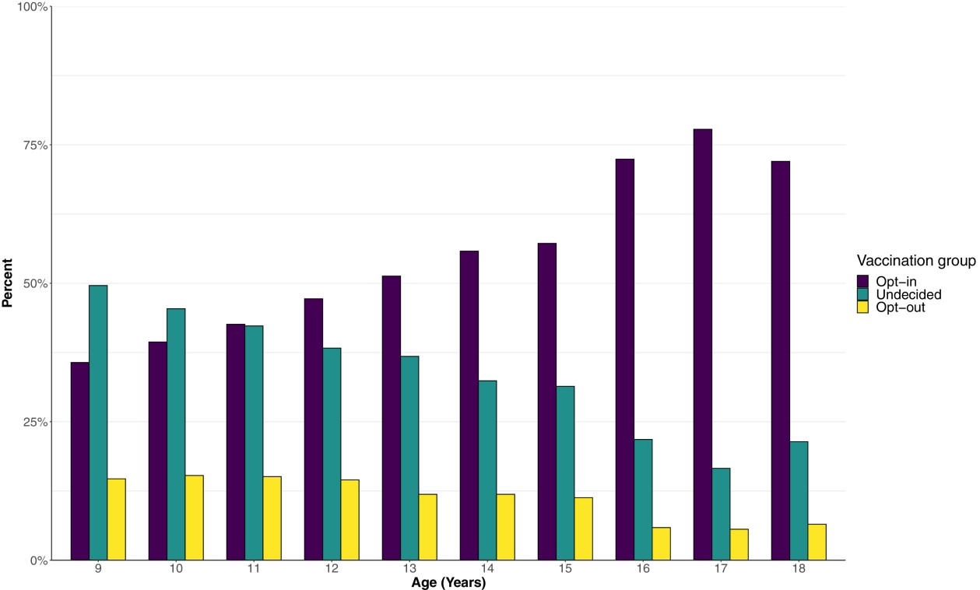

**CONCLUSION:**

Exploratory Data Analysis is a critical first step in COVID-19 vaccine analysis. It helps you gain a deeper understanding of the data, identify areas that require further investigation, and set the stage for more advanced statistical analyses and visualization to answer specific research questions.

*Statistical Analysis*

* Statistical analysis is a critical component for making inferences and testing hypotheses related to COVID-19 vaccine data. We will conduct hypothesis tests, regression analyses, and time series analyses to assess the impact of vaccination efforts on COVID-19 cases and outcomes.
* This analysis will allow us to draw meaningful conclusions and identify factors that significantly influence vaccination and its outcomes.

Statistical analysis of COVID-19 vaccine data is crucial for evaluating the impact of vaccination efforts and informing public health strategies.

* It enables researchers and policymakers to make data-driven decisions, track progress, and ensure equitable vaccine distribution.

**Descriptive statistics:**

Calculating basic summary statistics, such as vaccination rates, total doses administered, and demographic breakdowns.

**Hypothesis Testing:**

Conducting tests to determine if there are significant differences in vaccine outcomes among various groups or regions.

**Regression Analysis:**

Assessing the relationships between vaccine-related variables and

COVID-19 outcomes, while accounting for confounding factors

**Interpretation and Reporting:**

* Interpret the results of your statistical analysis in the context of COVID-19 vaccine research.
* Discuss the implications for public health policy, vaccination campaigns, and future research directions.

## Visualization

* Create various visualizations, including bar charts, line plots, heatmaps, and geospatial maps, to convey your statistical findings effectively.

* Visualize trends, correlations, and geographic disparities.

* Data Visualization plays an important role for patterns and trends analysis in trillion of data rows Big Data analysis, where the data can be represented in some graphical forms. Hence, the data could be more comprehensible in its visual summary in dashboards and storyboards. This study aims to discuss some issues and challenges in visualizing COVID-19 vaccination datasets.

* There are some possible issues in data visualization, as it is not easy and may be challenging to produce a good dashboard that are interesting and easy for viewers to understand. Therefore, this study focuses on some issues that may arise during performing a data visualization on the COVID19 dataset. In this study, there are three dashboards have been studied, which are the COVID-19 tracker, its effectiveness, and its acceptance. The first two dataset are derived from Ministry of Health Malaysia bank data, whereas the third dataset is from a survey to support this analysis.

* The selected attributes are states, the number of people who have received the vaccine as adults, children, and teenagers, and the number of people who already received boosters, and reasons to not get a booster.

* The visualization issues found within the dashboard are mis-choice of colors, mis-choice of visual object type, lack of interactivity, and plotting too much data. As a result, this proposed alternative solutions for those issues such as color deliberately, pick a suitable visual object, create an interactive dashboard, and reduce the information overload in visualizing the data.

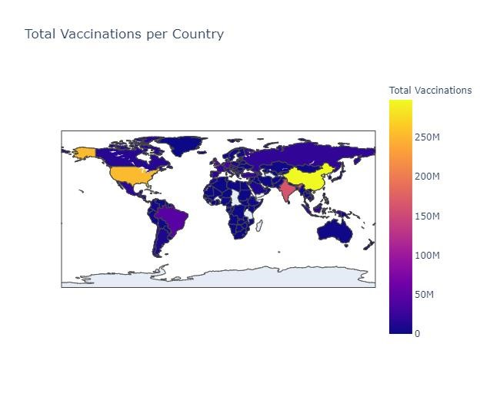

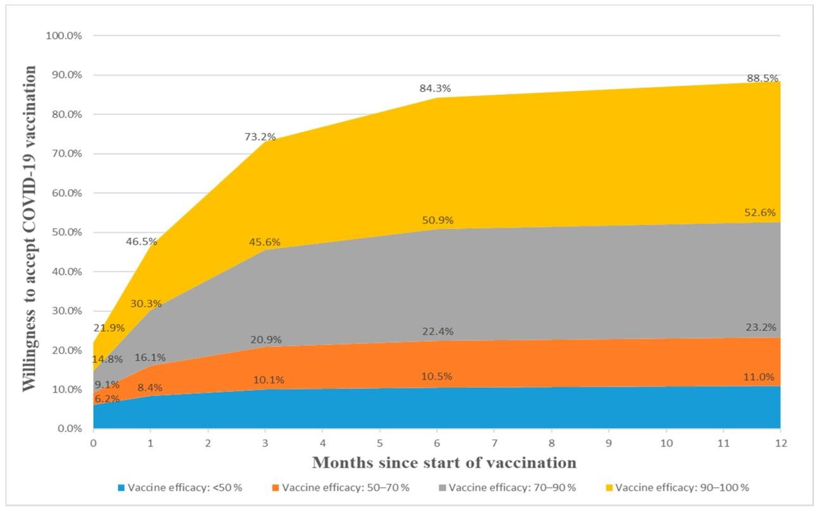

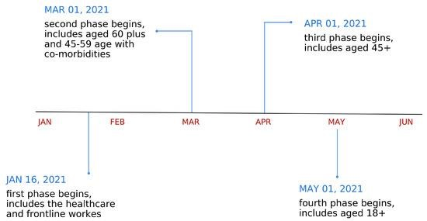

**Conclusion:**

* Exploratory Data Analysis (EDA) of COVID-19 vaccine data has provided valuable insights into the distribution, coverage, and trends related to vaccination efforts. Through EDA, we gained a better understanding of how vaccine doses were administered, the demographic characteristics of vaccine recipients, and the geographic distribution of vaccinations.
* Key findings from EDA include the identification of regional disparities in vaccination rates, age group preferences for specific vaccines, and the emergence of temporal trends in vaccine distribution. EDA has also revealed the impact of vaccination campaigns on controlling the spread of COVID-19.
* These insights will inform public health decision-making, optimize vaccine distribution strategies, and help address disparities in access to vaccines.