Manual Test Management
Manual test management focuses on planning, designing, executing, and tracking tests that are performed by testers without automation.
Key aspects:
- Test cases with step-by-step instructions
- Human execution and validation
- Suitable for exploratory, usability, and ad-hoc testing
- Requires detailed documentation and execution tracking
1.Creation:
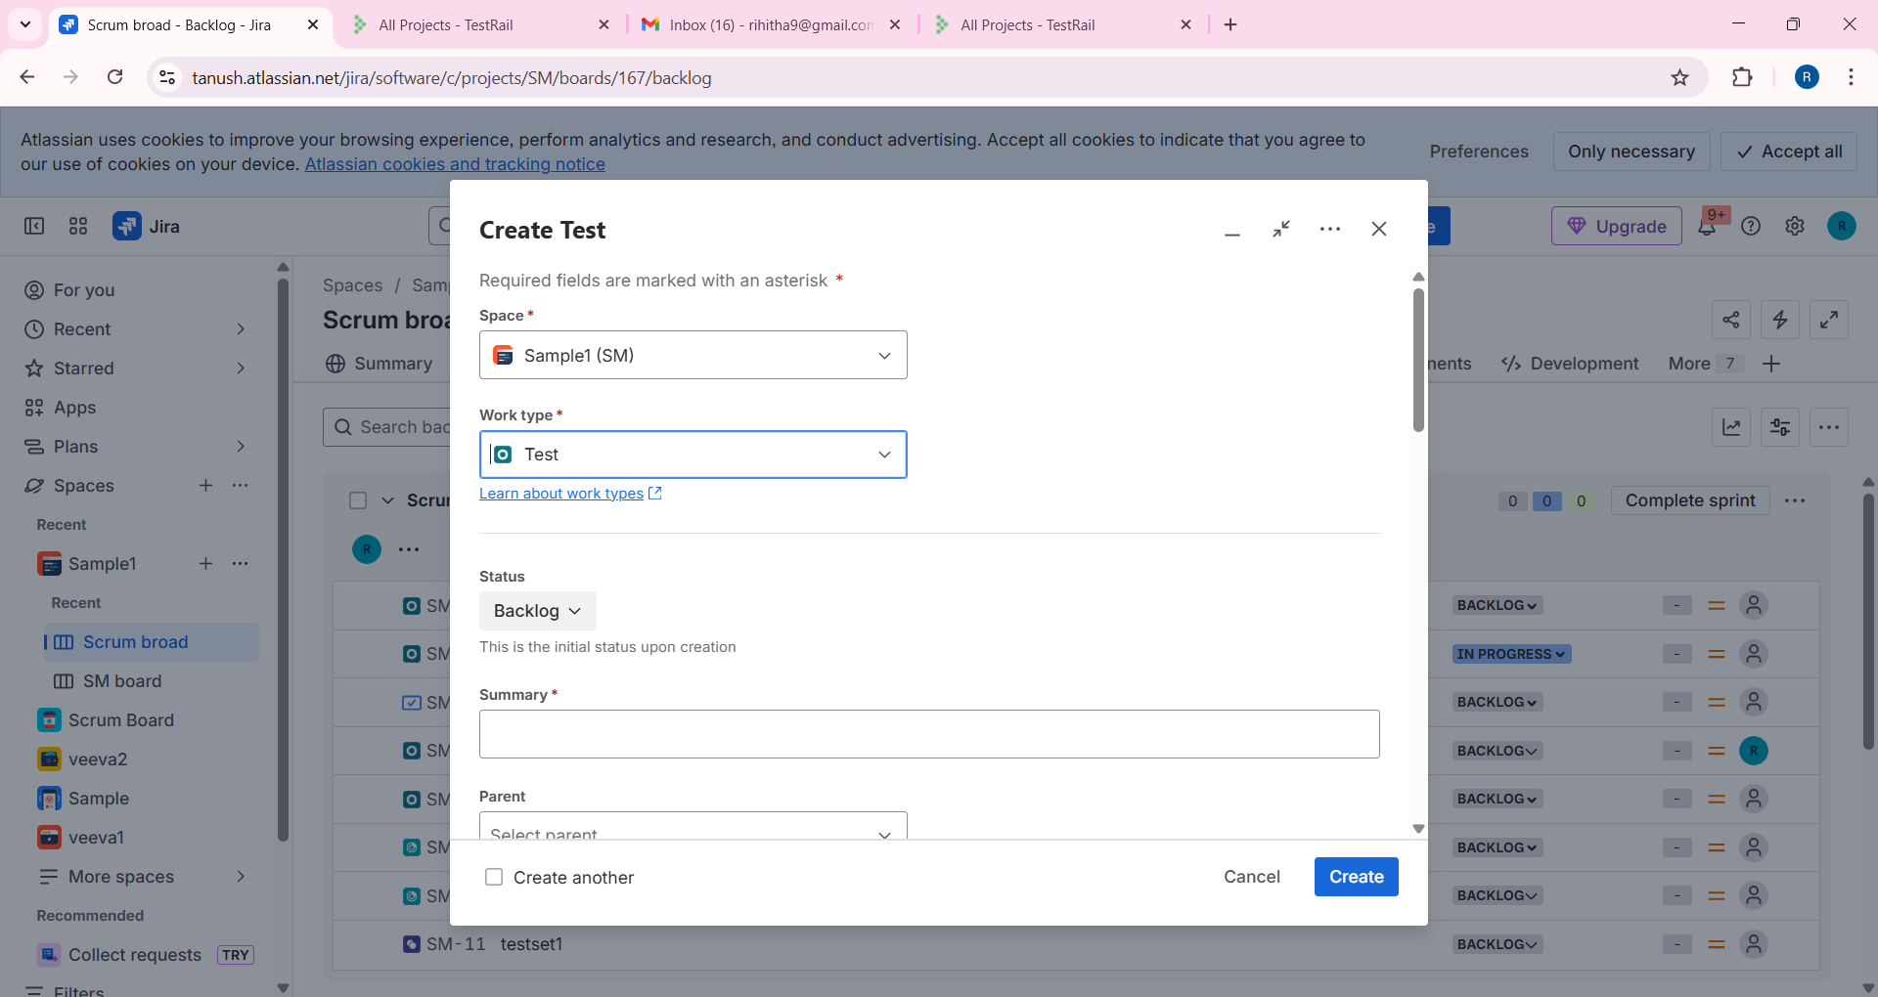

2.Using Preconditions
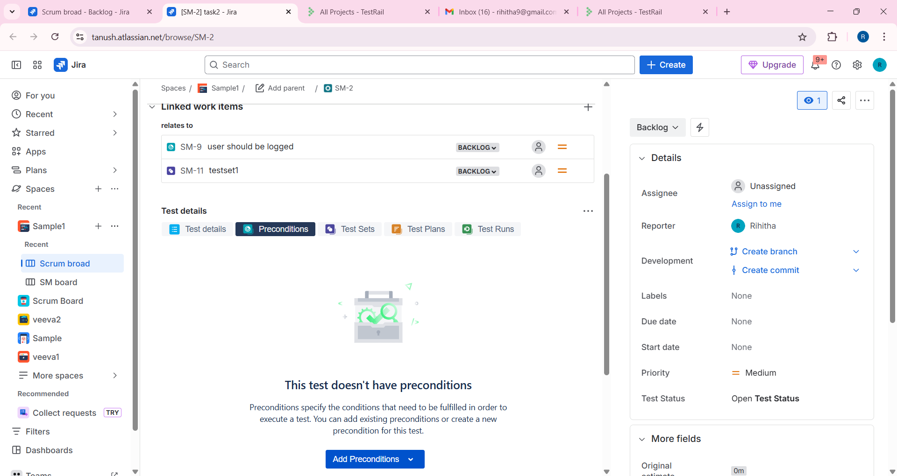

3.Test Sets for Organization:
