Test Execution in Xray
Test Execution in Xray is used to run test cases and record their results within Jira. It is managed through the Test Execution issue type, where multiple test cases can be added and executed in a single test run. Each test is marked as Pass, Fail, or Executing based on the execution outcome.
Xray allows testers to attach evidence such as screenshots or logs during execution. If a test fails, a defect can be created and linked directly from the execution screen. Test cases can be re-executed after fixes, and Xray maintains execution history for tracking and traceability.
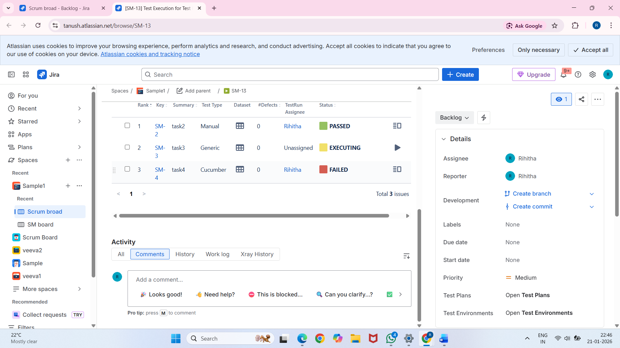
Failed Test with Evidence
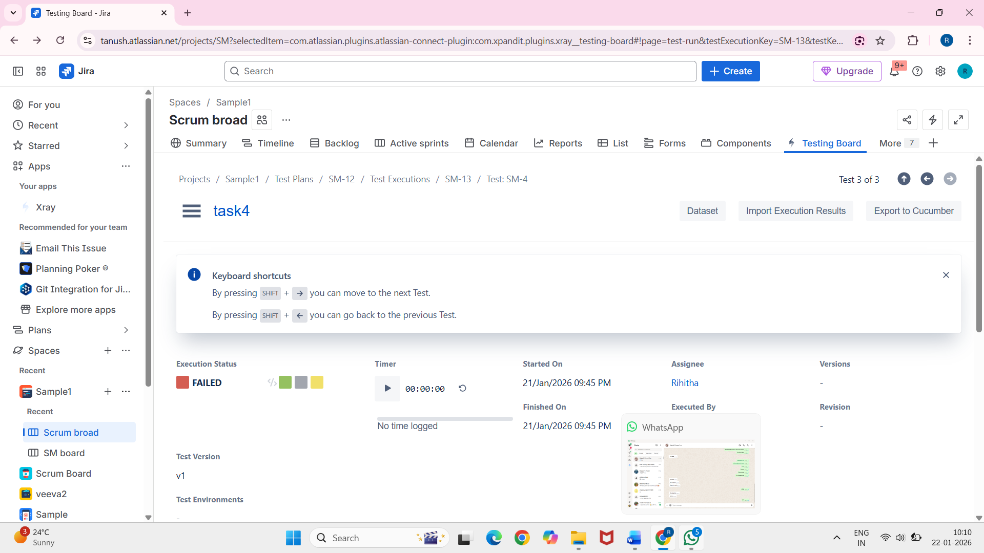
This screenshot displays a failed test with attached evidence such as screenshots or logs. Evidence helps developers understand failures clearly and speeds up defect fixing.

Defect Linking & Re-execution in Xray
Defect Linking in Xray allows testers to connect failed test cases directly to defects (bugs) in Jira. When a test fails during execution, a defect can be created and linked to the test, ensuring traceability between the test result and the issue that caused the failure.
Re-execution refers to running the same test cases again after the defect has been fixed. Xray maintains the execution history, allowing testers to track changes in test outcomes over time. This process ensures that fixes are validated and that testing coverage remains complete.
Defect Linking and Re-execution together help maintain clear communication between QA and development teams, improve testing efficiency, and provide a full audit trail of testing activities.

