Test Planning in Xray
Test Planning in Xray is used to organize and manage testing activities for a sprint or release. It is done using the Test Plan issue type, which groups related test executions and test cases under a single plan. Test Plans help teams track testing progress and ensure all requirements are covered.
In Xray, a Test Plan links requirements, tests, and executions, providing full traceability and better visibility of test coverage. This helps teams plan testing efficiently and maintain quality throughout the development lifecycle.

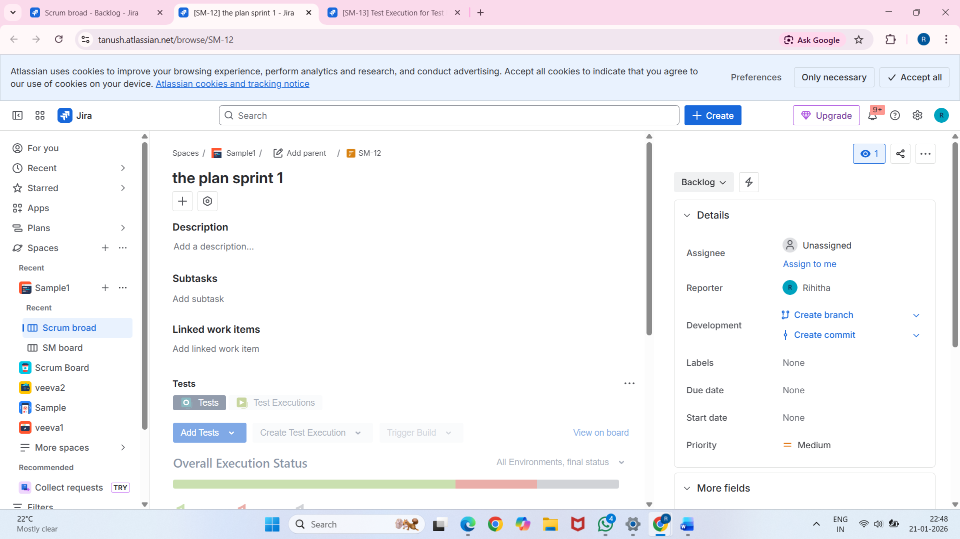

Traceability Matrix
The Traceability Matrix in Xray is used to track and verify the relationship between requirements, test cases, test executions, and defects. It ensures that every requirement is properly tested and helps identify gaps where testing is missing.
Xray provides a visual traceability view that allows teams to monitor test coverage, execution status, and linked defects, making it easier to maintain quality and meet compliance or audit requirements.

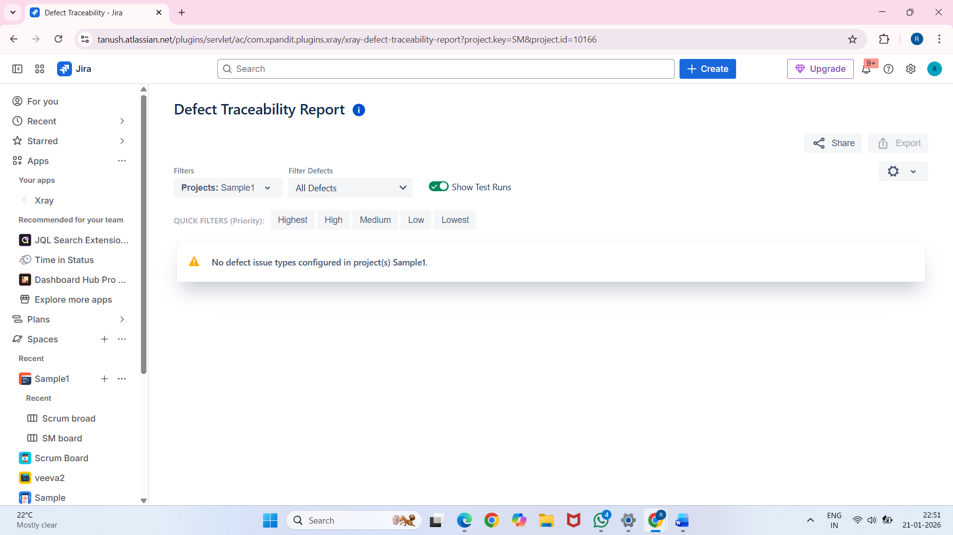

Compliance View in Xray
The Compliance View in Xray provides a clear overview of test coverage and execution status to ensure that all requirements are properly tested. It helps teams verify that testing activities meet quality standards and regulatory or audit requirements.
This view allows stakeholders to track the linkage between requirements, tests, executions, and defects, making Xray suitable for audit readiness and compliance-driven projects.

