Xray Execution Report
The Xray Execution Report provides a detailed summary of test execution results for a selected test run, test plan, or project. It displays the number of test cases executed along with their status such as Pass, Fail, and Blocked.
This report helps teams analyze testing progress, identify failed test cases, and evaluate overall product quality. It is commonly used by testers and stakeholders to monitor execution status and make informed release decisions.
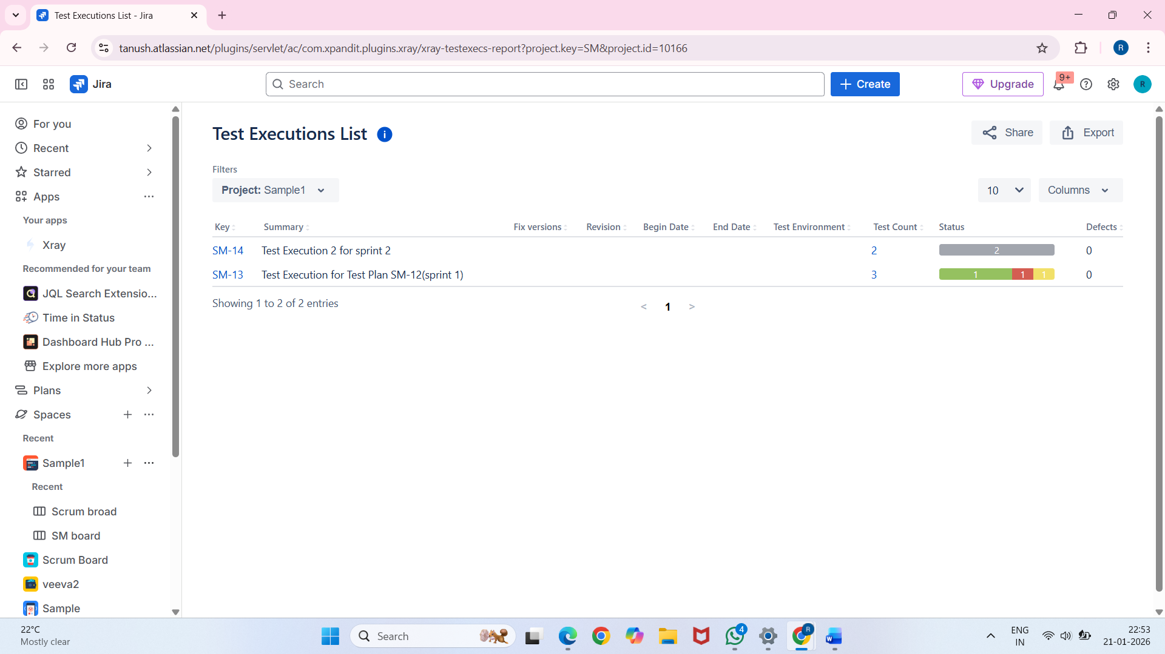

Jira Dashboard with Xray Gadgets
A Jira Dashboard with Xray Gadgets provides a visual overview of testing and quality metrics in one place. Xray gadgets display information such as test execution status, test coverage, pass percentage, and defect count.
These dashboards help testers, managers, and stakeholders quickly understand the current quality status of the project and track testing progress in real time.
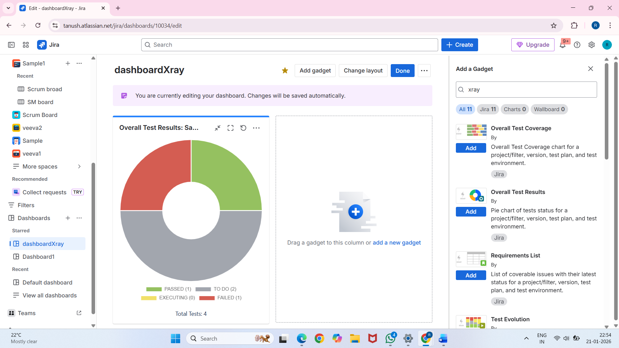
Document Generator in Xray
The Document Generator in Xray is used to export test management data into structured documents such as Word or PDF files. It allows users to generate documents for test cases, test executions, test plans, and traceability information.
This feature is useful for reporting, documentation, and audit purposes, as it helps teams share testing details with stakeholders in an organized and professional format.
