Jira Fundamentals
What Is a Jira Project?
A Jira Project is a workspace where teams track and manage their work. Each project contains issues, workflows, boards, and settings specific to a team or product.
Types of Jira Projects
Team-Managed Projects
- Managed directly by the team
- Quick and easy to set up
- Teams can change workflows, fields, and boards on their own
- Best for small teams or teams that want flexibility
Company-Managed Projects
- Managed by Jira administrators
- Supports advanced workflows and shared configurations
- Strong permission controls
- Best for large teams or organizations needing consistency
Main Difference:
- Team-Managed = more freedom for teams
- Company-Managed = more control and standardization for the organization
How to Create a Jira Project
- Sign in to Jira
- Navigate to Projects
- Click Create Project (+ icon)
- Select a project template (Scrum, Kanban, Bug Tracking, etc.)
- Choose the project type (Team-Managed or Company-Managed)
- Enter the project name and confirm the project key
- Review settings such as permissions and workflow
- Click Create
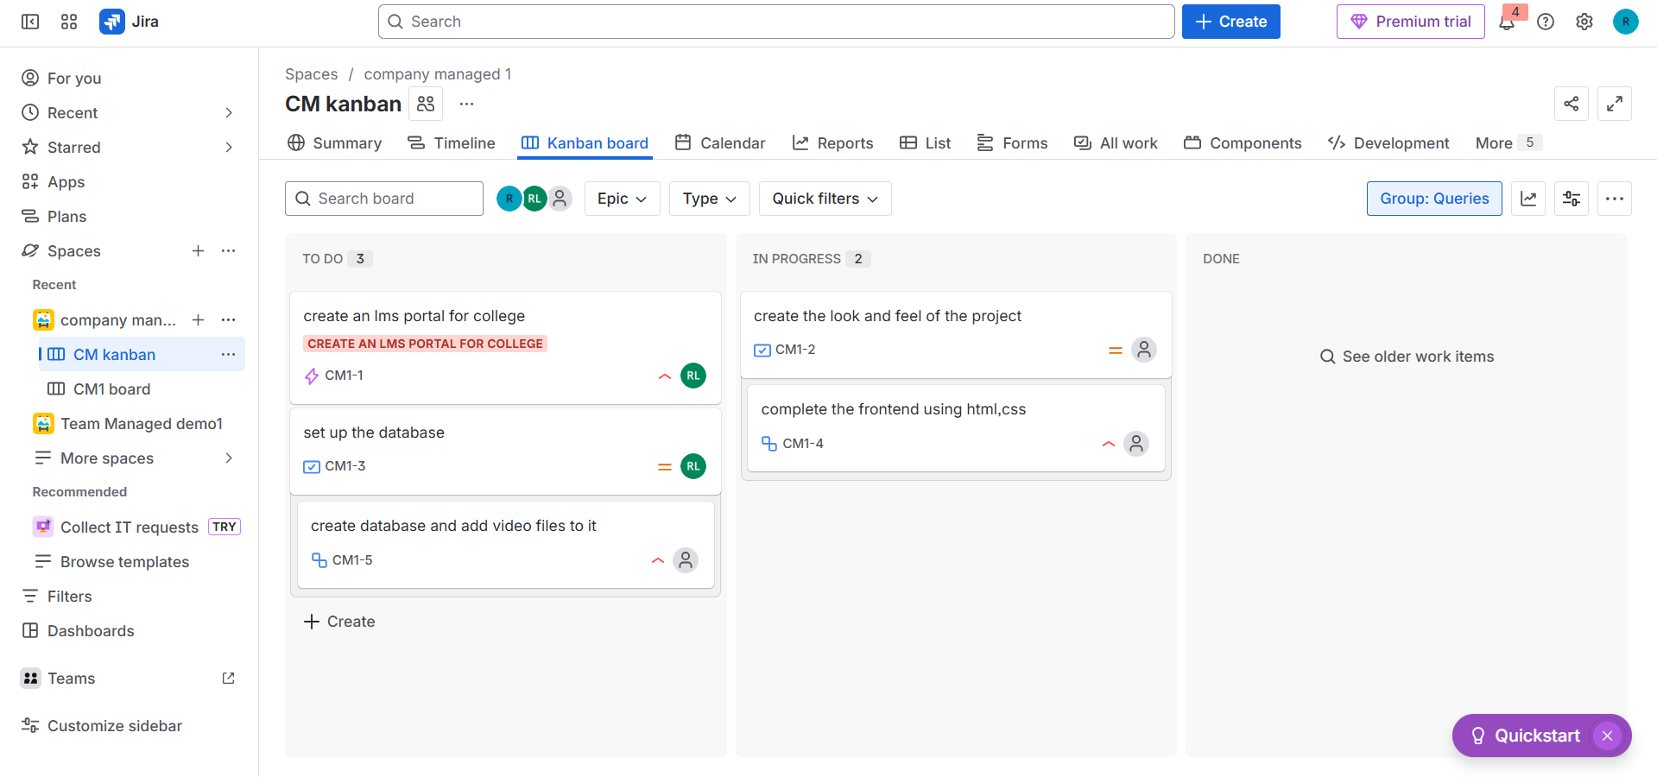
Jira Issue Types Overview
- Task – A basic unit of work
- Story – A requirement written from a user’s point of view
- Bug – A defect or problem that needs fixing
- Epic – A large feature made up of multiple stories or tasks
- Subtask – A smaller task that belongs to a story or task
Creating an Issue in Jira
- Log in to Jira
- Click Create
- Select the issue type (Task, Story, Bug, Epic, Subtask)
- Choose the project
- Add a summary (issue title)
- Fill in details like description, priority, assignee, or attachments
- Click Create
Managing Jira Issues
You can manage issues by:
- Changing status (To Do → In Progress → Done)
- Editing details like description or priority
- Adding comments for communication
- Uploading attachments
- Linking related issues
- Creating subtasks for detailed work
- Transitioning issues through the workflow
Issue Hierarchy in Jira
Structure
Epic → Story/Task → Subtask
- Epic – Represents a large goal or feature
- Story – Describes user requirements within an epic
- Subtask – Breaks stories or tasks into smaller actions
Creating the Hierarchy
- Create an Epic
- Create Stories or Tasks under the Epic
- Link stories to the Epic
- Open a story or task to create subtasks
Linking Issues in Jira
Linking helps teams understand dependencies and relationships.
Common Link Types
- Blocks / Is Blocked By – Shows dependencies
- Relates To – General relationship
- Clones / Duplicates – Similar or copied issues
How to Link Issues
- Open an issue
- Click More (•••) → Link issue
- Choose the link type
- Search for the issue key or summary
- Click Link
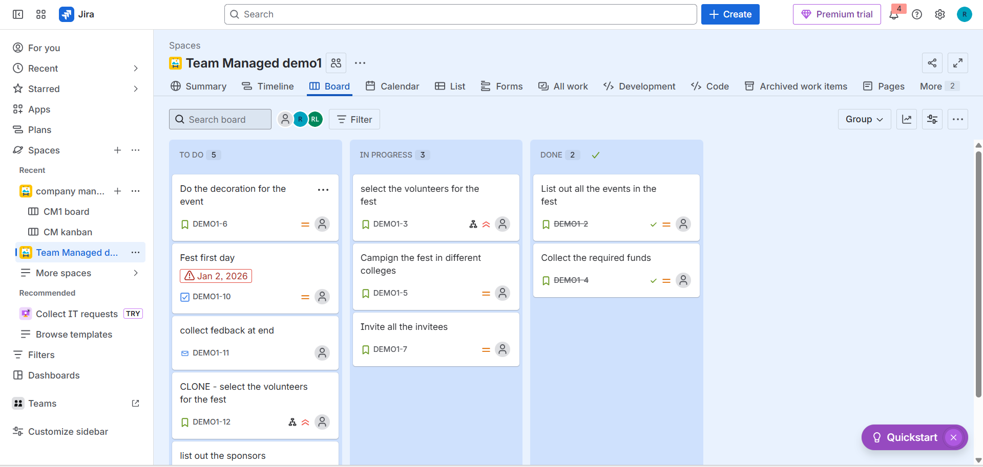
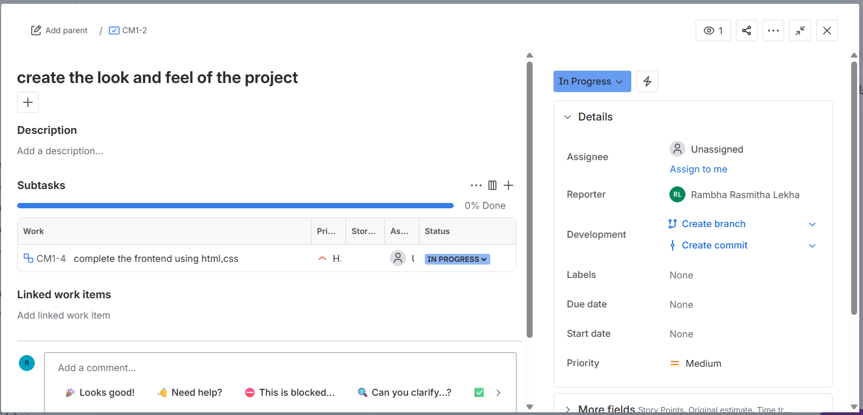
Jira Boards: Scrum vs Kanban
Scrum Board
Best for teams working in fixed-time iterations (sprints).
Features
- Product backlog
- Time-boxed sprints
- Sprint planning
- Burndown and velocity reports
How Scrum Works
- Create a Scrum project
- Add issues to the backlog
- Assign issues to a sprint
- Start the sprint
- Move issues across columns
- Complete the sprint and review reports
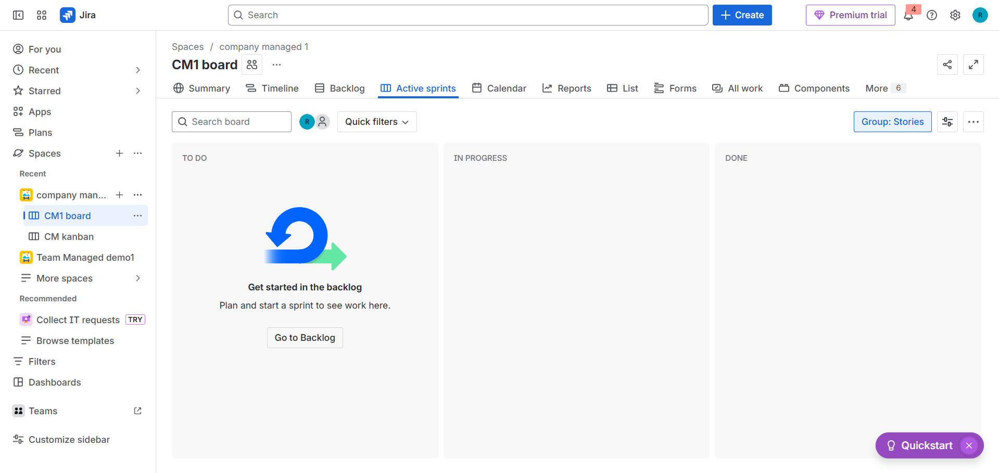
Kanban Board
Designed for continuous work without sprints.
Features
- Ongoing workflow
- Work-in-progress (WIP) limits
- Cycle time and flow reports
How Kanban Works
- Create a Kanban project
- Add issues directly to the board
- Customize workflow columns
- Monitor progress using reports
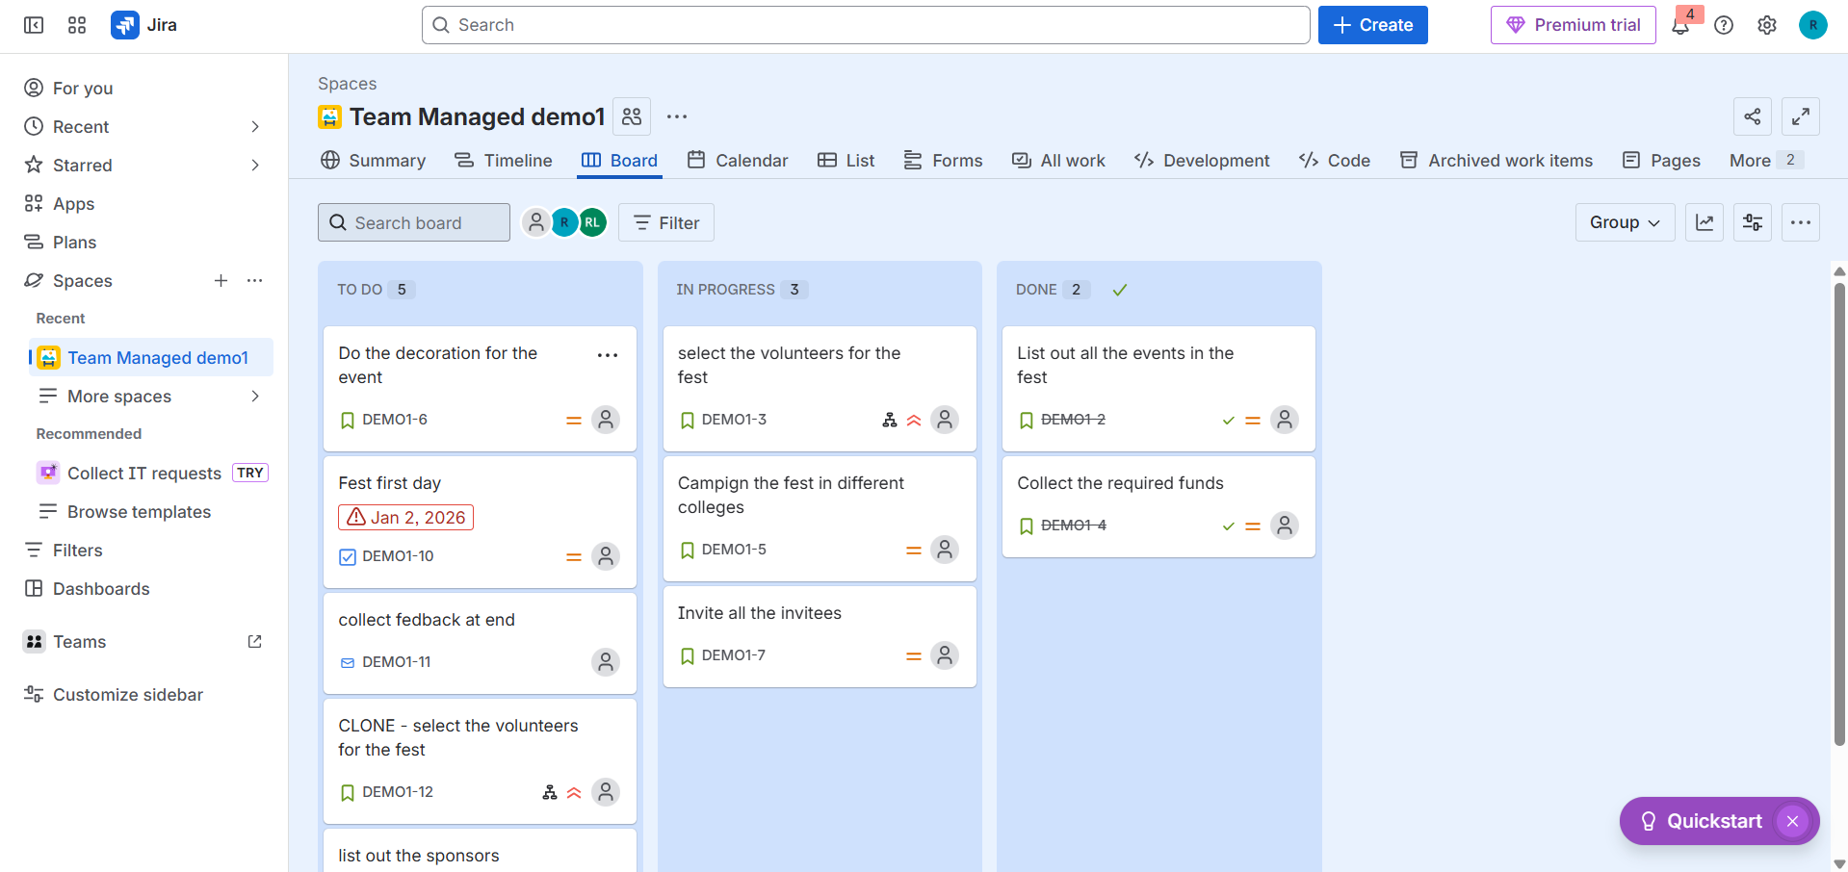
Jira Views Explained
Backlog View
- Used for planning future work
- Helps prioritize tasks and stories
Board View
- Shows active work visually
- Helps track progress and spot blockers
Issue Detail View
- Displays full information about a single issue
- Includes status, description, comments, and history

