Agile in Jira (Scrum and Kanban Workflows)
Scrum Workflow in Jira: Sprints, Planning, and Execution
Sprint Planning
Sprint planning is the process where the team selects prioritized stories from the backlog. The team estimates the effort required and commits to completing the selected work within the sprint.
Sprint Execution
During the sprint, team members work on assigned issues and move them across the workflow stages such as To Do, In Progress, and Done. Daily standup meetings are held to review progress, discuss upcoming work, and identify blockers.
Sprint Completion
At the end of the sprint, completed work is reviewed and the sprint is closed. Jira reports such as burndown charts and velocity reports are used to evaluate team performance and improve future sprints.

Estimating with Story Points and Time in Agile Projects
Estimation helps teams plan work, manage capacity, and deliver predictably. Agile teams commonly use story points and time-based estimates.
Story Points
Story points represent the relative effort required to complete a user story. They consider factors such as complexity, risk, and uncertainty. Story points are assigned during backlog refinement or sprint planning and are used to calculate team velocity for future forecasting.
Time-Based Estimates
Time-based estimates are expressed in hours or days and indicate how long a task or subtask may take to complete. These estimates help with daily execution, workload balancing, and tracking remaining work during a sprint.
Using Story Points and Time Together
Story points support high-level planning and predictability, while time estimates provide detailed visibility into execution. Using both methods allows teams to plan effectively without overcommitting.

Running Daily Standups Using Jira
Daily standups help teams stay aligned and quickly address issues. Jira supports standups by providing real-time visibility into work status.
Using the Board for Standups
Teams should review issues directly from the Scrum or Kanban board, moving across workflow columns to discuss progress.
Standup Questions
Each team member answers three questions:
- What work was completed since the last standup?
- What work will be done next?
- Are there any blockers?
Updating Jira
Team members should update issue status, comments, and remaining work during or immediately after the standup.
Managing Blockers
Blocked issues should be flagged or commented on in Jira to ensure visibility and quick resolution.
Time Management
Standups should be limited to 15 minutes. Any detailed discussions should take place outside the meeting.
Using Jira Reports
Reports such as burndown charts and control charts help identify trends but should support team discussions rather than replace them.

Working with Kanban in Jira
Kanban focuses on continuous flow rather than fixed iterations. Jira’s Kanban boards help teams visualize work and improve delivery over time.
Visualizing the Workflow
Each workflow stage is represented as a column on the board, such as To Do, In Progress, Review, and Done. This helps teams see progress and identify bottlenecks.
Limiting Work in Progress
WIP limits restrict the number of issues in each column, preventing overload and encouraging focus.
Pull-Based Work System
Team members pull new work only when they have available capacity, rather than pushing work into progress.
Managing Blockers
Blocked issues are clearly flagged in Jira and addressed quickly to maintain smooth flow.
Flow Metrics
Jira provides reports such as the Cumulative Flow Diagram, Control Chart, and Throughput to analyze cycle time and identify areas for improvement.
Continuous Improvement
Teams regularly review metrics and adjust workflows, WIP limits, and policies to improve efficiency and predictability.

Visualizing Work with WIP Limits and Swimlanes
Work in Progress Limits
WIP limits help control workload, improve focus, and identify bottlenecks early.
Swimlanes
Swimlanes organize issues horizontally based on criteria such as assignee, priority, or epic. They help group related work and make tracking easier.

Understanding the Cumulative Flow Diagram (CFD) in Jira
The Cumulative Flow Diagram shows the number of issues in each workflow stage over time. It helps teams identify bottlenecks, monitor work in progress, evaluate flow stability, and support continuous improvement, especially in Kanban environments.

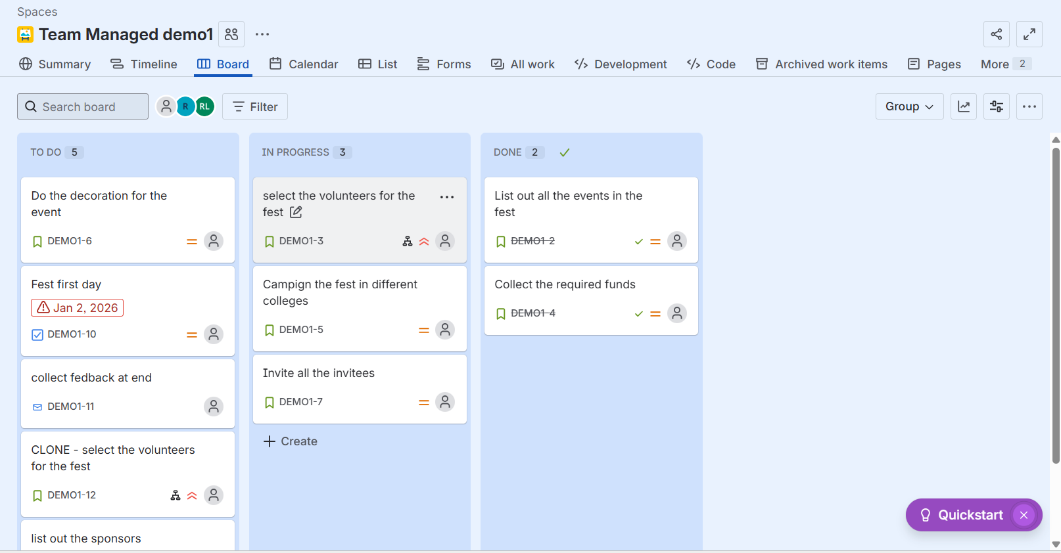
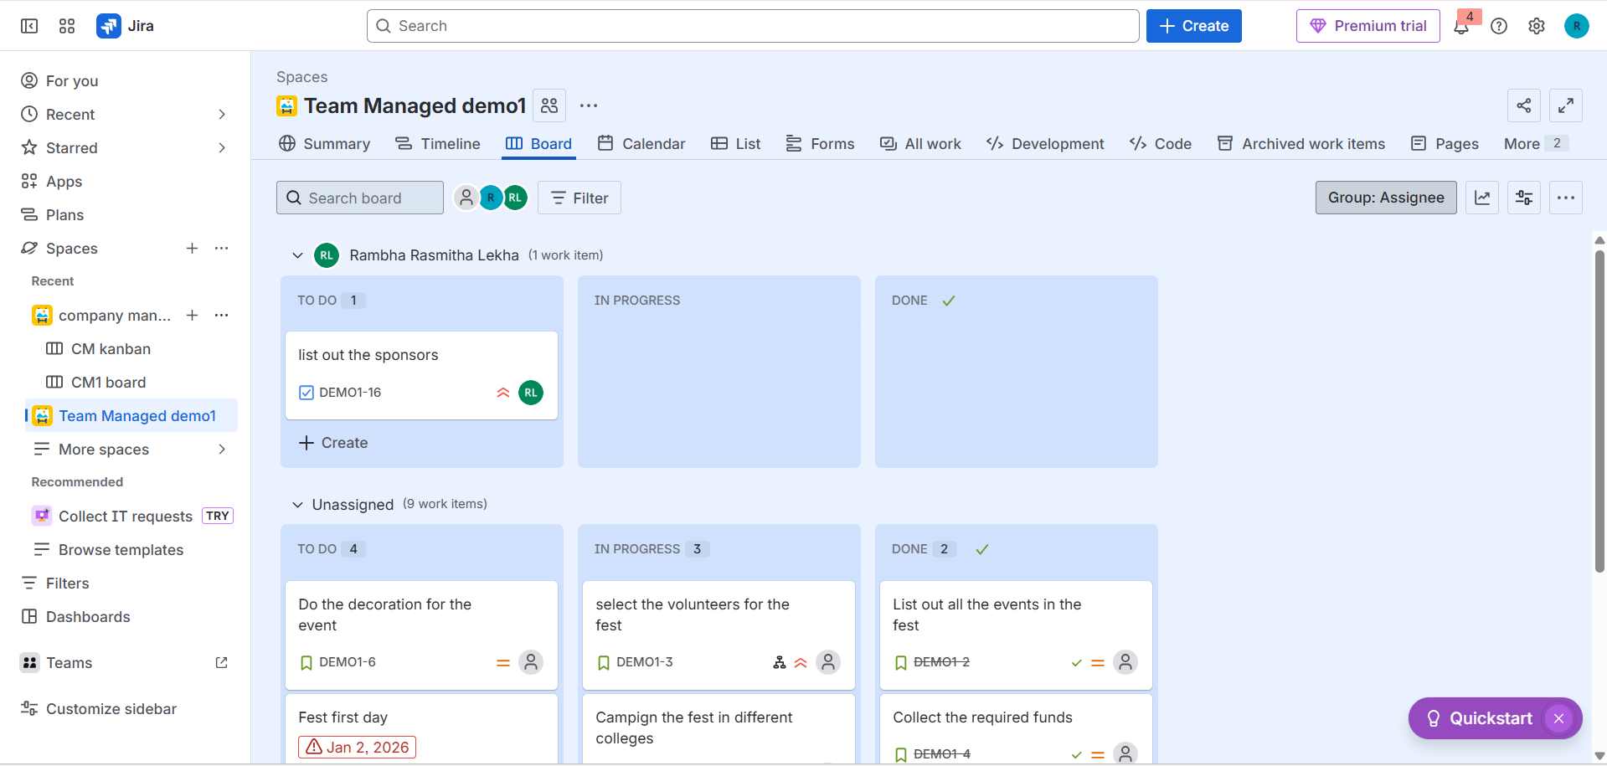
Bugs, Lifecycle, and Status Updates in Jira
Bugs represent defects or problems in software or processes. Managing their lifecycle ensures quality and timely resolution.
Bug Lifecycle
- Open or New – The bug is reported and logged
- In Progress – A team member begins working on the fix
- In Review or Testing – The fix is reviewed or tested by QA
- Resolved or Fixed – The bug has been fixed and awaits verification
- Closed – The fix is verified and confirmed
- Reopened – The bug is reopened if the issue still exists
Status Updates
Each status reflects the current stage of the bug. Jira allows team members to update statuses, add comments, attach files, log work, and trigger automated notifications to keep stakeholders informed.

