Organizing Your Work in Jira
Labels, Components, Versions, and Templates
Using Issue Labels and Priorities to Organize Work in Jira
Jira provides labels and priority fields to help teams categorize, filter, and manage work efficiently.
Issue Labels
Labels are custom tags used to group related issues. Examples include frontend, bug, or urgent. Labels make it easy to search, filter, and organize issues across boards and list views. They also help teams quickly identify related work, even across multiple projects.
Issue Priorities
Priorities indicate how important or urgent an issue is. Common priority levels include Highest, High, Medium, Low, and Lowest. Setting priorities helps teams decide what to work on first and allows critical tasks to stand out in reports and dashboards.
List Views
Jira allows issues to be viewed in a list or table format. This view displays key fields such as labels, priority, assignee, and status. List views are especially useful for sorting, filtering, and making bulk updates to issues.

Creating and Assigning Labels to an Issue
- Open the issue you want to label
- Locate the Labels field in the issue details
- Click the Labels field and type a new label or select an existing one
- Press Enter to save the label
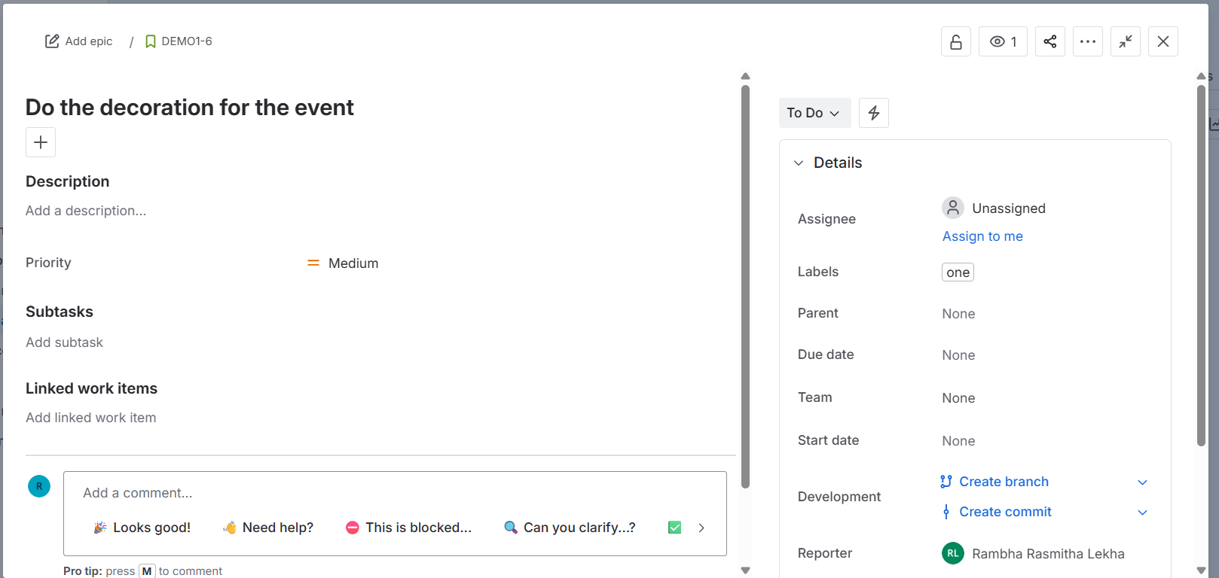
Setting the Priority of an Issue
- Open the issue
- Locate the Priority field
- Select a priority level from the dropdown
- The change is saved automatically
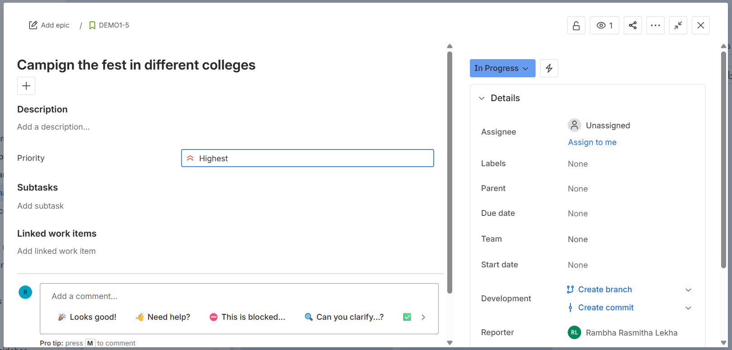
Viewing Issues in List View
- Open your Jira project
- Click Issues or Filters and select View All Issues
- Switch to List view from the top-right corner
- Customize columns to show Labels, Priority, Assignee, and Status
- Apply filters or sorting as needed
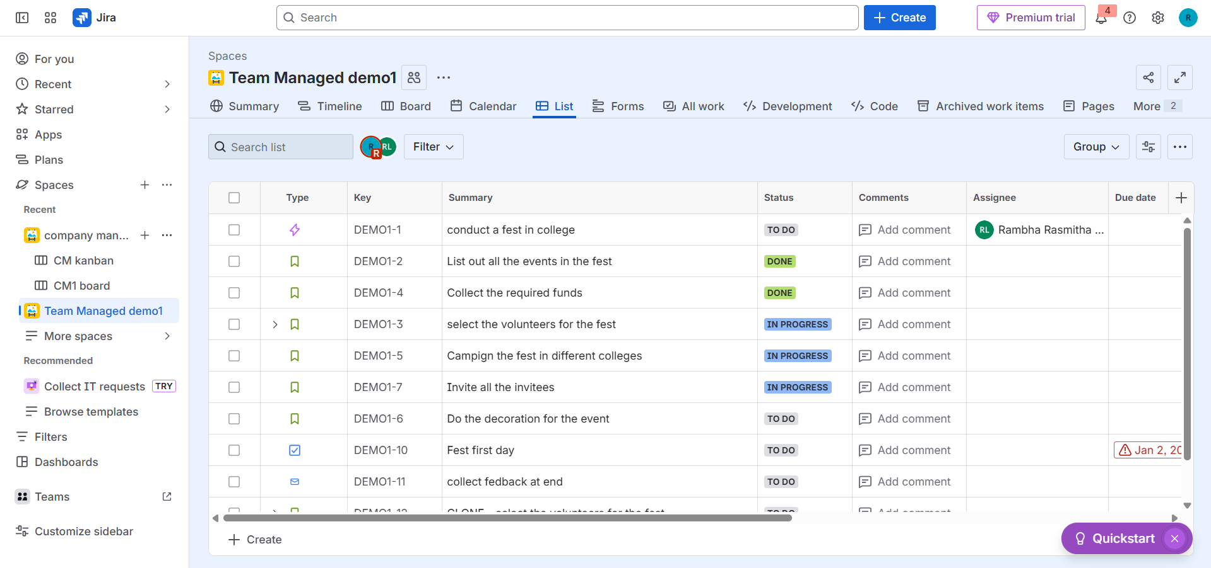
Structuring Work with Components in Jira Projects
Components help break a project into smaller functional areas such as Frontend, Backend, API, or UI/UX.
Key Features of Components
Components represent logical sections of a project. Each component can have a lead responsible for related issues. Components help with categorization, reporting, filtering, and automation, such as automatically assigning issues to component leads.
Benefits of Using Components
Components help organize large projects, track progress by functional area, generate focused reports, and improve accountability by clearly defining ownership.

Creating a Component in a Jira Project
- Go to your Jira project
- Click Project Settings
- Select Components
- Click Create Component
- Enter the component name, optional description, component lead, and default assignee
- Click Add to save

Assigning Issues to a Component
- Open the issue
- Find the Components field
- Select one or more components from the dropdown
- Save the changes
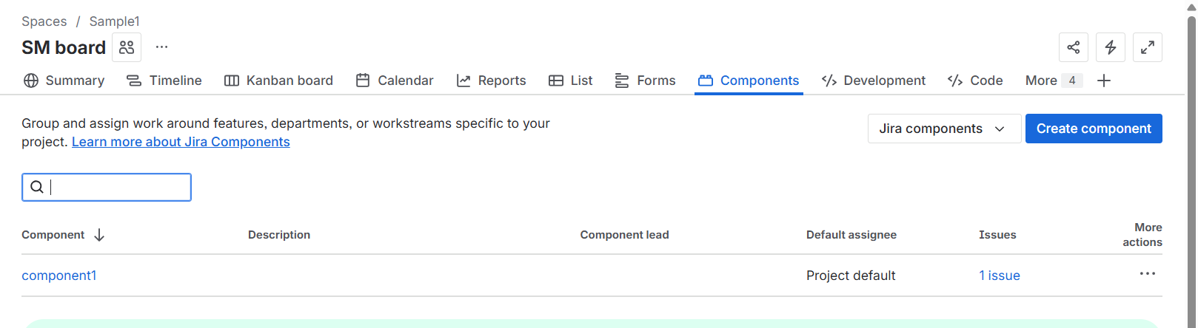
Planning and Releasing with Versions in Jira
Versions, also called releases, help teams plan and track work for a specific delivery milestone such as v1.0 or Sprint Release.
Key Version Concepts
A Version represents a planned release. The Fix Version field on an issue indicates which release the issue belongs to. Once all work is complete, the version can be marked as released.

Creating a Version
- Go to your Jira project
- Click Project Settings and select Versions
- Click Create Version
- Enter the version name, optional description, and dates
- Click Add to save

Assigning Issues to a Version
- Open an issue
- Locate the Fix Version or Release field
- Select the appropriate version
- Save the issue

Tracking and Releasing a Version
Teams can track progress using the Versions or Releases view to see completed, in-progress, and pending issues. Release reports and burndown charts help monitor readiness.
To release a version, go to Project Settings, select Versions, and click Release next to the version. Release notes can be added if required.

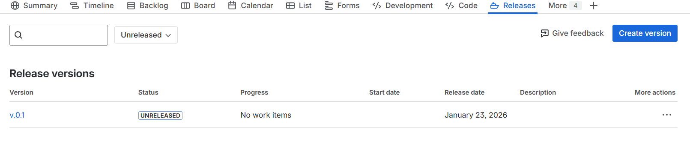
Creating Templates and Reusable Tasks in Jira
Templates help teams save time and maintain consistency for recurring work.
Using Issue Templates
Templates allow teams to pre-fill fields such as summary, description, labels, components, priority, and assignee. They are useful for recurring tasks like onboarding, bug triage, or standard checklists.

Creating an Issue Template
- Create or open an issue
- Fill in all required fields
- Save the issue as a template using a plugin or keep it as a master issue
- Copy or clone the issue for future use

Cloning Issues
Cloning allows teams to reuse existing issues.
- Open the issue
- Click More and select Clone
- Choose whether to include subtasks, attachments, or links
- Update details and save the cloned issue
