Filters and JQL
Advanced Search for Better Issue Management in Jira
Using Basic Search and Quick Filters in Jira
Jira provides powerful search tools that help users quickly find, track, and manage issues. Basic Search and Quick Filters are commonly used features that allow users to locate issues efficiently without needing advanced query knowledge.

Basic Search in Jira
What Is Basic Search?
Basic Search is a simple and user-friendly search option in Jira. It allows users to find issues using dropdown fields such as project, issue type, status, assignee, and priority instead of writing complex queries.
How to Access Basic Search
- Open Jira
- Click Issues in the top navigation bar
- Select Search for issues
- Make sure Basic Search mode is enabled (not JQL mode)
Basic Search is ideal for beginners and for quick searches using common criteria.
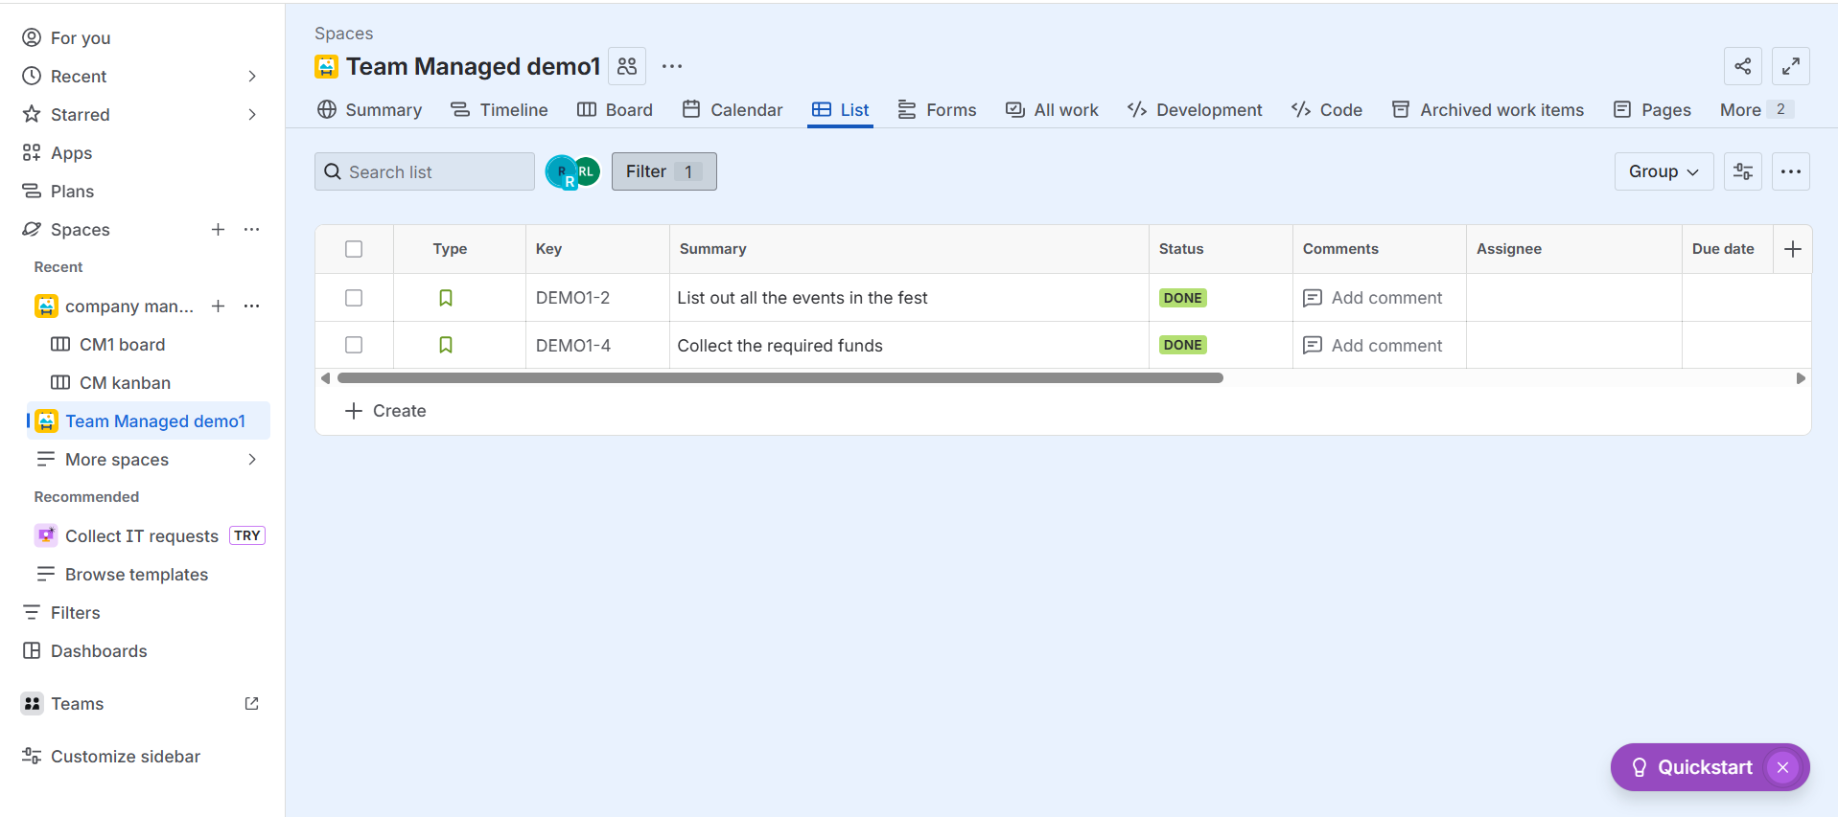
Quick Filters in Jira
What Are Quick Filters?
Quick Filters are predefined filters available on Scrum and Kanban boards. They allow users to instantly narrow down the issues shown on the board with a single click.
Where to Find Quick Filters
Quick Filters are located at the top of Jira boards. Clicking a filter immediately applies it to the board view.
Commonly Used Quick Filters
Only My Issues – Displays issues assigned to the current user
Recently Updated – Shows issues that were recently modified
High Priority – Displays issues marked as high or critical priority
Bugs Only – Shows only issues with the Bug issue type
Quick Filters help teams focus on specific work without changing the underlying board configuration.
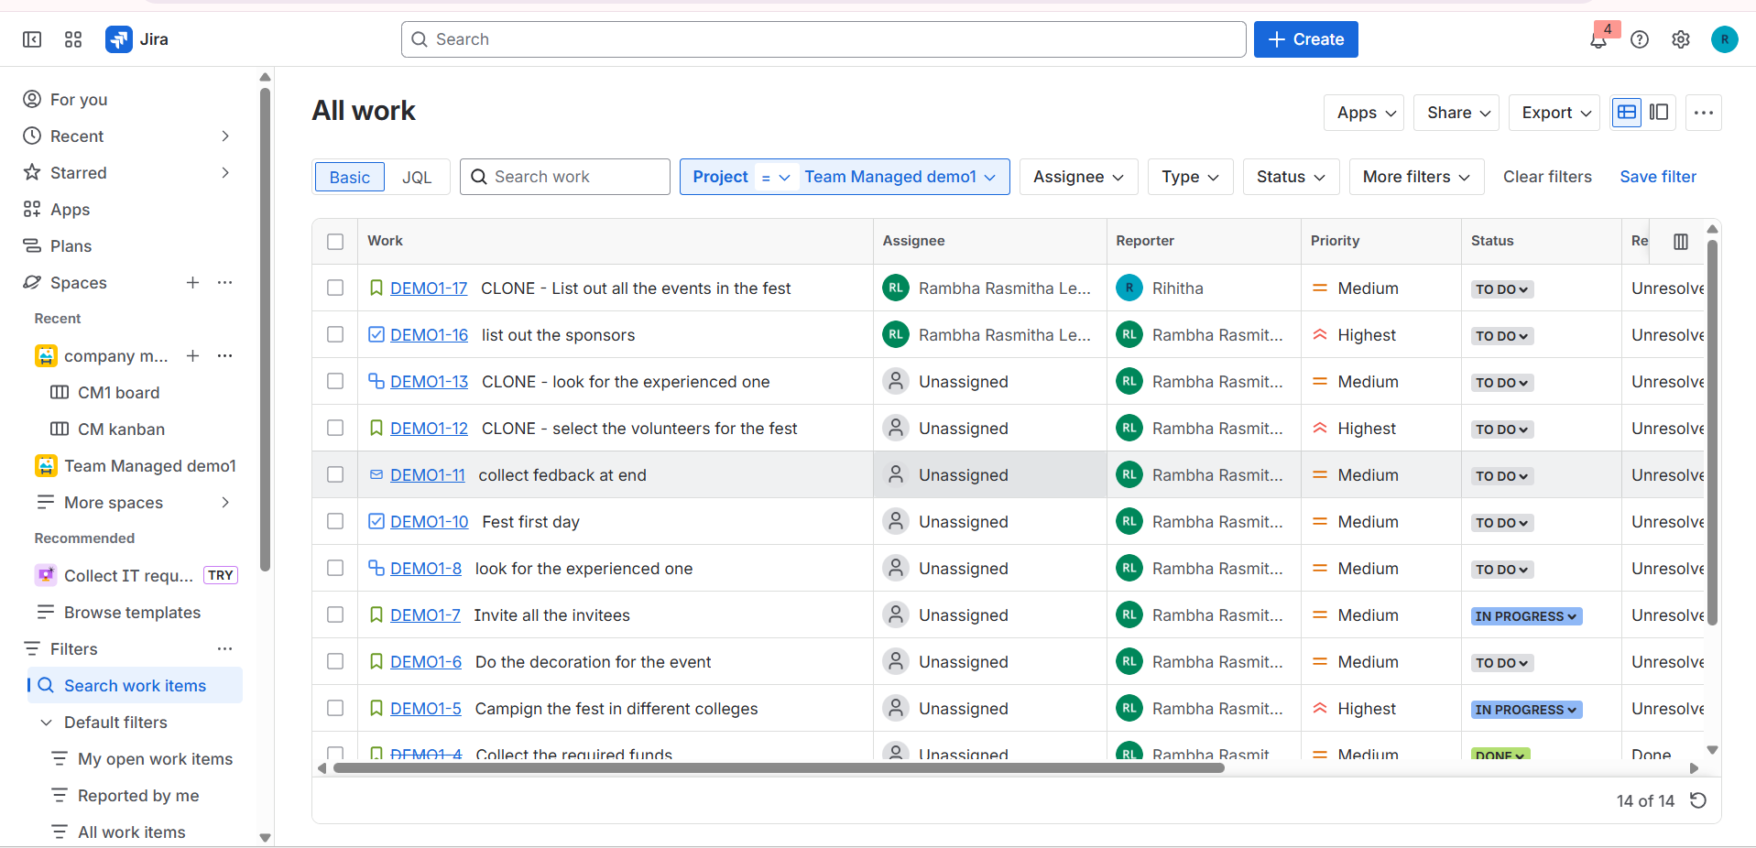
Creating and Saving Filters in Jira
Filters allow users to save search results for repeated use. Saved filters improve productivity by providing quick access to commonly used issue lists.
What Are Filters in Jira?
A filter is a saved search query that displays issues matching specific conditions. Filters can be reused, shared with others, and used in dashboards, boards, and reports.
Steps to Create and Save a Filter
- Log in to Jira
- Click Search for issues
- Apply search criteria using Basic Search or JQL
- Review and confirm the search results
- Click Save As
- Enter a filter name and optional description
- Click Save
Saved filters can be accessed later from the Filters menu.
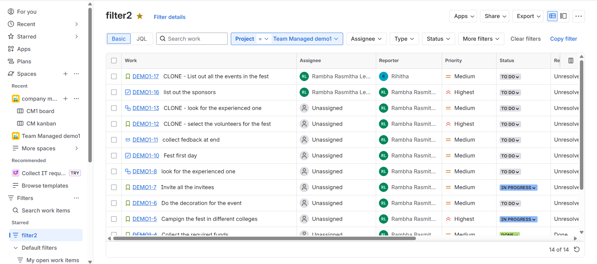
JQL Basics: Understanding Jira Query Language
Jira Query Language (JQL) is an advanced search language used to find issues based on precise conditions. Unlike Basic Search, JQL allows users to create complex queries using fields, operators, and functions.
JQL is important because it enables accurate searches, advanced filters, detailed dashboards, and efficient management of large projects. It saves time and provides greater control over issue tracking.

Time-Based JQL Queries in Jira
Time-based JQL queries are used to find issues based on dates and time-related fields. These queries are helpful for tracking progress, monitoring activity, and analyzing work over specific time periods.
Common Date Fields
Created – When the issue was created
Updated – When the issue was last modified
Resolved – When the issue was resolved
Due – The issue due date
Common Operators and Functions
JQL supports operators such as =, >, <, >=, and <=.
It also supports date functions like startOfDay(), endOfDay(), startOfWeek(), and endOfMonth() to perform relative date searches.
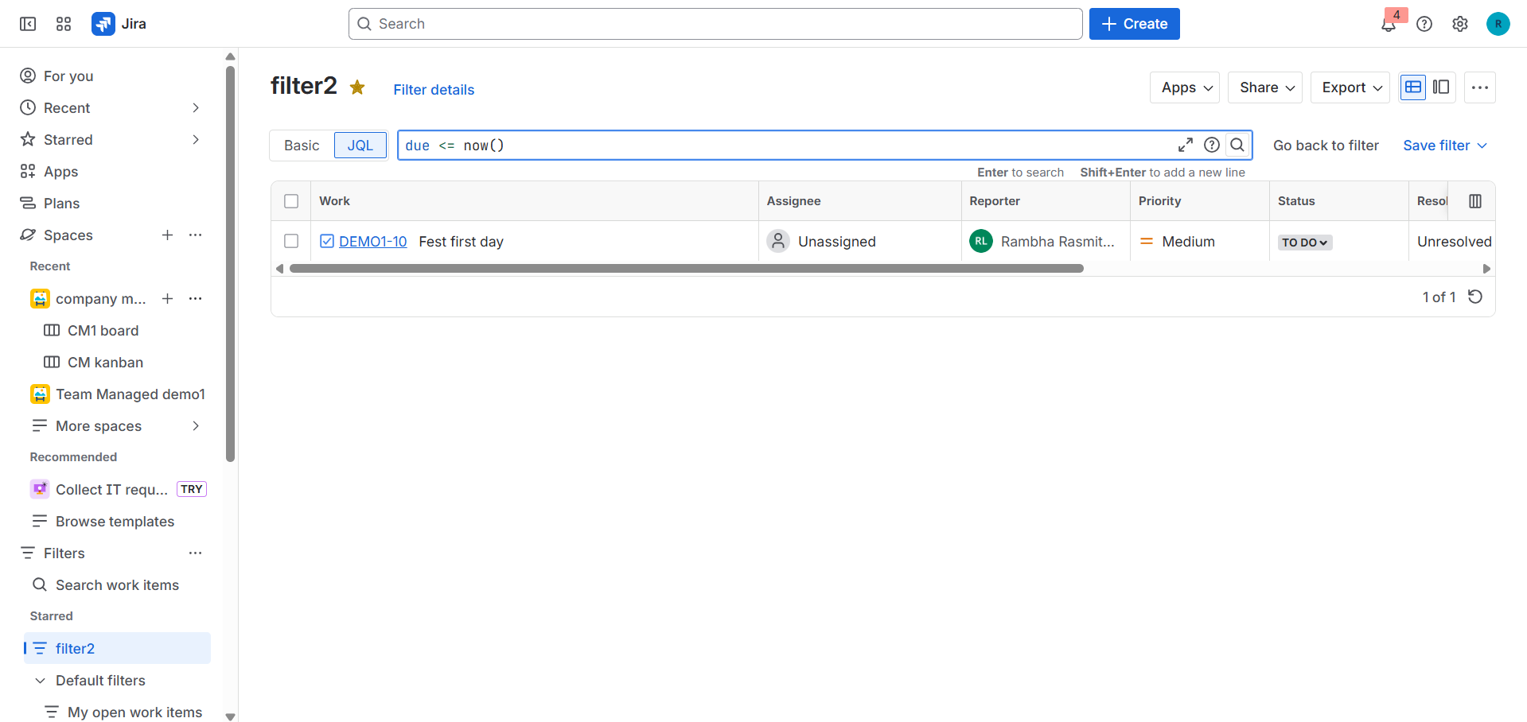
Link-Based and Hierarchy JQL Queries
Advanced JQL queries can be used to search for issues based on their relationships and structure within Jira.
Link-Based JQL Queries
Link-based queries find issues connected through relationships such as blocks, is blocked by, relates to, or duplicates. These queries help identify dependencies, blockers, and related work that may impact project progress.
Examples include finding issues that block a specific task or all issues related to a particular bug.
Hierarchy JQL Queries
Hierarchy queries focus on parent–child relationships between Epics, Stories, Tasks, and Sub-tasks. These queries are useful for tracking work across different levels of the issue hierarchy.
Common use cases include finding all stories under an Epic or identifying all sub-tasks linked to a parent issue.
