Understanding Projects, Boards, Statuses, and Workflows in Jira
Customizing Your Jira Board View Without Admin Access
Jira allows users to personalize how their boards appear even without administrator permissions. These customizations affect only the individual user and do not change the project or board settings for others.
Users can apply Quick Filters to display only specific issues, such as tasks assigned to them. The board search box can be used to find issues by name or issue key. Columns can be collapsed or expanded to focus on particular workflow stages.
Additional customization options include changing the card layout, adjusting swimlanes, and modifying sorting preferences. These settings help improve readability and make it easier to focus on relevant work.

Workflow States and Transitions in Jira
A workflow in Jira represents the lifecycle of an issue from creation to completion.
Workflow States
Workflow states are the stages an issue passes through, such as To Do, In Progress, and Done. The current state of an issue is visible on the board and within the issue details.
Transitions
Transitions are the actions that move an issue from one state to another. Examples include starting work, moving to review, or marking an issue as complete. Issues can be transitioned by dragging them across the board or by selecting transition buttons inside the issue view.
Permissions and Access
The transitions available to a user depend on their permissions. Users can only see and perform transitions allowed for their role. Modifying workflows or adding new transitions requires administrator access.

Working Smart: Cross-Team Collaboration and Long-Term Projects
Jira supports collaboration across multiple teams and long-running initiatives by providing shared visibility and structured tracking.

Managing Cross-Team Work in Jira
Cross-team work involves coordinating tasks handled by different teams within the same or related projects.
Teams can use linked issues to represent dependencies between tasks owned by different teams. Epics are used to group related work across teams, while shared boards and filters provide a single view of progress. Assigning clear ownership and using comments improves communication and accountability.
This approach helps teams stay aligned, manage dependencies, and deliver work efficiently across organizational boundaries.

Creating and Using Shared Boards for Team Collaboration
Shared boards provide a common workspace where multiple team members can view and manage issues together.
A shared board is created using a saved filter that includes relevant issues for all team members. The board is then shared with the team, allowing everyone to view progress, update issues, and move tasks through workflow stages.
Shared boards improve visibility, coordination, and communication, making collaboration more effective across teams.
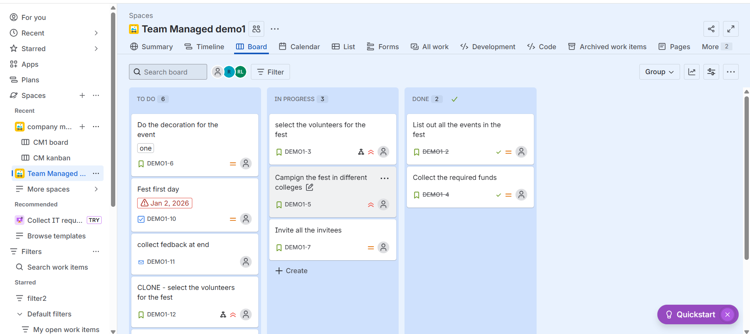
Roadmaps in Jira: Visualizing Plans and Dependencies
Roadmaps in Jira offer a high-level, visual timeline of work planned over weeks or months.
Roadmaps display Epics, related issues, start and end dates, and dependencies between work items. They help teams plan releases, understand how tasks are connected, and assess the impact of changes.
Users can adjust schedules, track progress, and identify risks early. Roadmaps support long-term planning and help teams stay aligned on goals, priorities, and deadlines.

