Jira Dashboards Overview
Jira dashboards provide a centralized, visual view of issues, progress, and project health. Dashboards can be personal (for individual tracking) or shared (for teams and stakeholders).

Creating Dashboards in Jira
1. Creating a Personal Dashboard
- Click Profile → Dashboards → Create Dashboard
- Enter a dashboard name and description
- Set Privacy:
  - Private
  - Shared with specific users or groups
- Click Create
Adding Gadgets
- Click Add Gadget
- Common gadgets:
  - Assigned to Me
  - Filter Results
  - Pie Chart
  - Sprint Health

2. Creating a Team Dashboard
- Follow the same steps as creating a personal dashboard
- Under Privacy, choose:
  - Share with Project
  - Share with Group
- Add team-focused gadgets such as:
  - Sprint Burndown
  - Project Progress
  - Epic or Story Status

3. Customizing Dashboards
You can tailor dashboards to meet your needs by:
- Resizing and rearranging gadgets
- Applying filters by:
  - Project
  - Issue type
  - Priority
- Setting refresh intervals for real-time updates
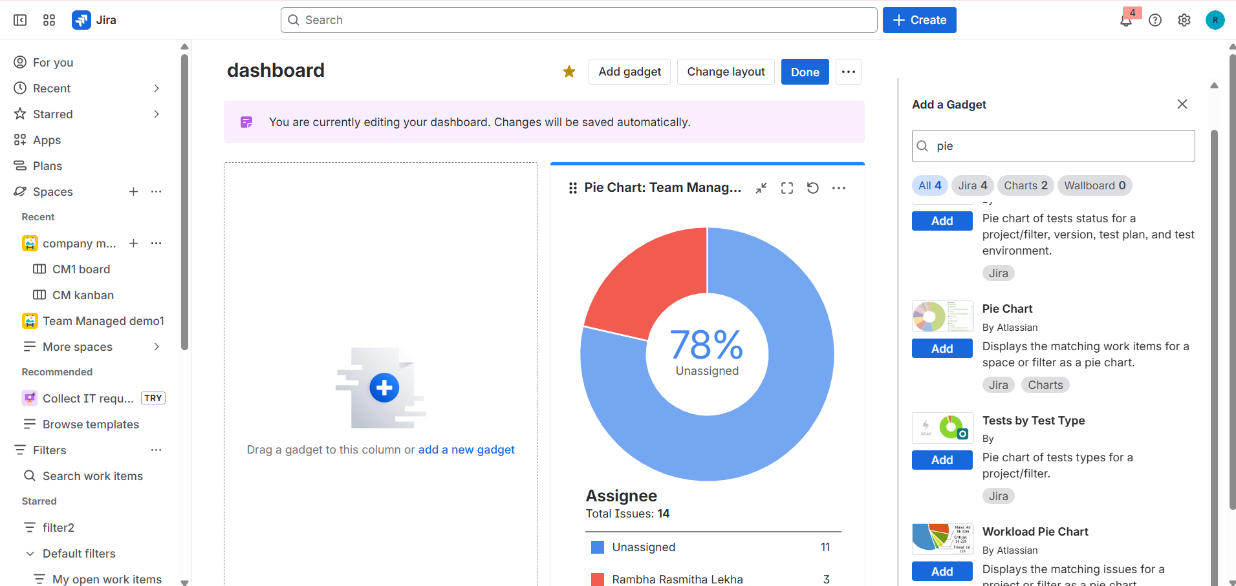
Useful Gadgets for Jira Dashboards
1. Assigned to Me
- Displays issues assigned to the logged-in user
- Helps prioritize personal work
- Can be filtered by project or issue type
2. Filter Results
- Displays issues based on a saved filter
- Useful for tracking:
  - High-priority bugs
  - Sprint tasks
- Allows custom columns (status, priority, assignee)
3. Pie Chart
- Visualizes issues by fields such as:
  - Status
  - Priority
  - Assignee
- Helps understand workload distribution
4. Sprint Health / Burndown
- Shows sprint progress and remaining work
- Helps teams determine if the sprint is on track
- Displays completed vs remaining issues or story points
5. Two-Dimensional Filter Statistics
- Displays issue data across two fields (e.g., Status vs Assignee)
- Useful for spotting bottlenecks and workload imbalances

Sharing and Cloning Dashboards
1. Sharing Dashboards
- Open the dashboard
- Click ••• (More) → Share Dashboard
- Choose visibility:
  - Specific users or groups
  - Project roles
  - All logged-in users
- Click Save
2. Cloning Dashboards
- Open the dashboard
- Click ••• (More) → Copy Dashboard
- Enter a new name and description
- Modify gadgets or filters independently of the original

Scrum Reports in Jira
1. Velocity Chart
- Shows completed work per sprint
- Helps predict future sprint capacity
- Measures work using:
  - Story points
  - Hours
  - Issue count
2. Burndown Chart
- Tracks remaining work throughout a sprint
- Indicates whether the team is on track
- Helps detect delays early
3. Sprint Report
- Summarizes sprint outcomes:
  - Completed issues
  - Incomplete issues
  - Scope changes
- Ideal for sprint reviews and retrospectives
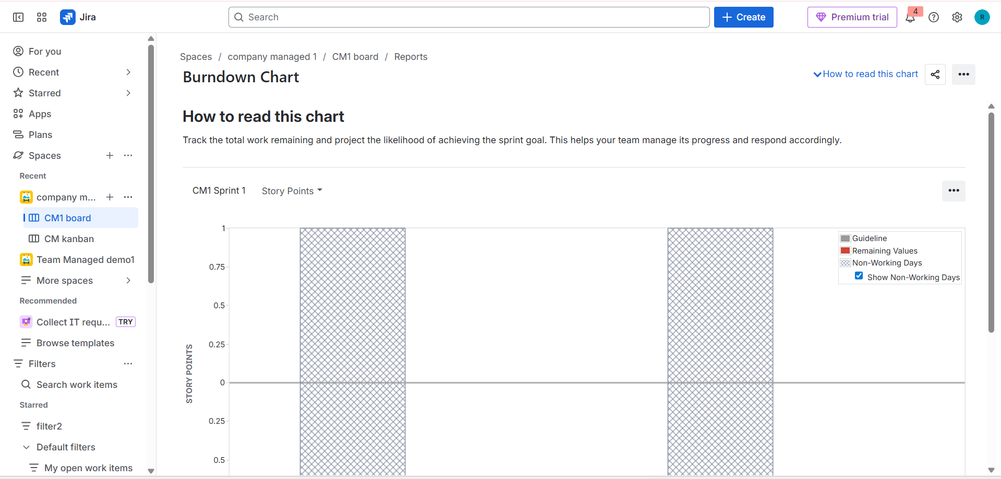
Kanban Reports in Jira
1. Control Chart
- Shows issue cycle time over a period
- Helps analyze how long work takes to complete
- Useful for identifying process inefficiencies
2. Cumulative Flow Diagram (CFD)
- Displays issue count by workflow status over time
- Helps identify bottlenecks
- Highlights work piling up in stages like “In Progress”
