Jira Automation – Save Time Without Admin Rights
Overview
Jira Automation helps teams save time by reducing manual work and keeping processes consistent. Even without Jira admin access, users can create automation rules within their own projects to handle repetitive tasks easily.

What Non-Admins Can Automate in Jira
Automation is a powerful Jira feature that allows non-admin users to improve daily work without changing Jira settings.
Non-admin users can automate tasks inside their project, such as assigning issues, updating fields, and sending notifications.

Core Parts of a Jira Automation Rule
Every automation rule has three main parts:
- Trigger – When the rule starts (example: issue created)
- Condition – Checks if the rule should run
- Action – What Jira does automatically

Automations Non-Admins Can Create
Without admin access, users can automate:
- Automatically assign issues
- Update issue fields
- Add comments automatically
- Send notifications
- Add labels
- Link related issues
- Move issues between statuses
These automations usually work within a single project and do not change Jira configuration.

Smart Checklists in Jira
What Is a Smart Checklist?
A Smart Checklist is a reusable list of steps added inside a Jira issue to guide work clearly and consistently.
Smart Checklists:
- Help follow the same steps every time
- Reduce mistakes
- Can be added automatically using automation
- Do not need admin access
Jira does not provide built-in checklists by default.

Ways to Create Checklists in Jira
Teams usually create checklists using:
- Issue Description
- Comments
- Automation with templates

How Smart Checklists Work
Using automation, checklists can be added when:
- An issue is created
- An issue moves to a specific status
- A certain issue type is selected

Why They Are Called “Smart”
Smart Checklists are:
- Automatic
- Consistent
- Reusable
- Admin-free

Simple Automation Rules for Teams
What Makes a Good Simple Rule
A good automation rule:
- Solves one small problem
- Uses one trigger, one or two conditions, and one clear action
- Is easy to maintain
- Has low risk
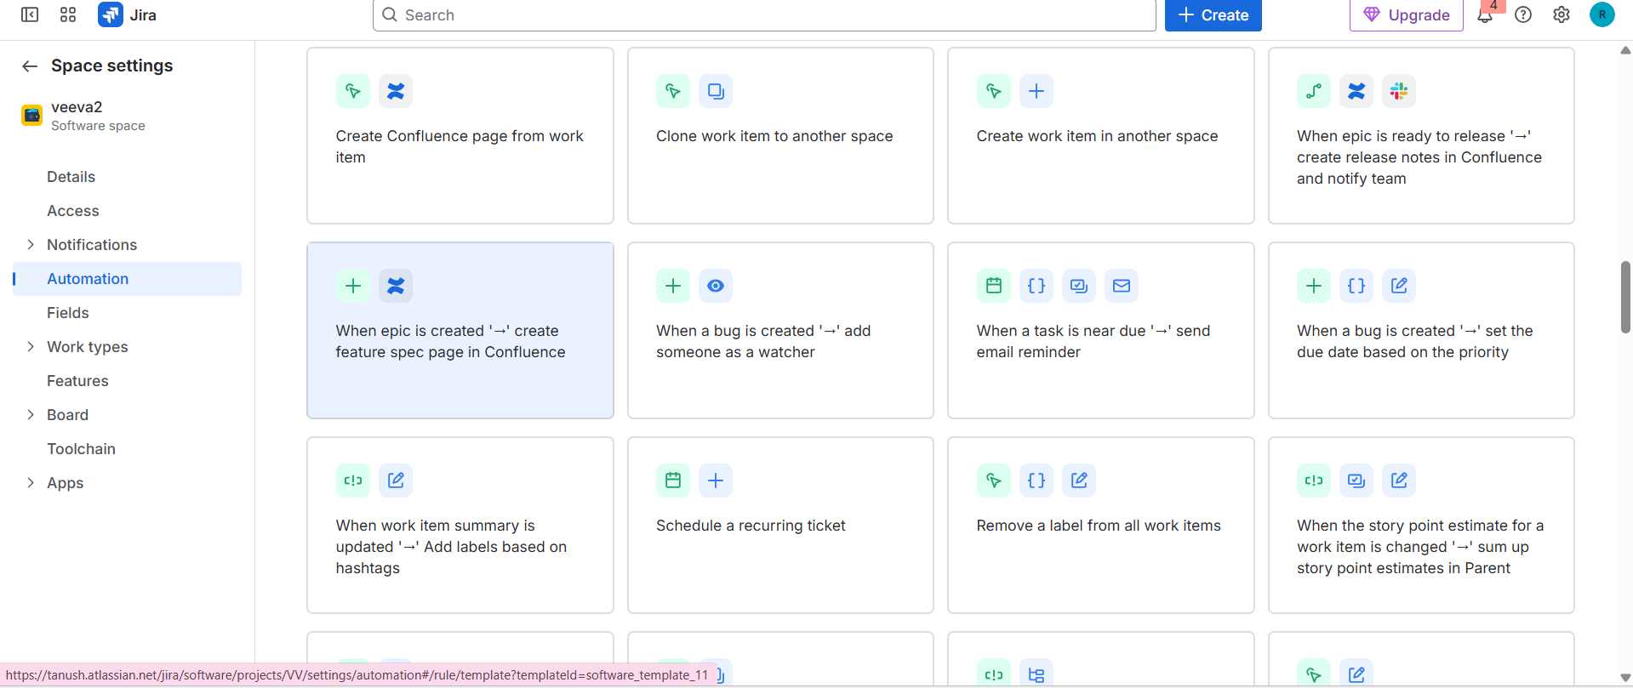

Common Simple Automation Examples
- Auto-assign issues – Avoids unassigned work
- Auto-add labels – Keeps labeling consistent
- Auto-set resolution when Done – Improves reports
- Auto-add comments when blocked – Makes blockers visible
- Auto-create subtasks – Saves setup time
- Scheduled reminders – Prevents overdue issues
- Auto-transition issues – Keeps status updated
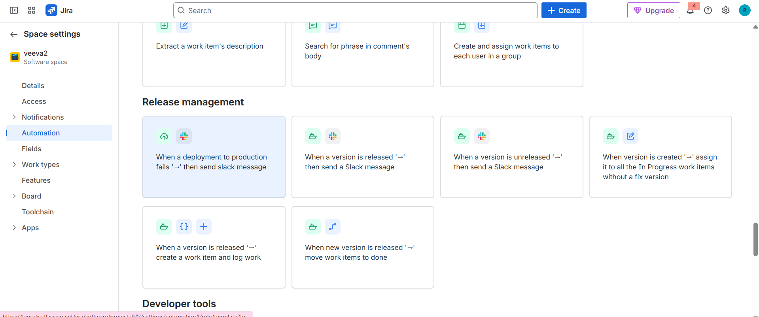

When to Ask Admins for Help
Some automation needs admin involvement. Ask an admin if:
- Automation affects multiple projects
- Required options are missing
- Rules work inconsistently
- Workflow changes are needed
- Validators or conditions must be added
- Post functions are required
- New custom fields are needed
- Status categories must be changed
- Issues must be created in another project
- Automation limits are reached
- Performance problems occur
- Security or permission issues are involved
Rule of Thumb:
If automation affects Jira structure, security, or performance, involve a Jira admin.

