Soupdog — The Concept Layer (Scoped Name Bindings)
Design Specification
v0.1 · Design draft for review · June 2026
Status: Design document, build-ready. Output of the concept-layer audit that the Unified End-Product Model (v0.4 §7) called for. It settles what the concept layer IS, why it is neither food_families nor parent_id, and how it is built almost entirely from mechanisms that already exist (forks, visibility tiers, groups). Open questions at the end.
One-line model: a concept is a scoped name binding — an owned, scoped label pointing at an ingredient — and the name a viewer sees is resolved per viewer by the same owner → grant → tier rule used for profile visibility. Naming is optional, social, and sparse; the ingredient graph underneath is always complete.

1. What the audit ruled out, and why
Not food_families. food_families / food_family_members were built as part of Food Model Stage 1 — a transformation-rule grouping (“red meat behaves like this when cooked”), sitting beside family_transfer_rules, target_state_rules, method_rules. That is a different axis from a concept (a perceptual grouping of things people regard as the same dish). “Fried egg” is not a cooking-rule class; “red meat” is not something anyone plans to eat. The table is also near-empty (3/2 rows) and read by no code. Overloading it would tangle two unrelated relationships — the same mistake that bred the recipes-mirror confusion. Leave it for the Food Model.
Not parent_id. A single-valued parent pointer cannot represent the concept layer, for two reasons surfaced in design:
- No principled parent among siblings. Home-fried-egg and airplane-fried-egg are siblings; neither is “the real one.” Unlike tools (a Tefal pan genuinely IS a kind of “Pan” — a real subset), fried eggs are not subsets of each other, so the tool precedent does not transfer.
- No reliable dominant ingredient. “The parent of a fried egg is egg” presumes a dominant ingredient, but a fried egg is egg + salt + pepper + oil, and dominance is not reliably by mass or volume (a pinch of saffron defines a dish; the rice does not). parent_id would force an often-nonexistent fact.
And concepts are subjective and overlapping. Whether a tweak makes “a different dish” varies by culture; a thing can belong to two concepts at once. A single-valued pointer structurally cannot hold “true in two cultures simultaneously.” An overlapping many-to-many can. (This matches the Recipe Model doc’s explicit conclusion: overlapping concepts, own m2m membership, NOT parent_id.)

2. The core reframe: naming is separate from the thing
A dish exists before it has a name, and naming is a separate, gradual, social act:
- Pasta + tomato + vodka → culturally crystallised into a named dish (“vodka pasta”).
- Pasta + tomato + cognac → the same kind of tweak, but society minted no name. It is just “tomato sauce with cognac.”
- Someone calls the cognac version “Lisa’s pasta” because his girlfriend loves it — a name with an audience of one, which may stay private forever or take off and become public.
Three things therefore vary independently: (1) the ingredient/method (the actual thing, always present); (2) whether it has a name at all; (3) who shares that name. A concept captures (2) and (3) without touching (1).
Key principle: “unnamed” is not a state — it is a fallback. Every ingredient always resolves to some displayable name; worst case it shows the name it references from the sibling it forked off (cognac-pasta shows “tomato sauce [with cognac]” until named). A concept is just a more-specific name layered on top, visible to whoever is in its scope. So nothing is ever nameless in the UI, yet naming stays genuinely optional.

3. A concept is a scoped name binding
A concept has: an owner (who minted the name — a person, a group, or “the culture” for global), a scope (private / group / global), a name, and membership (the ingredient(s) it points at — usually one). The displayed name is resolved per viewer:
- Boyfriend sees “Lisa’s pasta” — his private binding wins.
- A guest at his restaurant sees “Lisa’s pasta” — the group (restaurant) binding applies on that menu.
- A stranger sees “tomato sauce [with cognac]” — no binding applies, so the forked-from referenced name is the fallback.
Resolution rule = owner → grant/group → tier, the exact 3-step rule from Sharing & Delegation, applied to the name field instead of a profile field. Pick the most specific binding the viewer can see; fall back to the referenced name.

3.1 The model in one diagram
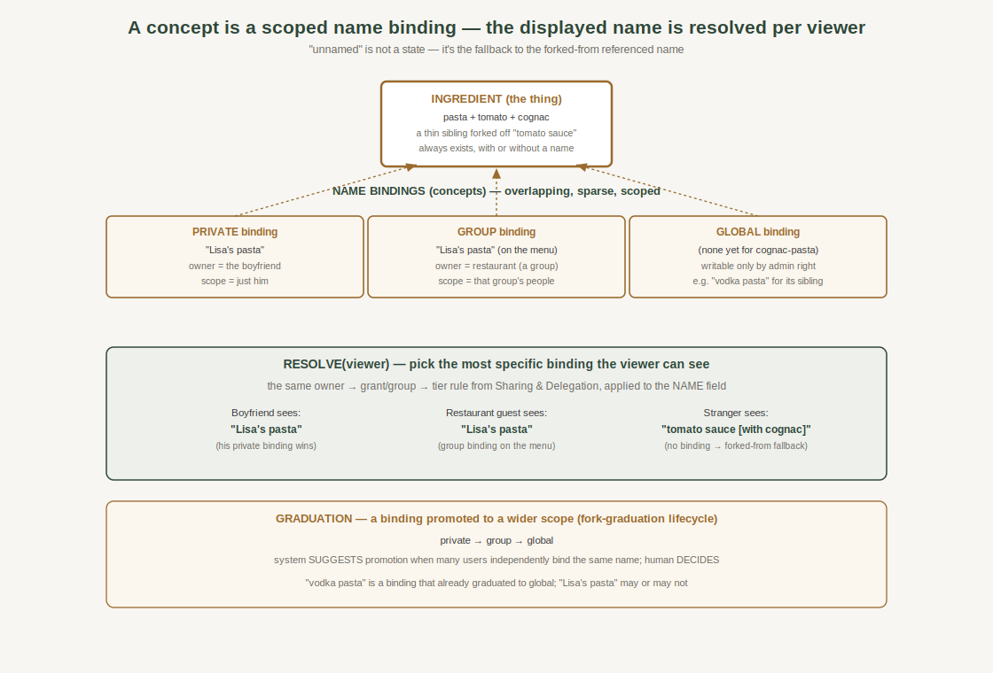
The cognac/Lisa example: one ingredient, several scoped name bindings, resolved differently per viewer, with a graduation path from private to global.

4. Nothing structurally new — it reuses three existing systems
The strongest signal the model is right: it required inventing no new primitive. Every mechanic is inherited.
Concept mechanic | Inherited from | How
Name as a referenced field with override | Fork reference-with-override | “Unnamed” = still showing the forked-from name; a binding overrides it.
Scope: private / group / global | Visibility tiers (private/connections/public) | The same standing-scope idea, applied to a name.
Per-viewer resolution | owner → grant → tier rule | Most-specific visible binding wins; fallback to referenced name.
Group-scoped names (the restaurant menu) | Groups | A restaurant is a group; a group binding shows to that group's people.
Promotion private → global | Fork graduation | System suggests when many independently bind the same name; human decides.
Who may write a global binding | Access model / admin rights | Global is admin-writable; group is owned-by-the-group.

5. The orthogonality rule (locked)
Changing the recipe makes a new INGREDIENT (a sibling). Naming makes a new CONCEPT (a label). They are orthogonal. Either can happen without the other:
- Vodka-pasta vs cognac-pasta = different ingredients (different inputs/method); one also happens to have a public name.
- “Lisa’s pasta” = the cognac version renamed — same ingredient, new name. No new food was created; a concept attached to an existing ingredient.
Relatedness between ingredients therefore comes from shared concept membership AND/OR shared task/lineage structure — never a parent pointer.

6. Schema sketch (build-ready, to confirm against live DB)
Indicative shape; audit live column names before DDL, per standing discipline.
- concept — id, name, scope (enum: private | group | global), owner_kind (person | group | global), owner_id (nullable for global), created_at. Optional: description, notes.
- concept_member — concept_id → concept, ingredient_id → ingredients (i.e. recipe_canonical / end-product), position, unique(concept_id, ingredient_id). The overlapping m2m.
- Resolution at read time — given a viewer, select bindings whose scope/owner the viewer can see (self private; groups they belong to; global), order by specificity (private > group > global), take the first; if none, use the ingredient’s referenced/forked-from name.
- RLS — public-scoped policies; private bindings readable only by owner; group bindings by group members; global by all. Re-grant after column adds. (Same patterns as People & Groups.)

7. Open questions
- Concept identity vs. membership. Is a concept purely a name + members, or can two concepts share a name at different scopes (likely yes — “Lisa’s pasta” private and a different “Lisa’s pasta” global are distinct rows)?
- Multi-ingredient concepts. Usually one ingredient per concept; when a concept legitimately spans several (a family of closely-perceived dishes), is that the same table or does it blur into food_families territory? Keep them separate.
- Graduation mechanics. What threshold/signal triggers a “promote this name?” suggestion (count of independent identical private bindings)? Who approves a global promotion?
- Search & the assistant. Search currently indexes titles. Once names are per-viewer, the index must resolve names per viewer (or index global names + overlay private). Note for the search/assistant layer.
- Interaction with execution_variants. A method-sibling may be an execution_variant rather than a full sibling ingredient; can a concept bind to a variant, or only to a canonical? (Ties to the v0.4 §6 sibling-method question.)

8. Suggested next step
This note is build-ready, but it is downstream of the meal layer, which already works. The pragmatic sequence: (a) confirm the live ingredient/recipe_canonical naming columns and the groups + visibility primitives this leans on; (b) build the minimal global-only concept + concept_member first (the common case: catalogue names), since it needs no per-viewer resolution; (c) layer private/group scopes and graduation on once the global case is proven. That staisfies the meal/method-sibling need early and defers the resolution machinery until there is a real private-naming case.
End of v0.1. The concept layer is a scoped name binding, resolved per viewer, built from forks + visibility tiers + groups. food_families and parent_id are both ruled out. Closes the last open piece of the v0.4 §9 audit.

