Soupdog — Meals, the Meal Editor & the Unified End-Product Model
Design Specification
v0.3 · Design draft for review · June 2026
Status: Design document, not an implementation plan to execute yet. v0.3 supersedes v0.2 and revises a decision v0.2 had locked. Where v0.2 settled on one canonical recipe entity distinguished by a composition_level field (one row, many levels), the design conversation that produced v0.3 reached a sharper conclusion: the spine is the ingredient (the end-product); a recipe is the method that produces it; and because method is constitutive of identity, a different method yields a different — though closely related and cheaply represented — ingredient. With no users yet, we are free to build the correct model rather than the non-breaking one. Open questions are collected at the end.
Scope: How the one-dish-per-slot meal scheduler becomes a system where everything plannable — an apple, a glass of water, a fried egg, a protein shake, a ten-person dinner party — is one kind of thing: an end-product ingredient, obtained by exactly one defining method (a recipe), and where the meal planner chooses among all such end-products and resolves the right one from context (tools, participants, habits, needs). The guiding persona is unchanged: the chef + nutritionist + butler trio caring for each eater — competent, anticipatory, never making the eater fill in forms.

1. The core realisation: a meal is a planned ingredient
“Meal,” “dish,” “drink,” “ingredient,” and “product” are not different kinds of thing. They are the same kind of thing — an end-product — seen at different scales. A protein shake, a fried egg, a glass of water, and a dinner for ten are each one item, and each has one method of obtaining it. The method may be “buy the bottled product,” “order it to your airplane seat,” “convert a raw egg with a pan and a spatula,” or “assemble these twelve participating recipes.” Buying is a method. Ordering is a method. Cooking is a method. They differ in kind of method, not in being a method.
Decision (locked): there is no separate meal entity. A meal is an ingredient someone planned to eat. The ingredient is the noun (the end-product); a recipe is the verb (how to get it). This is the Ingredient–Process Model and the Plan & End-Product Model meeting at their natural conclusion.

2. Method is constitutive of identity (the v0.2 revision)
The home-fried egg and the airplane-fried egg are not the same end-product. They share an ancestor (the same hen’s egg) and a family resemblance, but the airplane egg was par-cooked in a catering kitchen and reheated at altitude — different tools, different method, a genuinely different thing on the plate. Method partly determines what the thing is, not merely how you came to have it.
This flips the cardinality. It is not one ingredient with many interchangeable methods. It is one ingredient = one defining method; a different method is a different (related) ingredient. This is exactly consistent with the Ingredient–Process Model’s rule that every ingredient is the single output of exactly one process — the mirror of which is that each ingredient has exactly one defining process.
Relatedness is captured without shared identity. The home egg and the airplane egg are related by (a) shared lineage (both transformed_from the same raw egg) and (b) shared concept membership (both sit under the concept “fried egg”). “Same egg from the same hen” means a shared input, not a shared identity.

3. The three-layer spine
The model has three layers plus a resolution step. The diagram on the next page shows the whole shape; in words:
- Concept — “fried egg,” “breakfast for the table.” The stable thing a person plans. Global, overlapping, many-to-many; it groups related end-products. (The existing concept layer.)
- Ingredient (end-product) — home-fried-egg, airplane-fried-egg. THE SPINE. Each is the single output of one defining method. A different method is a different, thin, reference-based sibling ingredient.
- Method (recipe) — how this ingredient is obtained: cook / acquire / deliver / none. The method-kind lives here, on the verb, not on the noun. Bound roughly one-to-one to its ingredient.
The planner resolves Concept → concrete Ingredient by context. A plan entry references the concept (the intent) plus who and when. The planner then resolves it to a concrete method-ingredient using the eater’s context — and the user can override. This is covered in §5.

3.1 The spine, in one diagram
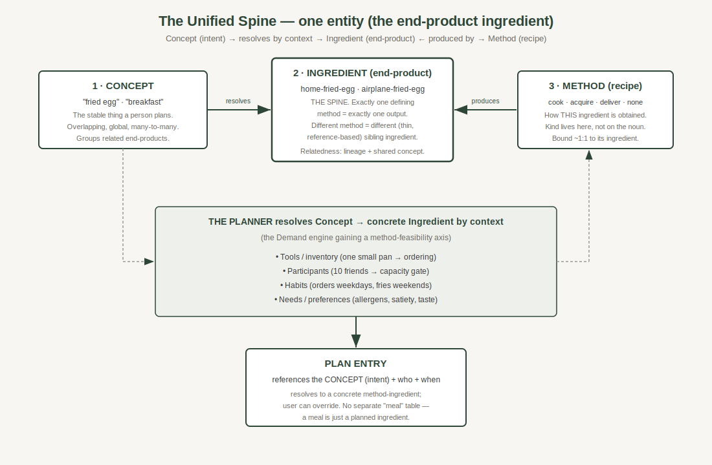
Concept (intent) resolves by context into a concrete end-product ingredient, which is produced by exactly one defining method. The plan references the concept; the meal is just a planned ingredient.

4. Forks are cheap, so “too many ingredients” is not a problem
The worry that one-ingredient-per-method spawns an explosion of rows dissolves once forks are thin. A sibling does not duplicate its relative; it references most of the relative’s fields and overrides only the few that differ. The airplane egg is “same as home-fried-egg except: method = par-cook + reheat; tools = catering oven; texture = firmer.” Its data footprint is roughly the footprint of the difference — which is what you would have stored anyway. So labelling each realisation an independent ingredient costs almost nothing and buys a uniform model in which everything plannable is a first-class ingredient, with no special-casing.
Reuse is pull-by-reference, declared by the consumer; no inheritance. A sibling explicitly points at the fields it borrows. Editing is therefore predictable: change the referenced source and referencers reflect it, because they pointed at it on purpose — not through a silent cascade.
The one caveat: the reference chain. If airplane-egg references home-egg which references a “fried egg base,” removing a middle node must not silently break dependents. The rules for that are §6.

5. Where the intelligence lives: the planner resolves method by context
The planner does not merely present a list of method-ingredients and ask the user to pick. It infers the right one from context, because context determines both feasibility and preference:
- Tools / inventory — a registered pan makes home-fried-egg possible; no pan and it is not.
- Participants — ten friends for breakfast and one small pan makes the home method infeasible at that scale, so the planner suggests ordering. Participants change the feasible method, which changes the ingredient.
- Habits — a user who orders on weekdays and cooks on weekends: the same concept “fried egg” resolves to the delivery-egg on Tuesday and the home-egg on Sunday.
- Needs / preferences — allergens, satiety, taste — exactly as the Demand engine already weighs them.
This is the Demand engine gaining a new axis, not a new system. Demand Phase 1 already does resolve → aggregate → score → plate over participants, needs, satiety, and allergens. “Which method is feasible and preferred” is the same engine with a method-feasibility dimension added: capability and capacity (one oven, one small pan) are constraints applied in scoring, identical in shape to how satiety or allergens are handled today. The plan stores the intent; the concrete method-ingredient is resolved and recorded, and remains overridable.

6. Archival and deletion of a referenced sibling
Because siblings reference each other’s fields, removing a referenced node needs explicit rules so nothing breaks and no content is lost.
- Archive = warn + block. Archival is reversible and must not silently rewire other rows. If anything references the node, the admin is warned and archival is blocked until the dependents are resolved. (You rarely want to archive something others still depend on.)
- Hard delete = warn, then detach-all. Deletion is the deliberate, destructive act. The admin is warned which ingredients depend on the node; on confirmation the system copies the referenced fields into each dependent and cuts every reference, so each dependent becomes fully self-contained. One materialisation per dependent, no arbitrary new hierarchy, no broken pointers.
Rejected alternative: “promote-and-repoint” (promote one dependent to own the content, re-point the others at it) is cheaper on data but creates a semantically odd new “source” sibling — diner-egg suddenly inheriting from airplane-egg. Since forks are thin, the data saving is negligible, so the simpler, hierarchy-free detach-all wins.

7. Validation against the five-item test set
Every claim in this note must hold for all five. It does:
End-product | It is one ingredient because… | Its defining method (recipe)
Apple | A single end-product, no transformation needed. | none / simple (pick or buy)
Glass of water | Water in a vessel; one trivial transformation. | simple (pour) — plannable like any other
Fried egg (home) | One output of one process from a raw egg. | cook (pan, spatula, stove)
Fried egg (airplane) | A different output — a thin sibling of the home egg. | deliver (par-cook + reheat; catering oven)
Protein shake | One end-product; may be made or bought. | cook (blend) OR acquire (bottled) = two siblings
Dinner for 10 | One high-composition end-product. | composed (assembled from participating recipes)

8. What this rebuilds (the deliberate change list)
With no users, this is a list to execute deliberately, not a migration to fear. The spine change touches:
- meal / meal_participant / person_meal_prefs — the current one-recipe-per-meal shape is replaced. A “meal” becomes a plan entry referencing a concept/ingredient; participants attach to the plan entry. Existing rows are re-expressed, not preserved.
- The plan schema — a plan entry references the concept (intent), records a resolved method-ingredient, and allows override.
- Demand Phase 1 match route — currently reads meal_participant + recipe_id; gains the method-feasibility axis and reads the new shape.
- recipe_canonicals.composition_level — audit whether this is the intended method-kind field. If so, it moves to expressing method-kind (cook/acquire/deliver/composed/none) on the recipe; do not add a duplicate enum.
- The concept layer — decide whether food_families is the concept layer (likely repurpose) and populate it; concepts are what the plan references and what the planner resolves from.
- Sibling references — the thin-fork reference-with-override mechanism (execution_variants already does reference-with-override and is the natural home) plus the §6 archive/delete rules.

9. Open questions to settle before building
- Concept storage. Is food_families the concept layer, or is a dedicated concept table cleaner? How does an ingredient declare its concept membership (many-to-many)?
- Method-kind field. Confirm composition_level is the kind enum vs. adding recipe.kind. Audit before writing DDL.
- Plannable end-product marker. What makes an ingredient appear in the planner’s candidate set (water yes, lemon pith no)? An explicit curatable flag/role is the leading option; derived-from-method is the alternative.
- Sibling reference granularity. Per-field references vs. per-section; how deep a reference chain may go; where execution_variants ends and a graduated sibling ingredient begins (the variant-vs-new-ingredient threshold — system measures and suggests, human decides).
- Resolution recording. When the planner resolves concept → method-ingredient, is the resolution stored on the plan entry (snapshot) or recomputed each view? Likely snapshot-with-refresh.
- On-the-fly creation. Composing a meal on the fly still produces a real saved ingredient + method, feeding the same catalogue and variation machinery. Confirm the create path (find-or-create at ingredient, method, and concept levels).

10. Suggested build sequence (after the questions are closed)
- Audit composition_level + food_families against §8–§9; confirm the concept layer and the kind field. No DDL until this returns.
- Establish the concept layer and the plannable-end-product marker; backfill the existing ~34 recipes’ end-products as ingredients with a defining method.
- Re-express the plan to reference concept/ingredient; rebuild meal/participant onto the plan entry.
- Extend the Demand match route with the method-feasibility axis (tools/inventory + participant-capacity constraints).
- Build the meal editor as an editor for an end-product ingredient (manual compose + AI compose), reusing the picker and find-or-create paths.
- Wire the planner resolution UI: choose the concept, see the resolved method, override if desired.
End of v0.3. This note supersedes v0.2 and gates the meal-plan rework: settle §9 before any schema work.

