Soupdog — Meals, the Meal Editor & the Unified End-Product Model
Design Specification
v0.4 · Reconciled with the as-built code · June 2026
Status: Design document reconciled with reality. v0.4 supersedes both v0.2 and v0.3. A schema audit (done before any DDL) found that the v0.2 model is substantially built — meals exist as recipes, the meal_component table is in use, and a real merge engine assembles the unified recipe. v0.3 had been written from memory and over-reached: it proposed migrating off composition_level/meal_component toward an ingredient-as-spine model, not realising that working, sophisticated code already implements the meal layer. v0.4 keeps everything v0.2 built and folds in v0.3's one genuinely-new idea — that method is constitutive of identity — as an additive ingredient-level layer beneath the meal model, disturbing nothing.
Process note (recorded as a lesson): audit the live schema BEFORE designing. v0.3's error is the same one the handover has flagged repeatedly — reasoning about the schema from a summary rather than the database. The audit caught it before a single line of teardown was written.

1. What is already built (the v0.2 model, kept)
The following is live code, not a plan. It is the foundation v0.4 builds on, and none of it is being torn out.
- A meal is a recipe one level up. A meal is a row in recipe_canonicals at composition_level = 'meal' (the two values in use are 'dish' and 'meal'). It shares the recipe entity, versioning, and editor. This is §9's audit question answered: composition_level IS the level/kind field, and it is load-bearing.
- Components are first-class. A meal_component row carries component_type (dish / side / drink), position, servings_target, note, and component_canonical_id → the dish (itself a recipe_canonical). A meal is a recipe that references other recipes as its components.
- The unified recipe is real, in two layers. L0 (the recipe route) renders a meal as one coherent page: a combined, name-deduplicated ingredient list plus per-component sections, reusing the existing step-group grammar. L1 (meal-merge.ts + the build route) is the hard part — see §2.
- Demand is wired to meals. The match route runs the full Phase-1 pipeline (participants → resolve → aggregate → score → plate) against a meal.
- Meals are plannable. The meal-plan options route filters candidates by composition_level; the plan stores and generates meals alongside dishes.
- Full surface: create / load / update / delete, browse + detail + recipe pages, a narrative route, a build route. The feature exists end to end.

2. The merge engine (the centrepiece v0.3 under-credited)
meal-merge.ts turns several dishes into one backward-scheduled, interleaved cooking timeline that finishes at a single serving time. It is the piece that makes “open a meal and get one recipe” real, and it is built on a physically-honest model:
- Attention model. A human (blocking) step occupies the cook’s hands — two human steps never overlap, they serialize. A machine/passive (non-blocking) step occupies an appliance, not the cook, so another dish’s human step fills that window (“the chicken in the oven while you make the salad”).
- Backward schedule. Each dish’s critical path is computed; every dish is anchored to finish at serving time; steps become absolute offsets-before-serving; a keep-warm hold is inserted for any dish that finishes early.
- Resource seam already cut. Every step occupies a named resource — today ‘hands’ (pool of 1) and an unbounded appliance pool. The code states explicitly that real equipment capacity drops in later as resource ids + pool sizes, with NO rearchitecture; multi-cook is hands-pool > 1. This is exactly v0.3’s “one small pan → suggest ordering” feasibility axis — the seam for it is already there.
- Honest L1 simplifications (documented in-code): no shared-prep dedup yet (needs the passive-decay graph), overlap is flagged “meanwhile” rather than fully re-solved (full multi-resource scheduling is bin-packing — deferred until real meals show how often it bites). The result is always safe to follow.

3. The one idea worth keeping from v0.3 (additive)
v0.3’s structural proposal (ingredient-as-spine, migrate off composition_level) is rejected — it would tear out the working meal layer for a purity that does not pay for itself. But v0.3 contained one genuinely-new insight worth adding beneath the meal layer, about how ingredients relate:
Method is constitutive of identity. A home-fried egg and an airplane-fried egg are different end-products — par-cooked-and-reheated is a different thing on the plate, not just a different route to one identity. So one ingredient has one defining method; a different method is a different, thin, reference-based sibling ingredient (it references most of its relative’s fields and overrides only what differs). Relatedness is captured by shared lineage + shared concept membership, not shared identity.
Why this is additive, not disruptive. It is a claim about ingredients and their methods, one layer below meals. The meal layer already composes recipe_canonicals; this just gives a principled account of how those component recipes relate to one another and to their concepts. It maps onto things that already exist: execution_variants already does reference-with-override (variant_step_overrides, variant_ingredient_scaling); composition_level already distinguishes levels; the find-or-create paths already mint ingredients.
What it adds in practice: (a) a concept layer so “fried egg” groups its method-variants; (b) the planner resolving a concept to the right method-ingredient by context (tools, participants, habits, needs) — which is the merge engine’s capacity seam used at plan time; (c) explicit reference-chain safety rules (§5).

3.1 The reconciled model in one diagram
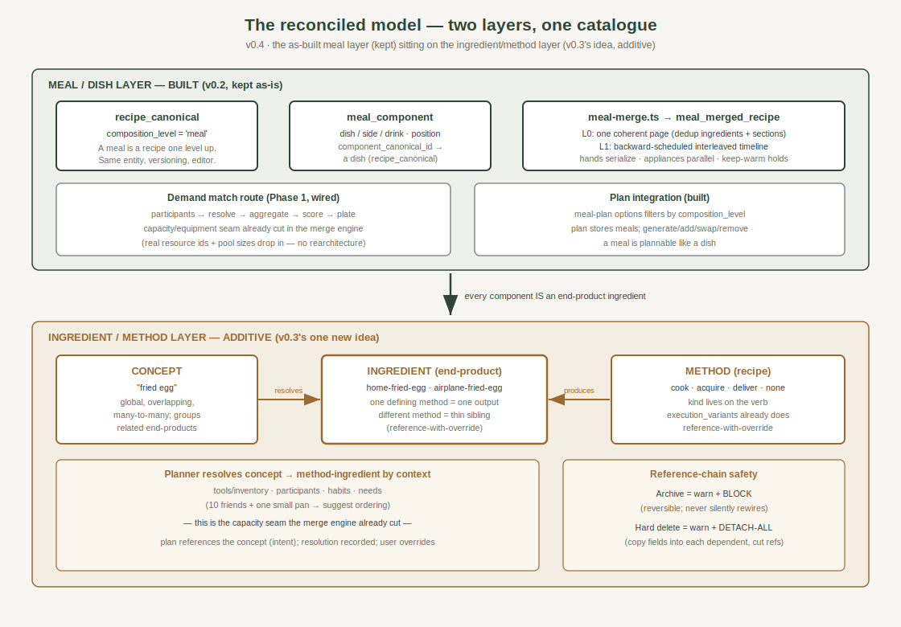
Green: the as-built meal layer, kept in full. Brown: the additive ingredient/method layer (v0.3’s one idea). The bridge: every component of a meal IS an end-product ingredient.

4. The five-item test set (still holds)
End-product | In the reconciled model | How it is obtained
Apple | An ingredient; trivially also a one-item 'meal' if planned. | none / simple
Glass of water | An ingredient; plannable like any other. | simple
Fried egg (home) | An ingredient; one output of one method. | cook
Fried egg (airplane) | A thin sibling ingredient of the home egg. | deliver
Protein shake | Made = one ingredient; bought = a sibling. | cook OR acquire
Dinner for 10 | A recipe_canonical at composition_level='meal' with components — the BUILT path. | composed (merge engine)

5. Reference-chain safety (from v0.3, retained)
- Archive = warn + block. Archival is reversible and must not silently rewire dependents; if anything references the node, block until dependents are resolved.
- Hard delete = warn, then detach-all. On confirmation, copy the referenced fields into each dependent and cut every reference, so each becomes self-contained. No arbitrary new hierarchy, no broken pointers. (Promote-and-repoint was rejected: negligible data saving, odd semantics.)

6. Open questions (revised for the reconciled model)
v0.3’s “migrate off composition_level” question is closed — we are NOT migrating. What remains:
- Concept layer. Is food_families the concept layer (it is m2m but barely populated) or is a dedicated concept table cleaner? How does an ingredient/dish declare concept membership? (This is the still-open half of §9’s audit.)
- Sibling-method representation. Does “same dish, different method” live as an execution_variant, or graduate to its own sibling recipe_canonical? Where is the threshold? (System measures divergence & suggests; human names & decides.)
- Method-kind field. composition_level is the LEVEL (dish/meal). Is there a separate need for a method-KIND (cook/acquire/deliver/none) on a recipe, or does source already carry it? Audit before adding.
- Planner method-resolution. Turning the merge engine’s latent capacity seam into a live plan-time resolver (tools/inventory + participant count → feasible method). When, and how is the resolution recorded on the plan entry?
- Plannable-end-product marker. What makes an ingredient appear in the planner’s candidate set (water yes, lemon pith no)?

7. Suggested next step (small, grounded)
Not a build — a continued audit. The meal layer works; the highest-value next move is to close the concept-layer question: inspect food_families (row counts, structure, m2m membership) and decide whether it is the concept layer or whether a dedicated table is cleaner. That single decision unblocks both the sibling-method representation and the planner’s concept-resolution, and it is the last open piece of the original §9 audit. Everything else can follow once the concept layer is settled.
End of v0.4. Supersedes v0.2 and v0.3. Keeps all built code; adds the ingredient/method layer as principle; next action is the concept-layer audit, not a migration.

