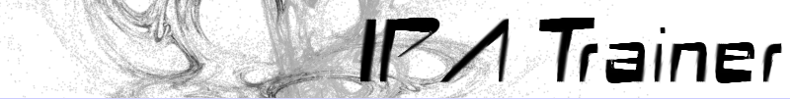

Administrator's Manual ver. 1.1
for IPA Trainer 1.0
Last updated 11.02.2009

I cannot guarantee that this manual is 100% updated. There may be differences
between the system as it is and the way it is presented in this manual.

Table of Contents
1. Introduction 4
1.1 What is IPA Trainer? 4
1.2 Specifications/requirements 5
2. The administrator: 6
2.1 Logging in/main menu 6
2.2 Creating a new consonant table: 6
2.3 Editing/deleting a consonant table 9
3. The user: 11
3.1 Accessing the site 11
3.2 View table 11
3.3 Memory game 12
3.4 Identify characters 12
3.5 Identify places 13
3.6 Identify sounds 14
4. Ending notes 15
4.1 Where do we go from here? 15
4.2 Credits 15
4.3 Bugs/suggestions 15

1. Introduction

1.1 What is IPA Trainer?
The IPA Trainer is a website which acts as a tool to teach students of phonetics IPA characters. Any lecturer can register and then customise as many IPA tables as he/she wants. In this way, the consonant tables the students will be exercising look like the ones the lecturer is using, and includes only the IPA characters/sounds that are relevant.

The project started when I was struggling to learn the IPA characters for the ex. fac. course at the University in Bergen. I wrote a limited version of IPA Trainer which proved so useful both to me and the other students, that, when given the opportunity to hand the program in as a course paper, I decided to write an extended version, improving the shortcomings of the former version. I have emphasised the following things:

Customisability:
What was important to me in this new version was that the IPA table to be practised could be customised as this was the major shortcoming of the former version. In this way, a lecturer of German, one of Spanish and one of Swahili can offer this tool to their respective students with exactly those characters included that they need.

Little need for registration:
Almost everywhere on the web you have to register to gain access to certain tools. I believe people are getting tired of this, and I wanted to avoid this. Still a certain amount of registration is required to be able to categorise the IPA tables and not make the entire system a huge mess containing hundreds of tables of varying quality. But in this system only someone who wants to customise consonant tables needs to register. He/she then gets a unique URL (http://www.ipatrainer.com/?username) which he can give to those who wish to take his/her tests. If a student has no lecturer who uses the system he/she can still search through consonant tables or choose from one of the most popular ones.

Usability:
Not all students have their own computer, and the system therefore had to be something which could be used with a minimum of installation required. This is the reason why it is a web application. It also uses images instead of a font to display the IPA characters, and the only things needed in order to use it are a web browser and access to the Internet.

1.2 Specifications/requirements
Browsers:
This system has been tested and found to work with the following browsers:

Opera    (Version 9.62/Linux) |   Firefox  (Version 3.0.4/Linux) | Safari    (Version 3.2.1/Windows XP) | Internet Explorer    (Version 7/Windows XP)

Since the system worked perfectly on all these systems, it will probably work in most other modern browsers as well. However, I cannot guarantee anything. The browser on which it ran best was Firefox.

JavaScript:
JavaScript is required...

- If you want to play memory
- If you want to access the system as an administrator.
- If you want to hear the sounds.

Flash:
Flash is required...

- If you want to hear the sounds.

2. The administrator:
An administrator is a person who wants to customise and create his/her own consonant tables. He/she has a username and a password to log into the administrator part of the system. This part is where he/she can create new IPA tables and edit the ones he/she has already created. The system has an administrator for demonstrational purposes, so if you do not have a username and password yet you can still log in with username “demo” and password “demo” (without the quotation marks.)

A username and password can be obtained from:
http://www.ipatrainer.com/user/site/index.php?pageID=admin_register

2.1 Logging in/main menu
The login screen can be found at the following URL:

http://www.ipatrainer.com/admin

You will now be prompted for username and password. Please enter them and click “Login”. (If you have no username/password, you can still access as a demo user. In this case, just enter “demo” (without the quotes) for both username and password.)
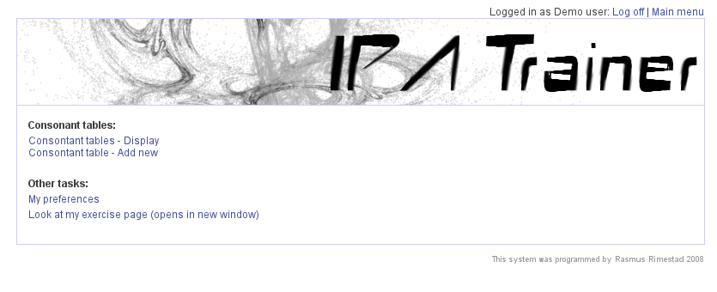Illustration 2.1.1: The administrator's main menu
When you have logged in you will see the following window:

2.2 Creating a new consonant table:
A consonant table is an IPA table containing certain IPA characters. In this way you can have one table for the sounds in English, one for the sounds in Swedish and one for the sounds in Swahili. Let us make a new consonant table. To do this, click “Consonant table - Add new” in the main menu. (See 2.1 on how to login). The system will then prompt you for a table name:
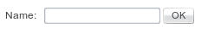

Let us call our table “English”. Enter “English” into the text box, and click “OK”:
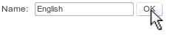

You will now get to the screen where you can customise your IPA table. Please see illustration 2.2.1 and note the red letters. They will henceforth be used to identify the various parts of the screen.
A D B C
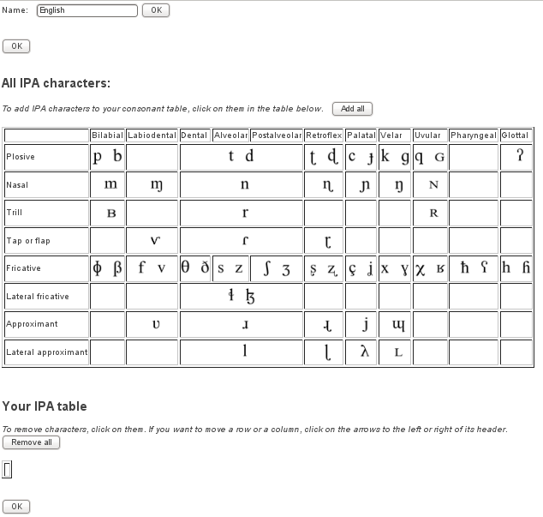Illustration 2.2.1: Customising the consonant table

If you, after you have created the table, decide to instead call it “British English” or “Cajun English”, you go to A, enter a different name and click OK.

B is your emerging consonant table. The small empty box will very soon be filled with all kinds of fun IPA characters.

C is your storage room. This table contains every single IPA character, and this is where you pick and choose.

D is when you feel you are done. Notice that there is an “OK” button at the bottom at the page as well.

Alright! Let us make the table. To move IPA characters from table C to table B, you click on the ones you want in table C. They will disappear from C and appear in B so you do not fall for the temptation of adding them twice. Notice that the order of manners and places of articulation is determined by the order you add your IPA characters. So if you want a certain order, it can be a good thing to plan a little ahead. But if you have not, do not worry. The order can be change at any point.

If you find it easier to add every single IPA characters and then remove the ones you do not want, notice that there is a button called “Add all” above table C.

If you want to remove a character from table B, you click on it in that table. It will then disappear from B, and reappear in C. If you have messed everything up, notice that there is a button saying “Remove all” above table B.

We have now made ourselves a wonderful IPA table, containing the relevant IPA characters for many varieties of English. Let us go to illustration 2.2.2 which can be found on the next page.

Illustration 2.2.2 is a close up of what was table B in illustration 2.2.1. As you can see it has grown considerably. But as you will probably notice, the palatal approximant ended up at the far right end of the table because it was the the last character I added. This is a rather uncommon way of drawing an IPA tables, and not to confuse the students, I would like to move it further to the left.

The way we do that is by using the little arrows. As you can see there is a little arrow pointing left on the left hand side of the header stating palatal place of articulation (A). These arrows can be found on one or both sides of all places of articulation. The reason why there is none on the right hand side of “Palatal”, is because it is already at the far right end. Clicking on this arrow will move the entire column one position to the left so it will appear between “Velar” and “Glottal”. Clicking it again will move it further to the left. And in this way we can move it all the way to where we want it to be. If we have moved it too far, it can be moved back by clicking on the arrow that should then have appeared on the right hand side of the header.

B A

If you have made a mistake in the order of manners of articulation, you will see some arrows pointing up and down to the left of their header (B). Clicking on these arrow will have the same effect as clicking on the left/right arrows only in a different dimension.
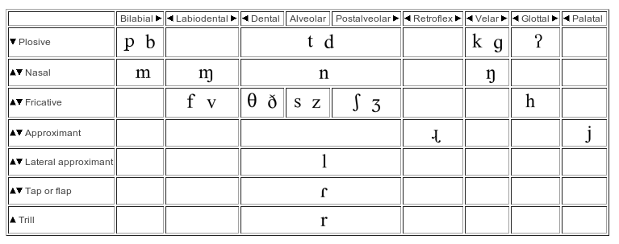Illustration 2.2.2: Our newly created consonant table

No you should know everything you need to know about creating a new consonant table. When you are done, click on the button labelled D in illustration 2.2.1.

2.3 Editing/deleting a consonant table
You have now created and saved your consonant table, and now you want to edit it. In that case, log in as described in 2.1 so that you get to the main menu. There, click on “Consonant tables - display”. You will see something not unlike illustration 2.3.1.

On your left, under the caption “Name:” you will find the various consonant tables, and if you follow the row towards the right you will find various actions you can perform on them. If you want to edit a consonant table, click on “Edit” to the right of the one you would like to edit (the line from A if you mean to edit the table “General English”). Click on it, and you will arrive at the screen described in 2.2. Deleting, logically, will be done if click on “Delete” to the right of that specific table (the line from B if you mean to delete the table “General English”). You will be asked for a confirmation, and when that it done the table will be gone.

A B
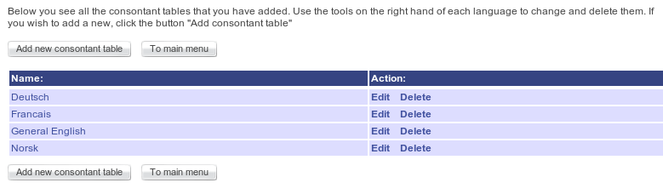Illustration 2.3.1: Consonant tables - display

3. The user:
The user is the person visiting the site to practice IPA tables. In order to be able to do that, they need to receive a username from the administrator. Let us continue using the username “demo” described in the introduction to the administrator. If you have received a username, you should, naturally, exchange any occurence of “demo” with your own username.

3.1 Accessing the site
To access the site, the user will have to enter the address containing the username into a web browser. In our example, the address would be

http://www.ipatrainer.com/?demo

The user will then arrive at a page containing all the consonant tables the adminstrator has made:
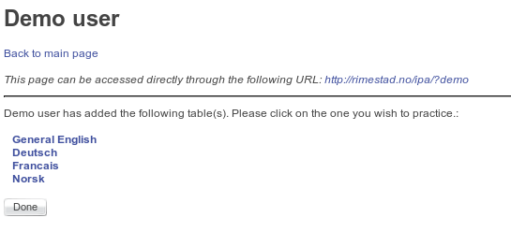Illustration 3.1.1: What a user sees

Clicking on any of these consonant tables brings us to the various choices for exercising this consonant table the user has.

Let us now go through each of these choices:

3.2 View table
This choice is very straight forward. Clicking on this will show the user what the table looks like with all IPA characters revealed. Useful to check if it is the correct one. If a user clicks on a character inside “View table” a sound file demonstrating how it is pronounced will be played.

3.3 Memory game
A fun way of being introduced to the characters in this IPA charts. The user sees a number of cards. The goal is to find the pairs of IPA characters hidden behind these cards. Clicking on one of the cards will turn it around, revealing a character in the table. At the same time its sound will be spoken. Now the user will have to click on the card below which he/she believes the same character is to be found. If it is, the pair remains open, if it is not, the cards will be turned to face the table again and the user will have to try again.

The goal is to find all pairs.

There are a maximum of 30 cards to be displayed, so if there are more than 15 characters in the table, 15 random will be chosen.

3.4 Identify characters
This exercise tests the user's ability to place a character in the correct position in the consonant table. Please see illustration 3.2.1 for the further description.

A B
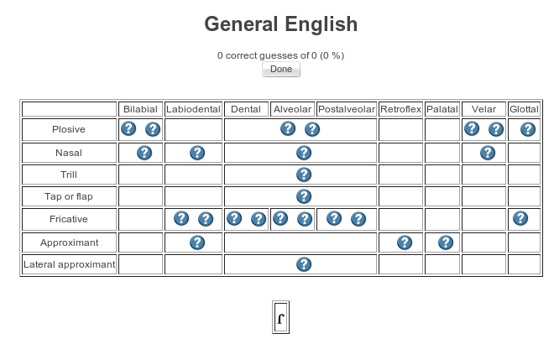Illustration 3.2.1: Identify characters

As you can see, there is an IPA character at the bottom (A). Above it, you see the IPA table with question marks everywhere where there is supposed to be a character. The task of the user is to find the question mark which is at the position where the character in A is supposed to be. In this case, this character is a voiced alveolar tap or flap, so it should go to the question mark which B is pointing at. If the user clicks on this question mark, he will get the message that his guess was correct, and a new IPA character will appear in A and the exercise goes on. If his/her guess was incorrect, he/she will be told so, and the alveolar tap will appear in the place it was supposed to be, so he can see what he/she should have guessed. At the same time, a new IPA character will appear in A, and the exercise goes on.

3.5 Identify places
This exercise tests the users ability to find the IPA character that should go in a certain place. Please see illustration 3.2.2 for the further description:

A B
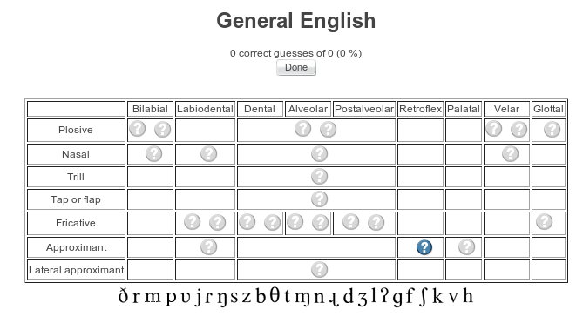Illustration 3.2.2: Identify places
As you can see, all the IPA characters in this table are at the bottom in a random order (A). Above them is the IPA table filled with only question marks one of which being highlighted (B). The user's task is to identify the character that should go where the highlighted question mark is. He/she will then have to find that character in the list at the bottom and click on it. In this specific screenshot, the highlighted question mark is a retroflex approximant, which is the character pointed at by A. Clicking on this character will tell the user that it was correct, and another question mark will be highlighted so the exercise goes on. If it is incorrect, the highlighted question mark will be replaced by the correct character so the user can see what he/she should have guessed, and at the same time a new question mark will be highlighted so the exercise goes on.

3.6 Identify sounds
This exercise is almost identical to “Identify characters” (3.4) except that instead of showing the user a character, the sound of a character is being spoken, and the user's task is to find its position.

4. Ending notes

4.1 Where do we go from here?
I believe that IPA Trainer is already a useful tool, although lacking in certain aspects. I would very much like to, in the future, include the following features.

- Possibility to view the site in other languages than English.
- Possibility to exercise vowel tables as well as consonant tables.
- Possibility to do exercises on various levels of difficulty.

4.2 Credits
Thanks go to...

...the University of Victoria, Humanities Computing and Media Centre by Martin Holmes & Shannon West for allowing me to use the graphics from their IPAKeypad for this site. Thus saving me a huge amount of work. Their IPAKeypad tool can be found at http://web.uvic.ca/hrd/ipa/

...professor J. C. Wells at the Department of Phonetics and Linguistics at the University College London for allowing me to use the sounds from The Sounds of the International Phonetic Alphabet on this site.

...my lecturer in English phonetics at the University of Tromsø, Martin Krämer, for allowing me to hand in this project as my final exam in his course. In this way I could spend lots more time on it than I could have if I was to use only my spare time.

4.3 Bugs/suggestions
If you stumble across any bugs, or would like to send me your suggestions on how to improve IPA-trainer, you can contact me by e-mail rasmusrim@gmail.com

