L1 Documentation
L.O.S.T

Logically Oriented Software Technology

Rasmus Tilljander - rati10@student.bth.se
Erik Hörlin - erhd10@student.bth.se
Calle Ketola - cake10@student.bth.se
Kim Hansson - kiha10@student.bth.se
Andreas Nilsson - annv10@student.bth.se

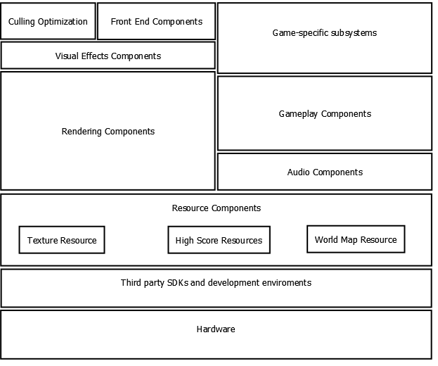Hardware
The application will be targeted for PC using Windows as OS

Third Party SDKs and development environment
DirectX10 will be used for rendering the game and FMOD Sound system will be used for implementing sound. The application will be developed using Microsoft Visual Studio 2010, C++.

Resource component
Handles resources such as textures, maps, and high score lists.

Gameplay component
Broad gameplay aspects such as collision detection and handling different gamestates.

Game-specific subsystems
Closely tied to the gameplay component. Subsystems for handling everything specific for this game such as player and enemy objects, game AI and power-ups.

Front End component
Will handle the In-game menus as well as a HUD for displaying key information for the user.

Audio component
Component for handling the third party sound system which in turns plays the game music, the character sounds etc.

Rendering component
DirectX components for rendering scenes and objects.

Visual Effects component
Closely tied to the Rendering component, will take care of more advanced visual effects and particle systems.

Culling Optimization
Tied together with the rendering. Handles pre-render culling for optimization.

