CS 461 / 462 / 463
Client Requirements Document

Quadrotor Flight Control System

Team Name: Falcon

Team Members:
Sarah Cooley cooleys@onid.oregonstate.edu
Torben Rasmussen rasmusto@onid.oregonstate.edu
Joey Tomlinson tomlinsj@onid.oregonstate.edu
Scott Rosenbalm rosenbas@onid.oregonstate.edu

Client/Sponsor/Mentor:
Client:
OSU Robotics Club – Aerial
Oregon State University, (541) 737-3101, info@engr.oregonstate.edu
Joey Tomlinson (team member) is the Aerial team lead.

Sponsor/Mentor:
Aaron Moore
Revolution Robotics Inc. (541) 357-7386, aaron@revolution-robotics.com

Introduction to the problem:
The International Aerial Robotics Competition (IARC) is an annual challenge in which robotics teams design an autonomous air vehicle to complete a “mission”. This year, the vehicle will need to autonomously fly over a fence, into a building, find a USB drive in a room, then replace it with another one, and get out.

In order to participate, all entries must be autonomous, free flying (no connections or tethers), lighter than 1.5kg, smaller than 1m in every dimension, electric, equipped with a kill switch, and able to transmit data to the judges.

Commercially, premade flight control systems are available though they are outside OSU Aerial’s budget. To compete with our solution, we’d have to spend at least $800. Furthermore, all major systems must be designed and built by students to compete.

Project Description:
OSU Aerial found in the 2010 International Aerial Robotics Competition (IARC) that our entry’s flight control system (see glossary) critically limited the vehicle’s performance. We have flight control systems from previous entries; however, we will only use them as a technical reference. This year, we will redesign the former system and replace it with a generic flight control system for quad-rotor aerial vehicles. However, the flight control system’s capabilities will be specifically engineered to meet the 2011 IARC requirements.

IARC requires the vehicle navigate indoors, often in close quarters. To compete, our flight control system will be designed with performance, stability, and versatility in mind. Our hardware will employ high bandwidth, high-resolution sensors and fast control systems in order to maximize stability performance. While our boards are designed with IARC in mind, they will be generic and available for other high-end quadrotor vehicles. The new sensors will provide sensor data more frequently and more accurately than previous sensors. To utilize the improved hardware, we will also need more efficient algorithms to process the sensor data into position correction vectors. Our flight control system keeps the quad rotor stable so the format of these position vectors will be degrees tilt, roll, and yaw. From there, the rest of the system needs to accept new positions at a higher frequency and translate the position data into motion correction more accurately to reflect our increased performance. As with our boards, our flight controller system will be open source and available for other quadrotor vehicles.

Our criteria for success are quite clear. Our solution must interface with the 2011 IARC entry properly, cost less than $1000, meet the IARC entry requirements, and improve the vehicle’s flight stability when compared to last years flight control system.

Requirements
- The vehicle must interface with the OSU IARC entry.
  - Battery powered by 9V-16V.
  - Serial (SPI) output.
  - Code written in C.
- There must be proper safety precautions in both hardware and software.
  - Physical kill switch.
  - Software failsafe and kill routines.
  - Some way to remotely deactivate.
- Flight control system must be small and light. Ideally, less than 300 grams.
- The system must be able to power four DC motors used for flight.
- The vehicle must find the correct flight path.
  - Use multiple sensors to confirm position accuracy.
  - Reduce wobble to less than 5˚ from normal.
  - Calculate flight path in 1ms or less.
Versions:
Version 1: Read data from the sensors.
Read data from each sensor and sanity check the sensor values. Check the read frequency to take full advantage of the sensors. We should be reading from a magnetometer, gyroscopes, and accelerometers.
Version 2: Use data to create motion vectors.
Write the algorithms to generate accurate motion vectors using sensor data. The motion vectors should use dead reckoning to maintain stability. The values to transmit are tilt, roll, and yaw correction.
Version 3: Add SPI (see glossary) interface and output correctly.
Write the interface to the flight controller and make sure the real world flight is as simulated.
Version 4: Optimize and integrate into the central controller. Maybe add PID (see glossary) to improve stability.

Design:
We will produce three circuit boards and the associated software, which, together, form a complete flight control solution. Our three modules will be the:

The Flight Control Unit (FCU) integrates input from the Inertial Measurement Unit and output to the Motor Controller Unit. It also interfaces with a master controller (already constructed by the OSURC Aerial Team). The main stability control loop runs on this processor at a rate of 1kHz. This board will also provide battery monitoring and emergency stop functionality.

The Inertial Measurement Unit (IMU) reads data from inertial sensors to calculate the angular and lateral motion of the platform. An ARM7 processor will process sensor data and provides a state estimate to the FCU every millisecond.

The Motor Controller Unit (MCU) controls the speed of the four brushless motors, which propel and control the quadrotor. They will drive motors up to 20A at 12V and will be easily modifiable to support higher current and voltage motors.

On the software side, raw data from the sensors will pass through a low pass filter then through an ADC (Analog to Digital Converter) before it reaches the microprocessor. If the data still seems noisy, we’ll implement some sort of software filter. Otherwise, those values will be calculated into tilt, roll, and yaw then we’ll pass the data to a Kalman Filter. A Kalman filter is a tool for computing a reliable estimate on linear systems. The filter should take our raw sensor estimated values, compare them to an error value, and produce a corrected value. The Kalman filter uses weighted averages so we can also weight more accurate sensors more heavily.

Either on the IMU or FCU we may then implement some form of PID to determine some estimation of location and reconfirm our motion vector’s accuracy.

High Level Block Diagram:
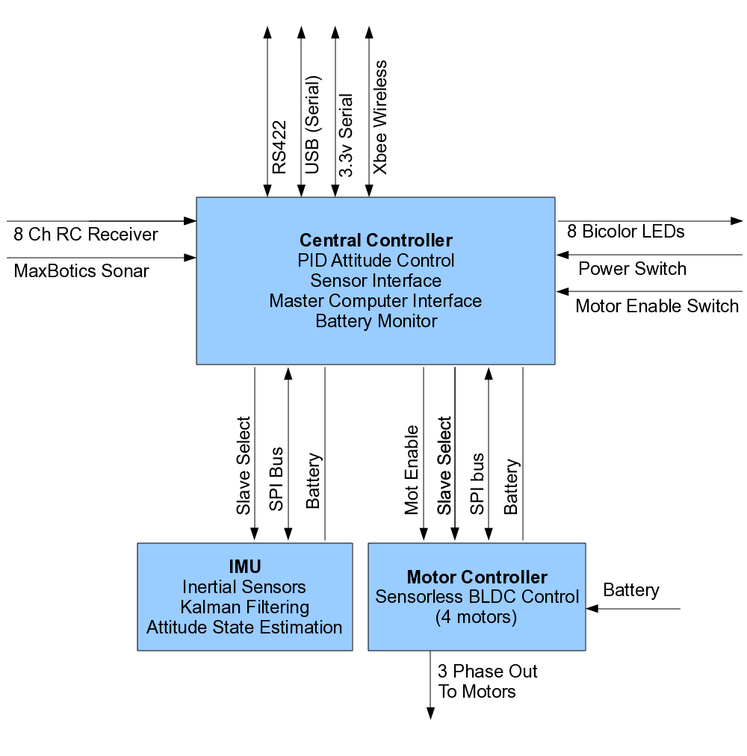

Specific tasks to be undertaken:
For the software side specifically:
- Generate some fake but reasonable data.
- Use the fake but reasonable data to calculate tilt, roll, and yaw in degrees.
- Research different filtering types; implement some of the interesting ones and test with various degrees of error.
- Pull out last year’s IMU and test calculation and filtering code on the old hardware. Optimize calculations and make sure they are with in our constraints.
- Once the IMU is done, adjust code to work with real data and error.
- Implement SPI (basic serial interface)
- Integrate with FCU. Make sure it works with my motion vector format and integrates with the main board.
- Test the system. Tweak code to work with the whole system.
- Work on documentation throughout.

Risk Assessment:
Print bad PCBs. It’s very easy to make mistakes when printing our circuit boards. We could have missed something in the circuitry, the part numbers need to be perfect, the packages need to match, and sometimes route optimizers mess the board up. In short, there are many ways printing the PCB could go wrong. To negate this, we are ordering our boards very early on so, if we do need to reprint them, we have the time and resources.

As far as programming, I think efficiency will be our greatest downfall. All of the algorithms we’re thinking about have many floating-point operations and are high precision. If we use PID we’ll also be integrating on fairly small processors. Heating, processing power, or the number of cycles could become issues. I’m hoping to negate this risk by beginning my preliminary programming on smaller microprocessors from last year. If my code doesn’t over heat the board and is sufficiently fast it should run beautifully on the new hardware. Furthermore, as with all other aspects of this project, we left time for added debugging. Obviously we will carefully monitor heat on all of the boards. If we’re really just doing too much computation (depending on time) we’ll have to remove some of the noise compensation/error reduction or reallocate resources.

Testing:
Testing will begin on last year’s IMU. While we’re using different components, I can still use the data from last year’s to play with Kalman filtering. Most testing, however, will be in functional blocks as I write the code. For example, I’ll calculate tilt then print tilt estimates and compare them to my expected values.

Preliminary Timetable:
See attached.

Roles of the different team members:
Sarah Cooley:
I will write the code that determines position vectors for stabilization. My code will be on the IMU then pass the position vector to the flight control unit, which will tell the motor controller to move.
Additionally, I drive meetings and am the taskmaster.
Torben Rasmussen:
Torben designed the MCU and worked with Joey on the FCU design. Torben digitized the schematics and ran many of the circuit analysis tests. Once the boards are printed, Torben will make sure the MCU is wired correctly, safe, and can drive the motors.
Joey Tomlinson:
Joey is the team lead. Torben and Joey designed the FCU and Joey converted the schematics into something that could be printed as a circuit board, using Eagle. He is also in charge of most integration testing since he is familiar with the entire project.
Scott Rosenbalm:
Scott designed the IMU board itself and will be in charge of testing the IMUs hardware.

Integration Plan: Each board has a set of known inputs and outputs and every board’s interface is known. Assuming everyone meets the correct input and output specifications, integration should be straightforward. Otherwise, we have been working together closely and have a round robin approach to debugging (each person has another team member sanity check their work) so everyone does, at some point, review everyone else’s work.

References:
- Falcon - Quadrotor Flight Control System (beaversource) http://beaversource.oregonstate.edu/projects/44x201007

- International Aerial Robotics Competition
http://iarc.angel-strike.com/

Glossary:
- IARC – International Aerial Robotics Competition
- FCU – Flight Control Unit – controls the overall direction changes, coordinates the IMU and MCU and performs system level activities like failsafe and battery monitoring.
- IMU – Initial Measurement Unit – reads data sensors to determine a new position vector to stabilize the vehicle.
- MCU – Motor Control Unit
- Dead reckoning –
- Kalman Filter – uses a system's predicted motion model and sensor data to form an estimate of the system's state that is better than the raw data.
- PID – is a three-term controller calculation with three separate parameters: the proportional (P), the integral (I) and derivative values (D). The proportional value determines the reaction to the current error, the integral value determines the reaction based on the sum of recent errors, and the derivative value determines the reaction based on the rate at which the error has been changing. The weighted sum of these three actions is used to adjust the process via a control element such as the position of a control valve or the power supply of a heating element. (wikipedia)
- SPI – Serial Peripheral Interface Bus is a serial data link. With SPI, devices can both read and write and have a master and slave.
Signatures: all team members and the Client/Sponsor/Mentor

