|  |
| --- |
| [Type the company name] |
| AIDS in South Africa |
| H312 Term Paper |
|  |
| **Torben Rasmussen** |
| **2/27/2011** |

|  |
| --- |
| [Type the abstract of the document here. The abstract is typically a short summary of the contents of the document. Type the abstract of the document here. The abstract is typically a short summary of the contents of the document.] |

# HIV/AIDS in South Africa

# Introduction

## Thesis: AIDS is a serious issue in South Africa because of the social and political climate, and because of difficult to deal with infection vectors.

# Background

## The Republic of South Africa is a country located at the southern tip of Africa, with a 2,798 kilometers (1,739 mi) coastline on the Atlantic and Indian Oceans. To the north lie Namibia, Botswana and Zimbabwe; to the east are Mozambique and Swaziland; while Lesotho is an enclave surrounded by South African territory

## An estimated 5.6 million people were living with HIV and AIDS in South Africa in 2009, more than in any other country

# Prevalence and Infection

## The Human Sciences Research Council, a South African institution, estimates 10.9% of all South Africans have HIV/AIDS

## HIV and Tuberculosis (co-infection)

## The age bracket that AIDS most heavily targets – younger adults – means it is not uncommon for one or more parents to die from AIDS while their offspring are young. The number of premature deaths due to HIV/AIDS has risen significantly over the last decade from 39 percent to 75 percent in 2010.

# Social Impacts

## children and families - there were an estimated 330,000 under-15s living with HIV in 2009

## AIDS Awareness - A principle part of the HIV counseling and testing (HCT) campaign launched in April 2010, is to scale up awareness of HIV.

## condom use - Condom use in South Africa is growing with the percentage of those using a condom during their last sexual encounter increasing from 27 percent in 2002, 35 percent in 2005 to 62 percent in 2008.

## Gender violence and inequality

## Orphaned children - In 2007 it was estimated that 1,400,000 orphans in South Africa were orphaned as a direct consequence of HIV/AIDS.

# Political Efforts and Problems

## Denial

### Pharmaceutical Conspiracy. (Mbeki is largely responsible for HIV rates)

### On 9 July 2000, Mr Mbeki opened the International AIDS Conference in Durban with a speech not about HIV or AIDS but about extreme poverty in Africa. In the speech, he confirmed his belief that immune deficiency is a big problem in Africa but that one can't possibly attribute all immune deficiency related diseases to a single virus.

## Antiretroviral Treatment

## Condom Use

### Condom use in South Africa is growing with the percentage of those using a condom during their last sexual encounter increasing from 27 percent in 2002, 35 percent in 2005 to 62 percent in 2008. Younger people show the highest rates of condom use which bodes well for the future of prevention, and could explain the decline in HIV prevalence and incidence among teenagers and younger adults.

OTHER THINGS TO INCLUDE:

TASO - TASO began in 1993 by Noerine Kaleeba, who lost her husband to AIDS. As the first AIDS organization in Africa, TASO developed the model of community-based, home care for both affected and infected persons.

Stigma

Clinton Foundation

Gates Foundation

PEPFAR - <http://www.pepfar.gov/countries/southafrica/index.htm>

Violence against victims

Also,

Prostitution

Virgin myth – myth that sex with a virgin could cure HIV/AIDS

Migrant worker population

World bank

Etc.

# Conclusion

## Conclusion goes here, basically South Africa has been greatly strained by HIV/AIDS, but a number of social and political solutions have the potential to greatly reduce the negative impact of the disease.

# Works Cited

1. <http://www.avert.org/aidssouthafrica.htm>
2. <http://en.wikipedia.org/wiki/AIDS_in_South_Africa>
3. <http://en.wikipedia.org/wiki/South_africa>
4. <http://www.hsrc.ac.za/Document-3238.phtml>

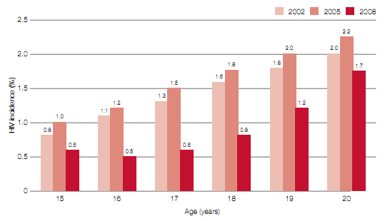

Figure : HSRC Comparison of HIV incidence in the 15-20 age group, South Africa 2002, 2005, and 2008