$(“#one”)

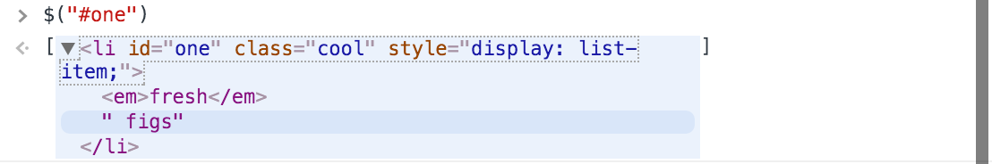

$(“li.cool")

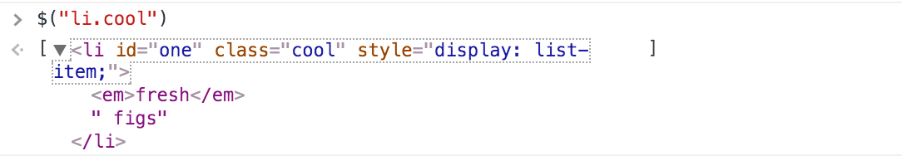

What command to get all “li” element that does not have “cool” class name?

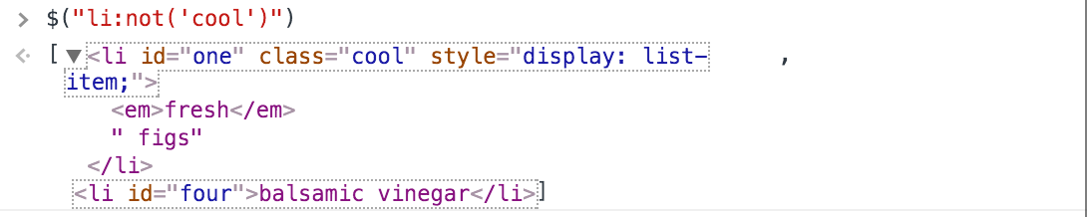

$(“li.cool").parent()

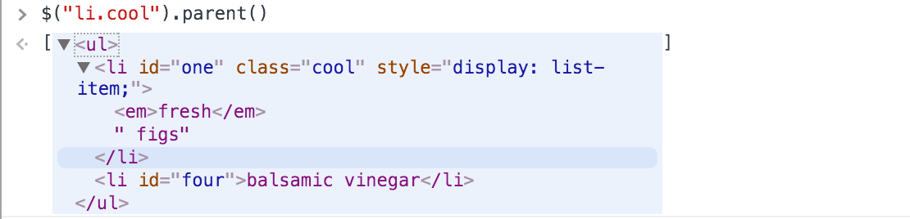

$("li")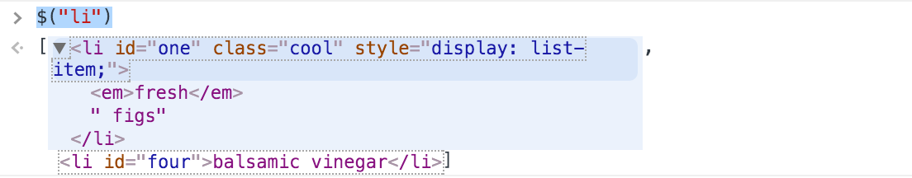

$(“li:even")

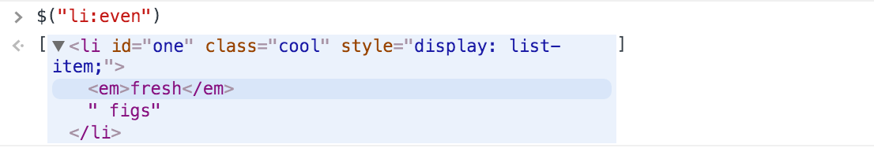

What command to get last “li” element?

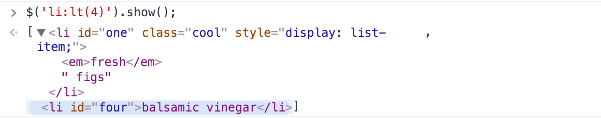

$(“li:gt(1)”).hide(), then run $("li:hidden")

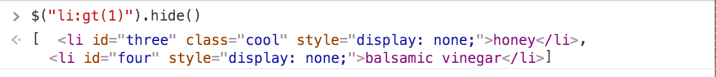

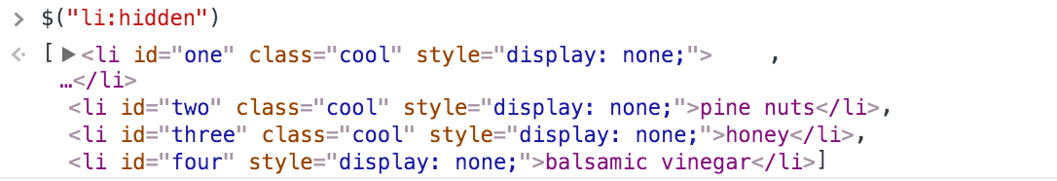

What command to get only visible li?

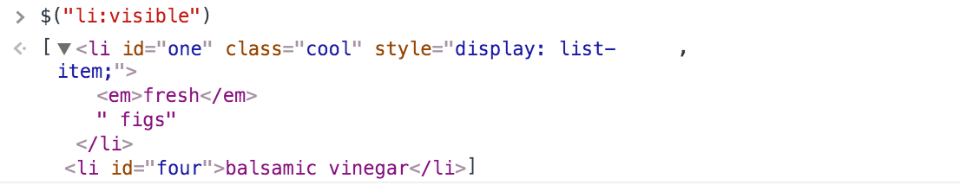

$(“.headline")

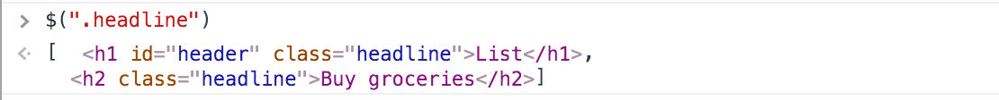

$("h2.headline").html("Bye bye”)



$(“li:first").addClass("favorite")

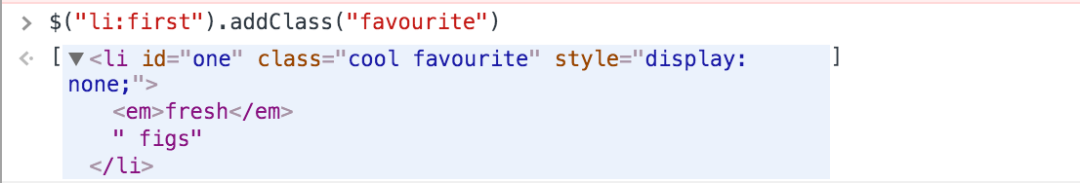

What command to add heart icon to only odd li item?

