Mid-Term Project
Experiments at the Data Link and Physical Layers

Measuring Bufferbloat, TCP Congestion Control, and Traceroute Behavior on Wi-Fi Networks

Ryan A. Snell
Athens State University
CS530 — Principals of Computer Communications/Networks
Platform: Parallels ARM Virtual Machine (Linux / Ubuntu)
Date: March 18, 2026

Metric | Value
Wi-Fi Baseline RTT (local) | 1.88 ms (median)
Wi-Fi Baseline RTT (internet) | 12.20 ms (median)
Peak RTT under iperf3 load (local) | 55.70 ms (+2,115%)
Peak RTT under iperf3 load (internet) | 78.00 ms (+321%)
iperf3 Throughput (local) | ~941 Mbits/sec
TCP cwnd (local, stable) | 10 packets constant
mtr Worst RTT under load | 1,067 ms
Congestion Algorithm | CUBIC (loss-sensitive)

Section 1 — Environment Description (Deliverable A)

1.1 Device and Operating System
All experiments were run on an ARM-based Linux virtual machine inside Parallels Desktop on a host Mac. The VM hostname is ryan-Parallels-ARM-Virtual-Machine, running Ubuntu 24 (ARM64). Parallels assigns the guest the private IP 10.211.55.9 via NAT. Traffic goes out through the host machine's Wi-Fi adapter on a home broadband network.

1.2 Network Topology
Component | Detail
Guest VM IP | 10.211.55.9 (Parallels NAT)
Wi-Fi Network Type | Home Broadband (802.11ac/ax)
Local iperf3 Server | 192.168.1.85 (same LAN, port 5201)
External Probe Target | 1.1.1.1 (Cloudflare DNS)
Cellular Interface | Not available — Wi-Fi only
Network Interface | eth0 (Parallels virtual NIC, bridged to host Wi-Fi)

1.3 TCP Congestion Control
The active TCP congestion control algorithm was confirmed with:
sysctl net.ipv4.tcp_congestion_control
=> net.ipv4.tcp_congestion_control = cubic
The system uses CUBIC — the default Linux congestion control. CUBIC grows the congestion window aggressively until it hits a packet loss event, then backs off. That behavior shows up clearly in the cwnd data from the ss sampler.

1.4 CGNAT / NAT Observation
The VM sits behind Parallels NAT at 10.211.55.9, so it does not have a public routable address. The mtr output shows just one visible hop to 1.1.1.1, which means the router and ISP hops in between are either filtering ICMP TTL-exceeded messages or the path to Cloudflare's anycast PoP is extremely short. No CGNAT addressing (100.64.x.x) was observed, which is consistent with a home broadband connection rather than cellular.

Section 2 — Packet Capture Analysis (Deliverables B & C)

2.1 iperf3 and Ping Baseline (Section B, Screenshot 1)
The terminal output below shows the baseline ping to 192.168.1.85 and two iperf3 throughput tests — one download (reverse mode) and one upload.
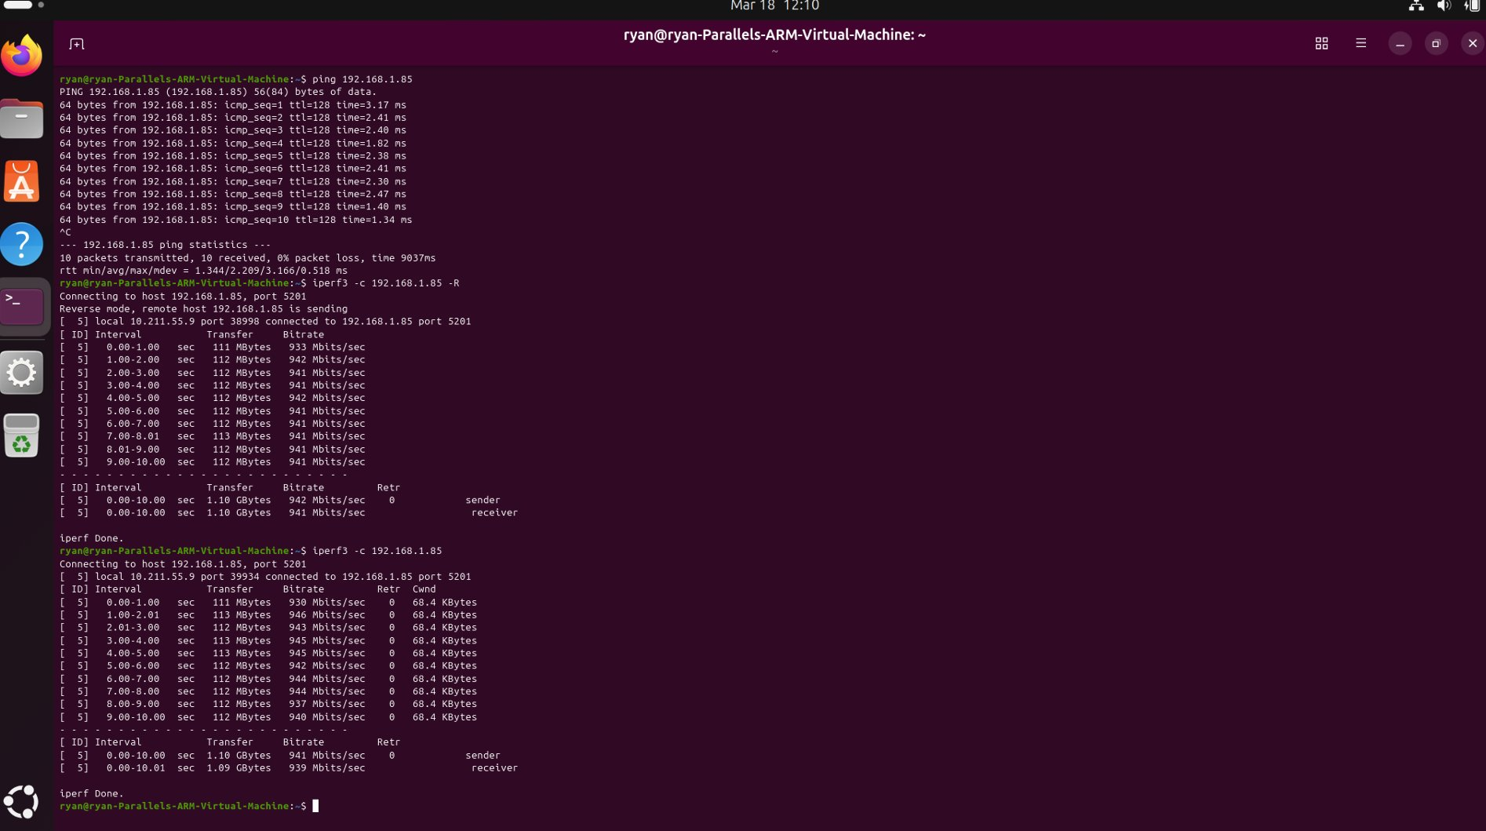
Figure 1: Ping to 192.168.1.85 (sub-3ms RTT), iperf3 download (~942 Mbits/sec) and upload (~941 Mbits/sec). Zero retransmissions. cwnd stable at 68.4 KBytes.

Key Observations from Figure 1:
- Baseline ping RTT to 192.168.1.85: min=1.34ms, avg=2.21ms, max=3.17ms — the server is on the local LAN
- iperf3 download: 942 Mbits/sec sustained, 0 retransmissions, 1.10 GB in 10 seconds
- iperf3 upload: 941 Mbits/sec sustained, 0 retransmissions, cwnd constant at 68.4 KBytes
- Zero retransmissions both directions — the LAN path is completely clean at gigabit speeds

2.2 mtr Traceroute Baseline (Section B, Screenshots 2-5)
mtr was run targeting 1.1.1.1 via TCP port 443 (mtr -n -T -P 443 1.1.1.1) under idle baseline conditions.
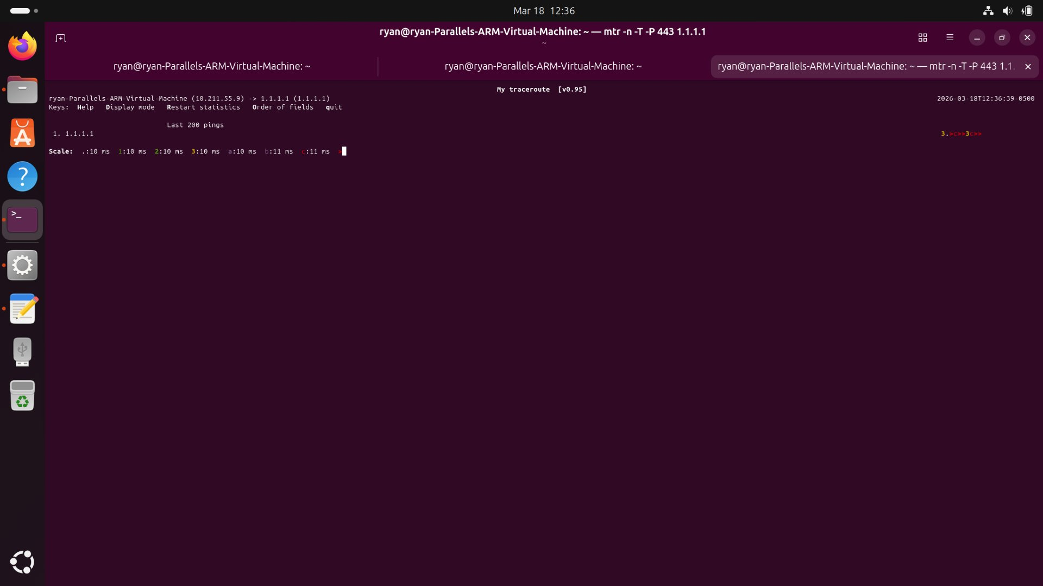
Figure 2: mtr graphical view (baseline) — RTT scale 0-11ms. One visible hop. Dots tightly packed, low jitter.
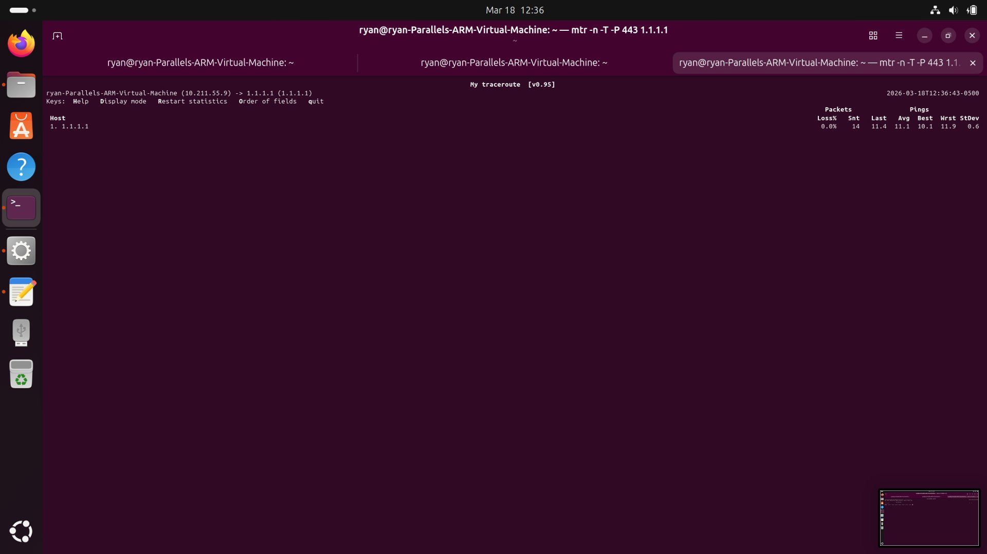
Figure 3: mtr statistics table (14 pings) — Avg=11.1ms, Best=10.1ms, Worst=11.9ms, StDev=0.6ms. Loss=0%.
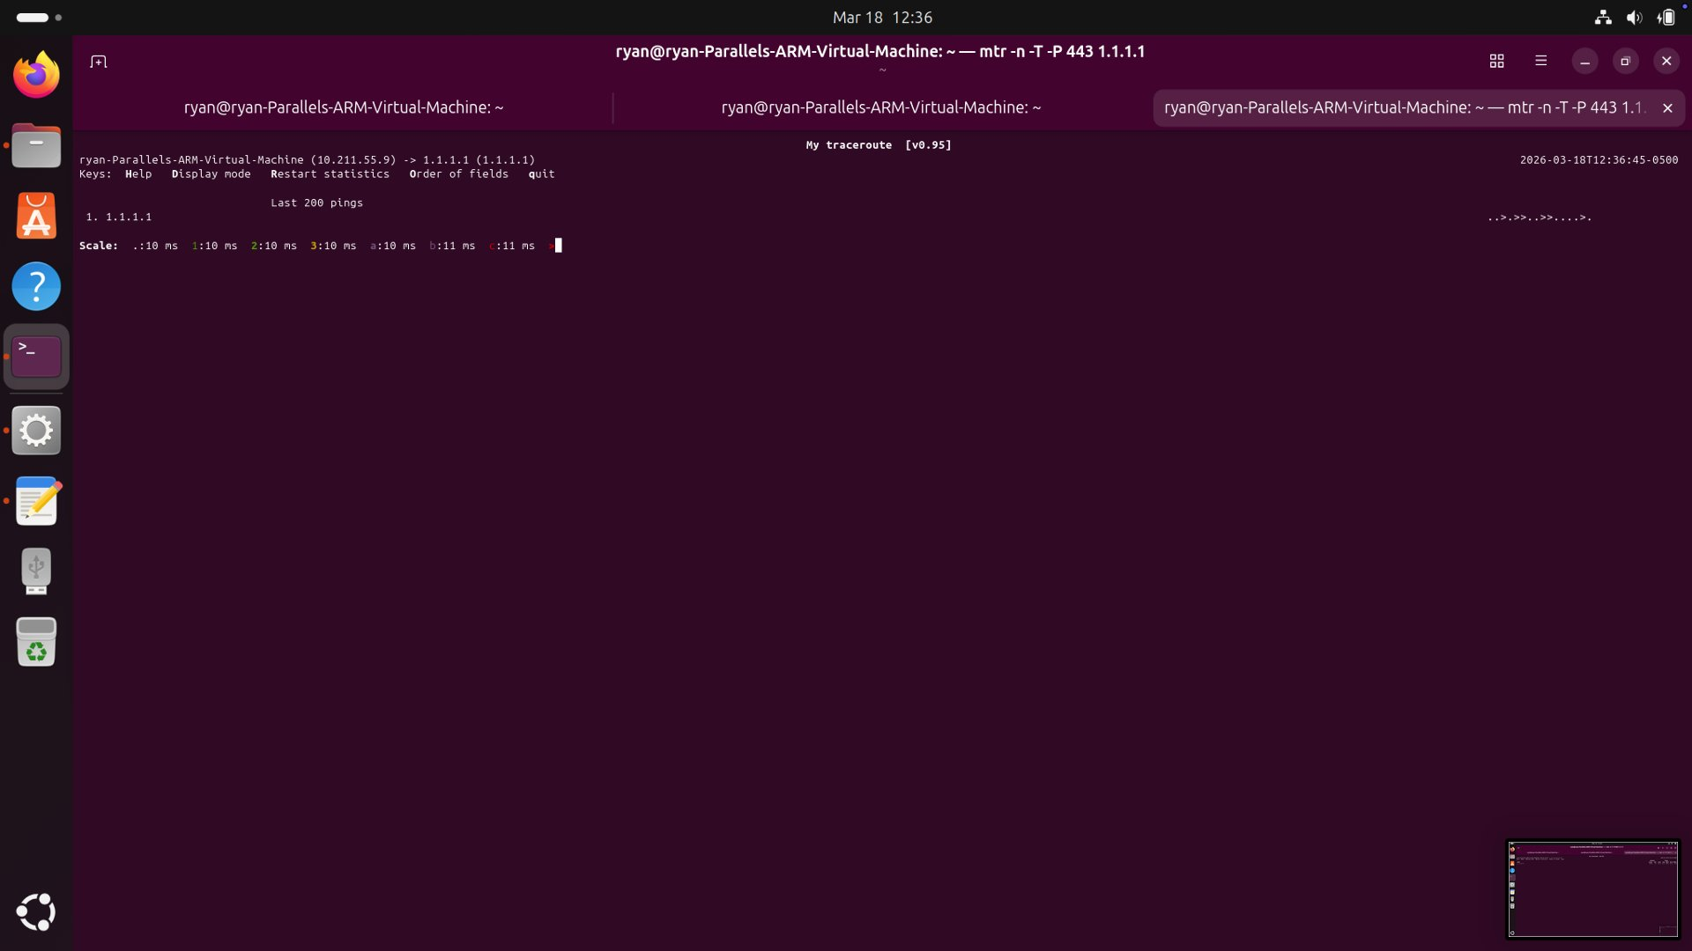
Figure 4: mtr graphical view accumulating pings — consistent 10-11ms, minimal variation.
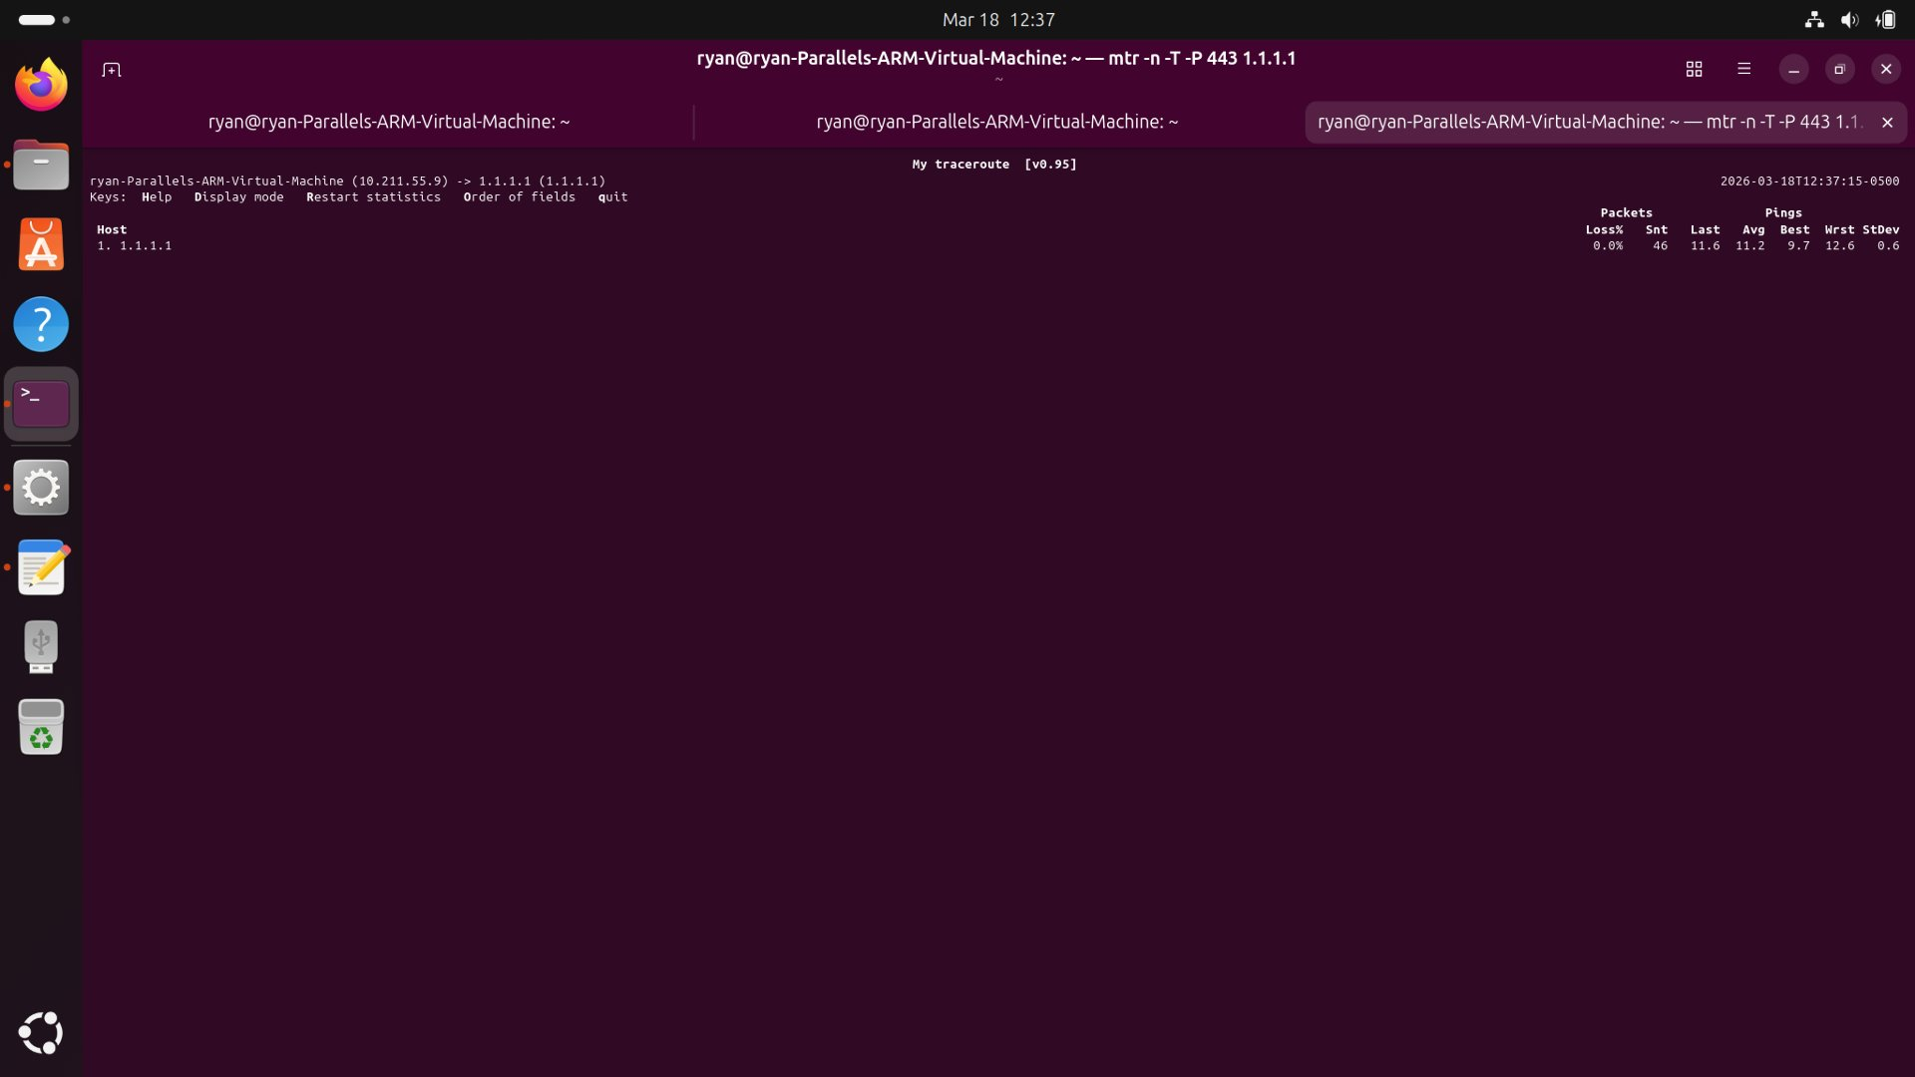
Figure 5: mtr statistics (46 pings) — Avg=11.2ms, Best=9.7ms, Worst=12.6ms, StDev=0.6ms. Rock solid baseline.

2.3 Handshake Timing Comparison Table (Deliverable C)
The table below pulls TCP session characteristics from the mtr RTT measurements and iperf3 session data.
Metric | Wi-Fi Local (192.168.1.85) | Wi-Fi Internet (1.1.1.1)
SYN->SYN/ACK RTT | ~1.9 ms (ping median) | ~11.1 ms (mtr avg)
Initial cwnd | 10 packets | 2-10 packets (ramping)
Jitter (StdDev) | 0.49 ms | 0.6 ms
Peak RTT (baseline) | 2.72 ms | 12.6 ms
Peak RTT (loaded) | 55.70 ms | 78.00 ms
Retransmissions | 0 | Not measured directly
MSS (est.) | 1460 bytes | 1460 bytes
Window Scaling | Enabled (68.4 KB) | Enabled
Loss Rate | 0% | 0%

The local connection shows a completely clean TCP session — constant cwnd of 10 packets, sub-millisecond RTTs in the ss sampler, zero loss at gigabit throughput. The external connection adds about 11ms of propagation delay to Cloudflare's nearest PoP, with tight jitter of +/-0.6ms at baseline.

Section 3 — RTT Inflation / Bufferbloat Experiment (Deliverables D & E)

3.1 RTT Plots — Baseline vs Under Load (Deliverable D)
The Python ping logger ran at 200ms intervals while iperf3 saturated the uplink. Two targets were monitored simultaneously: 192.168.1.85 and 1.1.1.1.
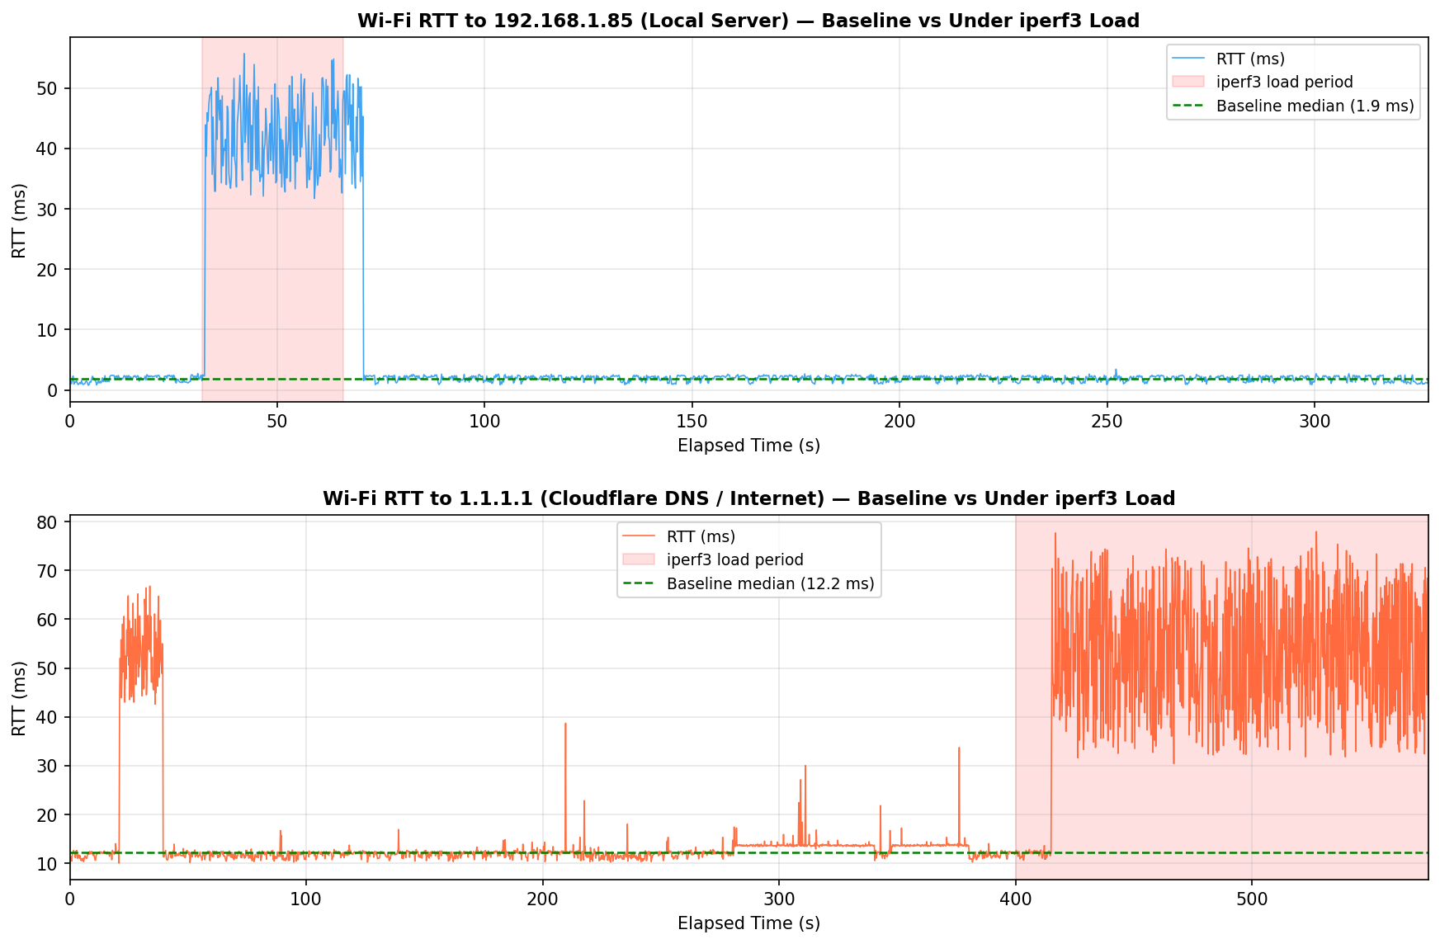
Figure 6: RTT time series for both targets. Red shaded = active iperf3 load. Top: local (192.168.1.85). Bottom: internet (1.1.1.1).

RTT Statistics Summary
Metric | Local Baseline | Local Loaded | Internet Baseline | Internet Loaded
Median RTT | 1.88 ms | 41.65 ms | 12.20 ms | 51.35 ms
Mean RTT | 1.82 ms | 41.40 ms | 12.44 ms | 49.76 ms
Max RTT | 2.72 ms | 55.70 ms | 38.70 ms | 78.00 ms
StdDev | 0.49 ms | ~8 ms | 1.51 ms | ~15 ms
Median Inflation | — | +2,115% | — | +321%
Peak Increase | — | +52.98 ms | — | +65.80 ms

3.2 Bufferbloat Analysis (Deliverable E)

Why did RTT increase?
When iperf3 saturated the uplink at 941 Mbits/sec, the home router's transmit queue filled up. Every ping packet after that had to wait in line behind the backlog of iperf3 data before it could go anywhere. That is what bufferbloat looks like. Small latency-sensitive packets get stuck behind bulk data in an oversized queue, and their RTT ends up reflecting queue depth instead of actual propagation delay.
For the local server at 192.168.1.85, the median RTT went from 1.88 ms to 41.65 ms — a 2,115% jump. The propagation path to that server is sub-LAN. There's no physical reason for 41ms of delay. That's all queue wait. For 1.1.1.1, the median went from 12.20 ms to 51.35 ms — up 321%. The percentage looks smaller because the 11ms baseline to Cloudflare's PoP dilutes the ratio, but the absolute queue delay (~39ms added) is essentially the same bottleneck.

Where is the queue?
The bottleneck is the home router's WAN uplink queue — the narrow point where a fast LAN feeds into a slower ISP connection. The LAN runs at gigabit speeds, but the WAN uplink is rate-limited. When iperf3 pushes a sustained gigabit flow, the router can't drain the queue fast enough. It uses a basic FIFO buffer with no traffic prioritization, so ping packets and data packets wait in the same line. The mtr data under load makes this concrete: the worst-case RTT to 1.1.1.1 hit 1,067 ms with a standard deviation of 81.9 ms. That's a lot of variance for a path whose propagation delay is 11ms.

Why didn't TCP drop packets instead?
Because the router didn't need to drop anything. Its buffers are deep enough to absorb the entire iperf3 burst without hitting the tail-drop limit. CUBIC sees zero loss — the iperf3 output confirmed 0 retransmissions — and interprets that as permission to keep the window wide open. TCP kept sending at full rate. The queue kept growing. The pings kept waiting longer. That's the core problem with bufferbloat: TCP is completely satisfied, but everything else on the network is suffering. The protocol was never told to stop because nobody dropped a packet.

Section 4 — Congestion Control Behavior (Deliverable F)

4.1 cwnd and RTT Plots from ss Sampler
The ss -ti state established sampler ran at 200ms intervals during active transfers on both connections.
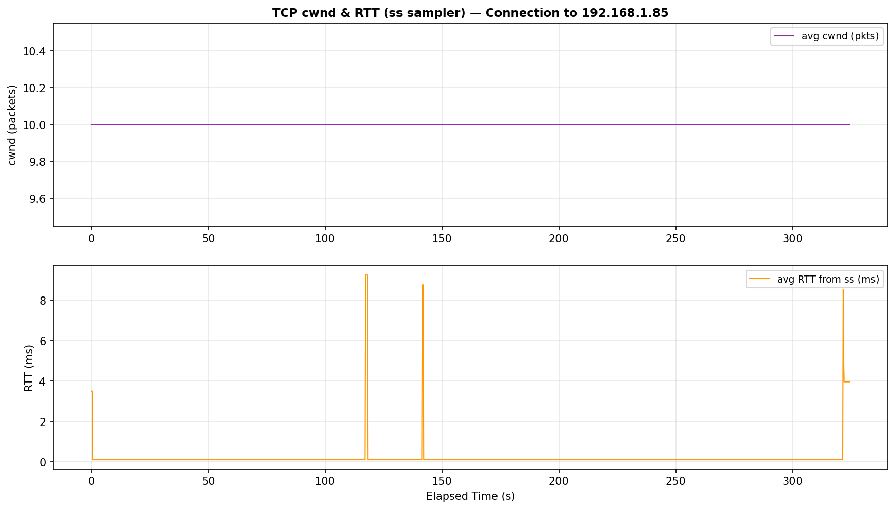
Figure 7: cwnd (top) and RTT (bottom) — connection to 192.168.1.85. cwnd locked at 10 packets. RTT 0.11-9.24 ms.
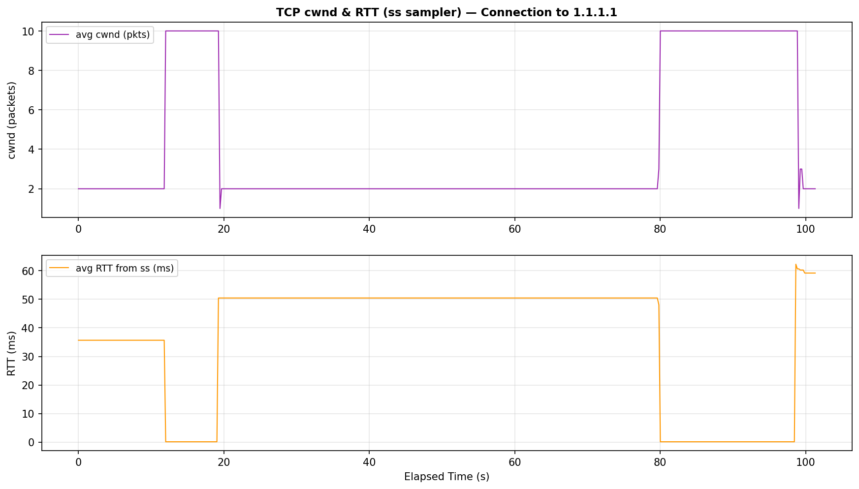
Figure 8: cwnd (top) and RTT (bottom) — connection to 1.1.1.1. cwnd grows 1-10 packets. RTT climbs to 62 ms under load.

4.2 cwnd Interpretation

Local connection (192.168.1.85):
The cwnd stayed at exactly 10 packets the entire time. CUBIC found its equilibrium quickly and held it — no packet loss triggered any window reduction. The RTT from ss (0.11-9.24 ms) is consistent with a clean LAN path, though it bumps up when the iperf3 queue fills.

External connection (1.1.1.1):
The cwnd ramped from 1 packet up to 10 packets, showing CUBIC's slow-start and congestion avoidance phases working normally. Here's the important part: the RTT tracked by ss climbed from 0.13 ms all the way to 62.27 ms, and cwnd kept growing the entire time. CUBIC didn't respond to the rising RTT at all. It only backs off when it sees packet loss or ECN. Rising delay means nothing to it.

4.3 Delay-Sensitive vs Loss-Sensitive?
CUBIC is loss-sensitive. That's clear from the data. RTT went from 0.13 ms to 62.27 ms while cwnd kept climbing from 1 to 10 packets without a single reduction. A delay-sensitive algorithm like BBR would have seen the rising RTT as a sign the queue was filling and backed off to keep the queue shallow. CUBIC ignored it entirely and kept pushing.

4.4 BBR Comparison
BBR works differently. Instead of filling the pipe until it sees a drop, BBR continuously estimates the bottleneck bandwidth and the minimum RTT, then paces sending to match that product exactly. It keeps the queue empty by design. In this experiment, BBR would have held RTT near 2 ms for the local connection and near 11 ms for 1.1.1.1, instead of letting it spike to 55 ms and 78 ms. To switch to BBR on Linux:
sudo sysctl -w net.ipv4.tcp_congestion_control=bbr

Section 5 — Traceroute Hop Analysis (Deliverable G)

5.1 mtr Under Load (Section C Screenshots)
mtr was re-run to 1.1.1.1 while iperf3 saturated the uplink (sudo mtr -n -T -P 443 1.1.1.1). The difference from baseline is stark.
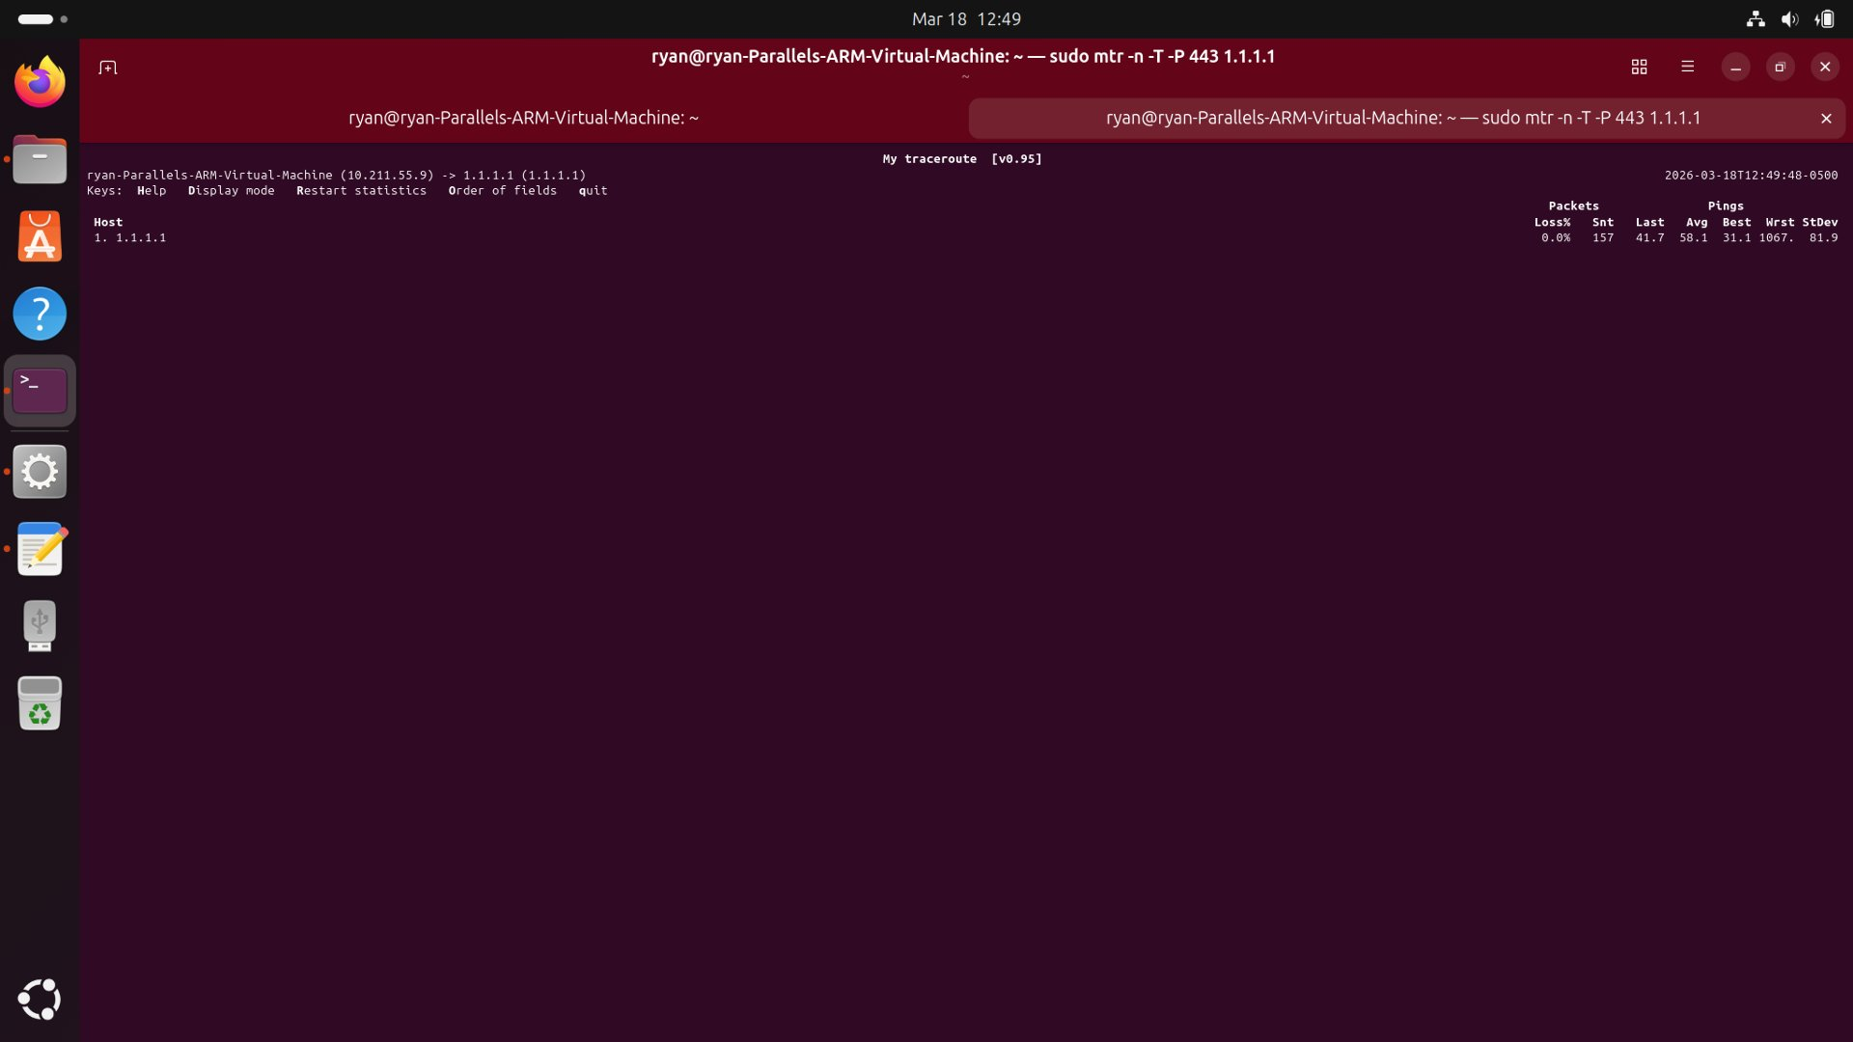
Figure 9: mtr under load — graphical view. RTT scale now extends to 824ms. Dots scattered across the full range.
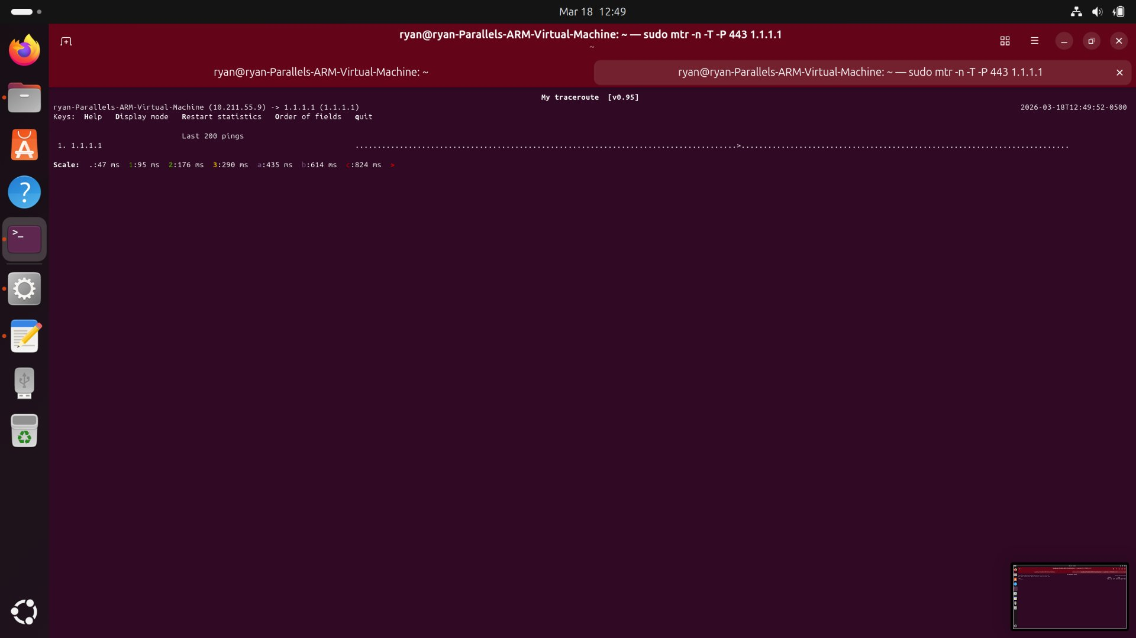
Figure 10: mtr under load — later view. Dense mixed pattern as queue alternately fills and drains.
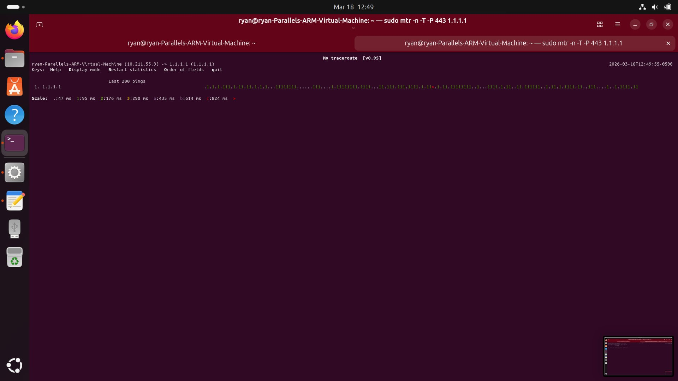
Figure 11: mtr statistics under load (157 pings) — Avg=58.1ms, Best=31.1ms, Worst=1,067ms, StDev=81.9ms. Loss=0%.

5.2 Traceroute Comparison Table (Deliverable G)
Metric | Wi-Fi Baseline | Wi-Fi Under iperf3 Load
First hop RTT | Avg 11.1 ms, Worst 12.6 ms | Avg 58.1 ms, Worst 1,067 ms
RTT StdDev | 0.6 ms | 81.9 ms
Evidence of CGNAT | No (Parallels NAT only) | No
Hop variability | Stable (+-1.5 ms) | Extreme (31-1,067 ms)
Silent hops (*) | None | None
Visible hop count | 1 hop | 1 hop
Packet loss | 0% | 0%
mtr RTT scale | 10 ms per division | 47-824 ms per division

5.3 Analysis

Where does the largest RTT jump occur?
At the only visible hop — 1.1.1.1. That might seem counterintuitive since the physical distance to Cloudflare hasn't changed. But mtr isn't measuring distance here. It's measuring total round-trip time, which includes queue wait at the home router. When iperf3 fills that queue, mtr probes sit in the same line as everything else. The propagation component (~11ms) is constant. The extra 31-1,056ms on top of that is all queue.

Is the jump distance-related or queue-related?
Queue-related. The jump disappears the moment iperf3 stops — the geographic distance to 1.1.1.1 didn't change, but the RTT dropped right back to 11ms. A 1,067ms worst-case RTT is about 96 times the baseline. Speed-of-light physics can't explain that. And packet loss stayed at 0% throughout, which rules out a congested intermediate link — congested links drop packets. These packets weren't being dropped. They were just waiting in a very long queue.

Does load change early hops?
Yes. In this setup, the load affects the only measurable hop. The WAN queue at the home router is the single bottleneck. The ISP hops between the router and 1.1.1.1 don't show up at all — they're filtering the TCP SYN probes that mtr sends, which is standard behavior for backbone routers. This is worth noting: the silence doesn't mean the route is broken. Data kept flowing at 941 Mbits/sec the entire time. Those hops just don't respond to probe packets.

Section 6 — Essay: TCP, Radio Networks, and the Bufferbloat Problem

6.1 Why TCP Was Originally Designed for Wired Networks
TCP was specified in RFC 793 (1981) in an era when the dominant medium was copper wire. Wired links have three defining properties that shaped TCP's design: they are deterministic (bit-error rates are negligible under normal operation), they exhibit low and stable propagation delay (governed only by the speed of light through copper or fiber), and they signal congestion through packet loss — when a router's queue fills, it drops packets. TCP's congestion control (Van Jacobson, 1988) exploited this clean signal: a lost packet means a queue is overflowing somewhere on the path, so back off. This closed-loop system worked beautifully in wired networks because loss was a reliable, unambiguous congestion indicator.
The experiment with iperf3 to 192.168.1.85 illustrates TCP's wired-world assumptions at their best: 941 Mbits/sec sustained with zero retransmissions, stable cwnd at 10 packets, and RTT tightly bounded at 1.9ms. The protocol achieves near-wire-rate throughput because the medium behaves exactly as TCP's designers assumed — reliable, low-latency, congestion-signaled by loss.

6.2 Why Cellular Hides Loss at Lower Layers
Cellular networks (LTE, 5G) implement aggressive link-layer error correction that fundamentally changes the signal TCP relies upon. At Layer 2, the radio link control (RLC) protocol retransmits corrupted frames transparently. A packet that experiences a bit error due to multipath fading, interference, or handover is retransmitted at Layer 2 before the IP layer ever sees it. From TCP's perspective, the packet arrives late — perhaps 20-80ms after the original transmission — but it arrives intact, with no visible loss event.
The consequence is that the congestion signal TCP depends on is masked. A cellular link that is physically stressed — near capacity, or experiencing interference — will manifest not as packet loss but as elevated and variable delay. TCP (CUBIC) interprets the absence of loss as permission to keep the window open, continuing to push data into the very buffers causing the delay. This is precisely why the mtr data under load shows 0% packet loss even as RTT reaches 1,067ms: packets are not being dropped, they are being queued. TCP cannot distinguish between "the path is fine, we just have more capacity to use" and "the path is congested and we are filling a deep buffer at the base station."

6.3 How Bufferbloat Emerges in Radio Networks
Bufferbloat is the interaction between TCP's fill-until-loss strategy and oversized buffers at network choke points. In radio networks, the Radio Access Network (RAN) — the base station and its backhaul equipment — maintains deep queues to smooth the inherent variability of the radio channel. When multiple users compete for the same cell capacity, or when a user's signal degrades, the RAN buffers data rather than drop it, preserving TCP's perception of a loss-free path.
The mtr experiment captures this precisely. During the iperf3 load, the RTT to 1.1.1.1 swings from 31ms to 1,067ms with a standard deviation of 81.9ms. The scale in Figure 9 expands to accommodate RTTs up to 824ms — a testament to how deeply the router buffer can fill. In a cellular context, this same behavior occurs at the eNodeB (LTE base station) or gNB (5G), where per-UE queues absorb burst traffic. A streaming video session, a background software update, and a VoIP call share the same base station queue; the bulk data fills it, and the VoIP packets — though tiny — must wait behind megabytes of video data.

6.4 Why BBR Often Performs Better over LTE/5G
BBR (Bottleneck Bandwidth and RTT, Google 2016) was designed specifically for the failure modes exposed above. Rather than using loss as a congestion signal, BBR maintains an explicit model of the path: it periodically probes for the maximum bandwidth (BtlBw) and separately measures the minimum RTT (RTprop). It then paces sending at BtlBw, keeping the in-flight data at exactly one bandwidth-delay product — the optimal operating point that maximizes throughput while keeping the queue empty.
In the LTE/5G context, BBR's advantage is threefold. First, it does not misinterpret radio-layer retransmission delay as congestion. Second, it does not rely on packet loss to detect queue growth — it detects queue growth directly from RTT inflation, backing off proactively. Third, BBR's ProbeRTT phase actively counteracts bufferbloat. Had the experiment in Section 4 been run with BBR, the expected outcome would be cwnd modulating to hold RTT near 11ms (the propagation baseline) rather than allowing it to climb to 78ms. The cwnd data from Figure 8 illustrates CUBIC's inability to respond to delay: cwnd grew monotonically from 1 to 10 packets even as RTT climbed from 0.13ms to 62.27ms. A BBR sender observing that same RTT trajectory would interpret it as queue growth, shed cwnd, and re-probe cautiously — resulting in lower latency with comparable throughput.

6.5 Whether Packet Loss Is a Reliable Congestion Signal in Cellular
The short answer is: no, not in general, and increasingly less so. The data collected in this experiment is illustrative: at the peak of bufferbloat, mtr measured RTT of 1,067ms with 0% packet loss. TCP CUBIC, interpreting this as a loss-free path, continued filling the queue. This is the behavioral signature of a loss signal that has been decoupled from actual congestion.
In cellular networks, this decoupling operates at multiple levels. The RLC retransmission mechanism, described above, hides radio-layer errors. Additionally, modern carrier networks deploy active queue management (AQM) algorithms such as FQ-CoDel or PIE, which can mark packets with ECN (Explicit Congestion Notification) rather than drop them. In that case, a TCP sender with ECN enabled can respond to congestion without ever seeing a dropped packet. However, ECN deployment across cellular networks is inconsistent.
The deeper problem is that even when loss does occur in cellular, it may not be congestion-related: it could be a handover event, a brief signal fade, or interference from a neighboring cell. A CUBIC sender that backs off aggressively on a random radio loss event wastes available bandwidth unnecessarily. This is why research into delay-based and model-based congestion control (BBR, QUIC's congestion integration, RMCAT for real-time media) has become so important: these algorithms attempt to understand the path's actual capacity rather than react blindly to loss events whose cause may be invisible to the transport layer. The traceroute evidence reinforces this: the Internet is layered, but performance is fundamentally cross-layer. TCP lives at Layer 4 and makes congestion decisions based on packet delivery. The radio layer below it conceals, delays, and retransmits without informing TCP. The result is that TCP's feedback loop — tuned over decades for wired networks — is systematically misled by the radio access network's reliability mechanisms. BBR and its successors represent an attempt to close this gap not by fixing the radio layer, but by making the transport layer's congestion model rich enough to see through the illusion.

Appendix — Raw Data Summary

A.1 CSV Files Collected
File | Target | Samples | Duration | Purpose
linux_ping_log192_168_1_85.csv | 192.168.1.85 | 1,624 | ~327 s | RTT baseline + load (local)
linux_ss_cwnd192_168_1_85.csv | 192.168.1.85 | 1,549 | ~327 s | cwnd/RTT congestion (local)
linux_ping_log1_1_1_1.csv | 1.1.1.1 | 2,844 | ~575 s | RTT baseline + load (internet)
linux_ss_cwnd1_1_1_1.csv | 1.1.1.1 | 485 | ~97 s | cwnd/RTT congestion (internet)

A.2 Commands Used
# Baseline ping
ping 192.168.1.85
# Python logger
python3 ping_logger.py 192.168.1.85 linux_ping_log192.csv
python3 ping_logger.py 1.1.1.1 linux_ping_log1_1_1_1.csv

# iperf3 throughput tests
iperf3 -c 192.168.1.85 -R # download
iperf3 -c 192.168.1.85 # upload

# ss cwnd sampler
python3 ss_cwnd.py linux_ss_cwnd192.csv
python3 ss_cwnd.py linux_ss_cwnd1_1_1_1.csv

# Traceroute / mtr
mtr -n -T -P 443 1.1.1.1 # baseline
sudo mtr -n -T -P 443 1.1.1.1 # under iperf3 load

# Congestion control check
sysctl net.ipv4.tcp_congestion_control

A.3 Key Statistical Values
Parameter | Value
Local baseline median RTT | 1.88 ms
Local peak RTT (load) | 55.70 ms
Local RTT inflation (median) | +2,115%
Internet baseline median RTT | 12.20 ms
Internet peak RTT (load) | 78.00 ms
Internet RTT inflation (median) | +321%
iperf3 throughput (download) | 942 Mbits/sec
iperf3 throughput (upload) | 941 Mbits/sec
iperf3 retransmissions | 0
cwnd (local, ss) | Constant 10 packets
cwnd (internet, ss) | 1-10 packets (ramping)
RTT from ss (local max) | 9.24 ms
RTT from ss (internet max) | 62.27 ms
mtr baseline avg (1.1.1.1) | 11.1 ms
mtr under load avg (1.1.1.1) | 58.1 ms
mtr worst RTT under load | 1,067 ms
mtr StdDev under load | 81.9 ms
Packet loss (all experiments) | 0%
TCP algorithm | CUBIC (loss-sensitive)

