THE YEREVAN HOUSING MARKET
Prices, Rents, Short-Term Rentals, and the Neighborhood Map — an Assessment for a Prospective Buyer
Working draft — August 26, 2026
Yerevan’s housing market is past the peak of an extraordinary, policy- and migration-fueled boom. Prices rose about 11 percent a year in 2022–24 — far more in U.S. dollar terms, given a dram that strengthened from 480 to about 365 per dollar — propelled by the arrival of some 110,000 Russians, more than 100,000 Nagorno-Karabakh refugees, a mortgage-interest tax subsidy worth 0.7 percent of GDP, and 30-percent credit growth. The subsidy expired in Yerevan on January 1, 2025; prices there went flat that year (+0.3 percent, with the center down 1–2 percent) while still-subsidized regions rose 16 percent, and rents settled roughly 30–40 percent below their 2022 peak but 50–80 percent above pre-war levels. Growth resumed in the second quarter of 2026, against a macro backdrop of 7.2 percent GDP growth in 2025, consensus projections of 5.3–5.7 percent for 2026–27, record international reserves, and positive outlooks from all three rating agencies — but also a current account deficit near 6 percent of GDP and a growth model still tethered to Russia-linked flows. The IMF has estimated overvaluation of 8–25 percent and the central bank warns of oversupply and a deteriorating price-to-rent ratio; no institution forecasts a bust, and local analysts expect stabilization with 3–7 percent growth in prime areas. Gross rental yields of roughly 5–7 percent in the center and 7–10 percent in mid-tier districts, thin Airbnb premia, seismic-quality dispersion in the building stock, and the still-undefined investment-residency rules due around November 1, 2026 frame the investment decision. The center’s post-subsidy construction freeze argues for quality central assets on a five-year-plus horizon; the currency, which flattered every recent return, is now the main two-sided risk.
CONTEXT
1. Armenia has been among the fastest-growing economies in the region, and housing sat at the center of the expansion. Real GDP grew 12.6 percent in 2022, 8.7 percent in 2023, 5.9 percent in 2024, and 7.1 percent in 2025, powered by inflows of people, capital, and re-routed trade following Russia’s invasion of Ukraine. The dram appreciated from about 480 per U.S. dollar before 2022 to roughly 365 by August 2026, and consumer inflation collapsed to near zero in 2024 (0.3 percent average) — so housing, rising at 9–14 percent in dram terms in the boom years, outpaced every other price in the economy by a wide margin. The IMF’s 2024 review summarized the episode plainly: house prices rose by an annual average of 11 percent over three years, driven by strong demand and buoyant mortgage and construction lending.
2. Three overlapping demand shocks, amplified by a large fiscal subsidy, produced the boom. First, roughly 110,000 Russians relocated to Armenia in 2022 (60,000–65,000 stayed, concentrated in Yerevan), doubling or tripling central rents within months. Second, more than 100,000 ethnic-Armenian refugees arrived from Nagorno-Karabakh in late 2023, adding demand concentrated in the budget segment. Third, foreign and diaspora purchases have run at a three-year high — 2,014 properties in 2025 (+27 percent), about two-thirds bought by Russian citizens. Underneath all of this, a mortgage income-tax refund program subsidized new-build purchases at a fiscal cost reaching 0.7 percent of GDP (Box 1). Its geographic phase-out is now the single most important force shaping relative prices across the country.
3. This note splices official and private sources, whose definitions differ; figures should be read as consistent in direction rather than to the last digit. Price levels come mainly from the State Real Estate Cadastre Committee’s “average market value” series (transaction-based, published by district) as republished in the Armenian press, cross-checked against the Central Bank of Armenia’s hedonic residential property price index (RPPI), IMF and ADB assessments, Grant Thornton’s annual market reviews, listing portals, and three competing short-term-rental analytics providers. Listing-based sources (Numbeo, portals) skew toward renovated, dollar-priced stock and sit 20–30 percent above cadastre transaction values; both are reported below and labeled.
THE MACROECONOMIC BACKDROP
4. Armenia enters 2026 with strong momentum, and the institutional consensus projects growth of 5.3–5.7 percent in 2026–27 against potential of about 5 percent. Real GDP grew 7.2 percent in 2025 (accelerating to 9.8 percent in the fourth quarter), with construction (+21 percent), ICT, and finance leading; activity was up 7.7 percent through July 2026 and second-quarter GDP rose 6.7 percent. The forecast range is tight: the IMF projects 5.3 percent for 2026 and 5.5 percent for 2027 (April 2026 WEO; the June 2026 program review says “around 5¼”), the World Bank 5.3 and 5.1, the EBRD 5.5 and 5.5, the ADB 5.5 and 5.7, Fitch 5.2, Moody’s 5.0–5.5, the government’s budget 5.4, and the EDB 6.0 — all converging toward roughly 5 percent over the medium term (Figure 1, Table 1). Notably, the IMF raised its estimate of potential growth from 4.5 to about 5 percent in the December 2025 Article IV, with 2026–27 growth above potential partly on the opening of the Amulsar gold mine. For housing, the demand backdrop this implies — nominal wages up 5.6 percent in 2025, registered employment up 4.6 percent — is supportive but no longer extraordinary.
Figure 1. Armenia real GDP growth, actual and projected, 2021–2027.
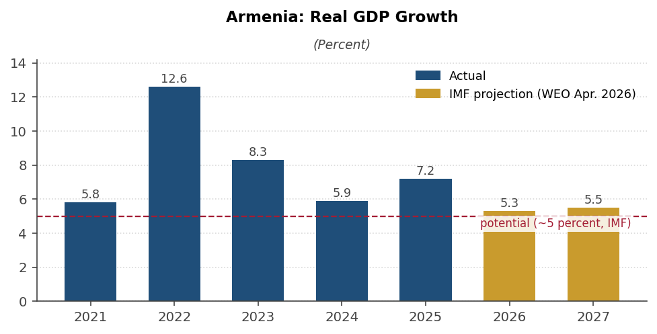
Sources: Armstat; IMF World Economic Outlook (April 2026); and IMF 2025 Article IV Consultation.
5. Inflation is back, modestly: prices are running 4–5 percent against a 3 percent target, and the easing cycle has stopped. After averaging 0.3 percent in 2024 and 3.3 percent in 2025, headline inflation printed 4.2–5.3 percent year on year through mid-2026, with food up 8.6 percent. Forecasts put 2026 average inflation at 3.6 percent (IMF) to 4.6 percent (World Bank), converging to target by 2027–28; the IMF attributes the near-term elevation to commodity prices and trade-rerouting logistics costs. The central bank cut its refinancing rate from a peak of 10.75 percent (December 2022) to 6.50 percent (December 2025) and has held it since, with the IMF advising that it “should be prepared to raise” rates. The practical implication for property: dram mortgage rates of about 12.5 percent are unlikely to fall meaningfully soon, keeping local leverage expensive and cash buyers advantaged.
6. The external accounts are the soft spot: a current account deficit near 6–7 percent of GDP, headline trade whipsawed by a re-export boom that has ended, and FDI at a historic low. The current account swung from a 0.7 percent-of-GDP surplus in 2022 to deficits of 4.6 percent in 2024 and 5.4–6.7 percent in 2025 (estimates vary; the IMF’s April 2026 WEO shows 6.7 percent), projected at 5–6 percent through 2027. Headline exports fell 36 percent in 2025 — entirely the unwind of the extraordinary gold-and-diamond re-export arbitrage with Russia, which peaked at US$15.4 billion of precious-metals trade in 2024 and collapsed after Russia scrapped its gold export duty; excluding precious metals, exports grew 8.9 percent. Remittance-type inflows remain large (US$6.0 billion gross, US$1.6 billion net in 2025) and Russia-heavy (about 65 percent). Net FDI fell to 0.3 percent of GDP in 2024 — a historic low, on Russian divestment — though a US$3.5 billion U.S.-linked AI data-center project (about 12 percent of GDP) is a prospective offset. The financing cushion, meanwhile, has never been thicker: gross reserves reached a record US$5.2 billion at end-2025 and US$5.7–6.9 billion by mid-2026 (over four months of imports), and the dram — up roughly 28 percent against the dollar since 2021, at 365 in August 2026 — remains firm.
7. Fiscal policy is loosening moderately from a strong position, public debt sits near 50 percent of GDP, and all three rating agencies moved to positive outlooks in mid-2026. Deficits of 3.7 percent of GDP in 2024–25 came in well under budget; the 2026 budget targets 4.5 percent, notably financing a 15 percent cut in defense spending — the first since the 2020 war, a direct dividend of the August 2025 Washington peace declaration — while the medium-term path targets 2.8 percent by 2028. Government debt of 49–51 percent of GDP stays comfortably below the 60 percent fiscal-rule threshold, peaking near 52 percent in 2028 on IMF projections. A 36-month precautionary IMF Stand-By Arrangement (SDR 128.8 million, approved December 2025, first review completed June 2026, undrawn) provides insurance. Fitch (BB–), Moody’s (Ba3), and S&P (BB–) all affirmed with positive outlooks in July–August 2026, citing the peace framework, record reserves, and above-peer growth.
8. The macro risk map and the housing risk map are the same map: both concentrate on the durability of Russia-linked flows, now joined by Middle East spillovers. The IMF’s adverse scenario — a geopolitical shock cutting remittances 45 percent — takes 2026 growth to 3.0 percent, pushes debt above 60 percent of GDP, and drains reserves toward US$2.6 billion; its June 2026 review flags “unprecedented uncertainty” from the Middle East war via energy import bills, logistics, and tourism. Russia still accounts for roughly two-fifths of trade and tourists and two-thirds of transfers, so the housing investor and the macro forecaster are exposed to the same variable. Upside is equally identifiable: implementation of the peace treaty and TRIPP corridor, a Türkiye border opening, and the EU-accession process launched by the March 2025 law (membership would require a referendum). For the purchase decision, the point is that Armenian macro risk and Yerevan property risk do not diversify each other — they are one bet, taken once.
Table 1. Armenia: selected economic indicators, 2022–2027.
 | 2022 | 2023 | 2024 | 2025 | 2026 proj. | 2027 proj.
Real GDP growth (%) | 12.6 | 8.3 | 5.9 | 7.2 | 5.3 | 5.5
CPI inflation (avg., %) | 8.6 | 2.0 | 0.3 | 3.3 | 3.6 | 3.4
Current account (% of GDP) | 0.7 | -2.8 | -4.6 | -6.7 | -6.0 | -5.2
Fiscal balance (% of GDP) | -2.1 | -2.0 | -3.7 | -3.7 | -4.5 | -3.5
Government debt (% of GDP) | 49.2 | 50.5 | 50.0 | 49.0 | 50.6 | 51.2
Gross reserves (US$ billion) | 4.1 | 3.6 | 3.7 | 5.2 | 5.7–6.9 ¹ | …
Drams per U.S. dollar (avg.) | 436 | 393 | 393 | 383 | 365 ¹ | …
Sources: IMF World Economic Outlook (April 2026) and 2025 Article IV Consultation; Armstat; Central Bank of Armenia; S&P. Projections are IMF. ¹ Mid-2026 actual (reserves range reflects differing S&P and Ministry of Finance citations).
PRICE DEVELOPMENTS
9. After a decade of quiet, prices rose sharply from 2022, paused in 2025, and are rising again in 2026. The cadastre’s Yerevan average stood at AMD 268,000 per square meter in early 2013 and only AMD 330,000–350,000 in 2020–21, COVID dip included — essentially a decade of stagnation in dram terms. The 2022 influx lifted prices about 14 percent citywide (Davtashen led at +17.5 percent), 2023 brought a pause, and 2024 delivered +8.8 percent to AMD 426,800 per square meter as buyers rushed to beat the tax-refund cutoff. In 2025 the market went flat: +0.3 percent for the year, with Kentron down 1.4 percent, Arabkir down 1.75 percent, and pockets of the center down 4–7 percent. The IMF noted that July 2025 saw the first year-on-year contraction in the average Yerevan square-meter price after 50 months of growth. From the second quarter of 2026 the central bank reports renewed increases of 1–1.5 percent a month, and the June 2026 district table shows Kentron roughly 7 percent above its December 2025 level (Figure 2).
10. The 2024 surge was a policy artifact: demand pulled forward ahead of the subsidy’s expiry. Yerevan purchase-sale transactions jumped 32.1 percent in 2024 (apartments +35.5 percent, to 10,940), December 2024 was the strongest month in a decade, and mortgage growth peaked near 37 percent at end-2024 as buyers locked in the expiring credit. The hangover followed on schedule: mortgage growth fell to 13.1 percent in 2025 — the slowest major lending segment — and Yerevan prices stalled even as nationwide purchase-sale transactions hit a record 59,748.
11. The 2025 stagnation was specific to Yerevan apartments; the rest of the market kept booming. Prices of apartments outside Yerevan rose 9.4 percent (regional cities +16.4 percent per the cadastre), and individual houses — a segment the capital’s data barely capture — rose 17.4 percent on the year and 27.2 percent in the fourth quarter (CBA RPPI). The still-live regional tax refunds, refugee resettlement, and spillover demand from priced-out Yerevan buyers all point the same way. Within Yerevan, the cheaper mid-ring outperformed: Ajapnyak rose 13.7 percent in 2025 while the prestige center declined — a classic late-cycle rotation.
12. In dollar terms the run-up is larger and levels are no longer cheap for the region. At June 2026 cadastre values, secondary-market Kentron runs about US$2,500 per square meter, Arabkir US$1,830, the mid-ring US$1,200–1,450, and Nubarashen US$700 (Figure 3, Table 3). New-build asking prices are materially higher — the minimum asking average across Kentron projects is AMD 1,293,000 (about US$3,360) per square meter, with Northern Avenue at US$3,200-plus and elite projects quoting US$5,000–10,000. A dollar-based buyer has faced both the dram price rise and roughly 25 percent currency appreciation since 2021; the same leverage works in reverse if inflows fade.
Figure 2. Yerevan average apartment price, 2020–2025, with 2026 direction.
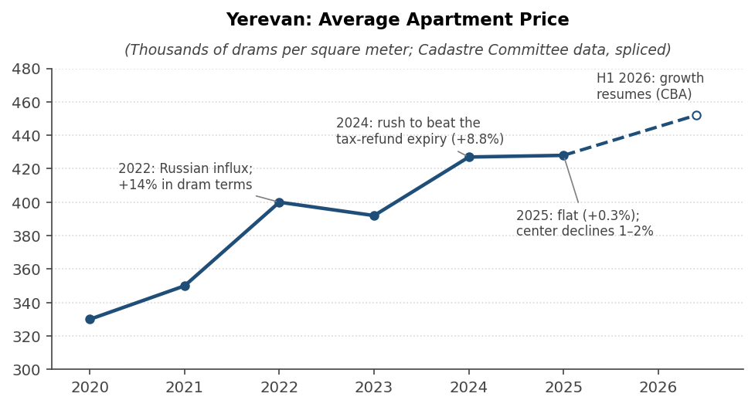
Sources: State Real Estate Cadastre Committee via Finport, Armenpress, and EVN Report; Central Bank of Armenia; and author’s splicing.
Figure 3. Secondary-market prices by district, July 2022 versus June 2026.
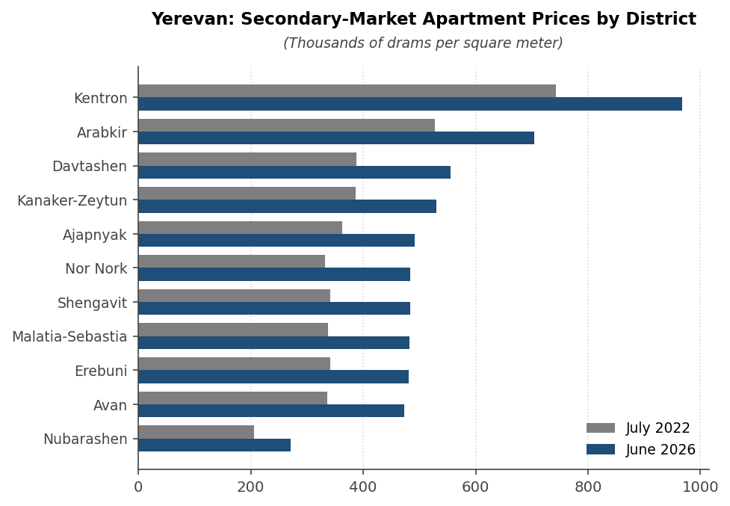
Sources: Official statistics via news.am (Jul 2022) and b24.am (Jun 2026).
THE RENTAL MARKET
13. Rents doubled to tripled within months of the 2022 influx — the sharpest dislocation in the market’s history. A central two-to-three-room apartment that rented for AMD 140,000–180,000 (US$370–460) in January 2022 peaked at AMD 400,000–500,000 (US$1,050–1,300) by late 2022. Landlords raised rents mid-lease with impunity — informal, unregistered contracts dominate the market — and Kentron accounted for a third of all rental deals. Economists’ estimates of the aggregate spike converge on “two to three times” depending on segment.
14. The correction from mid-2023 gave back roughly a third of the spike, and the market has since settled well above pre-war levels. As a majority of the 2022 relocants moved on — survey work found 57 percent intending to leave — rents fell about 30–40 percent from peak through 2024. Nagorno-Karabakh refugees partially offset the departures but at far lower purchasing power, shifting demand to the budget segment: agents report the most-demanded bracket at US$300–500 a month, a tenant shortage in the US$1,000–3,000 premium tier, and rental transactions down 28.6 percent in 2025. Realtors’ consensus is that rents will not return to pre-2022 levels: a central one-bedroom that cost about US$400 in 2021 now runs US$550–850 — roughly 50–80 percent above pre-war (Figure 4).
15. Current listing averages: about US$850 for a one-bedroom in the center, US$575 outside it, with survey-based sources 20–30 percent below listing platforms. Numbeo (August 2026, listing-skewed) shows a one-bedroom in the center at AMD 326,000 (≈US$847; range 250,000–450,000), a three-bedroom in the center at AMD 508,000 (≈US$1,320), and one-bedrooms outside the center at AMD 221,000 (≈US$575). Expat cost-of-living guides put Kentron one-bedrooms at US$550–850 and two-bedrooms at US$800–1,200, which is more representative of the full stock. Utilities are tenant-paid; deposits of one month and discounts for 6–12-month prepayment are market practice; there is no rent control.
16. Gross rental yields cluster at 5.5–7 percent in the center and 7–10 percent in mid-tier districts — and the central bank says the ratio is moving against investors. Numbeo puts gross yields at 5.7 percent in the center and 7.5 percent outside; practitioner estimates run 7.8 percent citywide gross and about 6 percent net, with Arabkir at 8–10 percent gross; deduct roughly 1.5–2 percentage points for tax, voids, and maintenance to reach net. CBA Governor Galstyan stated in May 2026 that the price-to-rent ratio has risen — prices grew while rents fell — “which may lead to a decline in the investment attractiveness of real estate.” The arithmetic favors the mid-ring over the prestige center for income buyers.
Figure 4. Indicative central-Yerevan one-bedroom rent, 2021–2026.
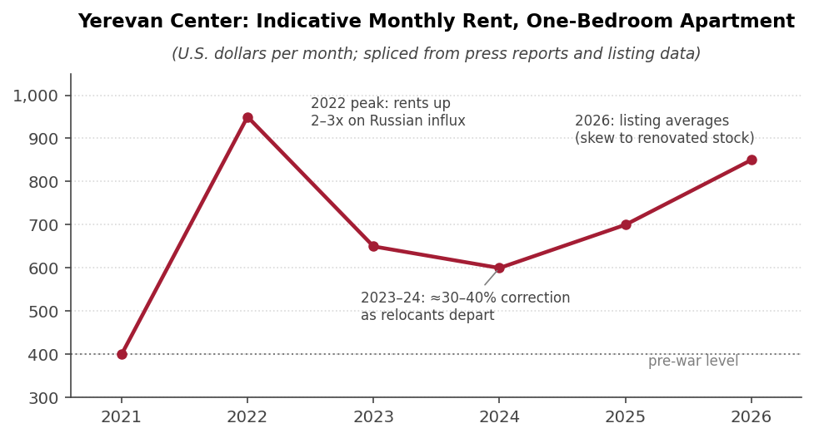
Sources: CivilNet; JAMnews; Mirror-Spectator; Numbeo (Aug 2026); and author’s splicing.
SHORT-TERM RENTALS (AIRBNB)
17. Yerevan’s Airbnb market is mid-sized, fast-growing on the supply side, and dominated by amateur hosts. The three analytics providers disagree on levels — active listings of 2,400–6,000 depending on definitions — but agree on direction: supply is growing 14–34 percent a year, only 0.2 percent of listings are professionally managed, and about half of hosts are superhosts (Table 2). Guests are 88 percent international, with Russia the top origin.
18. The revenue math is modest: US$60–76 average daily rates and realistic occupancy of 50–65 percent put a well-run central one-bedroom at US$10,000–15,000 of gross annual revenue. Seasonality is pronounced — August peaks near US$1,300–1,450 a month against US$730–780 in February — and the average stay is long (7.3 nights), reflecting relocation and remote-work demand rather than pure tourism. Against a long-term lease on the same unit (roughly US$8,000–10,000 a year at current central rents), the short-term premium is thin once cleaning, utilities, platform fees, management time, and voids are deducted. The premium is real mainly for well-located, well-managed Kentron units in the May–September window.
19. Demand has plateaued while supply keeps compounding — the occupancy and rate outlook is therefore soft. Tourist arrivals hit a record 2.33 million in 2023 (+40 percent), slipped 4.6 percent in 2024, and set a marginal record again in 2025 with the Russian share falling from about half to 41 percent as Georgian, Iranian, and Gulf visitors diversify the mix. Arrivals in 2023–2026 have effectively flatlined at 2.2–2.4 million a year against listing growth of 25 percent-plus — a recipe for rate compression that the strong dram aggravates for dollar-earning hosts.
20. Taxation is light and identical across rental modes, and regulation remains permissive. Rental income of an unregistered individual is taxed at a flat 10 percent of gross (rising to 20 percent only above AMD 60 million a year); short-term rentals require no permit, license, or zoning approval in Yerevan, and the new tourism notification system effective July 2026 exempts private individuals letting a single apartment. Registered entrepreneurs can use a 10 percent turnover-tax regime instead. Property tax is progressing to full cadastral market value from 2026 at 0.05–1.5 percent. Fines apply for undeclared leases (up to AMD 500,000), and platforms do not withhold Armenian tax — compliance is the owner’s problem.
Table 2. Yerevan short-term rental metrics across analytics providers.
Metric (TTM to mid-2026) | AirDNA | AirROI | Airbtics (Jan 2026)
Active listings | 6,014 (all STR) | 2,430 | 2,762
Average daily rate | US$74 | US$76 | US$60
Occupancy | 62% | 39% (calendar basis) | 66% (median)
Revenue per listing, per year | US$8,100 (avg.) | US$7,400 avg.; US$10,000 median | US$15,000 median
Supply growth, y/y | +13.7% | +25.8% | +34.1% (3-yr +102%)
Sources: AirDNA; AirROI; Airbtics (trailing-twelve-month data to mid-2026). Definitional differences explain the level gaps; direction is consistent.
THE NEIGHBORHOOD MAP
21. The price hierarchy across Yerevan’s twelve districts has been stable for a decade: Kentron trades at 2.1–2.3 times the city average, Arabkir at about 1.5 times, and Nubarashen at little more than half. What moves is the second derivative. In 2021–22 Davtashen rose fastest; in 2024 the top group was Nor Nork, Davtashen, Avan, and Kanaker-Zeytun; in 2025 Ajapnyak (+13.7 percent) led while the prestige center declined; and the first half of 2026 shows a broad-based rebound with Nork-Marash and the southern mid-ring jumping most. Table 3 assembles the June 2026 levels, 2025 changes, and new-build asking prices.
Table 3. Yerevan district panorama, mid-2026.
District | Price, Jun 2026 (AMD th./sq m) | ≈US$ /sq m | 2025 y/y (%) | New-build min. asking (AMD th.) | Character
Kentron | 966.9 | 2,510 | -0.8 | 1,293 | Prime center; tuff-stone classics and dense elite new-builds; Northern Avenue/Small Center at US$3,200+ new; metro; STR hub
Arabkir | 703.7 | 1,830 | -1.5 | 751 | No. 2 prestige; established middle class; Komitas corridor; best rental yields (8–10% gross reported)
Nork-Marash | 562.2 | 1,460 | n.a. | 714 | Small hillside district; Monument area luxury enclave with Ararat views; car-dependent
Davtashen | 555.0 | 1,440 | -0.1 | 596 | Green, elevated; heavy new construction; fastest riser of 2021–22; family-oriented
Kanaker-Zeytun | 529.7 | 1,380 | +1.7 | 586 | Mid-priced; strong new-build demand as Arabkir spillover
Ajapnyak | 491.0 | 1,280 | +13.7 | 540 | NW massivs; fastest-rising district of 2025; new complexes near Hrazdan gorge; affordable
Nor Nork | 483.0 | 1,260 | +3.6 | 527 | Largest bedroom district; construction boom in upper massivs; first-time buyers
Shengavit | 483.0 | 1,260 | -0.7 | 654 | Best metro coverage outside center; Arshakunyats Avenue new-build corridor — widest new-vs-secondary price gap after Kentron
Malatia-Sebastia | 482.9 | 1,250 | +1.1 | 601 | Largest western district; budget secondary stock; Dalma Garden zone emerging premium
Erebuni | 481.0 | 1,250 | -2.3 | n.a. | Southeast, mixed industrial; budget segment; refugee-driven rental demand
Avan | 473.0 | 1,230 | -0.7 | 533 | Village-like northeast; cheapest new-build entry ticket (≈AMD 16 million)
Nubarashen | 271.0 | 700 | +4.1 | n.a. | Detached semi-rural exclave; lowest prices; minimal construction
Sources: official statistics via b24.am (Jun 2026 levels; Dec 2025 y/y); Karucapatoxic/korter.am (new-build minimum asking, Jul 2026, mean across 81 projects); district characterizations from agency and portal guides. US$ at AMD 385 per dollar.
22. Kentron is the liquidity and prestige play — and the one district where the supply picture argues for scarcity. The center holds the tuff-stone classics, Northern Avenue, the Cascade, and most elite new construction, draws the diaspora, expat, and short-term-rental demand, and books a third of the city’s rental contracts. Within it, the Small Center (inside the ring) commands a premium over the rest of the administrative district. Because the tax-refund cutoff hit central zones first (2022–23), the new-build pipeline in Kentron and Arabkir has thinned sharply — a medium-term scarcity argument for quality central stock. Two caveats: 2025’s only district-level price declines were here, and the US$3,000-plus elite segment carries absorption risk, with developers now openly marketing to non-residents to move units. Redevelopment optionality (Firdus district, the Kond concept) adds long-dated upside for adjacent blocks.
23. Arabkir is the yield-and-solidity play; its satellites capture the spillover. The city’s second-prestige district — established middle-class, strong schools, the Komitas corridor as its investor sub-market — posts the best reported rental yields in the city (8–10 percent gross) because prices sit 30 percent below Kentron while rents do not. Adjacent Kanaker-Zeytun and Davtashen absorb the demand Arabkir prices out, which is why they appear repeatedly among the fastest risers; Nork-Marash’s Monument plateau is a separate luxury-villa enclave whose upper reaches price near Kentron.
24. The mid-ring is where the construction wave and the price momentum now live; the southern and eastern budget districts are rent-demand, not appreciation, stories. Shengavit’s Arshakunyats Avenue corridor shows the city’s widest gap between new-build asking (AMD 654,000) and secondary values (AMD 483,000) outside Kentron — the clearest bet on district transformation, with the best metro coverage in the city. Ajapnyak, Malatia-Sebastia (Dalma Garden flank), Nor Nork’s upper massivs, and Davtashen carry most of the current pipeline. Erebuni, Avan, and Nubarashen remain budget markets where the refugee influx lifted rents off a small base; they are the highest-yield, lowest-liquidity corner of the city.
SUPPLY, CREDIT, AND POLICY
25. A supply wave is landing on the market: completions doubled in 2024 and construction keeps growing 20–27 percent a year. Housing commissioned in January–November 2024 reached 928,900 square meters, up 89 percent year on year; construction output rose about 20 percent through 2025 and 24.5 percent in the first half of 2026; and construction credit has expanded around 30 percent for two consecutive years — the fastest-growing loan segment. The central bank’s Financial Stability Report flags the combination explicitly: completions doubling while permits edge down and demand normalizes “could lead to the formation of excess supply,” with attendant credit losses. The pipeline has rotated away from the de-subsidized center toward the mid-ring and the regions.
26. The mortgage market has downshifted from 37 percent growth to 13 percent, under a progressively tighter macroprudential frame. Mortgage debt stands near 14.7 percent of GDP (a six-fold rise since 2018, now a quarter of bank lending); average dram mortgage rates run 12.4–12.5 percent; and 76 percent of mortgages fund primary-market purchases. The CBA capped loan-to-value at 90 percent for dram mortgages and 70 percent for FX-linked real-estate loans from May 2025, banned FX mortgages outright in 2023, and raised the countercyclical buffer to 1.75 percent. The IMF keeps further LTV cuts and higher construction risk weights explicitly on the shelf should mortgage growth re-accelerate. For a foreign cash buyer these constraints matter mainly as a brake on local leverage-driven price spirals — and as a reason financing a purchase locally is unattractive.
Box 1. The Mortgage Income-Tax Refund Program — the Boom's Policy Engine
Since 2015, salaried employees purchasing a newly built apartment directly from a developer have been able to reclaim their salary income tax against mortgage interest, up to a quarterly cap. The program grew from roughly AMD 1 billion per year in 2015–17 to AMD 22.7 billion in 2021; cumulative refunds reached AMD 299 billion (over 70,000 beneficiaries) by January 2026, and the IMF put the fiscal cost at about 0.7 percent of GDP in 2024. The ADB judged that the program “had the unintended consequence of further inflating housing prices,” and the IMF identified it as a principal driver of the tripling of banks’ mortgage books.
The phase-out has proceeded by geography: central Yerevan (Zone 1) lost eligibility for new loans in July 2022, Zones 2–3 during 2023, and the rest of Yerevan on January 1, 2025 — since when no new Yerevan mortgage qualifies. Four regions surrounding the capital (Aragatsotn, Ararat, Armavir, Kotayk) lose eligibility on January 1, 2027, and the remaining regions on January 1, 2029, with border settlements exempt. For loans issued from 2025 the quarterly cap was halved to AMD 750,000 with a property-price ceiling of AMD 55 million.
The program’s footprints are visible in every data series: the 2024 rush to buy before the Yerevan cutoff (transactions +32 percent, mortgage growth peaking at 37 percent), the 2025 stagnation of Yerevan prices and deceleration of mortgage growth to 13 percent, the 16 percent price surge in the still-subsidized regions, and the collapse of the new-construction pipeline in Kentron and Arabkir.
Yerevan prices no longer enjoy this subsidy — the market there now runs on unsubsidized demand — while the 2027 regional cutoff may generate one more round of anticipatory buying outside the capital in late 2026.

WHAT THE SPECIALISTS SAY
27. The IMF has quantified overvaluation and endorsed the cool-down. The 2023 Article IV estimated house-price overvaluation of 8–25 percent on a borrowing-capacity approach, attributed much of the price dynamic to the tax-credit-fueled tripling of mortgage books, and recommended tighter borrower-based limits. The December 2025 Article IV describes a market “now cooling,” documents the July 2025 price contraction, credits the subsidy phase-out with helping cool the market, and judges deposit-outflow risks from the Russian money “contained” given banks’ liquid-asset backing (capital adequacy near 20 percent). No IMF numeric price forecast exists.
28. The Central Bank of Armenia is the most explicitly cautious voice. Its own estimates put prices 16–22 percent above fundamentals by 2022, revised to about 25 percent by May 2023. The 2024 Financial Stability Report warns of excess supply, notes that falling rents against firm prices erode the servicing capacity of investment mortgages, and the Governor’s 2026 presentation urged banks to underwrite against worst-case scenarios while flagging the deteriorating price-to-rent ratio as a signal of declining investment attractiveness — even as the Deputy Governor confirmed the Q2 2026 price recovery.
29. The ADB judges the market to be near the top of its cycle, with affordability stretched to exclusion. Its 2025 housing-finance assessment records prices up over 100 percent since 2014, calculates that an average two-income Yerevan household can afford a home of AMD 18–23.5 million — below prevailing prices — with the bottom three income deciles “effectively excluded,” and concludes the market “may be approaching the peak of its cycle, thereby resulting in reduced activity and potential price correction.”
30. Local analysts converge on “soft landing, then modest growth” — with dissenters worried about credit, not prices. Grant Thornton expects 2026 demand sustained by 5–5.9 percent GDP growth and the still-live regional refunds, with possible anticipatory buying in late 2026 ahead of the 2027 regional cutoff; the realtors’ association expects flat real prices; the SIEVN agency forecasts 3–7 percent annual growth in prime areas with stabilization overall, recommending only quality locations on five-year-plus horizons; Orbeli sees a long-term upward trend and no bubble. The skeptics — the Luys Foundation, Hrant Mikaelian, Suren Parsyan — aim their warnings at the credit boom (loans growing at twice deposits, debt burdens outpacing incomes) and at growth quality rather than predicting a housing bust. Nobody credible calls Yerevan cheap; nobody credible forecasts a crash.
OUTLOOK AND RISKS
31. The base case for 2026–27 is stabilization-plus: low-single-digit growth in Yerevan apartments, continued outperformance of houses and regions, and renewed central momentum led by non-resident demand. The Q2 2026 re-acceleration (1–1.5 percent a month on the central bank’s reading) is consistent with the June district tables and with developers’ pivot to foreign buyers. The 2027 removal of subsidies in the four regions ringing Yerevan should redirect some demand back toward the capital from 2027, while the supply wave caps the pace. A reasonable planning assumption is dram-terms appreciation of 3–7 percent a year in good central and mid-ring stock, near zero in the elite new-build overhang.
32. Risks to the outlook remain tilted to the downside, and they are unusually concentrated in a single external variable: the Russian connection. Non-resident deposits amount to US$1.8 billion (7.2 percent of GDP); FDI has already collapsed from US$926 million in 2022 to US$76 million in 2024 with net Russian divestment; net money inflows from Russia halved in 2024; and the IMF’s adverse scenario — remittances down 45 percent — cuts growth to 2.5–3 percent. The rental market has already demonstrated the mechanism: the marginal renter and the marginal buyer of central Yerevan property are disproportionately non-resident. Secondary risks: (i) absorption failure in the elite new-build segment; (ii) the credit boom (lending growing at twice deposits) meeting a slower economy; (iii) dram depreciation, which would cut dollar-basis values even if dram prices hold — the mirror image of the 2022–25 tailwind; and (iv) geopolitics, where the August 2025 Washington peace treaty and TRIPP corridor are genuine upside but remain unconsolidated.
33. Building quality is a first-order screening criterion, not a detail: the Seismic Service assesses 45 percent of Yerevan’s buildings as highly susceptible in an earthquake, with only about 5 percent retrofitted. The premium on post-2010s construction by reputable developers is partly a seismic-quality premium and is rational. Two further structural cautions for a buyer: off-plan purchases register in official statistics only at completion — title and completion risk sits with the buyer in the interim — and the rental market’s informality (most leases unregistered) is an enforcement risk that market practice, which leans landlord-friendly, only partly offsets.
CONSIDERATIONS FOR THE PURCHASE DECISION
34. On timing: the entry point is defensible — the policy-fueled blow-off is behind the market — but this is not a distressed market, and the window of flat prices is closing. A 2026 buyer is not paying into the 2024 rush; central prices are 1–2 percent off their peak and stagnant for eighteen months. Against that, the central bank itself flags valuations as stretched against rents, institutional estimates of overvaluation (8–25 percent) have not been worked off, and the Q2 2026 re-acceleration means waiting has begun to cost money again. The strong dram makes the dollar entry price near its historic high; a staged or negotiated entry — secondary-market sellers in Kentron have been the market’s weakest hands — is preferable to chasing new-build asking prices.
35. On location: the analysis favors two configurations — quality Kentron secondary stock for capital preservation and liquidity, or Arabkir and the strong mid-ring for income. Kentron offers the deepest resale and rental market, the short-term-rental option, the post-subsidy construction freeze as a scarcity argument, and redevelopment optionality — at 5.5–7 percent gross yields and the highest exposure to non-resident demand swings. Arabkir (and its Kanaker-Zeytun/Davtashen satellites) offers 8–10 percent reported gross yields, steadier local demand, and lower entry prices; the Arshakunyats corridor in Shengavit is the speculative transformation play. The demand sweet spot is 50–75 square-meter units in new or renovated buildings. The elite US$3,000-plus new-build segment is the part of the market to avoid: it carries the absorption risk and the thinnest secondary market.
36. On the income case: expect roughly 4.5–6 percent net, whichever rental mode is chosen — the investment thesis must rest on total return, not yield alone. A worked example: a renovated 60-square-meter Kentron one-bedroom at cadastre-consistent values costs about AMD 58 million (≈US$150,000). Let long-term at US$700–850 a month it grosses 5.6–6.8 percent, or about 4.5–5.5 percent net of the 10 percent income tax, property tax, voids, and upkeep. Run as a short-term rental it grosses US$10,000–15,000 in a good year — similar net after platform fees, cleaning, utilities, and management, with more work and more seasonality. An equivalent Arabkir or mid-ring unit at US$85,000–100,000 renting at US$450–600 clears 6.5–8 percent gross. Adding base-case appreciation of 3–7 percent gives a respectable but not exceptional dram-terms total return of roughly 8–12 percent, with the dollar outcome hostage to the exchange rate in both directions.
37. On mechanics: foreign individuals buy apartments freely and cheaply, but financing locally is unattractive and the tax details reward structuring advice. Foreign nationals may own apartments and buildings outright (direct land ownership is reserved for citizens and local entities — relevant only for a standalone house purchase, where a local company or long lease is the standard route). Transaction costs are low, registration is fast, and the market prices in dollars by custom. Dram mortgages at 12.5 percent make cash purchase the default for a foreign buyer. Rental income is taxed at a flat 10 percent of gross; the treatment of an eventual resale differs by counterparty and seller status — individual-to-individual sales are generally untaxed while sales to entities and entrepreneurial activity are not — and the 2026 move of property tax to full cadastral market value modestly raises carry costs. These specifics, and the entrepreneurial-versus-personal structuring question in Box 2, are worth an hour of Armenian counsel’s time before signing anything.
Box 2. Property Purchase and the Residence-Permit Question
Buying an apartment in Armenia confers no residence status by itself under current rules. A new framework for investment-based residence permits is expected to be defined by Government decision around November 1, 2026; Armenian counsel consulted in August 2026 report that the appointment system for business-based permits is fully booked until that date, that the investment route’s parameters (threshold, eligible assets) are not yet established, and that the one confirmed feature is an immediate five-year permit for successful applicants.
Whether residential real estate will qualify as an eligible investment is genuinely open. One reading is that if the decision borrows the definition of “investment” from the Law on Foreign Investments, property acquired for entrepreneurial purposes (for example, an apartment operated commercially as a rental) could qualify, while a purely residential purchase likely would not. A quota applies to all residence-permit categories, so an investment does not by itself guarantee a grant.
If part of the motivation for a Yerevan purchase is the residence permit, the prudent sequencing is to wait for the November decision text before committing — the structure of the purchase (personal versus entrepreneurial) may determine its immigration value.

38. Bottom line: a fair-value, income-plus-modest-growth market with one large binary attached. Yerevan is past its policy-fueled peak and has absorbed the correction that the flat 2025 delivered; the institutions that called it overvalued also describe an orderly cool-down, not a bust in waiting. A selective purchase — central or strong mid-ring, seismically sound, 50–75 square meters, bought against cadastre values rather than elite asking prices — should earn its 8–12 percent dram-terms total return with moderate risk. The two questions that dominate the expected outcome are outside the housing data: the dram, which has flattered every recent return and can just as easily reverse, and the November 2026 investment-residency decision, which could convert an ordinary property investment into the anchor of a residence strategy — or leave it as just an apartment. Sequencing the purchase after that decision text is available costs little and may be worth a great deal.
ANNEX. SOURCES
Official and institutional
Central Bank of Armenia, Residential Property Price Index Report, 2025Q4 — cba.am/file_manager/Statistics_reports/RealSector/RPPI Report 2025Q4_eng.pdf
Central Bank of Armenia, Financial Stability Report 2024 — cba.am/file_manager/Financial Stability Report 2024 ENG.pdf
IMF Country Report No. 25/323, 2025 Article IV Consultation and Sixth SBA Review (Dec 2025) — imf.org
IMF Country Report No. 23/416, 2023 Article IV Consultation (house-price overvaluation box) — imf.org
IMF Country Reports No. 24/348 and 25/152 (Fourth and Fifth SBA Reviews); First Review under the 2025 SBA (June 2026, PR 26/195) — imf.org
IMF World Economic Outlook database, April 2026 (growth, inflation, current account, fiscal, debt series) — imf.org/external/datamapper
World Bank Macro Poverty Outlook (Spring 2026) and Armenia Monthly Economic Updates (Nov 2025, Jul 2026)
EBRD Regional Economic Prospects (June 2026); ADB Asian Development Outlook (April 2026), Armenia chapter
Rating actions: Fitch BB– Positive (Jul 13, 2026); Moody’s Ba3 Positive (Jul 29, 2026); S&P BB– Positive (Aug 2026) — via ArmBanks/ArmRadio/ARKA
ADB, Sector Assessment: Housing Finance, RRP ARM 58122-001 (2025) — adb.org/sites/default/files/linked-documents/58122-001-ssa.pdf
State Committee of the Real Estate Cadastre annual/quarterly market analyses, as republished by Finport, ARKA, Armenpress, news.am, and b24.am
Swiss Embassy Yerevan, Economic Report Armenia 2024/25 (Oct 2025)
World Bank, Armenia Monthly Economic Update (Mar 2026) and Economic Pulse
Market data and analysis
Grant Thornton Armenia, “Analysis of the Real Estate Market in Armenia” (2025) and “Armenia Real Estate Market 2025” (Mar 2026) — grantthornton.am
b24.am district price tables, Dec 2025 (452329) and Jun 2026 (463458), citing official statistics
Finport.am: cadastre 2024 annual results (id 52389); quarterly district table (id 50253)
Armenpress interview with Edgar Kirakosyan, Cadastre Committee (Feb 2026, article 1241577); CBA Deputy Governor remarks (Aug 2026, article 1257155)
Orbeli Analytical Center, “Real Estate Market of the Republic of Armenia” (Feb 2025)
EVN Report: “The Shifting Real Estate Market”; “Income Tax Refund Program for Housing Curtailed in Yerevan”
CivilNet, “From War to Rents” (Feb 2026); JAMnews rental-market reports (2024–25); Mirror-Spectator (Mar 2025)
Karucapatoxic.am (korter.am family): new-build prices by district (Jul 2026); mortgage refund rules 2026
AirDNA, AirROI, and Airbtics Yerevan market pages (mid-2026); Numbeo Yerevan (Aug 2026); Global Property Guide Armenia (2022)
Vardanyan & Partners / armenian-lawyer.com: Yerevan prices, rental yields, short-term rental rules, property management guides
PwC Tax Summaries Armenia; Fincore, turnover-tax changes 2025
news.am (Jul 2022 district table, article 719015; seismic-risk interview, article 838100); ARKA; ArmBanks; Hetq; Eurasianet; Global Finance (Nov 2025)
Note: cadastre and CBA source PDFs (kadastr.am, cba.am) were partially inaccessible to direct retrieval; where noted, figures are taken from press republications of the official reports. Figures from different sources use differing definitions and should be read as consistent in direction rather than to the last digit.

