# بررسی تطبیقی تاثیر بهینه سازی توپولوژیکال و سازه های بتنی در حوزه ارتقاء عملکرد سازه

**کیوان ملک زاد1*، علیرضا کریم پور2**

*1- کارشناسی ارشد فناوری معماری، دانشکده هنر و معماری، دانشگاه آزاد اسلامی واحد تهران جنوب،*

*kevin.malekzad@gmail.com*

*2- استادیار، دانشکده هنر و معماری، دانشگاه آزاد اسلامی واحد تهران جنوب،*

*Alireza.karimpour@iau.ac.ir*

**چکیده**

گسترش تکنولوژی در صنعت ساختمان این امکان را به معمار می دهد تا بجای پنهان کردن سازه در طراحی، از آن به عنوان المانی در راستای بهبود کیفی و عملکردی پروژه مورد طراحی استفاده کند. هدف از انجام پژوهش حاضر، فرم یابی و بهینه سازی توپولوژیکال روی یک نمونه موردی و مقایسه تطبیقی آن در حوزه عملکرد سازه ای در قیاس با استفاده از سازه ای بتنی در همان نمونه است. انجام پژوهش حاضر که از نظر هدف پژوهشی کاربردی است، در دو گام پیش بینی شده است، در گام نخست مبانی نظری و اطلاعات پایه و زیر بنایی با رویکرد کیفی و از طریق مطالعات کتابخانه ای گرد آوری خواهد شد. در گام دوم سازماندهی فضایی یک ساختمان نمونه یکبار با استفاده از بهینه سازی توپوژیکال و یکبار با استفاده سازه ای بتنی، با بهره گیری از پلاگینهای کانگورو، ویوربرد و توپوس از افزونه گرس هاپر در نرم افزار راینو صورت گرفته است. نتایج پژوهش نشان می دهد که سازه بدست آمده توپولوژیکال می تواند علاوه بر عملکرد سازه ای و یکپارچه کردن سازه، در راستای معماری داخلی و زیبایی بصری به عنوان یک عنصر معماری و تندیس گونه ایفای نقش کند. در خصوص عملکرد سازه توپولوژیکال این نکته قابل تامل است که سازه مذکور به دلیل قالب گیری و ریخته گری فولادی علاوه بر اینکه سبک تر از سازه بتنی بوده، انتشار کربن کمتری به محیط زیست داشته و در جهت معماری پایدار هم ایفای نقش می کند.

**کلمات کليدي:** بهینه سازی توپولوژیکال، فرم یابی، سازه، سازماندهی فضا

**A Comparative Study on the Impact of Topological Structural Optimization and Concrete Structures in Enhancing Structural Performance**

**Abstract**

The advancement of technology in the construction industry allows architects to utilize structure as an element in design, rather than concealing it, towards improving the quality and performance of a project. The objective of this research is to shape and optimize the topological structure on a case study and comparatively evaluate its structural performance with the use of a concrete structure in the same case study. This research, which has applied research goals, is planned in two steps. In the first step, theoretical foundations and foundational information will be gathered through qualitative approaches and library studies. In the second step, spatial organization of a sample building will be done once using topological optimization and once using a concrete structure, with the utilization of plugins such as Kangaroo, Weaverbird, and Topos in the Grasshopper extension of Rhino software. The results of the research indicate that the obtained topological structure can serve as both a structural performance element and an architectural feature, contributing to the interior architecture and visual aesthetics. Regarding the structural performance of the topological structure, it is noteworthy that, due to its steel fabrication and casting, it is not only lighter than a concrete structure but also has lower carbon emissions, thus promoting sustainable architecture.

**Keywords:** Topological optimization, shaping, structure, spatial organization.

**Introduction**

Fast spreading of generative and parametric techniques allows to extend existing design procedures including form finding process with additional aspects. Architects are looking for new approaches which may support that process with new and unique solutions for particular problem. Amalgamate of architects’ design experience and precise engineering tools through generative design procedures, can bring new and undiscovered forms into contemporary architecture (Bialkowski, 2018).

The contemporary design of buildings is linked to the interdependence of aesthetic quality with structural optimization. The construction sector is one of the main economic sectors in which the consumption of natural resources is the highest. Therefore, it is undergoing transformations involving savings in the management and production of building materials and increased innovation in ecological methods of their production. Improvements in the AEC (Architecture, Engineering, and Construction) sector can significantly improve energy efficiency through sustainable design and decrease climate changes, as well as preventing rapid erosion of buildings (Dixit and et al,2021). The search for rational design solutions, which are the basis for sustainable development, leads to the search for inspiration in Nature, which ’has been sustainable and Energy-efficient for billions of years’ (Radwan GA and Osama N, 2016). Cooperation in an interdisciplinary environment, at the conceptual stage, with specialists from different industries, such as bioengineering, biology, IT, improves the quality of solutions and stimulates development in the AEC sector (Hua and et al, 2020). Thanks to such actions, structural optimization is not conducted posterior, but parallel to the stages of architectural design. The use of optimization algorithms has changed the way of designing. In the work of designers of the last century, such as A. Gaudi, F. Otto, B. Fuller, F. Candela, P.L. Nervi, or S.de Chateau, the inspirations were taken from structures found in Nature, and the research was conducted on physical models (Rian and Sassone, 2014) (Bendsoe and et al, 2004). The use of the phenomena observed in Nature and their translation into genetic algorithms understandable by the designer environment allowed to use them in architecture (Aziz, M. S, 2016). The development of computer aided design, visible at the turn of the 20th and 21st century, introduced many tools that improved calculation methods, allowing to develop algorithms that generate shapes according to the ‘‘form follows forces” principle at the initial design stage (Li, Q, 2018). Topological optimization has become a technology, where not only the calculation methods of the structure are improved but also, among others, the automation of the fabrication. Attempts to characterize topological optimization are known (Dixit and et al, 2021). Nowadays, there is a noticeable emphasis on two types of creative searches: Form-finding and Structural Optimization, both of them, however, are the basis of a more advanced method, which is Structural Morphology. It has become possible to be inspired by bionics in search of the properties of materials at the nanoscale, use minimal energy, and optimize structures with advanced geometry. The knowledge of mathematical algorithms and relations between the acting forces are described by the patterns found in Nature is a fundamental tool of contemporary design (Li, Q, 2018). Public spaces are one of the most important urban spaces (J. Gehl, 2013) and the perception of the city depends on their attractiveness. Moreover, through them, cities are valued as friendly and attractive to people. Not only the scale and form of row spaces, but also their surface quality and usability are significant (R. Blazy and et al, 2013).

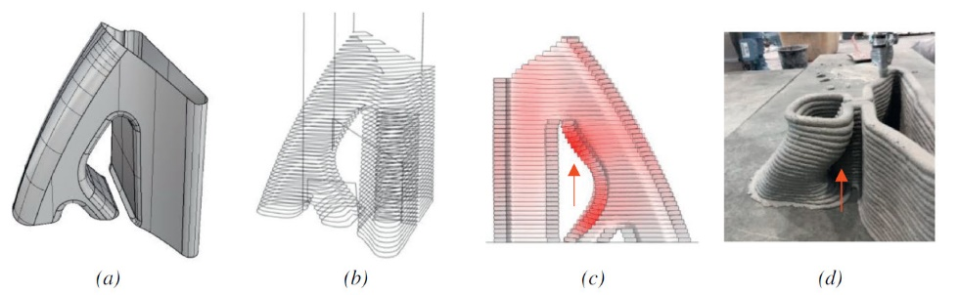

**Fig 1- The complete design to digital manufacturing process: the design to actual manufacturing process (Menna and et al, 2020).**

In recent years, advances in computational design tools and industrial automation have allowed architects and engineers to carry out construction projects characterized by an increasing overall complexity and a high level of digitalization (H. Van Damme, 2018), (G. De Schutter, 2018), (N. Gershenfeld, 2020), (L. Sass and M. Botha, 2006), (E. Lloret, 2018). The growing number of irregular-shape buildings or structures recently constructed, or planned in various countries, represents the evidence of technological progress characterized by an evolution of conventional construction materials, design approaches, and manufacturing methods. In this context, digital fabrication is becoming a valuable approach to overcome the existing manufacturing limitations, as it can transform digital design into physical products (N. Ham and S. Lee, 2019). by adopting one or more materials (polymers, steel, wood, clay, etc.) and different automated processes (e.g., robotic assembly, extrusion, lamination, and additive manufacturing). Different advantages are potentially offered for the specific construction project wherein digital fabrication is implemented (P. Wu and et al, 2016), (I. Agustí-Juan and et al, 2017), (S.C. Paul and et al, 2018). Besides a higher degree of customization, the positive performance of a digitally fabricated system can be evaluated by monitoring four main factors: time, cost, quality, and flexibility (I. Gibson and et al, 2010). In other words, removing the formworks in favor of modularization and prefabrication or part of the concrete/reinforcement due to material (J.L. Jewett and J.V. Carstensen, 2019), (A. Søndergaard and et al, 2016) and shape efficiency (J. Schwartz, 2018) results in cost and CO2 emission reduction (Y.W.D. Tay and et al, 2017) while providing additional functions (G. Vantyghem and et al, 2019), (D.D. Camacho and et al, 2017) the resulting features represent, in practice, the key decision-making factors for the overall construction management of the project (N. Ham and S. Lee, 2019) (I. Agustí-Juan and et al, 2017).

**Theory and research background**

framework of arches and vaults masonry construction, which was an advanced and fundamental technique available at that time. In the 19th century, during the period of Art Nouveau, the fascination towards vegetal and floral forms had reached to its apex, especially when architects developed the skills of using cast iron in construction, allowed designers to execute a wide variety of vegetal features, possessing some structural characters, too. In the same century, the development of ‘graphic statics’ as a theoretical approach, helping to understand the association between structural forms and equilibrium of forces, allowed 19th century architects to build several unique style dendriform structures. During the modern period of early and mid-20th century, architects abstracted the form of tree's complex configuration as a simple Euclidean and hyperbolic geometries, and built dendriform structures like a mushroom or umbrella shape by using a newly developed reinforced concrete technology and a cantilever technique. Nowadays, the imitation of the complex and almost inexpressible appearances of vegetal shapes has become possible, in new effortless ways, within a short time, by using digitally advanced computational processes and simple mathematical algorithms. The mathematical revolution of the fractal theory and the development of computer technology made architects and engineers able to connect architecture and trees fractal-like complex appearance in much more structurally rational and optimal ways (Rian and Sassone, 2014). Some studies, such as the research conducted by Li Hui-jun, have examined the sustainability and execution details of such structural forms. The relationship between the form, the number of branches, the angle between the branches, and the diameter of the members has been investigated when using metal materials. Detailed characteristics of the members have also been examined. In his research, Hui first investigated the reliability of tree-like forms for structural use and then classified the structural members into four categories based on their design. The variables considered were thickness, outer radius, Young's modulus, and vertical load as random variables. Four performance indicators, including node deviation, maximum stress, natural frequency, and buckling values, were taken into account. In the next step, the sensitivity of the four aforementioned performance indicators was examined to identify the effects of the random variables and different member locations, ultimately exploring the correlations among the performance functions (Hui-Jun and et al, 2013). Regarding modeling and simulating the shape of trees, many works have been done using different algorithms, especially the Lindenmeyer system, but the most important study and research in this field has been done by the Computer Science Department of the University of Calgary, and the results of the research can be found on the site <http://algorithmicbotany.org> states that all the researches were conducted under the supervision of Professor Przemyslaw Prusinkiewicz. In these investigations, the Lindenmeyer system and fractals have been worked on, and the differences as well as the types of spectra of these algorithms for modeling living structures, especially plants, have been investigated (Nikeghbali and Damavandi, 2018).

The principal idea behind Gaudi's use of the fractal-like tree column can be referred to as the center of force method that can be analyzed by ‘graphic statics. During his time, ‘graphic statics’ was an advanced tool that allowed the designers to take forms and forces into account simultaneously. Antonio Gaudi, famously known for the physical scale modeling method for structural calculations, also used ‘graphic statics’ as a form-finding tool for visualizing the stress equilibrium in designing some of his signature style structures in the late 19th century. In designing tree like column in Sagrada Familia Cathedral, the weight sand centers of gravity of the main parts were fixed and the base of the column was also fixed. Gaudi used a graphical equilibrium analysis method to design the tree-like structure that would collect the roof weights and take the loading forces to the bases of the columns[f12]. By using the graphic static method, Gaudi calculated the total weight and center of force for each roof segment to attain equilibrium between various segments of a roof mass. Afterward, he fixed the position of a base column, which diverges in to multiple branches directed towards the center of gravity of all roof segments. In doing so, each particular branch is assigned to each roof segment, and the weight load of each segment is transferred axially all the way to the ground. Finding an equilibrium solution was the main but the fundamental basis for each single analysis and design method used by Antonio Gaudi for the construction of tree like column (Huerta, 2006). Gaudi intentionally maintained the acute angle of branching so that the branches can transfer the load towards the center of gravity more efficiently and quickly by following minimal paths principle. He made a series of different scales of physical models to understand the actual stress behavior and to confirm his assumptions and calculations (Figure 2a and b). Gaudi's structural dendriform are one of the earliest and finest examples of making tree like concrete- made branching structures inspired by nature. When in early 20th century the trend of structural minimalism was becoming popular, Gaudi's tree like sculpted structural supports, in contrast, were stunningly appealing and uniquely special in the field of architecture (Huerta, 2006).

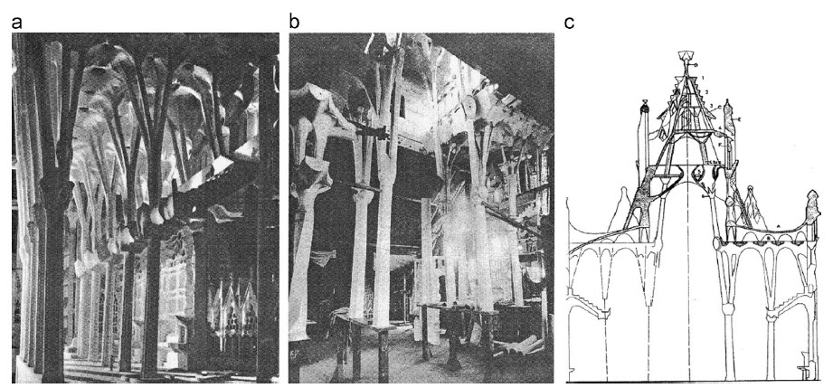

**Fig 2-(a)View of the interior of a plaster model of interior of the Sagrada Familia. (b)Big model in Gaudi's workshop. (c) Gaudi placed ‘hidden’ flying buttresses to absorb some of the horizontal thrusts of the roof (Puig Boada, 1929)**

Observations of the phenomena and attempts to use them in architecture were made by many designers, including Leonardo da Vinci, who noticed that the cross-sectional area of tree branches is equal to the mother's trunk (Loehle, 2016). Nature has been the inspiration of architecture since ancient times. In the design process, these forms are realized as the shaping of humanoid, animal, plant and microscopic organisms in their living environments, the façade, the structure and the transfer of them to the form. Developing natural sciences and computer technologies architects are beginning to see terms such as development, adaptation, mutation, evolution morphogenetics in biology and its sub-branches in architecture as well (Önal MB and Karakoç E, 2019).

Since 1960 computer scientists started to explore a way to create genetic algorithms which are capable of imitating evolution and natural selection, to solve design problems and introducing semi-automatic software. In 1990 architects took these algorithms to be introduced into computer software which is responsible for architectural design and also design of artifacts. Nowadays computers are vastly involved in design where their roles vary from drafting and modeling to intelligent knowledge-based processing of architectural information. CAD software is now used at the structural design as it helps at the best and the most efficient structure picking, also conducting simulations on different forms of structure to recognize the effect of the load and the different forces on them. Computer also is very useful in the construction level as the complex forms cannot be constructed by the ordinary ways (Aziz, 2016).

These kinds of structural systems follow the ‘Form follows Force’ principle. The most important problem during their design or analysis process is to generate a stable equilibrium state subject to the architectural space constraints or mechanical constraints, such as the requirements of the distribution of stresses, which is generally called ‘Form-Finding’ (Li, Q, 2018). Due to the growing power of the computer function and structural construction technology, it seems that ‘anything can be carried out as long as you want to’ has become the key characteristic of the modern structural technique, and the rationality of the mechanical behavior has been placed in a relatively minor position. Therefore, new methods, techniques, and structural system innovations are needed to coordinate the relationship between structural form and its mechanical behavior. In this case, related research on Structural Morphology shows its increasing significance (Li, Q, 2018). It has become possible to be inspired by bionics in search of the properties of materials at the nanoscale, use minimal energy, and optimize structures with advanced geometry. The knowledge of mathematical algorithms and relations between the acting forces are described by the patterns found in Nature is a fundamental tool of contemporary design (Dixit and et al, 2021). It should be noticed that the search for optimal solutions, taken from Nature observation, should be as intuitive as possible for designers - especially for architects in the early conceptual phase and allow for making decisions logical with the principle of eliminating unnecessary geometry. At present, the leading research on the search for geometry and form optimization is being carried out by researchers performing advanced structural calculations (Dixit and et al, 2021). In the search for modern inspirations in Architectural form-making, it is essential for the processes of topological transformations to involve both aesthetics and structural logic (Tarczewski, 2013). Among the features describing both structures encountered in Nature and human-made structures, it can be seen that both variants are shaped based on principles described by mathematical formulas, describing the analysis of the flow of physical forces or reduction of unnecessary geometry. The visible inspiration from arboreal systems shows that the cross-sectional characteristics of natural structures coincide with the graphical interpretation of bending moments (see Fig. 3). In trunks and branches, the most significant cross-section occurs in place of the largest bending moment and the smallest at the ends on the side of growth cones (as those carrying the smallest load) (Dixit and et al, 2021).

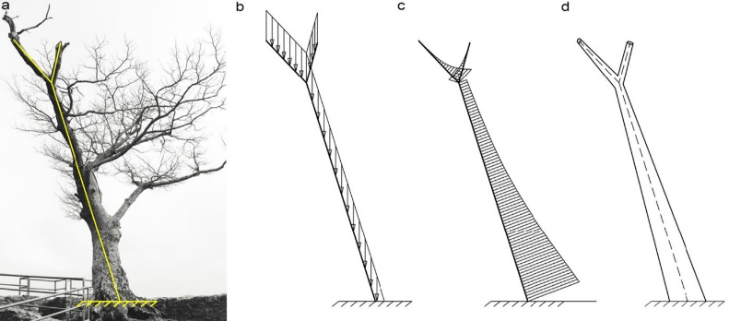

**Fig. 3. Comparison of the tree geometry with the statically determinable cantilever: (a) tree and marking of a simplified scheme of boughs and branches, (c) bending moment diagram, (d) structure with variable cross-section, analogous to the shape of the moment diagram (Dixit and et al, 2021).**

The tree is thickest near its base, and as it grows, its branches become thinner (Fig. 3a). The analogy to this arrangement is visible in the diagrams of the maximum moment of the cantilever structures (Fig. 4b-c). The value of the maximum moment is the biggest next to the fixed support and decreases towards the free end. The selected geometry of the structure according to the shape of the bending moment diagram (as load, which is directly proportional to the strain of the elements) allows the material optimization. In Fig. 3, a simplified static diagram of the tree is presented, as well as the bending moment diagram shape and the structure geometry. The geometry of the structure selected based on the moment diagram is identical to the simplified geometry found in Nature in trees (i.e., the thickest cross-section at the base, and decreasing with growth). The research presented in the article is an initial phase of work on an algorithm for optimizing bar structures. The case studies in the paper have been simplified to bending moments analysis only, as they are leading force determining the cross-section of bent elements (such as the geometries shown in Fig. 3). The other forces (Normal, Shear) have, compared to the moment, a small influence on the size of the bar’s optimization in the context of the final architectural form. The aim of the algorithm is the initial optimization of the geometry shape. The subsequent dimensioning of the structure serves to check the correctness of the geometric shape (see Fig. 5).

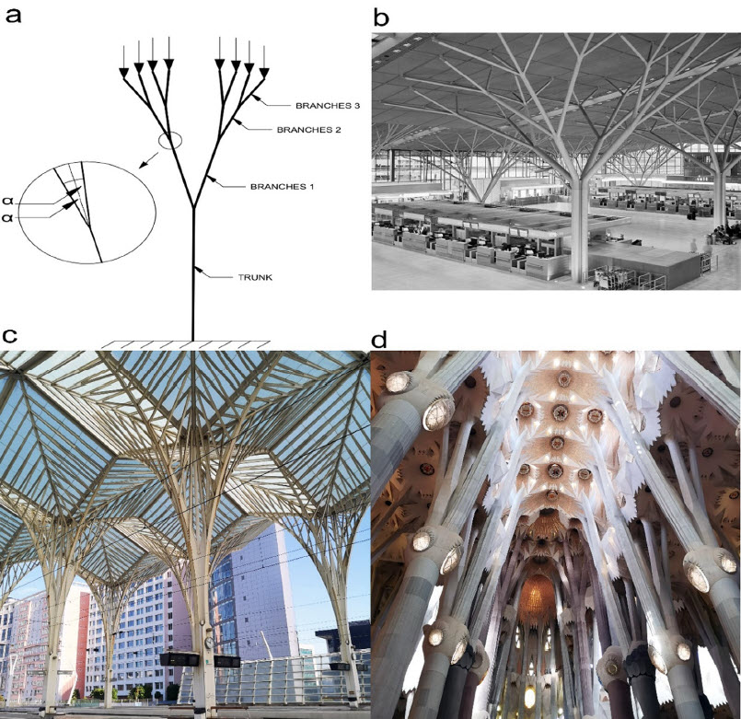

**Fig. 4. Examples of basic structural elements inspired by natural processes: (a) research and design-based geometry, (b) arboreal structure, Airport, Stuttgart, Germany, 2004, (c) Canopy at Railway Station, Lisbon, 1998, (d) Sagrada Familia, Barcelona (Dixit and et al, 2021).**

The paper presents the case studies indicate that there is a need to link architectural and structural optimization processes at the early stage of designing to achieve multicriterial sustainable results. The research presents an introduction algorithm that, bases on interdisciplinary cooperation between those two sectors, and in the future, might be used to enhance the construction processes.

In recent years many research and construction of buildings based on fractal and arboreal pattern optimization were conducted. Some of the most relevant examples of such studies were shown in the literature review. The research methodology describes boundary conditions and the case studies analysis flowchart. The description of the case studies, with visual representations of the results, indicate the need to implement parametric algorithmizing based on arboreal patterns to the early stage of support structure optimization. The paper is concluded with an explanation of the need for combining aesthetic expression with structural logic basing on computational design methods based on bio structural parametric algorithms.

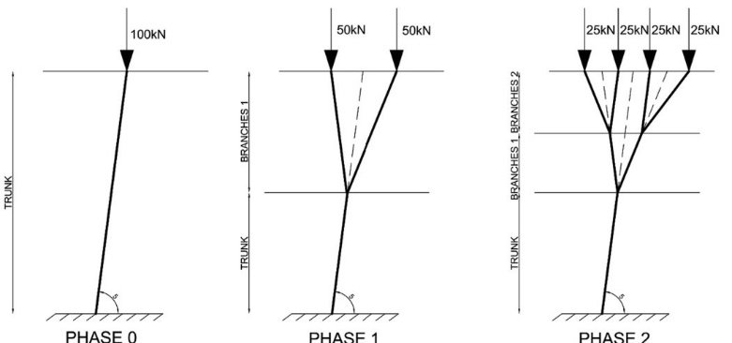

**Fig. 5. Phases of growth divisions of trunk and branches: (a) phase 0- single trunk, (b) phase 1- in the middle of the trunk length division into two branches, (c) phase 2- in the middle of the family 1 branches lengths division into two new families 2 branches (Dixit and et al, 2021).**

Bionics inspiration in contemporary architecture and construction is an inspiring and complex phenomenon, and the effects of these activities are not always carried out following the optimization of the structure, but rather an architectural vision. Nowadays, thanks to the use of digital tools, it is possible to design the geometry of load-bearing structures which, thanks to ‘‘skillful application of the achievements of human thought in the field of technology and aesthetics” (Otto, 1990) achieve forms that are surprisingly similar to those observed in Nature. Comparative analyses of various inspirations taken from the natural world were the starting point for research on the optimization of the geometry of arboreal support structures used in 21st-century architecture. Tree-like branching structures, are also known as ’dendritic structure’ and ’arboreal,’ which means ’relating to or resembling a tree’ (Rian and Sassone, 2014). Often, due to the geometric similarity, fractally divided arboreal support systems are noticeable in two main types of structures. In the first one, where the independence between the canopy and supporting structure is visible in material and geometry, and the other where supporting structure ’seamlessly’ passes into roofs. Inspiration from such phenomena is not only the domain of the 21st century and the use of digital tools. It is essential to emphasize the diversity of mechanical work in the tree, which varies depending on the season. The analogies of tree mechanics and arboreal structures discussed in the article are based on the winter work system. The work of the tree structure is similar to the work of load-bearing columns (limited impact of wind force through the lack of leaves, compared to the dead load). In the simplified arboreal structures analyzed in the paper, the wind load was omitted, the structure is designed as interior structural elements. Arboreal systems have appeared in human activity since prehistoric times. Tents, as described by Frei Otto, are ‘‘something biological, something non-technical, or rather: para technical” (Otto, 1990).

In his most famous work - Sagrada Familia Antoni Gaudi also uses arboreal systems in load-bearing columns. The research on tree structures and fractal divisions were carried out based on simplified mathematical models, characterized, among others, by the angle of inclination of branches to their length or the assumption that branches have a constant cross section along their entire length (Honda, 1971), (Jinasena and Sonnadara, 2013).

**Methods**

As an extraordinary utility in the architectural design practice, topology optimization methods might be pointed. On it bases, topology optimization is a mathematical approach that optimizes material layout within a given design space, for a given set of loads and boundary conditions, such that the resulting layout meets a prescribed set of performance targets. It could be implemented through the use of Finite Element Methods (FEM or FEA) for the analysis and a variety of optimization techniques such as the Method of Moving Asymptotes, Genetic Algorithms, the Optimality Criteria method, Level Sets or Topological Derivatives. Topology optimization algorithm is very widely used in the industrial product design such as aerospace and automotive where mechanical parts efficiency and its material usage is crucial. Also, Civil Engineering is not lagging in this field (Guest and Moen, 2010).

Many scientific discourse and researches have been made, implementing Structural Optimization for various purposes. Nevertheless, topology optimization as an engineering tool is rarely applied in the architectural design process. Commonly it is caused by a complex and time taking process to achieve results which would satisfy a designer. Existing architectural adaptation of topology optimization are the result of deep research and time-consuming experiments often aided by specialists in Civil Engineering. The tools applied for that projects are either highly specialized and expensive engineering software or individually developed toolsets for current problem. However, general purpose engineering programs available on the market containing Structural Optimization algorithms, except of the cost, has many additional limitations which decrease a possibility of usage those methods by architects for enriching their design process. Their explicit user interface and moreover, plethora of options and decisions which user has to make, put it as a highly specified software dedicated to the limited range of users. All presented arguments affirm the author about the need for developing a new tool for designers. It is highly intended to give the opportunity to variety of architects and designers to use the exceedingly complex and compound process to improve their designs without any specialized knowledge. Complementary to the described application of Structural Optimization method in architecture, author will present a new approach concerning form finding tool based on Topology Optimization algorithm accelerated with the GPGPU (General Purpose computing on Graphics Processing Units) technology Creation of new tools, adjusted to the nowadays performance requirements, enforces a software developer to use always up-to-date technologies. Topology optimization as a material distribution method based on a numerical approach can be successfully enhanced by a contemporary computing tool (Bialkowski, 2018).

Based on scientific researches (Schmidt and Schulz, 2011) authors came up with an idea of developing and implementing own topology optimization algorithm enhanced with the GPU acceleration which may speed up calculation process up to 160 times. The aim of the author research is to create a form finding real-time tool for an architects based on the engineering Structural Optimization Methods.

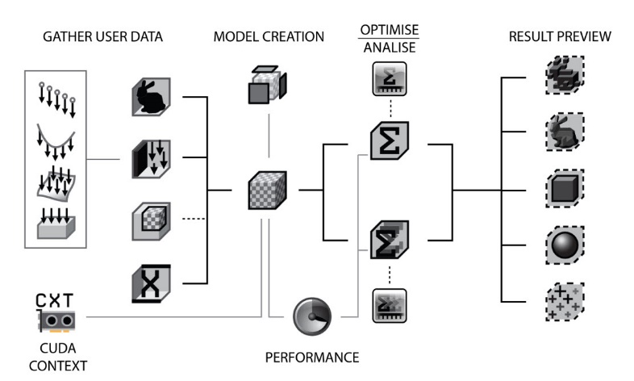

**Fig. 6 topos workflow based on icons (Bialkowski, 2018).**

As a main theorem, Simple Isotropic Microstructure with Penalization (SIMP) method developed by Bendsøe and Sigmund (Bendsoe and Sigmund, 2004) was chosen. The project, named “topos”, unlike the complicated and expensive commercial tools for engineers is meant to be simpler, faster and more efficient. The basic environment for topos is Rhinoceros3D software with the Rhino common libraries. The McNeel software is used as a 3D engine for data display and what is more, as a modelling environment necessary for the algorithm to create input data. topos also utilizes Rhino common library to process meshes and vectors. The plugin core is based on the host code (performed on CPU) implemented on DotNet C# with acceleration kernels (performed on GPU) based on the CUDA API (Sanders and et al, 2012), the extension of C language. Interconnection between CUDA C and C# is managed by 1:1 wrapper named managed CUDA developed by Michael Kunz, which allows to use pure CUDA API without losing computational power and functionality. The GPGPU allows to exploit parallel architecture pipeline to bring a new approach to a real time application (Białkowski, 2017).

Created software gives unlimited possibilities in the process of creation of forms. Each new boundary conditions, the shape of the design space, whether the restrictions, will result in generating a new form, adapted to the requirements set by the user. The implementation of the form-forming principles of topological optimization using the idea of parametric design enables designers and architects to look for structures and inspirations for architectural forms in a simplified and intuitive way. The use of numerical methods as a base for generating forms has resulted in receiving interesting structures rich in interesting detail, which have gained additional value. Final forms are not composed from ready-made architectural solutions, but it is a unique answer to a given problem (Bialkowski, 2018).

**Conclusion**

In this research, an attempt has been made to compare a sample structure with dimensions of 8*15 meters and a height of 3.5 meters, designed using the Topos plugin, with a concrete structure. It seems that the final designed structure, utilizing topological tree structures, can not only serve as a structural component in the building but also contribute to the interior decoration from an architectural perspective. As a result, it provides the potential for a more aesthetically pleasing and architecturally appealing design compared to a concrete structure, enhancing the overall presence and attractiveness of the building. In Figure 7, which is presented below, the code related to the topological tree structure of the design is shown. Using the Topos plugin, the structure is formed and optimized for the intended surface, and column supports are created to encompass the designed shell and roof, allowing the design process to continue. Then, according to the instructions provided by the Topos plugin, supports need to be placed on the floor and ceiling to guide the positioning of the columns. Once the supports are created, the necessary values for the components are assigned based on the materials, concrete columns, and beams. Specifically, the Poisson's ratio of the "Boundry_domain" component is set to 0.2, and the Young's modulus is assigned a value of 210. It is worth mentioning that Young's modulus is a measure to describe the stiffness of solid materials and represents the ratio of stress to strain. It is typically expressed in units of pressure, such as gigapascals (GPa). Poisson's ratio, on the other hand, represents the ratio of transverse strain to longitudinal strain in a solid sample. For most solid materials, the Poisson's ratio ranges between 0.2 and 0.3. The optimization process involves 10,000 iterations for the structural design, with a resolution set to 0.25. Finally, the Topos engine is executed to carry out the optimization.

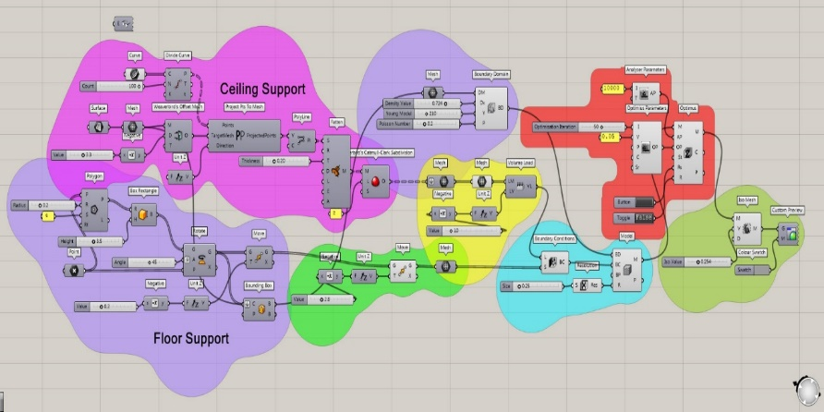

**Fig.7 Coding related to the tree topological structure with the Topos plugin**

After ten thousand repetitions to find the best answer for the desired structure, the following design is obtained, which creates the most optimal state of the structure as well as the form.

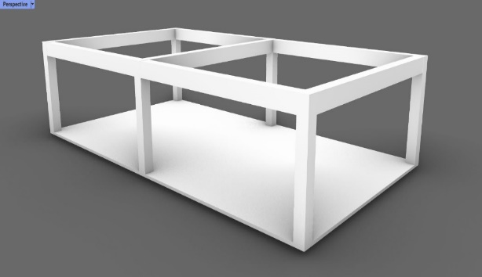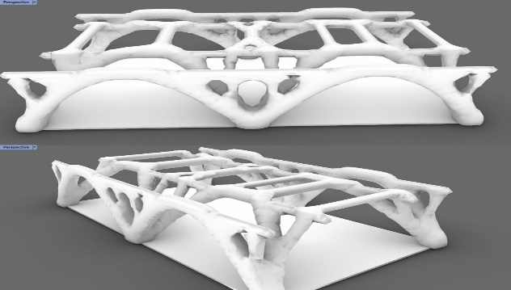

**Fig.8 Optimized design and form of tree topological structure.**

**Fig.9 Proposed beams and columns based on a concrete structure**

**Suggestions**

Dealing with the discussion of structure and architecture in buildings has always been a challenge between engineers and architects in both fields. In the realm of contemporary architectural discourse, considering the inseparability of structure and architecture, both structure and architecture play a simultaneous role, and essentially these two aspects are not separate from each other. Therefore, exploring new and innovative structural approaches can contribute to closer collaboration and synergy in the construction industry.

With the advancement of technology in all fields, especially in the construction and architectural industries, designers will be able to use the latest design methods in the world to design such complexes. Since the use of topological tree structures in the design of this center has not yet been done in the country, and also due to the visual attractiveness and beauty that such structures possess, this building can be considered as an exemplary structure for other architects. Apart from that, considering the new tools used in contemporary architecture, the designer will be able to have a more precise control over what they design. One of the most important and useful of these tools is the use of algorithmic methods and tools in the design process. Architectural and algorithmic thinking enables the designer to take control of and modify and update the design elements whenever necessary, based on the conditions that arise.

What distinguishes this project from others is that, for the first time in the architectural process of the country, an optimized form and topological tree structures will be created using parametric architecture and algorithmic tools, resulting in a space that, in addition to its special functionality, has unique attractions to attract the attention and interest of visitors to the complex and invite people to use it. Regarding the form of this complex, it is worth mentioning that since the final form of the complex originates from the optimized form of topological tree structures, both the form and the structure of this complex will be highly unique. As previously mentioned, this building, as the first example, will not only have architectural grandeur and beauty but also exhibit a unique structure inspired by tree-like structures.

**References**

* Bialkowski, S. (2018). Topology Optimization Influence on Architectural Design Process. Computing for a better tomorrow, 139.
* Dixit, S., Stefańska, A., & Musiuk, A. (2021). Architectural form finding in arboreal supporting structure optimization. Ain Shams Engineering Journal, 12(2), 2321-2329.
* Radwan GA, Osama N. Biomimicry, an approach, for energy efficient building skin design. Procedia Environ Sci 2016; 34:178–89. doi: <https://doi.org/10.1016/j.proenv.2016.04.017>.
* Hua, H., Hovestadt, L., & Tang, P. (2020). Optimization and prefabrication of timber Voronoi shells. Structural and Multidisciplinary Optimization, 61(5), 1897-1911.
* Rian, I. M., & Sassone, M. (2014). Tree-inspired dendriforms and fractal-like branching structures in architecture: A brief historical overview. Frontiers of Architectural Research, 3(3), 298-323
* Aziz, M. S. (2016). Biomimicry as an approach for bio-inspired structure with the aid of computation. Alexandria Engineering Journal, 55(1), 707-714.
* Li, Q. (2018). Form Follows Force: A theoretical framework for Structural Morphology, and Form-Finding research on shell structures. A+ BE| Architecture and the Built Environment, (2), 1-278.
* J. Gehl, Cities for People, Island press, 2013.
* R. Blazy, E. We˛cławowicz-Bilska, Urban structure in contact with water, in: R.O.J. Furdík (Ed.), MobEx 2011-2012 Water City, Towarzystwo Słowaków w Polsce, Cracow, 2012, pp. 75–80.
* Menna, C., Mata-Falcón, J., Bos, F. P., Vantyghem, G., Ferrara, L., Asprone, D., ... & Kaufmann, W. (2020). Opportunities and challenges for structural engineering of digitally fabricated concrete. Cement and Concrete Research, 133, 106079.
* H. Van Damme, Concrete material science: past, present, and future innovations, Cem. Concr. Res. 112 (2018) 5–24, <https://doi.org/10.1016/j.cemconres.2018.05>. 002.
* G. De Schutter, K. Lesage, V. Mechtcherine, V.N. Nerella, G. Habert, I. Agusti-Juan, Vision of 3D printing with concrete — technical, economic and environmental potentials, Cem. Concr. Res. 112 (2018) 25–36, <https://doi.org/10.1016/j>. cemconres.2018.06.001.
* N. Gershenfeld, How to make almost anything: the digital fabrication revolution, Foreign Aff (2012) 91 <https://heinonline.org/HOL/Page?handle=hein.journals/> fora91&id=1077&div=114&collection=journals (accessed January 6, 2020).
* L. Sass, M. Botha, The instant house: a model of design production with digital fabrication, Int. J. Archit. Comput. 4 (2006) 109–123, <https://doi.org/10.1260/> 147807706779399015.
* E. Lloret, A.R. Shahab, M. Linus, R.J. Flatt, F. Gramazio, M. Kohler, S. Langenberg, Complex concrete structures: merging existing techniques with digital fabrication, Comput. Des. 60 (2015) 40–49, <https://doi.org/10.1016/j.cad.2014.02.011> (accessed May 11, 2018).
* N. Ham, S. Lee, Project benefits of digital fabrication in irregular-shaped buildings, Adv. Civ. Eng. 2019 (2019), <https://doi.org/10.1155/2019/3721397>.
* P. Wu, J. Wang, X. Wang, A critical review of the use of 3-D printing in the construction industry, Autom. Constr. 68 (2016) 21–31, <https://doi.org/10.1016/> j.autcon.2016.04.005.
* I. Agustí-Juan, F. Müller, N. Hack, T. Wangler, G. Habert, Potential benefits of digital fabrication for complex structures: environmental assessment of a robotically fabricated concrete wall, J. Clean. Prod. 154 (2017) 330 340, <https://doi>. org/10.1016/j.jclepro.2017.04.002.
* S.C. Paul, G.P.A.G. van Zijl, I. Gibson, A review of 3D concrete printing systems and materials properties: current status and future research prospects, Rapid Prototyp. J. 24 (2018) 784–798, <https://doi.org/10.1108/RPJ> 09-2016-0154.
* I. Gibson, D.W. Rosen, B. Stucker, Additive Manufacturing Technologies: Rapid Prototyping to Direct Digital Manufacturing, Springer, US, 2010, <https://doi.org/> 10.1007/978-1-4419-1120-9.
* J.L. Jewett, J.V. Carstensen, Experimental investigation of strut-and-tie layouts in deep RC beams designed with hybrid bi-linear topology optimization, Eng. Struct. 197 (2019), <https://doi.org/10.1016/j.engstruct.2019.109322>.
* A. Søndergaard, O. Amir, P. Eversmann, L. Piskorec, F. Stan, F. Gramazio, M. Kohler, Topology optimization and robotic fabrication of advanced timber space-frame structures, Robot. Fabr. Archit. Art Des. 2016, Springer International Publishing, 2016, pp. 190–203, , <https://doi.org/10.1007/978-3-319-26378-6_14>.
* J. Schwartz, Graphic statics and their potential for digital design and fabrication with concrete, Cem. Concr. Res. 112 (2018) 122–135, <https://doi.org/10.1016/j>. cemconres.2018.06.015.
* Y.W.D. Tay, B. Panda, S.C. Paul, N.A. Noor Mohamed, M.J. Tan, K.F. Leong, 3D printing trends in building and construction industry: a review, Virtual Phys. Prototyp. 12 (2017) 261–276, <https://doi.org/10.1080/17452759.2017.1326724>.
* G. Vantyghem, V. Boel, W. De Corte, M. Steeman, Compliance, stress-based and multi-physics topology optimization for 3D-printed concrete structures, RILEM Bookseries, Springer, Netherlands, 2019, pp. 323–332, <https://doi.org/10.1007/978-3-319-99519-9_30>
* D.D. Camacho, P. Clayton, W. O’Brien, R. Ferron, M. Juenger, S. Salamone,C. Seepersad, Applications of additive manufacturing in the construction industry a prospective review, ISARC 2017 — Proc. 34th Int. Symp. Autom. Robot. Constr, International Association for Automation and Robotics in Construction I.A.A.R.C, 2017, pp. 246–253, , <https://doi.org/10.22260/isarc2017/0033>
* I. Agustí-Juan, G. Habert, Environmental design guidelines for digital fabrication, J. Clean. Prod. 142 (2017) 2780–2791, <https://doi.org/10.1016/j.jclepro.2016.10.190>
* Hui-Jun, L., Zheng-Zhong, W., & Zhan-Chao, L. I. (2013). Reliability and Sensitivity Analysis of Dendriform Structure. International Journal of Space Structures, 28(2), 75-86.
* Nikeghbali S, Damavandi A. analysis of the challenges and technical solutions for revitalization of traditional buildings in hot and humid climate (case study:anthropology museum of local residents in Kish Island). Civil Eng J 2018;4(10):2466–73. doi: <https://doi.org/10.28991/cej-03091173>.
* Huerta, S. (2006). Structural design in the work of Gaudi. Architectural science review, 49(4), 324-339.
* Puig Boada, I. (1929). El temple de la Sagrada Familia.
* Loehle, C. (2016). Biomechanical constraints on tree architecture. Trees, 30(6), 2061-2070.
* Önal MB, Karakoç E. Innovative approaches to organic architecture: natureinspired architectural design. In: XXII generative art conference, rzym, 2019.
* Li, Q. (2018). Form Follows Force: A theoretical framework for Structural Morphology, and Form-Finding research on shell structures. A+ BE| Architecture and the Built Environment, (2), 1-278.
* Dixit, S., Stefańska, A., & Musiuk, A. (2021). Architectural form finding in arboreal supporting structure optimisation. Ain Shams Engineering Journal, 12(2), 2321-2329.
* Tarczewski, R. (2013, September). Natural and geometrical prototypes of organic forms in architecture. In Proceedings of IASS Annual Symposia (Vol. 2013, No. 12, pp. 1-6). International Association for Shell and Spatial Structures (IASS).
* Otto, F. (1990). Das hängende Dach: Gestalt und Struktur. Deutsche Verlags-Anstalt.
* Honda, H. (1971). Description of the form of trees by the parameters of the tree-like body: Effects of the branching angle and the branch length on the shape of the tree-like body. Journal of theoretical biology, 31(2), 331-338.
* Jinasena, K. D. S., & Sonnadara, D. U. J. (2013). Computer simulation of tree development with random variations and probabilistic growth of branches.
* Guest, JK and Moen, CD 2010 ’Reinforced Concrete Design with Topology Optimization’, 19th Analysis and Computation Specialty Conference, pp. 445-454
* Schmidt, S and Schulz, V 2011, ’A 2589-line topology optimization code written for the graphics card’, Computing and Visualization in Science, 14(6), pp. 249-256
* Bendsoe, MP and Sigmund, O 2004, Topology Optimization: Theory, Methods, and Applications, Springer Berlin Heidelberg, Berlin, Heidelberg
* Sanders, J, Kandrot, E and Piwko, Ł 2012, Cudaw przykładach: Wprowadzenie do ogólnego programowania procesorów, Helion, Gliwice
* Białkowski, S 2017 ’tOpos - GPGPU Accelerated Structural Optimisation Utility for Architects’, eCAADe2017, Rome, pp. 679-688