DHT11
(TEMPERATURE AND
HUMIDITY MODULE)

DESCRIPTION
The DHT11 is a basic, low-cost digital temperature and humidity sensor. It uses a capacitive humidity sensor and a thermistor to measure the surrounding air, and spits out a digital signal on the data pin (no analog input pins needed). Its fairly simple to use, but requires careful timing to grab data. The only real downside of this sensor is you can only get new data from it once every 2 seconds.

FEATURES
- Full range temperature compensated
- Relative humidity and temperature measurement
- Calibrated digital signal
- Outstanding long-term stability
- Extra components not needed
- Long transmission distance
- Low power consumption
- 4 pins packaged and fully interchangeable

PIN CONFIGURATION
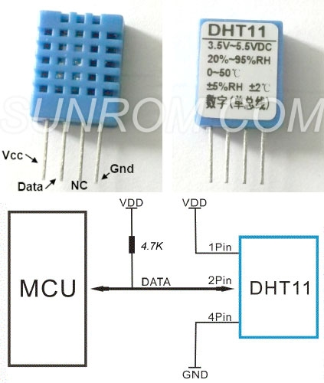

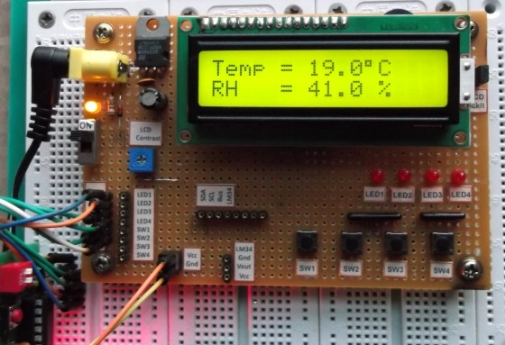

WORKING
STEP BY STEP WORKING
1. Typical application circuit recommended in the short cable length of 20 meters on the 5.1K pull-up resistor, the resistance of greater than 20 meters under the pull-up resistor on the lower of the actual situation.
2. When using a 3.5V voltage supply cable length shall not be greater than 20cm. Otherwise, the line voltage drop will cause the sensor power supply shortage, caused by measurement error.
3. Each read out the temperature and humidity values are the results of the last measurement For real-time data, sequential read twice, but is not recommended to repeatedly read the sensors, each read sensor interval is greater than 5 seconds can be obtained accurate data.

Communication Process: Serial Interface (Single-Wire Two-Way)
The interesting thing in this module is the protocol that uses to transfer data. All the sensor readings are sent using a single wire bus which reduces the cost and extends the distance. In order to send data over a bus you have to describe the way the data will be transferred, so that transmitter and receiver can understand what says each other. This is what a protocol does. It describes the way the data are transmitted. On DHT-11 the 1-wire data bus is pulled up with a resistor to VCC. So if nothing is occurred the voltage on the bus is equal to VCC. Communication Format can be seperated into three stages
1) Request
2) Response
3) Data Reading

APPLICATIONS
- HVAC
- dehumidifier
- testing and inspection equipment
- consumer goods
- automotive, automatic control
- data loggers
- weather stations
- home appliances
- humidity regulator
- medical

