The MQ series of gas sensors use a small heater inside with an electro-chemical sensor. They are sensitive for a range of gasses and are used indoors at room temperature.
They can be calibrated more or less (see the section about "Load-resistor" and "Burn-in") but a know concentration of the measured gas or gasses is needed for that.

The output is an analog signal and can be read with an analog input of the Arduino.

Read the datasheet
Try to find a few datasheets for the sensor, and read them careful.
Since there are no electronic components inside, therefor most sensors can be used with AC and DC voltages.
Be careful when connecting it for the first time. If the pins are connected wrong, the sensor could get damaged, or it could be broken instantly. There are also shields available with these sensors pre-installed.

Wiring
The preferred wiring is to connect both 'A' pins together and both 'B' pins together. It is safer and it is assumed that is has more reliable output results. Although many schematics and datasheets show otherwise, you are advised to connect both 'A' pins together and connect both 'B' pins together.
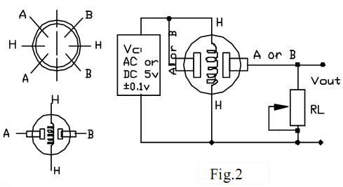
In the picture, the heater is for +5V and is connected to both 'A' pins. This is only possible if the heater needs a fixed +5V voltage.
The variable resistor in the picture is the load-resistor and it can be used to determine a good value. A fixed resistor for the load-resistor is used in most cases.
The Vout is connected to an analog input of the Arduino.

The heater
The voltage for the internal heater is very important.
Some sensors use 5V for the heater, others need 2V. The 2V can be created with a PWM signal, using analogWrite() and a transistor or logic-level mosfet.
The heater may not be connected directly to an output-pin of the Arduino, since it uses too much current for that.
Some sensors need a few steps for the heater. This can be programmed with an analogWrite() function and delays. A transistor or logic-level mosfet should also in this situation be used for the heater.
If it is used in a battery operated device, a transistor or logic-level mosfet could also be used to switch the heater on and off.
The sensors that use 5V or 6V for the internal heater do get warm. They can easily get 50 or 60 degrees Celcius.
After the "burn-in time", the heater needs to be on for about 3 minutes (tested with MQ-2) before the readings become stable.

Load-resistor
The sensor needs a load-resistor at the output to ground. It's value could be from 2kOhm to 47kOhm. The lower the value, the less sensitive. The higher the value, the less accurate for higher concentrations of gas.
If only one specific gas is measured, the load-resistor can be calibrated by applying a know concentration of that gas. If the sensor is used to measure any gas (like in a air quality detector) the load-resistor could be set for a value of about 1V output with clean air.
Choosing a good value for the load-resistor is only valid after the burn-in time.

Burn-in
Some datasheets use the term "preheat", but it is the time to burn-in the sensor. This is meant to make the sensor readings more consistent. A time of 12 or 24 hours is usually used for the burn-in time.
The Burn-in is achieved by applying normal power to the sensor (to the heater and with the 'A' and 'B' pins connected, and with a load-resistor). In some special cases a specific burn-in is needed. See

