Table of Contents

Requirements 2

Setting Up the Project 2

Set Up a Folder 2

Install the Necessary Dependencies 2

Running the Project 2

Using the Site*** 3

Maintenance Tips 3

Troubleshooting 3

Couldn’t Download Compiler Version List 4

Hardhat doesn’t work*** 4

Deploying the Smart Contract Does Not Result in an Address 4

Could Not Decode Result Data 4

Wallet doesn’t connect*** 5

Unable to Confirm Transaction 5

Received invalid block tag #. Latest block number is #. 5

Limit shown is negative*** 5

Limit shown is N/A*** 5

Other Issues 6

Managing Smart Contract Interactions 6

# Requirements

* Have read/write permissions for folders and files.
* Download the project.
* 300MB free space, minimum.

# Setting Up the Project

## Set Up a Folder

* Make a new directory.
* Copy/paste or unzip the project directly into directory.
* Move into the directory with the project.

## Install the Necessary Dependencies

* Install Node.js and npm, if they are not already installed.
  + Instructions on how to do so, with specific operating systems, [can be found on the Node.js website](https://nodejs.org/en/learn/getting-started/how-to-install-nodejs).
    - To install from the command line, a [Package Manager](https://nodejs.org/en/download/package-manager) option can used.
    - To instead utilize an executable, download Node.js [from the Prebuilt Installer](https://nodejs.org/en/download/prebuilt-installer) page.
  + Verify that the installation worked by running npm -v from your terminal.
* From your terminal, run npm install.
* Move into the frontend directory (cd frontend).
* Run npm install again.
* Open a browser and install the MetaMask extension, if it is not already installed.
  + Instructions on how to do so, with specific browser and browser codebases, [can be found on MetaMask’s website](https://metamask.io/download/).
  + Set up your MetaMask account so it can be used

# Running the Project

* From your terminal, move back into the main project directory.
* Run npx hardhat node.
* Open a new terminal tab or window.
* Move back into the main project directory.
* Deploy the smart contract using npx hardhat run ignition/deploy.js.
* Verify that output/target address matches the contractAddress on line 20 in “frontend/src/web3Handler.js”.
  + If not, replace it with the output address.
* [iot handler instructions go here]
* Move to the frontend folder (cd frontend).
* Then start the frontend with npm run dev.
* Open the localhost link as specified in a browser with MetaMask installed.

# Using the Site***

* (describe how to add accounts onto MetaMask and connect them to the project)
* Section for monitoring events on the blockchain
* Section for manually inputting data onto the blockchain
* Section for adding to limits (must be deployer)

# Maintenance Tips

* After updating dependencies, check to make sure the project still runs.
* Make sure your wallet activity data gets cleared from time to time – MetaMask doesn’t like persistent data.
* The blockchain will clear if it is closed. If this is not a desired outcome, it should remain open and running.
* Check in on IoT use – IoT devices generate a lot of data, and while filtering the data does greatly reduce the amount they would have to send, the number of function calls they have could still be higher than anticipated.

# Troubleshooting

* Use the developer tools to see specific errors – sometimes the log will output something that’s not fully shown in the frontend.
* Check the blockchain to see if there were any invalid eth_calls or any bounced contract calls. A reason for the bounce or invalid call will be shown directly below its occurrence.
* Try turning it off and turning it on again – end all the terminal tasks, clear MetaMask activity data (see Received invalid block tag #. Latest block number is #.), close the browser, then restart everything.

## Couldn’t Download Compiler Version List

* Try a different network. Once the compiler is downloaded, this should no longer be an issue: recompiling in the future on the original network should not prove to be an issue.
* [Try compiling the contract on Remix](https://remix.ethereum.org/) instead and download the compilation when done.

## Hardhat doesn’t work***

* Something something two hardhat.config.js files, even in different folders

## Deploying the Smart Contract Does Not Result in an Address

* Double check the dependencies – try running npm install again in the main project directory.
* If an update to a dependency was just installed, consider downgrading or using a separate virtual environment for this project that contains the exact versions needed.
  + A tutorial on Python’s venv can be found [here](https://www.geeksforgeeks.org/python-virtual-environment/). After activating, reinstall npm and Hardhat within the virtual environment.

## Could Not Decode Result Data

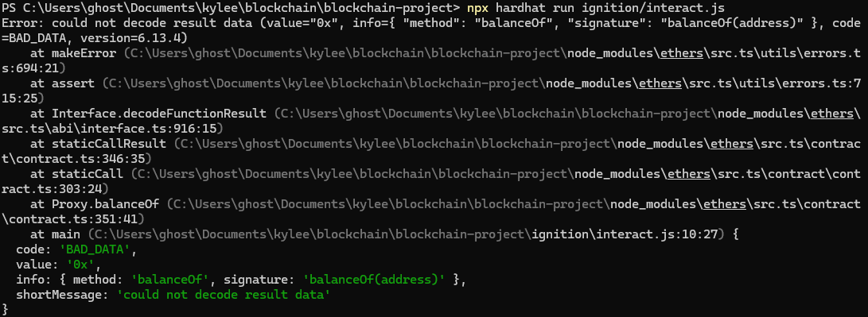

* Verify that you have a Node network running in another terminal. If not, navigate to the project directory in another terminal and start a Node network by using npx hardhat node.
* Make sure your command is correct: running the deployment script should also include specifying the network. The correct command is npx hardhat run ignition/deploy.js --network localhost.

## Wallet doesn’t connect***

* Check that MetaMask is unlocked and that the account is connected.
* Verify that you’ve added the network correctly in MetaMask.
  + ---
* Refresh the page.
* Restart the browser.

## Unable to Confirm Transaction

* Insufficient funds prevent users from adding to the blockchain. Verify that your account has enough tokens to pay for the gas.
* The deployment address can transfer tokens to and limits on other accounts; consider asking the deployment address for a boost.

## Received invalid block tag #. Latest block number is #.

* If in use, close the IoT terminal (Ctrl+C/ ⌘+C).
* Close the Node network (blockchain) terminal (Ctrl+C/ ⌘+C).
* Close the frontend terminal (Ctrl+C/ ⌘+C).
* Clear your MetaMask nonces.
  + Open your MetaMask extension.
  + Go to “Settings” (in the hamburger/navigation menu in the corner).
  + Select “Advanced”.
  + Hit “Clear activity tab data”.
  + Repeat this on any MetaMask accounts you are using with this project.
  + Restart the blockchain and frontend terminals, as well as the IoT one if necessary.

## Limit shown is negative***

* This means your account has gone over its limit. While chemicals from the IoT devices and manual input will continue to be pushed to the blockchain, the initial limit set for your account was lower than the amount of chemicals you have used.

## Limit shown is N/A***

* Your account never had its chemical limits set. This means that the deployer has not authorized you (set your limits), and it unfortunately means that you cannot push anything to the blockchain.

## Other Issues

* If anything in the smart contract changes, it has to recompile. This will generate a new ABI.
  + Whenever this occurs, the ABI beginning on line 21 in the web3Handler.js file must be replaced with the new version.
  + The new ABI can be found in line 5 of the CropToken.json file in the “artifacts/contracts/FarmChemicalContract.sol” folders.
  + The easiest way to copy this over is to use an IDE that supports “closing” functions (see example below), then highlight the whole bracketed chunk and replace it.



* Run into a bug or an issue that isn’t covered by this manual? [Open a GitHub issue.](https://github.com/raspberrymilkyway/blockchain-project/issues)

# Managing Smart Contract Interactions

* Again, verify that IoT devices aren’t utilizing too many resources.
* Don’t share private keys with anyone – if you were to switch devices, that’s how you’d log into your account again, so anyone with your private key would be able to log into your wallet.
  + If your account has smart contract calls that you don’t remember adding and that aren’t from your IoT devices, consider whether or not someone else could have obtained access to your account.
* Clear your nonce/activity data from MetaMask every time you close the blockchain, to ensure that the data doesn’t persist the next time it’s used.