Apple vs tomato

AI/ML Project brief Apple vs tomato

Introduction
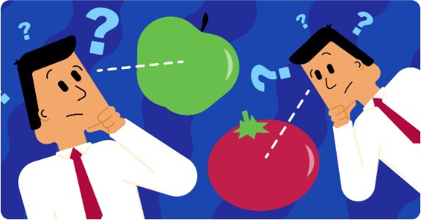
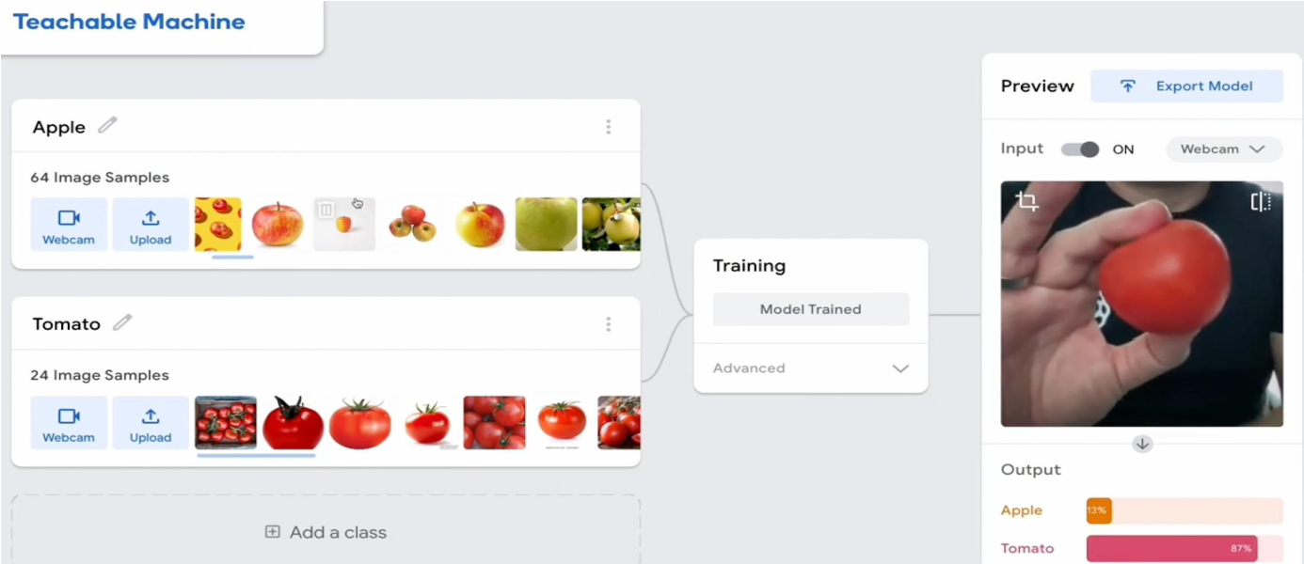
In this project, you will learn how to train a machine learning model to detect if you are holding an apple or a tomato, then improve it by including more diverse training data
Hvad du vil lave
Træn en maskine learning model til at opdage, hvis du holder et æble eller en tomat. Derefter, forbedre klassificeret ved hjælp af mere forskelligartede træningsdata.
What you will need
- A computer with webcam
- A green apple, a red apple, a red tomato
- You will need to download and save files to your computer
Where are my images stored?
- This project uses a technology called ‘machine learning’. Machine learning systems are trained using a large amount of data.
- Dette projekt kræver ikke, at du opretter en konto eller logger ind. Til dette projekt gemmes de billedeksempler, du bruger til at lave modellen, kun midlertidigt i din browser (kun på din maskine).
- Ingen billeder fra dit webcam sendes til denne hjemmeside eller nogen anden hjemmeside.
Download the project videos!
You can download all the videos for this project (https://rpf.io/p/en/apple-vs-tomato-go).
Licence
We would like to thank Samuel Cortinhas
(https://www.kaggle.com/datasets/samuelcortinhas/apples-or-tomatoes-image- classification/data) for the concept and images for this project.
Apple vs tomato
AI/ML Project brief

1. Create a model
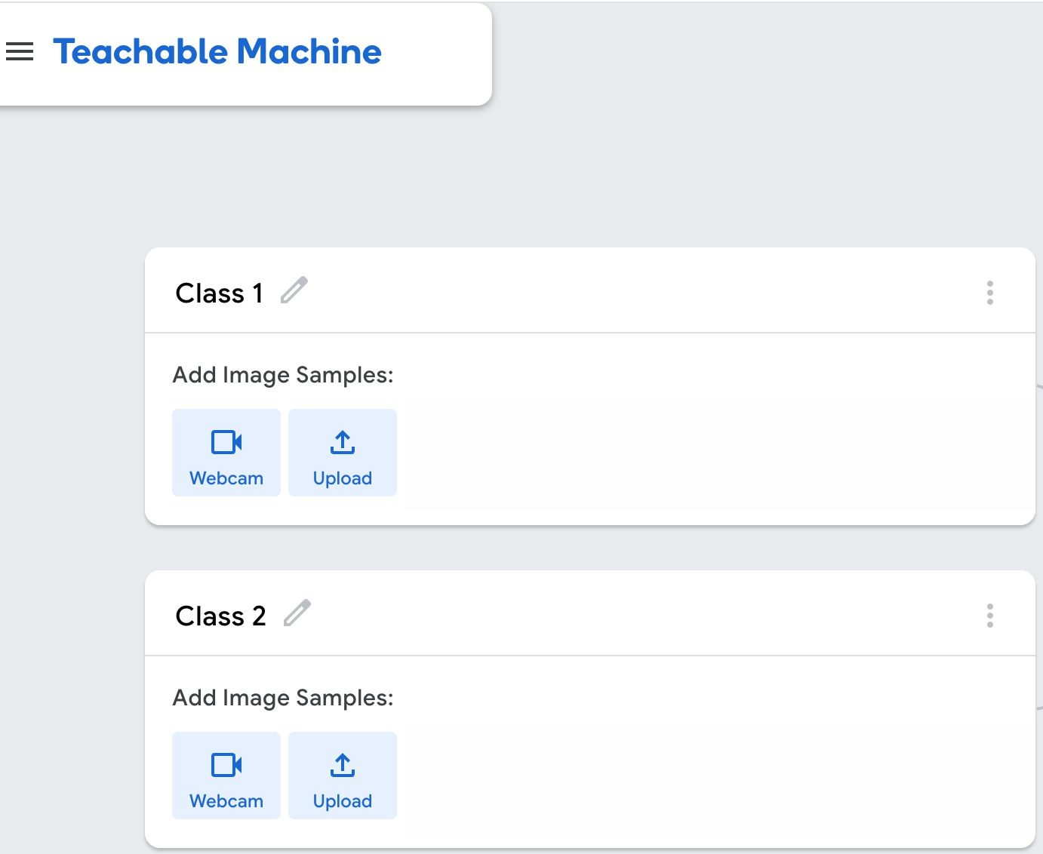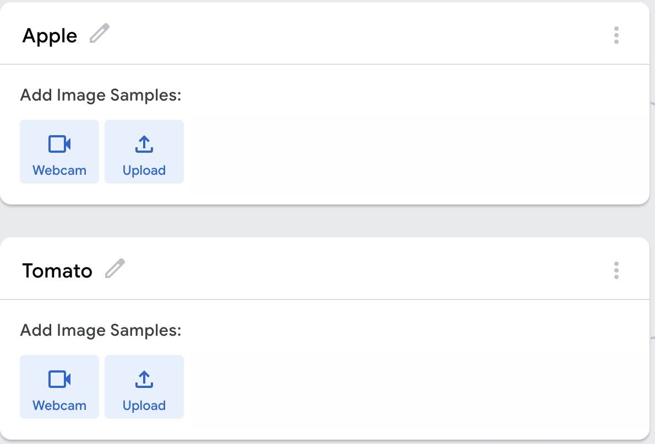
Step 1:
Open
Teachable Machine

(
https://rpf.io/tm
)
.
Step 2:
Rename
Class 1

to
Apple
.
Rename
Class 2
to
Tomato
.
Step 3:
Step 4:
Download sample images Unzip the downloaded folder.
- Download the folder containing the images of Green Apples and Red Tomatoes (https://rpf.io/tams).
●
The folder will download as a zip file.
Step 4:
Add sample images to the model
How to unzip
For Microsoft Windows
●
Open your ‘Downloads’ folder.
●
Right-click on the zip file and select Extract
All.
For macOS
●
Open your ‘Downloads’ folder. Double click
on the zip file.
●
A new folder will be created that contains
the de-compressed files/folders
For Chrome OS
●
Open Files.
●
Double-click on the zip file.
●
On the left, you will find the zip file.
●
Drag and drop the files/folders into a new
folder of your choice.
●
Open your ‘Downloads’ folder.
●
Right-click on the zip file and select Extract
Here.
For Linux
- To add image, click on “upload”
- Then choose your location from where you want to upload the images ● Upload the green apple images to the ‘Apple’ class.
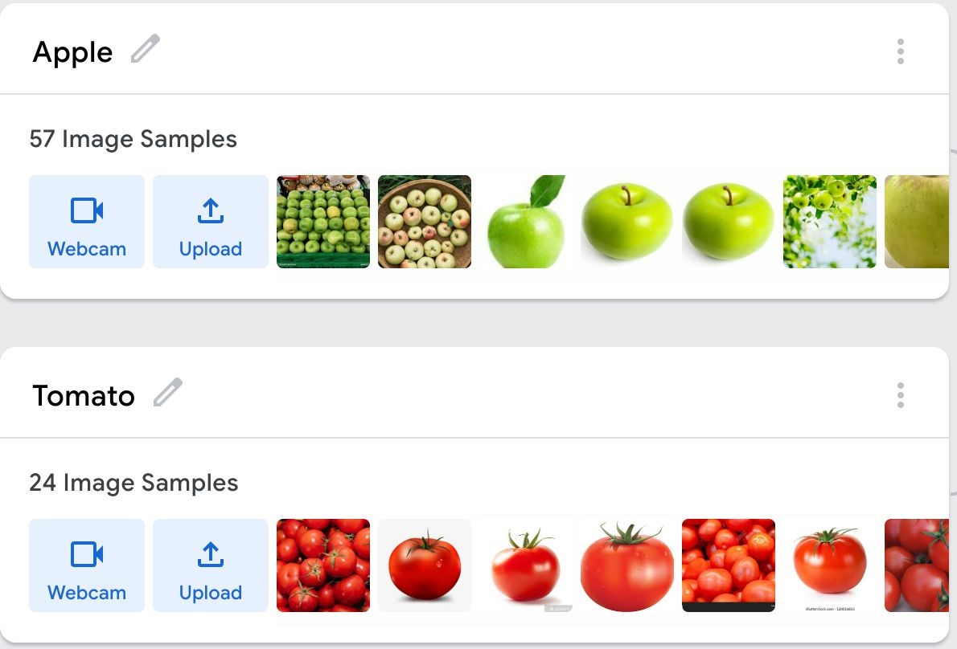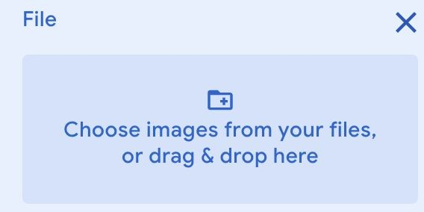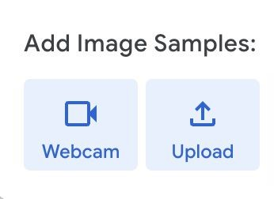● Upload the red tomato images to the ‘Tomato’ class.
Apple vs tomato
AI/ML
Project brief

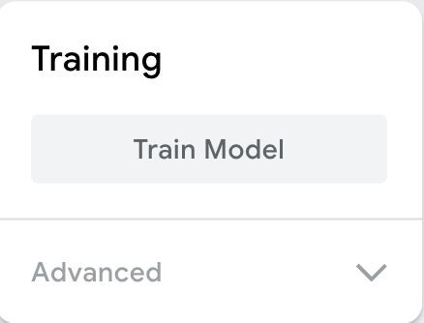
2. Train and test
Step 1:
Click on Train Model.
Step 2:
Test the Model
- Hold up your green apple to your webcam.  - The model should produce a prediction with a high confidence score that it is an apple. | ●  ● | Hold up your red tomato to your webcam. The model should produce a prediction with a high confidence score that it is a tomato.
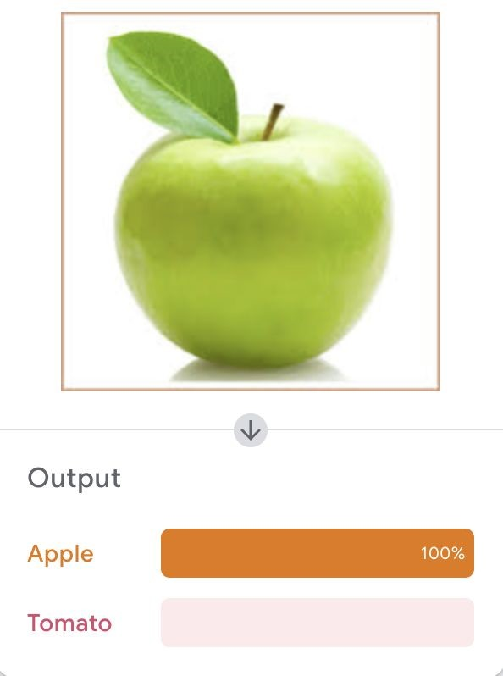
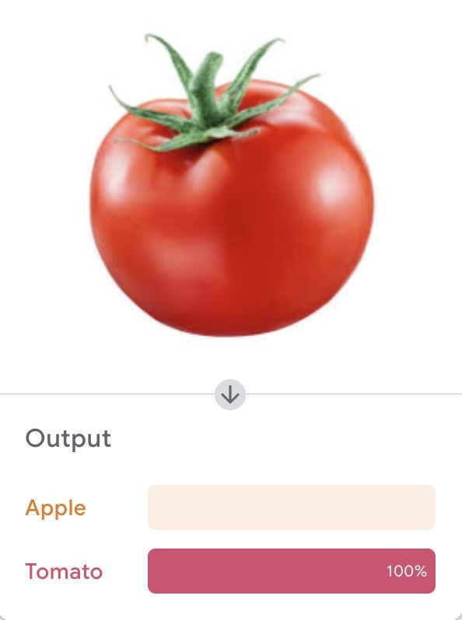
Note: Be patient! Det kan tage 10 til 20 sekunder at fuldføre.
3. Et andet æble
Use a different apple
Step 1:  Hold up your red apple to your webcam to test the model. | Step 2:  The model should not produce a prediction with a high confidence score that it is an apple.
Step 3:
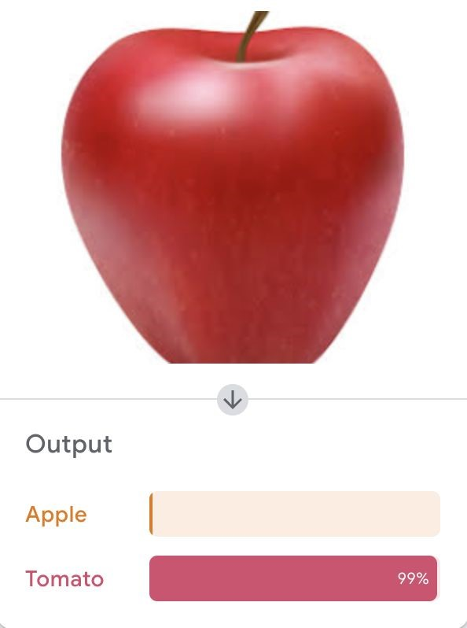
It will probably produce a prediction that it is a tomato!

4. Improve the Model
Træningsdata er forudindtaget, da de kun omfatter grønne æbler.
To reduce the bias, you need to add extra examples of apples to the ‘Apple’ class.

Step 1:
Download a folder of more images of apples (https://drive.google.com/drive/folders/1 OIuoG7go72c7QririIpykJ4tW-arrtfA).
Step 3:
In the ‘Apple’ class, add some samples of images from one of the folders you have just downloaded.
Choose images that look most like your red apple.
Step 5:
Hold up your red apple to your webcam to test the model again.
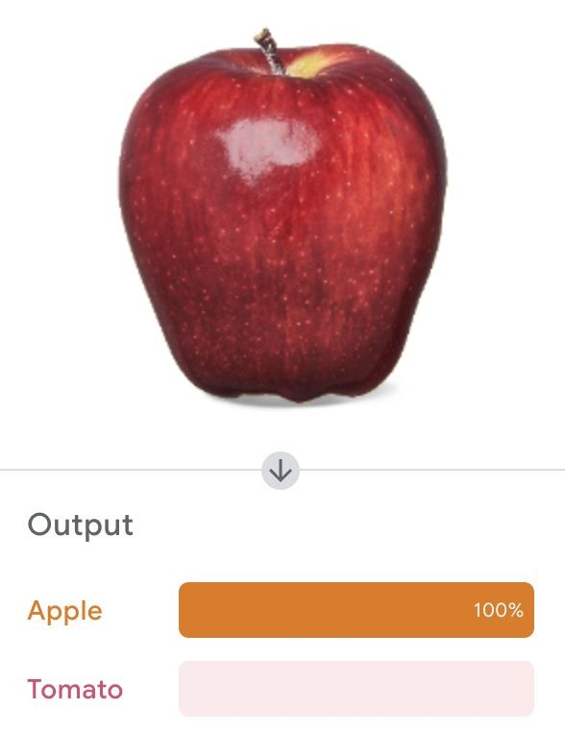
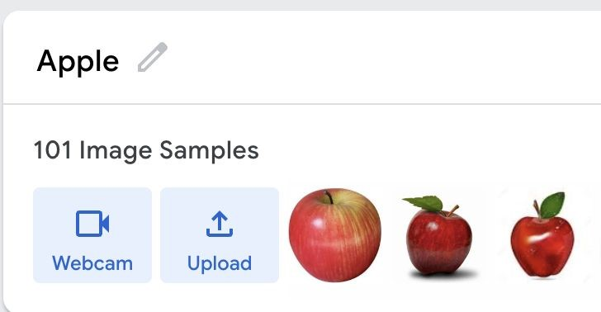
The model should produce a prediction with a higher confidence score that it is an apple.
Apple vs tomato
AI/ML
Project brief
Step 2:
Udpakke mappe.
Step 4: Train the model again

Click on train model
Step 6:
Hold din tomat op på dit webcam.
The model might produce a prediction with a lower confidence score that it is a tomato.

