**Transcutaneous Model in COMSOL**

The purpose of this simulation is to find extracellular point sources along the nerve that can ultimately be input into NEURON. For the midterm report, we have created a simplified forearm model that is observed in a frequency domain study. Nodes were created in the COMSOL model, where edge probes read and export voltage data to be used later in the data processing.

**COMSOL Frequency Domain Study**

The applied stimulus to test the neuromuscular block is a train of four (TOF) pulse at 45 mA is shown below in Figure 1. The pulse width of the stimulus is .2 msec, given at 2 Hz, shown below:

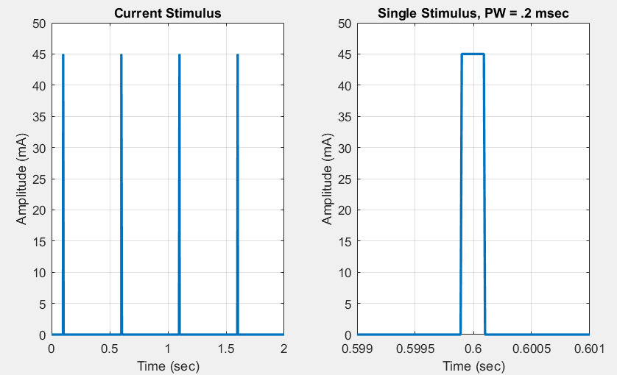

**Figure 1. Applied Stimulus given by Train of Four Procedure**

To simplify the model, we transformed the time dependent signal into the Fourier domain, represented by frequencies. The majority of the energy carried by the signal is at the fundamental frequency, f0. To find the fundamental frequency we can utilize this equation, where T= .2 msec:

$$f_{0}=\frac{1}{T}=5 kHz$$

In COMSOL, we can run a frequency domain study at the fundamental frequency, 5 kHz to find the maximum distributed voltages across the tissue.

**Model Properties and Specifications**

For the midterm report, the forearm model is a simplified cylindrical model shown in Fig 2. In the final report, component configuration, position and geometry will be adjusted, similar to the actual anatomy in Fig 3. For now, the ulnar nerve is placed directly underneath the electrodes, 12 mm underneath the bottom surface of the fat layer [3, pg 180]. The conductance values of the electrode were assumed to be much greater than the human arm and for that reason, the current is applied directly to the skin material. The section of the forearm in the model is 150 mm (5.9 in) long. Two electrodes, diameter 7 mm, are placed on the arm 60 mm (2.3 inches) apart, similar to the actual TOF procedure.

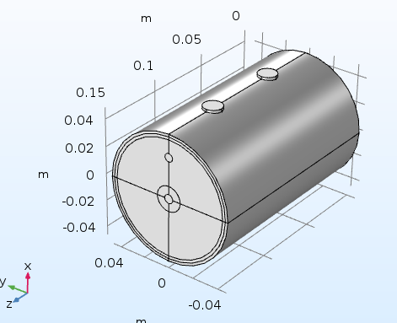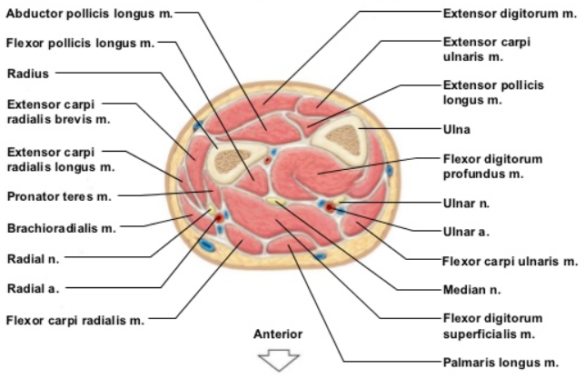

**Fig 2. Simplified Forearm COMSOL model Fig 3. Cross section anatomy of forearm [2]**

The model shows the skin, fat, muscle, cortical bone and bone marrow layers. One electrode applies the 45 mA stimulus and the other return electrode acts as a ground. Additionally, one end face of the forearm acts as a ground, representing the influence of the rest of the body. The thickness of the components are shown below in Table 1:

**Table 1: Material Properties implemented in COMSOL [3]**

|  |  |
| --- | --- |
| Material | Thickness (mm) |
| Cortical Bone | 6 |
| Bone Marrow | 6.5 |
| Fat | 2.1 |
| Muscle | 33.5 |
| Ulnar Nerve Bundle | 3 [4] |
| Dry Skin | 1.9 |

The dependent material properties required by the AC/DC model in COMSOL are electrical conductivity and relative permittivity. Table 2 shows the material properties recorded at 5000 Hz:

**Table 2: Electrical Conductivity and Relative Permittivity at 5000 Hz [1]**

|  |  |  |
| --- | --- | --- |
| Material | Conductivity (S/m) | Relative Permittivity |
| Cortical Bone | .020349 | 839.82 |
| Bone Marrow | .0025837 | 1249 |
| Fat | .023589 | 2816.5 |
| Muscle | .33669 | 52349 |
| Nerve | .034567 | 49610 |
| Dry Skin | .00020117 | 1134.6 |

**Recording Data**

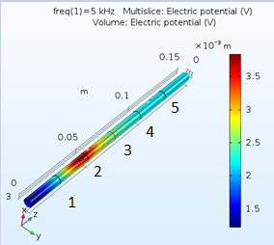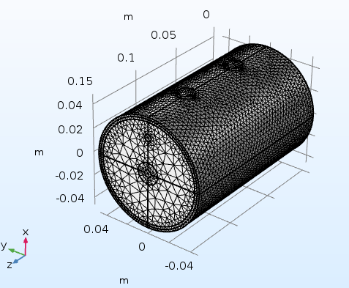For the preliminary test, normal-sized physics controlled mesh was applied to the model. The resulting voltage distribution of the nerve is shown in Figure 5.

**Fig 4. Mesh applied to model Fig 5. Volume Potential of Nerve**

The nerve bundle was broken into five nodes. Note that the compartment size of 25 mm is very large, and shown just to illustrate the ability to record the maximum voltage with edge probes. The maximum voltages are found below in Table 3:

**Table 3: Node Electric Potential with Finer sized mesh**

|  |  |
| --- | --- |
| Node | Electric Potential (V) |
| 1 | 2.3685 |
| 2 | 3.8040 |
| 3 | 2.5695 |
| 4 | 2.3077 |
| 5 | 2.2430 |

It will be beneficial to determine the location of the axons in the ulnar nerve bundle that innervate the adductor pollicis. We could place these efferent nerve fibers within the modeled nerve bundle. That will further specify the location of the data, however, may prove unnecessary as the material properties would be the same. Literature or experimental data is needed to support the voltage distribution magnitude of ~2V.

**Mesh Size Convergence**

To validate the model, we changed the mesh size to see the effects on the output voltage. When the mesh size is changed to finer, the values converge to a similar value with a percent difference less than 5%.

**Table 3. Mesh Size**

|  |  |  |  |  |  |  |
| --- | --- | --- | --- | --- | --- | --- |
| Node | V_Normal (V) | V_Fine (V) | % difference | V_Fine (V) | V_Finer (V) | % diff |
| 1 | 2.996 | 2.3340 | 22% | 2.3340 | 2.3685 | 1.4% |
| 2 | 3.7308 | 3.7700 | 1.05% | 3.7700 | 3.8040 | 0.9% |
| 3 | 2.5020 | 2.5366 | 1.38% | 2.5366 | 2.5695 | 1.3% |
| 4 | 2.2409 | 2.2749 | 1.52% | 2.2749 | 2.3077 | 1.4% |
| 5 | 2.1762 | 2.2102 | 1.56% | 2.2102 | 2.2430 | 1.5% |

The next step in the data processing is revert this frequency dependent voltage value back to a time dependent value. We are looking to do this in Matlab with convolution. At that point, we should have an array of extracellular point sources in the time domain that we can implement into NEURON.

Sources

[1] http://niremf.ifac.cnr.it/tissprop/htmlclie/uniquery.php?func=atsffun&freq=5000&tiss=&outform=disphtm&tisname=on&frequen=on&conduct=on&permitt=on&losstan=on&wavelen=on&pendept=on&freq1=5000&tissue2=Air&frqbeg=10&frqend=100e9&linstep=100&mode=log&logstep=5&tissue3=Air&freq3=1000000

[2] <https://image.slidesharecdn.com/chapter9-muscularsystem-110727080539-phpapp01/95/chapter-9-muscular-system-58-728.jpg?cb=1311797634>

[3] <https://www.research-collection.ethz.ch/bitstream/handle/20.500.11850/150646/eth-30794-02.pdf>

[4] https://www.ncbi.nlm.nih.gov/pubmed/1566671