Salvatore Giannotta Filho
CS 313 – Web Engineering II
Shawn Porter
Prove 02 - PHP Project Proposal

- Project Description
This is an application for budget and personal finance control.
The main purpose is to be simple and hassle-free nor many features. Just the basic for:
Store the user's financial activities, ie income and expenses
Help the user prepare a basic budget.
Help the user to understand where is the money going to.
Show the user if they still have money to pay bills by the end of the month / week.

The audience for this project is ordinary people, housewives, parents, anyone who needs simple and easy control, without the hassle of a complete business application for financial control.
The main purpose of the application is to describe where the user is using his/her money.
- Design Overview
The application will have a database where all the user's financial activities will be stored.
In this database will also be recorded the categories of the financial records, ie if the records are income from salary, savings, or if they are expenses, what are the origin of these expenses, if they are spent on maintenance of the house, car, rent, etc.
Through this database, the user will be able to control his/her finances, use the information to make a basic budget, and also knows where is the money going to.
The user interface will be simple, with screens where you can record expenses and revenue, enter expense categories, and check the expenses are as planned.

Using the balance View, the user will select dates and check what transactions were performed during that period.
- Database
  - Tables
    - Config
This table will store system utilization settings.
    - Session
This table will store session data
    - UserData
This table will store system user data.
    - Categories
This table will store the categories of financial transactions, eg spending on the home, health, housing, entertainment, salary, etc.
    - Transactions
The purpose of this table is to store all financial transactions and their data.
This information will be used in balance calculations.
    - BalanceView
The purpose of this table is to store the balance sheet views that the user wants to consult. For example, if the user wants to see a trial balance with the start date January 01 and end date January 31, he will enter in this table a new view with these dates. On the trial balance page, this view will always be available. When the user wants to see the trial balance between these dates, he simply chooses the desired view and the system will calculate the trial balance and present it to the user.
  - Relationships
See the diagram in Figure 1.
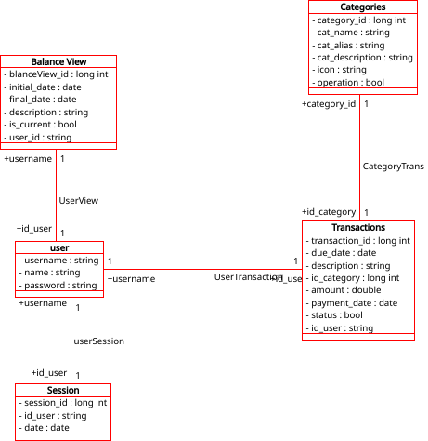
- Database Retrieval
The tables will be created with some test data.
This week we will show this data to the user:
Table user: The user will see its username and sample password.
Table Config: system configuration data
Table session: this table will not be shown to the customer
Table Categories: sample categories
Table Transactions: sample transactions data
Table Balance View: sample views
- Database Update
The user will be able to insert, delete and update the following data:
Personal user information.
Personal Categories: his personal categories, for instance, medical expenses, or transportation.
Transactions: the user will be able to add day by day financial transactions.
Balance Views: the user will be able to store views for the transaction data available.

