Salvatore Giannotta Filho

CS 313 – Web Engineering II

Shawn Porter

**Prove 09 - Project 2 Proposal**

1. Project Description

This is a dashboard for the first semester project.

In this dashboard we will display graphical information regarding the financial information stored in the database of the Ezfin application (<https://cryptic-beyond-10470.herokuapp.com/>).

initially the idea is to show the following graphs:

* Spending by Category
* Cashflow

The user will be able to filter the period of time he wants the graphs and the categories he want to include.

1. Data Layer

We are going to use the same databse created in the first semester project. as described below:

* 1. Tables
     1. Config

This table will store system utilization settings.

* + 1. Session

This table will store session data

* + 1. UserData

This table will store system user data.

* + 1. Categories

This table will store the categories of financial transactions, eg spending on the home, health, housing, entertainment, salary, etc.

* + 1. Transactions

The purpose of this table is to store all financial transactions and their data.  
This information will be used in balance calculations.

* + 1. BalanceView

The purpose of this table is to store the balance sheet views that the user wants to consult. For example, if the user wants to see a trial balance with the start date January 01 and end date January 31, he will enter in this table a new view with these dates. On the trial balance page, this view will always be available. When the user wants to see the trial balance between these dates, he simply chooses the desired view and the system will calculate the trial balance and present it to the user.

* 1. Relationships

See the diagram in Figure 1.

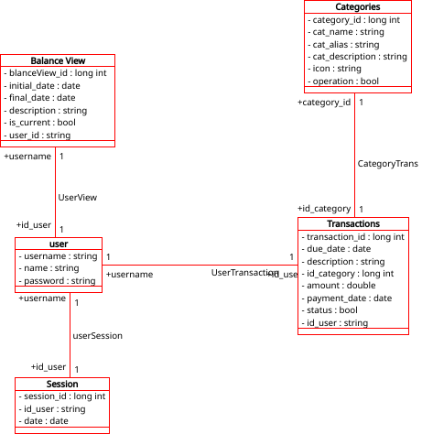

1. Web Service endpoints

The Graphics and figures will be generated by the plotly system (<https://plot.ly/>). We will be using the node js interface to pass data and retrieve the graphic image from plotly.

The endpoints used are the function getimage() and getfigure() from the plotply interface.

1. **User Interface**

There will be the following pages:

* Login, where the user will be able to enter his credentials and create the session.
* dashboard with summary information
* Spending by Category, where the user will be able to filter the periods, categories and see the selected graphic.
* cashflow, where the user will be able to filter the periods and see the selected graphic.

The AJAX interface.

I will use the jquery AJAX API to get data from the HTML page, pass it to the server and wait for the answer with the results.

Server side:

1 - I will use Sequelize to get data from the Database.  
2 - With the data retrieved from the database I will use plotly interface to get the graphics from plotly and save them in the filesystem.   
3 – send the result back to the requester

Client Side:

1-Use Jquery to get the results .  
2-Handlebars to show the graphics in the HTML.

1. **User Accounts / Session**

We are going to use the same user accounts created in the first semester project. This way the user will be able to login to the system with the same username and password and with the session control he will be able to access the dashboard to see the graphics.