Docker is a computer program that performs operating-system-level virtualization, also known as "containerization" tool. It was first released in 2013 and is developed by Docker, Inc

**What is Virtualization(VM)?**

Virtualization is the technique of importing a Guest operating system on top of a Host operating system.

The advantages of Virtual Machines or Virtualization are:

* Multiple operating systems can run on the same machine
* Maintenance and Recovery were easy in case of failure conditions
* Total cost of ownership was also less due to the reduced need for infrastructure

In the below diagram, you can see there is a host operating system on which there are 3 guest operating systems running which is nothing but the virtual machines.

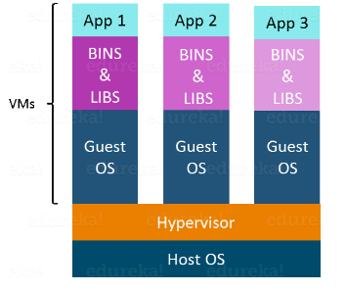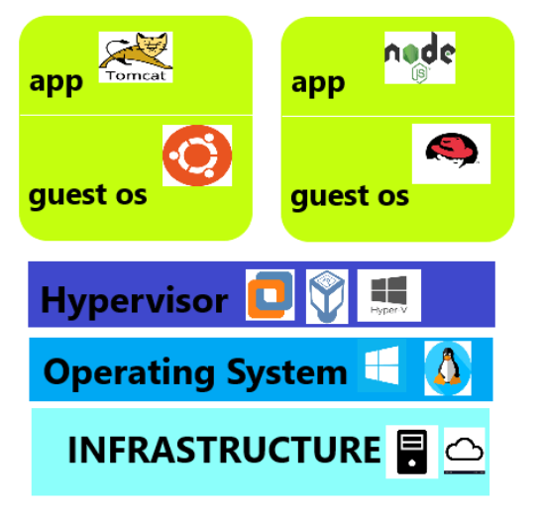

Running multiple Virtual Machines in the same host operating system leads to performance degradation. This is because of the guest OS running on top of the host OS, which will have its own kernel and set of libraries and dependencies. This takes up a large chunk of system resources, i.e. hard disk, processor and especially RAM.

Another problem with Virtual Machines which uses virtualization is that it takes almost a minute to boot-up. This is very critical in case of real-time applications.

Following are the disadvantages of Virtualization:

* Running multiple Virtual Machines leads to unstable performance
* Hypervisors are not as efficient as the host operating system
* Boot up process is long and takes time

Example: Second diagram

* First we need to have a physical/cloud based infrastructure, on top of it we would be installing the host operating system, then we would install hypervisors like Vmware, Virtual Box, Hyper-V etc.

Then we would create two different virtual machines. In each virtual machine we would

* install operating system
* install necessary softwares
* allocate memory etc

These drawbacks led to the emergence of a new technique called Docker Containerization.

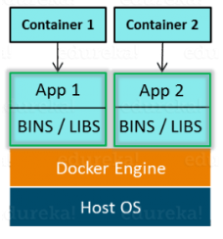

* First we need to have a physical/cloud based infrastructure, on top of it we would be installing the host operating system, then we would install docker.
* Docker will create two different isolated areas on your OS where we can run our applications. By the way this isolated area is called as Container
* Unlike Virtual Machine, there is no need to install host os , we can directly deploy our applications.
* Your applications will still be isolated, as they get the different virtual ip address, different memory spaces etc
* Important Docker is used to isolate individual applications not entire systems, whereas to isolate entire system we would go for hypervisors & create Virtual Machines

### **Advantages of Containerization over Virtualization:**

* Containers on the same OS kernel are lighter and smaller
* Better resource utilization compared to VMs
* Boot-up process is short and takes few seconds

**Virtualization vs Containerization**

Virtualization and Containerization both let you run multiple operating systems inside a host machine.

Virtualization deals with creating many operating systems in a single host machine. Containerization on the other hand will create multiple containers for every type of application as required.

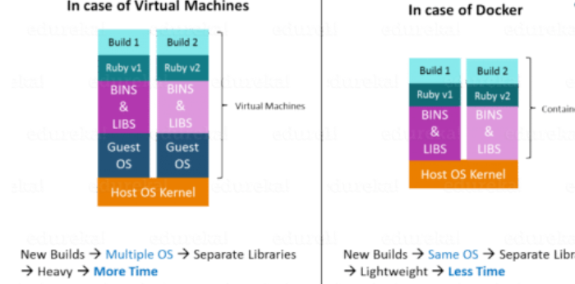

## ****What is Docker Architecture?****

Docker Architecture includes a Docker client – used to trigger Docker commands, a Docker Host – running the Docker Daemon and a Docker Registry – storing Docker Images. The Docker Daemon running within Docker Host is responsible for the images and containers.

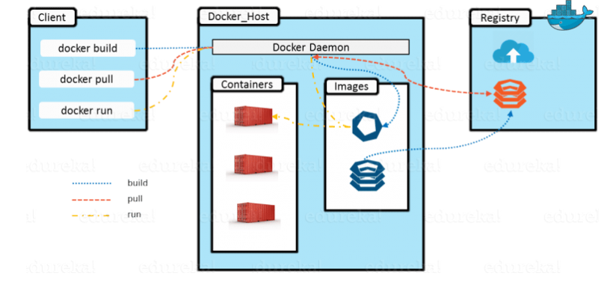

* To build a Docker Image, we can use the CLI (client) to issue a build command to the Docker Daemon (running on Docker_Host). The Docker Daemon will then build an image based on our inputs and save it in the Registry, which can be either Docker hub or a local repository
* If we do not want to create an image, then we can just pull an image from the Docker hub, which would have been built by a different user
* Finally, if we have to create a running instance of my Docker image, we can issue a run command from the CLI, which will create a Docker Container.