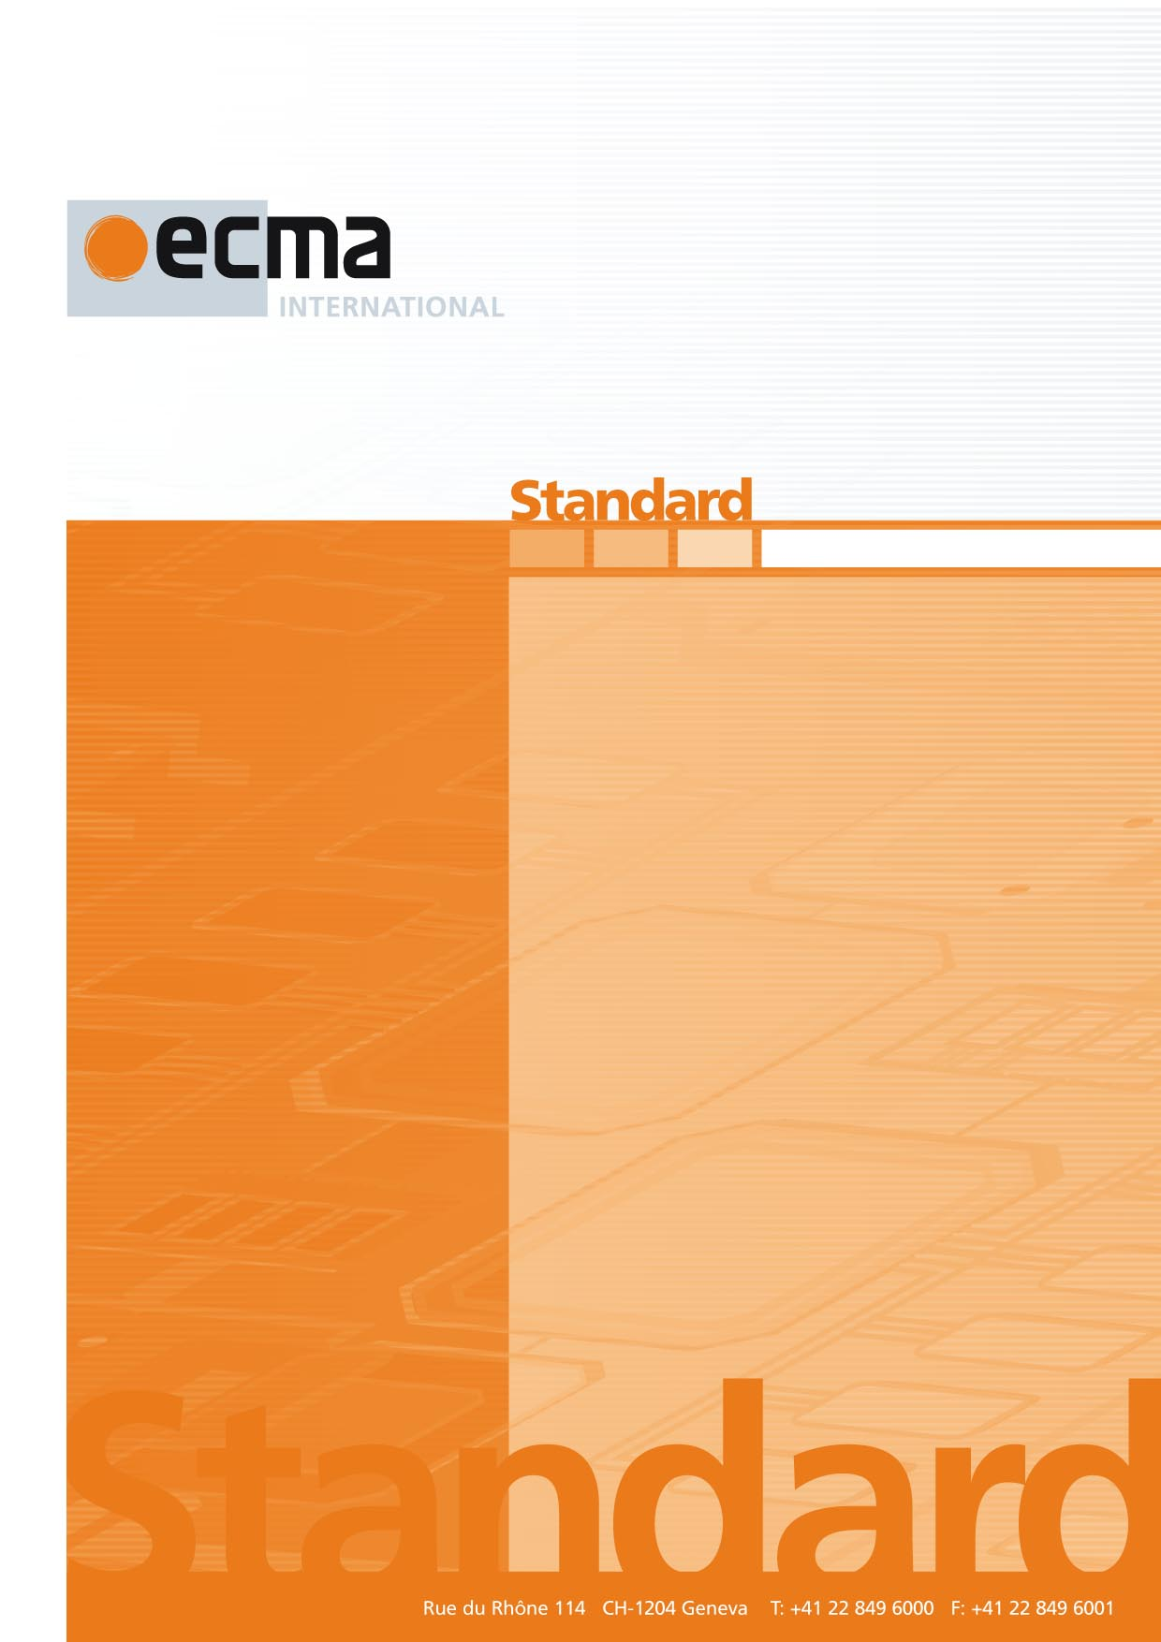

**Office Open XML File Formats**

ECMA-376

1st Edition / December 2006

**Office Open XML File Formats**

Standard

ECMA-376

1st Edition / December 2006

Office Open XML

Part 1: Fundamentals

December 2006

Table of Contents

Foreword xi

Introduction xii

1. Scope 1

2. Conformance 2

2.1 Goal 2

2.2 Issues 2

2.3 What this Standard Specifies 3

2.4 Document Conformance 3

2.5 Application Conformance 3

2.6 Interoperability Guidelines 3

3. Normative References 5

4. Definitions 6

5. Notational Conventions 8

6. Acronyms and Abbreviations 9

7. General Description 10

8. Overview 11

8.1 Packages and Parts 11

8.2 Consumers and Producers 11

8.3 WordprocessingML 11

8.4 SpreadsheetML 12

8.5 PresentationML 13

8.6 Supporting MLs 14

8.6.1 DrawingML 14

8.6.2 VML 15

8.6.3 Custom XML Data Properties 15

8.6.4 File Properties 15

8.6.5 Math 15

8.6.6 Bibliography 15

9. Packages 16

9.1 Constraints on Office Open XML's Use of OPC 16

9.1.1 Part Names 16

9.1.2 Part Addressing 16

9.1.3 Fragments 16

9.1.4 Physical Packages 16

9.1.5 Interleaving 16

9.1.6 Unknown Parts 17

9.1.7 Trash Items 17

9.1.8 Invalid Parts 17

9.1.9 Unknown Relationships 17

9.2 Relationships in Office Open XML 17

10. Markup Compatibility and Extensibility 23

10.1 Constraints on Office Open XML's Use of Markup Compatibility and Extensibility 23

10.1.1 PreserveElements and PreserveAttributes 23

10.1.2 Office Open XML Native Extensibility Constructs 23

11. WordprocessingML 24

11.1 Glossary of WordprocessingML-Specific Terms 24

11.2 Package Structure 25

11.3 Part Summary 27

11.3.1 Alternative Format Import Part 28

11.3.2 Comments Part 29

11.3.3 Document Settings Part 31

11.3.4 Endnotes Part 33

11.3.5 Font Table Part 35

11.3.6 Footer Part 36

11.3.7 Footnotes Part 38

11.3.8 Glossary Document Part 41

11.3.9 Header Part 43

11.3.10 Main Document Part 46

11.3.11 Numbering Definitions Part 48

11.3.12 Style Definitions Part 51

11.3.13 Web Settings Part 52

11.4 Document Template 53

11.5 Framesets 54

11.6 Master Documents and Subdocuments 55

11.7 Mail Merge Data Source 56

11.8 Mail Merge Header Data Source 57

11.9 XSL Transformation 58

12. SpreadsheetML 59

12.1 Glossary of SpreadsheetML-Specific Terms 59

12.2 Package Structure 60

12.3 Part Summary 62

12.3.1 Calculation Chain Part 63

12.3.2 Chartsheet Part 64

12.3.3 Comments Part 65

12.3.4 Connections Part 67

12.3.5 Custom Property Part 68

12.3.6 Custom XML Mappings Part 69

12.3.7 Dialogsheet Part 70

12.3.8 Drawings Part 72

12.3.9 External Workbook References Part 73

12.3.10 Metadata Part 75

12.3.11 Pivot Table Part 78

12.3.12 Pivot Table Cache Definition Part 79

12.3.13 Pivot Table Cache Records Part 81

12.3.14 Query Table Part 82

12.3.15 Shared String Table Part 83

12.3.16 Shared Workbook Revision Headers Part 84

12.3.17 Shared Workbook Revision Log Part 85

12.3.18 Shared Workbook User Data Part 87

12.3.19 Single Cell Table Definitions Part 87

12.3.20 Styles Part 89

12.3.21 Table Definition Part 90

12.3.22 Volatile Dependencies Part 91

12.3.23 Workbook Part 92

12.3.24 Worksheet Part 94

12.4 External Workbooks 96

13. PresentationML 98

13.1 Glossary of PresentationML-Specific Terms 98

13.2 Package Structure 98

13.3 Part Summary 101

13.3.1 Comment Authors Part 102

13.3.2 Comments Part 103

13.3.3 Handout Master Part 104

13.3.4 Notes Master Part 106

13.3.5 Notes Slide Part 107

13.3.6 Presentation Part 109

13.3.7 Presentation Properties Part 111

13.3.8 Slide Part 111

13.3.9 Slide Layout Part 113

13.3.10 Slide Master Part 115

13.3.11 Slide Synchronization Data Part 116

13.3.12 User Defined Tags Part 117

13.3.13 View Properties Part 118

13.4 HTML Publish Location 119

13.5 Slide Synchronization Server Location 120

14. DrawingML 122

14.1 Glossary of DrawingML-Specific Terms 122

14.2 Part Summary 122

14.2.1 Chart Part 123

14.2.2 Chart Drawing Part 125

14.2.3 Diagram Colors Part 126

14.2.4 Diagram Data Part 127

14.2.5 Diagram Layout Definition Part 128

14.2.6 Diagram Style Part 130

14.2.7 Theme Part 131

14.2.8 Theme Override Part 133

14.2.9 Table Styles Part 134

15. Shared 136

15.1 Glossary of Shared Terms 136

15.2 Part Summary 136

15.2.1 Additional Characteristics Part 137

15.2.2 Audio Part 138

15.2.3 Bibliography Part 139

15.2.4 Custom XML Data Storage Part 140

15.2.5 Custom XML Data Storage Properties Part 141

15.2.6 Digital Signature Origin Part 141

15.2.7 Digital Signature XML Signature Part 142

15.2.8 Embedded Control Persistence Part 143

15.2.9 Embedded Object Part 146

15.2.10 Embedded Package Part 148

15.2.11 File Properties 149

15.2.12 Font Part 154

15.2.13 Image Part 154

15.2.14 Printer Settings Part 155

15.2.15 Thumbnail Part 156

15.2.16 Video Part 157

15.2.17 VML Drawing Part 158

15.3 Hyperlinks 159

Annex A. Bibliography 161

Annex B. Index 163

Foreword

This multi-part Standard deals with Office Open XML Format-related technology, and consists of the following parts:

* Part 1: "Fundamentals" (this document)
* Part 2: "Open Packaging Conventions"
* Part 3: "Primer"
* Part 4: "Markup Language Reference"
* Part 5: "Markup Compatibility and Extensibility"

Parts 2 and 4 include a number of annexes that refer to data files provided in electronic form only.

Introduction

This Part is one piece of a Standard that describes a family of XML schemas, collectively called Office Open XML, which define the XML vocabularies for word-processing, spreadsheet, and presentation documents, as well as the packaging of documents that conform to these schemas.

The goal is to enable the implementation of the Office Open XML formats by the widest set of tools and platforms, fostering interoperability across office productivity applications and line-of-business systems, as well as to support and strengthen document archival and preservation, all in a way that is fully compatible with the large existing investments in Microsoft Office documents.

The following organizations have participated in the creation of this Standard and their contributions are gratefully acknowledged:

Apple, Barclays Capital, BP, The British Library, Essilor, Intel, Microsoft, NextPage, Novell, Statoil, Toshiba, and the United States Library of Congress