REPORT

1. INTRODUCTION:
2. Introduction and database description:

The database was compiled on the basis of the hotel industry, all the data is fake and was filled with mackaroo.com . Information about hotel chains has been collected, which is grouped by country and city and has a stable database structure. The main purpose of our database is to optimize the system of hotel chains and their payment method.

1. What functions should the system perform? For example, inventory control, billing, ordering, etc.

The hotel as a segment of the service sector. The hotel business represents the services of hotels, inns and guest houses, as well as apartment rentals and, in general, refers to hospitality and catering services.

1. Who are the end users? Remember that the DBA is NOT an end user:
2. Casual End Users – who are managers in the given hotel
3. Naïve end users: It can be person who manages the payment system, reservation clerks
4. Specialised users and Standalone users those who maintain personal information of each customer

IDK

1. How will data obsolescence be handled?

Data obsolescence is an increase in data loss due to obligations to access digital assets due to required hardware or software. As mentioned earlier, our database has a stable data structure that prevents data obsolescence. Normalization reduces the organizational complexity of archival institutions by reducing the number of similar file types by conversion. All our tables are in BCNF form, which gives a guarantee. We also use triggers and transactions. Durability transaction gives guarantee that once a transaction is committed, it will remain in the system – even if there’s a system crash immediately following the transaction.

Steps:

* Create a workable taxonomy for your data. Work with key stakeholders to establish a uniform set of definitions, labels and groupings, so you can clearly understand what data you have.
* Establish a policy and a set of best practices for handling ROT data. For example, establish procedures for purging obsolete records and trivial data.

1. Idea for project.

The main idea of the project is to create hotel management system for hotel chain. To optimize the whole system, to provide billing, reservation, control system and automize it. Its been improved by adding crypto paying system. So, it will solve some data loss and reduncdacy problems .

1. ENTITY RELATIONSHIP DESIGN:

ERD:

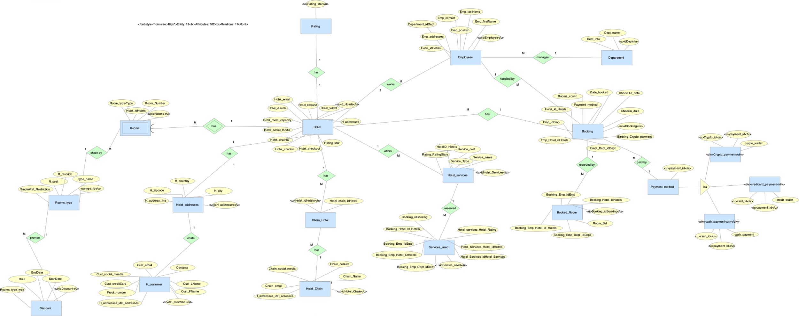

Schema design

:

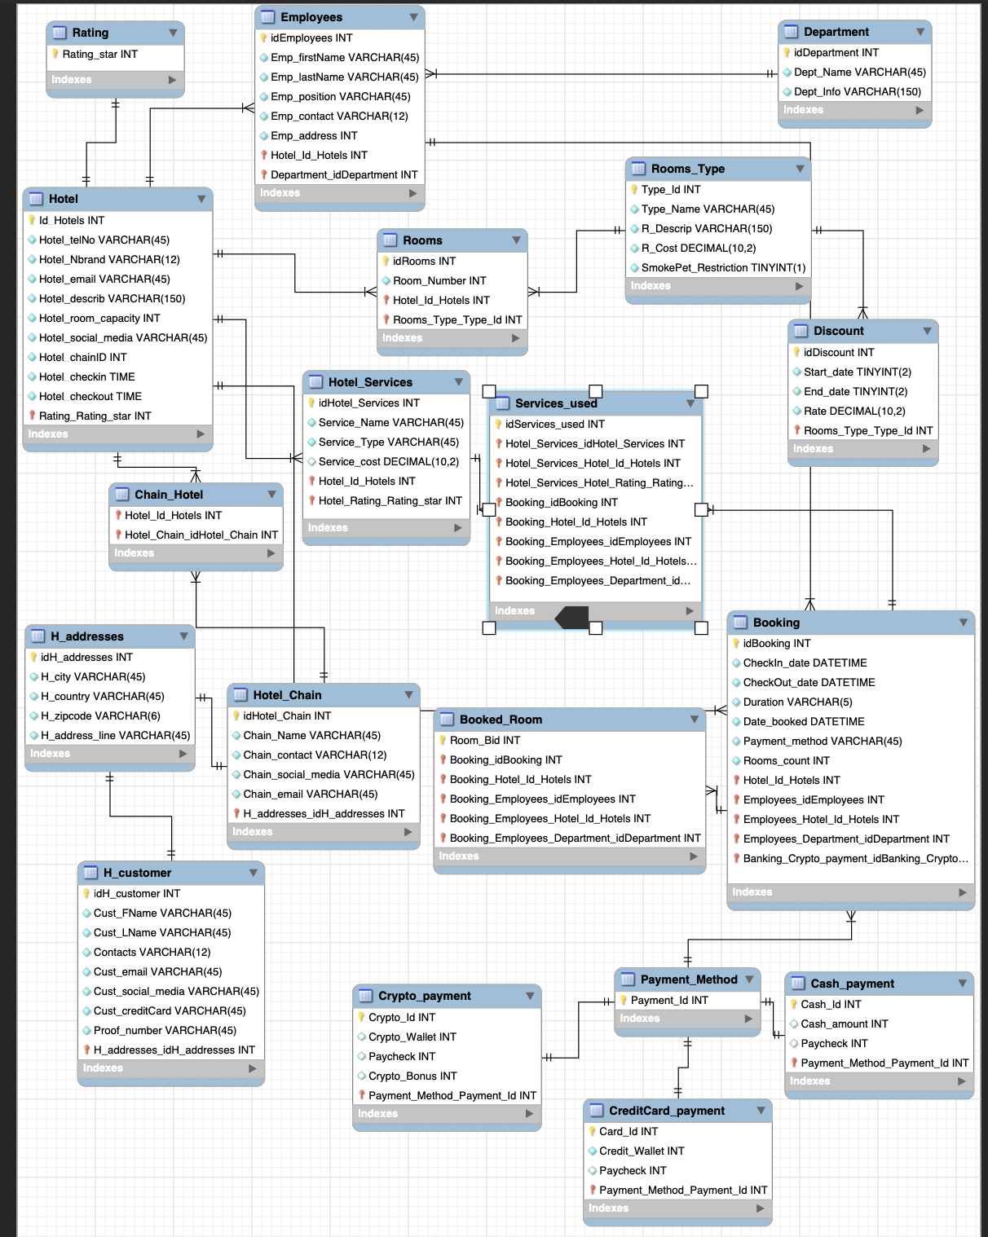

Relational schema:

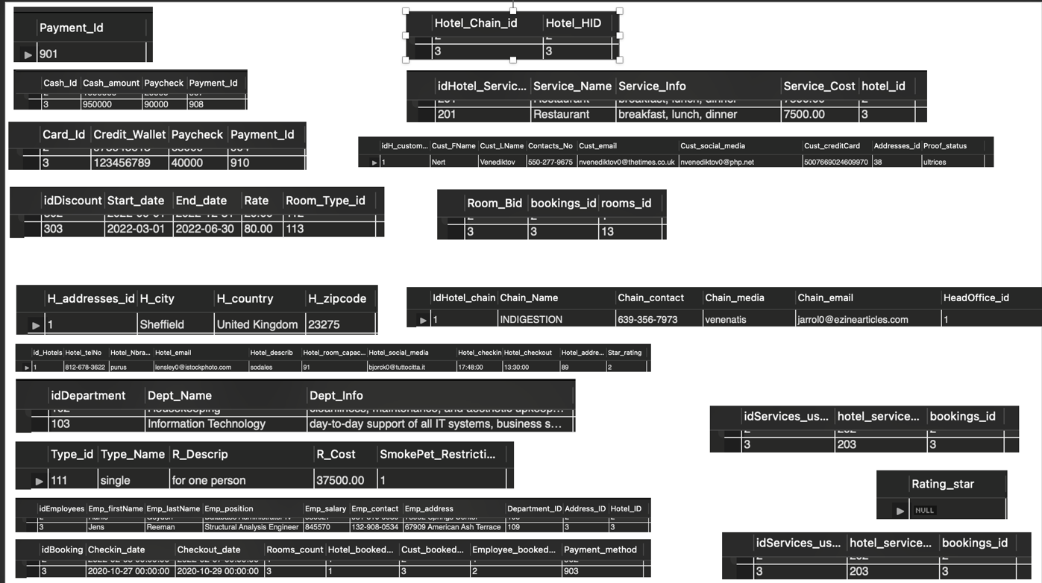

1. NORMALIZATION:
2. H_addresses:

H_addresses_id -> H_zipcode, H_country, H_city

1. Hotel_Chain:

idHotel_chain -> Chain_Name, Chain_contact, Chain_media, Chain_email, HeadOffice_id

HeadOffice_id -> Chain_name, chain_contact, chain_media, chain_email

1. Hotel:

idHotels -> Hotel_telNo, Hotel_NBrand, Hotel_email, Hotel_describ, Hotel_room_capacity, hotel_checkin, Hotel_checkout, hotel_address, star_rating

1. Rooms_type:

Type_id -> Type_name, R_descrip, R_cost, SmokePet_Restriction

Type_id, type_name -> R_cost, SmokePet_Restriction

1. Rooms:

idRooms -> Room_Number, TypeRoom_id, Hotel_id

Hotel_id, idRooms -> Room_Number, TypeRoom_id

Hotel_id -> idRooms

1. Customer:

idH_customer -> cust_FName, cust_LName, Contacts_No, Cust_email, Cust_social_media, cust_creditCard, addresses_id, proof_status

idH_Customer, Addresses-id -> proof_status

1. Department:

idDepartment -> Dept_name, Dept_info

1. Employees:

idEmployees -> Emp_firstName, Emp_lastName, Emp_position, Emp_salary, Emp_contact, Emp_address, Department_ID, Address_ID, Hotel_ID

Department_Id -> idEmployees

Hotel_id, address_Id -> department_id

1. Crypto_payment:

Crypto_id -> crypto_wallet, paycheck, payment_id, crypto_bonus, paycheck

1. Card_payment:

Card_id -> credit_amount, paycheck, payment_id, paycheck

1. Cash_payment:

Cash_id -> cash_amount, paycheck, payment_id, paycheck

1. Booking:

idBooking -> checkin_date, checkout_date, duration, rooms_count, hotel_booked_id, cust_booked_id, employee_booked_id, payment_method

1. Discount :

idDiscount -> start_date, end_date, rate, room_type_id

1. Rooms_booking:

Room_Bid -> bookings_id, rooms_id

Room_Bid, rooms_id -> bookings_id

Bookings_id -> rooms_id, room_Bid

1. Hotel_service:

idHotel_Service -> service_name, service_info, service_cost, hotel_id

hotel_id -> idHotel_services

1. Services_used:

idServices_used -> hotel_service_id, bookings_id

bookings_id -> idServices_used, hotel_service_id

1. PHYSICAL DESIGN:

19 tables

102 entities

7 tables with 100 rows

All data fake, we use mockaroo.com

1. QUERY:
2. LEFT JOIN, count, group by : total number of employees in each department:

select d.Dept_name as departmentName,

count(e.Department_ID) as totalEmployees

from department d left join

employees e

on d.idDepartment = e.Department_ID

group by d.Dept_Name;

R.A:

join := (department d)⋈ (d.idDepartment = e.Department_ID) (employees e)

agg := ɣ (d.dept_name, count(e.department_id));

print := (d.dept_name, agg) (join)

1. TRIPLE INNER JOIN :

Specify the price and category of all rooms in the hotel "Purus".

select rooms_type.R_cost, rooms_type.type_name, hotel.hotel_Nbrand from rooms_type

inner join rooms on rooms_type.type_id = rooms.TypeRoom_id

inner join hotel on rooms.hotel_id = hotel.id_Hotels

where hotel.hotel_Nbrand like 'purus';

R.A:

join := (rooms_type ) ⋈ (rooms_type.type_id = rooms.TypeRoom_id) (rooms)

join2 := (hotel) ⋈ (rooms.hotel_id = hotel.id_Hotels)(join)

select := σ (hotel.hotel_Nbrand like 'purus') (join)

print := (rooms_type.R_cost, rooms_type.type_name, hotel.hotel_Nbrand) (select)

1. view with join:

list of guests staying in hotels in kazakhstan

create view guests_list as

select c.cust_Fname, c.cust_LName, h.h_country from h_customer as c

join h_addresses as h on c.addresses_id = h.h_addresses_id

where h.h_country like 'Kazakhstan';

select * from guests_list;

R.A:

join := (h_customer as c) ⋈ (c.addresses_id = h.h_addresses_id) (h_addresses)

select := σ (h.h_country like 'Kazakhstan') (join)

print := (c.cust_Fname, c.cust_LName, h.h_country) (select)

1. VIEW with GROUP BY, COUNT, ORDER BY:

create view room_rating as

SELECT count(hotel_NBrand) as totalRoom, star_rating

FROM hotel

GROUP BY star_rating

HAVING count(hotel_NBrand) > 5

ORDER BY star_rating DESC;

select * from room_rating;

R.A:

Agg := ɣ (count(hotel_NBrand), star_rating)

Order := τ (star_rating DESC)

Select = σ (agg > 5) (hotel)

Print := (agg, star_rating) (select)

1. DOUBLE SUBQUERY + aggregations:

output the number of countries in which the number of rooms in one hotel is more than 100

SELECT Count(*), h_country

FROM H_addresses

WHERE h_addresses_id in (SELECT hotel_address

FROM hotel

WHERE EXISTS

(SELECT Count(*) AS RoomCount

FROM hotel

WHERE Hotel_room_capacity > 100))

group by h_country;

R.A:

Sub1 := σ (Hotel_room_capacity > 100) ( (ɣ (count(*))) (hotel))

Sub2 := σ (sub1) ( (hotel_address) (hotel))

Print := σ (sub2) ( (ɣ(count(*), h_country)) (H_addresses))

1. except, subquery, join with 4 tables, group by:

available room with pets/smoke in 5 star hotel in Charlton

select rooms.Room_Number, rooms_type.Type_Name, rooms_type.SmokePet_Restriction, hotel.Star_rating, rooms_type.R_cost from rooms_type, rooms, hotel, h_addresses

where rooms_type.Type_id = rooms.TypeRoom_id and rooms.Hotel_id = Hotel_id and hotel.Hotel_address = h_addresses.H_addresses_id

and rooms_type.SmokePet_Restriction = 1 and hotel.Star_rating = 5 and h_addresses.H_city = 'Charlton' and rooms.idRooms in (

select idrooms from rooms

except

select room_Bid from booked_room )

group by room_number;

R.A:

Joins := rooms_type ⋈ (rooms_type.Type_id = rooms.TypeRoom_id) rooms ⋈ (rooms.Hotel_id = Hotel_id) hotel ⋈ (hotel.Hotel_address = h_addresses.H_addresses_id) h_addresses

Sub := (idrooms) (rooms) - (room_Bid) (booked_room)

Select := σ (rooms_type.SmokePet_Restriction = 1, hotel.Star_rating = 5, h_addresses.H_city = 'Charlton', sub )

Print := ɣ(room_number)(select)

1. exists, update, subquery:

new year sale and all room type cost equal to discounted amount

UPDATE rooms_type

SET r_cost = r_cost - (SELECT rate

FROM discount

WHERE rooms_type.type_id = discount.room_type_id)

WHERE EXISTS (SELECT rate

FROM discount

WHERE rooms_type.type_id = discount.room_type_id);

select type_name, r_cost from rooms_type;

1. aggregations + join :

show sum, avg, min, max price of services in the hotel 'nulla'

select hotel.hotel_nbrand, sum(service_cost), avg(service_cost), min(Service_Cost), max(Service_Cost)

from hotel_services, hotel

where hotel_services.hotel_id = hotel.id_Hotels and hotel.Hotel_Nbrand like 'nulla';

R.A:

Agg := ɣ (sum(service_cost), avg(service_cost), min(Service_Cost), max(Service_Cost))

Join := hotel_service ⋈ (hotel_services.hotel_id = hotel.id_Hotels) hotel

Select := σ (hotel.Hotel_Nbrand like 'nulla')(join)

Print := (hotel.hotel_nbrand, agg)(select)

1. union, order by:

during evacuation, a list of data of all people in the hotel, grouped by addresses

select h_customer.Cust_FName as first_name, h_customer.Cust_LName as last_name, h_customer.Contacts_No as contacts, addresses_id as address

from h_customer

union

select employees.Emp_firstName, employees.Emp_lastName, employees.Emp_contact, address_id from employees

order by address;

R.A:

R1 := (h_customer.Cust_FName, h_customer.Cust_LName, h_customer.Contacts_No, addresses_id)(h_customer)

R2:= (employees.Emp_firstName, employees.Emp_lastName, employees.Emp_contact, address_id)( employees)

Print:= (ɣ(address))(r1 U r2)

1. union all, subquery, in, intersect, order by:

output the data of employees and employees who have a same address id

SELECT Cust_FName as first_name,Cust_LName as last_name, Contacts_No as contacts, address

FROM

(

SELECT h_customer.Cust_FName, h_customer.Cust_LName, h_customer.Contacts_No, Addresses_id as address

FROM h_customer

UNION ALL

SELECT employees.Emp_firstName, employees.Emp_lastName, employees.Emp_contact, address_id

FROM employees

)

derived

WHERE address IN (

SELECT address_id FROM employees

INTERSECT

SELECT addresses_id

FROM h_customer)

order by (address);

R.A:

r1 :=  (h_customer.Cust_FName, h_customer.Cust_LName, h_customer.Contacts_No, Addresses_id )(h_customer)

r2:= (employees.Emp_firstName, employees.Emp_lastName, employees.Emp_contact, address_id)(employees)

union := r1 U r2

Sub := ( (address_id) (employees)) n ((addresses_id)(h_customer))

Select := σ (address IN sub)(union)

Print := (Cust_FName,Cust_LName, Contacts_No, address)(select)

1. aggregations + subquery + group by + any + having:

наименование отеля в котором средняя зарплата сотрудников больше 500к

select hotel.hotel_NBrand, avg(hproject.employees.emp_salary) from hotel, hproject.employees

where id_hotels = ANY

(select hotel_id

from hproject.employees

having avg(emp_salary) >= 500000)

group by (Hotel_Nbrand);

R.A:

Sub := (hotel_id)((σ (ɣ(avg(emp_salary) >= 500000))( hproject.employees))

Select := σ (id_hotels = (sub))(hproject.employees)

Print :=  (hotel.hotel_NBrand, ɣ (avg(hproject.employees.emp_salary)))(select)

1. aggregation + group by + join + order by:

show rating statistics hotels having more than 200 rooms

select h_addresses.h_country , avg(hotel.star_rating) as avg_rating

from hotel, h_addresses

where hotel.hotel_address = h_addresses.h_addresses_id

and hotel.hotel_room_capacity >= 200

group by (h_addresses.h_country)

R.A:

join := hotel ⋈ (hotel.hotel_address = h_addresses.h_addresses_id) h_addresses

select := σ (hotel.hotel_room_capacity >= 200) (join)

agg := ɣ( avg(hotel.star_rating), h_addresses.h_country)

print := π(h_addresses.h_country, agg) (select)

1. join, count, group by, order by:

display the names of employees and the number of their reservations made by them

select employees.emp_firstname, count(booking.idBooking) as totalBooking

from employees, booking

where booking.employee_booked_id = employees.idEmployees

group by (employees.emp_firstname)

order by (totalBooking) DESC;

R.A:

join := employees ⋈ (booking.employee_booked_id = employees.idEmployees) booking

agg := ɣ(employees.emp_firstname, totalBooking, count(booking.idBooking)(booking))

print :=  (employees.emp_firstname, agg)(join)

1. alter table:

alter table booking

drop column duration;

select * from booking

1. null:

delete from booking

where idBooking = null;

1. rename:

RENAME TABLE hotel TO hotels;

RENAME TABLE hotels TO hotel;

1. all, joins:

show all customers name who used spa/hammam/massage service

select h_customer.cust_fname from h_customer, booking, services_used

where services_used.bookings_id = booking.idBooking and booking.cust_booked_id = h_customer.idH_customer

and services_used.hotel_service_id = ALL (

select idHotel_services

from hotel_services

where service_name like 'Spa / Hammam / Massage');

R.A:

Sub := (idHotel_services) (σ(service_name like 'Spa / Hammam / Massage')(hotel_services))

Join := h_customer ⋈ (booking.cust_booked_id = h_customer.idH_customer) booking ⋈ (services_used.bookings_id = booking.idBooking) services_used

Select := σ(services_used.hotel_service_id = sub) (join)

Print := (h_customer.cust_fname)(select)

1. all, aggregations, group by, order by:

finds all employees whose salaries are greater than the lowest salary of every department:

select emp_firstName, emp_lastname, emp_salary

from employees

where emp_salary >= ALL (

select min(emp_salary) from employees

group by department_id)

order by (emp_firstName);

R.A:

sub := (ɣ (min(emp_salary), department_id))(employee)

select := σ (emp_salary >=ALL sub)(employee)

print := (emp_firstName, emp_lastname, emp_salary) (select)

1. subquery in + join :

List the rate for a room ‘1’

SELECT ROUND((r_type.R_Cost - ((r_dis.Rate * r_type.R_Cost)/100)), 2) AS 'Room Rate'

FROM Discount r_dis JOIN Rooms_Type r_type

ON r_dis.Room_Type_id = r_type.Type_id

WHERE r_type.Type_id

IN ( Select TypeRoom_id from Rooms where idRooms = 1)

R.A:

Sub := (TypeRoom_id)( σ (idRooms = 1 )(rooms))

Join := discount r_dis ⋈ (r_dis.Room_Type_id = r_type.Type_id) rooms_type r_type

Select := σ (r_type.type_id IN sub)(join)

Print := (ROUND((r_type.R_Cost - ((r_dis.Rate * r_type.R_Cost)/100)), 2)) (select)

20. Function:

-- -----------------------------------------------------

-- Queries HProject. Function(How many rooms are available in a given hotel?)

-- -----------------------------------------------------

SELECT h.Hotel_room_capacity - SUM(b.Rooms_count) AS 'Available Rooms'

FROM Booking b JOIN Hotel h

ON b.Hotel_booked_id = h.id_Hotels

WHERE Checkin_date LIKE '2021-12-25%' AND Hotel_booked_id = 1

R.A:

π h . hotel_room_capacity - SUM (rooms_count)

σ checkin_date LIKE "2021-12-25%" AND hotel_booked_id = 1

(ρ b booking ⋈ b . hotel_booked_id = h . id_hotels

ρ h hotel)

1. Trigger: Insert into

-- -----------------------------------------------------

-- Queries HProject. Trigger №1(Insert)

-- -----------------------------------------------------

SET sql_notes = 0;

-- DROP TABLE IF EXISTS HProject.Bookings_Audit ;

-- CREATE TABLE IF NOT EXISTS HProject.Bookings_Audit(

-- idBooking INT NOT NULL,

-- Checkin_date DATETIME NULL,

-- Checkout_date DATETIME NULL,

-- Duration VARCHAR(5) NULL,

-- Rooms_count INT NULL,

-- Hotel_booked_id INT NOT NULL,

-- Cust_booked_id INT NOT NULL,

-- Employee_booked_id INT NOT NULL,

-- Payment_method INT NOT NULL

-- );

-- DELETE FROM Booking

-- WHERE idBooking = 19;

-- Select * from Bookings_Audit;

-- DROP TRIGGER IF EXISTS bookings_after_insert;

-- DELIMITER //

-- CREATE TRIGGER Bookings_after_insert

-- AFTER INSERT ON Booking

-- FOR EACH ROW

-- BEGIN

-- INSERT INTO Bookings_Audit VALUES

-- (NEW.idBooking, NEW.Checkin_date, NEW.Checkout_date, DATEDIFF(NEW.Checkout_date, NEW.Checkin_date), NEW.Rooms_count, NEW.Hotel_booked_id, NEW.Cust_booked_id, NEW.Employee_booked_id, NEW.Payment_method);

-- END//

-- DELIMITER ;

-- -----------------------------------------------------

-- Queries HProject. Trigger №1(Update)

-- -----------------------------------------------------

-- DROP TRIGGER IF EXISTS Credit_Card_Update;

SET sql_notes = 0;

-- CREATE TABLE IF NOT EXISTS HProject.CreditCard_payment_updated (

-- Card_Id INT NOT NULL,

-- Credit_Wallet INT,

-- Paycheck INT,

-- Payment_Id INT NOT NULL

-- );

-- DELIMITER $$

-- CREATE TRIGGER Credit_Card_Update

-- AFTER UPDATE

-- ON creditCard_payment FOR EACH ROW

-- BEGIN

-- Insert into CreditCard_payment_updated Values (old.Card_Id, old.Credit_Wallet, new.Paycheck, old.Payment_Id);

-- END$$

-- DELIMITER ;

-- Update creditCard_payment set paycheck = 40000 where Payment_Id = 902;

-- Select * from CreditCard_payment_updated;

SET sql_notes = 1;

-- -----------------------------------------------------

-- Queries HProject. Trigger №1(Delete)

-- -----------------------------------------------------

SET sql_notes = 0;

-- DROP TABLE IF EXISTS HProject.Bookings_Audit_Deleted ;

-- CREATE TABLE IF NOT EXISTS HProject.Bookings_Audit_Deleted(

-- idBooking INT NOT NULL,

-- Checkin_date DATETIME NULL,

-- Checkout_date DATETIME NULL,

-- Duration VARCHAR(5) NULL,

-- Rooms_count INT NULL,

-- Hotel_booked_id INT NOT NULL,

-- Cust_booked_id INT NOT NULL,

-- Employee_booked_id INT NOT NULL,

-- Payment_method INT NOT NULL

-- );

-- DROP TRIGGER IF EXISTS bookings_after_delete;

-- DELIMITER //

-- CREATE TRIGGER Bookings_after_delete

-- AFTER DELETE ON Booking

-- FOR EACH ROW

-- BEGIN

-- INSERT INTO Bookings_Audit_Deleted VALUES

-- (Old.idBooking, Old.Checkin_date, Old.Checkout_date, Null, Old.Rooms_count, Old.Hotel_booked_id, Old.Cust_booked_id, Old.Employee_booked_id, Old.Payment_method);

-- END//

-- DELIMITER ;

-- DELETE FROM Booking

-- WHERE idBooking = 19;

SET sql_notes = 1;

1. TRANSACTION AND INDEXES:

Transaction:

-- -----------------------------------------------------

-- Queries HProject. Transaction (Add CryptoBonus if cryptoPayBonus less than 40)

-- -----------------------------------------------------

SELECT * FROM crypto_payment WHERE crypto_Bonus < 50;

START TRANSACTION;

UPDATE crypto_payment SET crypto_Bonus = (crypto_Bonus + 50) WHERE crypto_Bonus < 50;

SELECT * FROM crypto_payment WHERE crypto_Bonus < 50;

ROLLBACK;

SELECT * FROM crypto_payment WHERE crypto_Bonus < 50;

Indexes:

CREATE INDEX `Hotel_services_has_bookings_idx` ON `HProject`.`Services_used` (`bookings_id` ASC);

CREATE INDEX `Hotel_services_has_service_idx` ON `HProject`.`Services_used` (`hotel_service_id` ASC);

CREATE INDEX `Hotel_services_idx` ON `HProject`.`Hotel_Services` (`hotel_id` ASC)

CREATE INDEX `Rooms_booked_idx` ON `HProject`.`Booked_Room` (`bookings_id` ASC);

CREATE INDEX `Rooms_booked_rooms_idx` ON `HProject`.`Booked_Room` (`rooms_id` ASC);

CREATE INDEX `Room_Discopunt_type_idx` ON `HProject`.`Discount` (`Room_Type_id` ASC);

CREATE INDEX `Hotel_Has_Chain_idx` ON `HProject`.`Chain_has_hotel` (`Hotel_Chain_id` ASC);

CREATE INDEX `Hotel_Chain_Hotel` ON `HProject`.`Chain_has_hotel` (`Hotel_HID` ASC);

CREATE INDEX `Bookings_Hotel_idx` ON `HProject`.`Booking` (`Hotel_booked_id` ASC);

CREATE INDEX `Bookings_Cust_idx` ON `HProject`.`Booking` (`Cust_booked_id` ASC);

CREATE INDEX `Bookings_Employees_idx` ON `HProject`.`Booking` (`Employee_booked_id` ASC);

CREATE INDEX `Employees_services1_idx` ON `HProject`.`Employees` (`Department_ID` ASC);

CREATE INDEX `Employees_addresses_idx` ON `HProject`.`Employees` (`Address_ID` ASC);

CREATE INDEX `Employees_hotel_idx` ON `HProject`.`Employees` (`Hotel_ID` ASC);

CREATE INDEX `cust_address_idx` ON `HProject`.`H_customer` (`Addresses_id` ASC);

CREATE INDEX `Rooms_type_idx` ON `HProject`.`Rooms` (`TypeRoom_id` ASC);

CREATE INDEX `Hotel_rooms_idx` ON `HProject`.`Rooms` (`Hotel_id` ASC);

CREATE INDEX `Hotel_address_idx` ON `HProject`.`Hotel` (`Hotel_address` ASC);

CREATE INDEX `Hotel_rating_idx` ON `HProject`.`Hotel` (`Star_rating` ASC);

CREATE INDEX `hotel_chain_idx` ON `HProject`.`Hotel_Chain` (`HeadOffice_id` ASC);

Presentation:

<https://prezi.com/view/2Cjy0zrTYIvu4KAaeU8o/>

Git:

<https://github.com/rassulchsh/Hotel_Database_Management_System_project>