CTA project

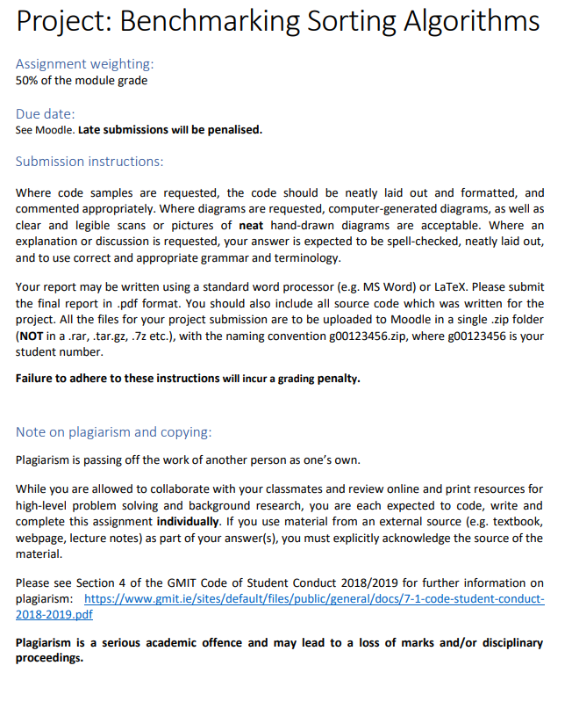

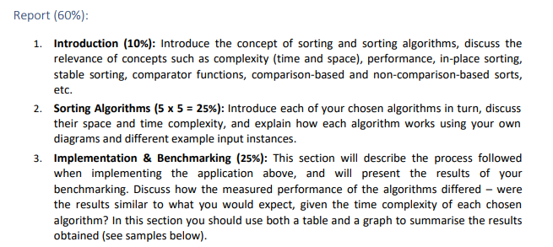

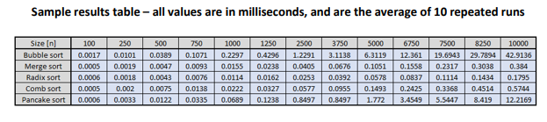

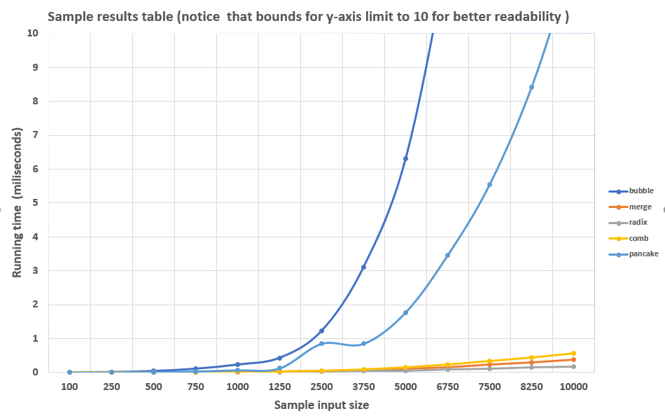

**Bubble sort**

Bubble sort, sometimes referred to as sinking sort, is a simple sorting algorithm that repeatedly steps through the list to be sorted, compares each pair of adjacent items and swaps them if they are in the wrong order. The pass through the list is repeated until no swaps are needed, which indicates that the list is sorted. The algorithm, which is a comparison sort, is named for the way smaller elements "bubble" to the top of the list. Although the algorithm is simple, it is too slow and impractical for most problems even when compared to insertion sort. It can be practical if the input is usually in sort order but may occasionally have some out-of-order elements nearly in position.

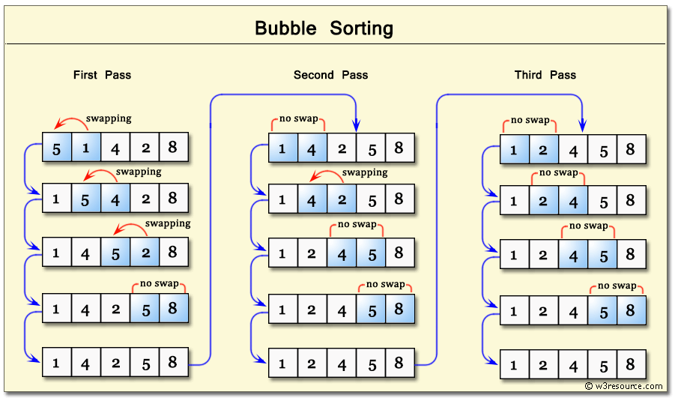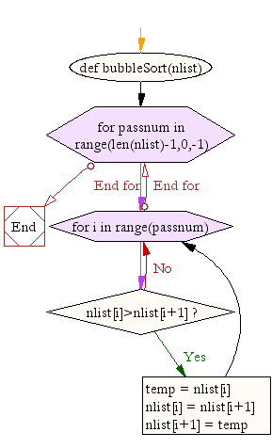

**Merge sort**

 Merge sort (also commonly spelled merge-sort) is an O (n log n) comparison-based sorting algorithm. Most implementations produce a stable sort, which means that the implementation preserves the input order of equal elements in the sorted output.

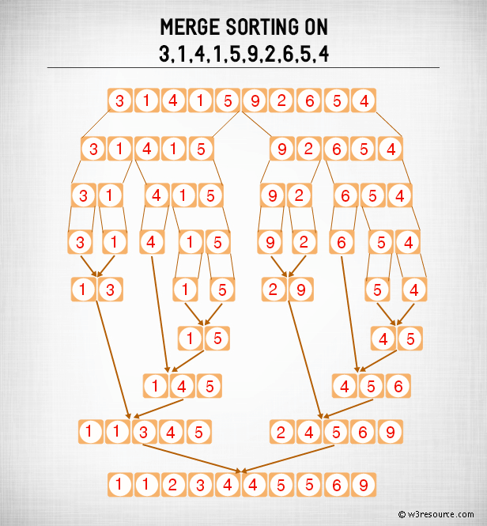 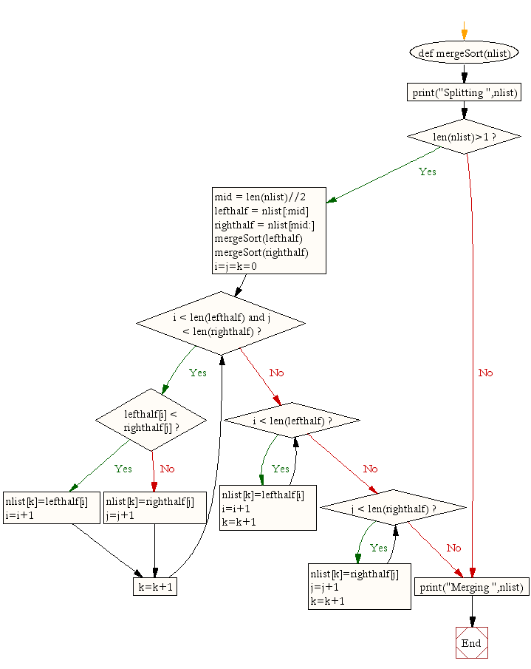

**Radix sort**

In computer science, radix sort is a non-comparative integer sorting algorithm that sorts data with integer keys by grouping keys by the individual digits which share the same significant position and value.

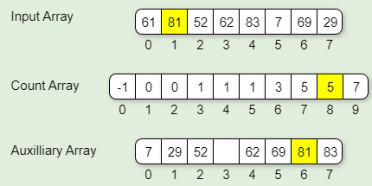 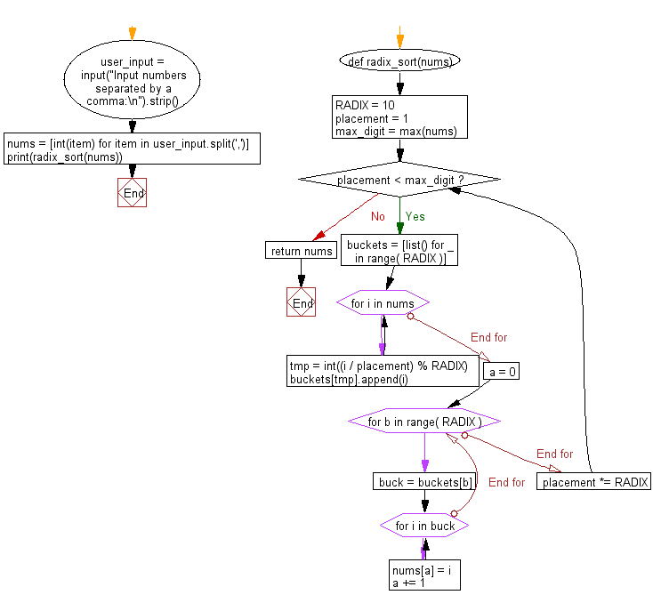

**Comb sort**

The Comb Sort is a variant of the Bubble Sort. Like the Shell sort, the Comb Sort increases the gap used in comparisons and exchanges. Some implementations use the insertion sort once the gap is less than a certain amount. The basic idea is to eliminate turtles, or small values near the end of the list, since in a bubble sort these slow the sorting down tremendously. Rabbits, large values around the beginning of the list do not pose a problem in bubble sort. In bubble sort, when any two elements are compared, they always have a gap of 1. The basic idea of comb sort is that the gap can be much more than 1.

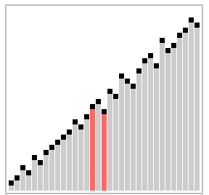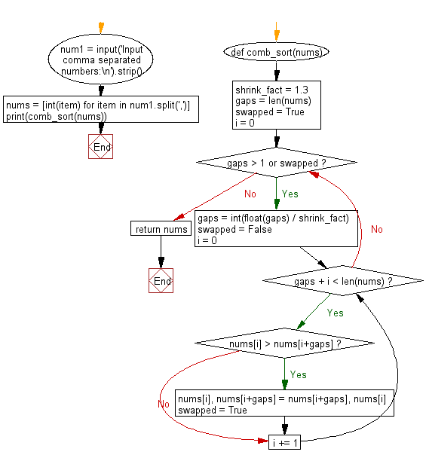

**Pancake sort**

Pancake sorting is the colloquial term for the mathematical problem of sorting a disordered stack of pancakes in order of size when a spatula can be inserted at any point in the stack and used to flip all pancakes above it. A pancake number is the minimum number of flips required for a given number of pancakes. The problem was first discussed by American geometer Jacob E. Goodman. It is a variation of the sorting problem in which the only allowed operation is to reverse the elements of some prefix of the sequence.

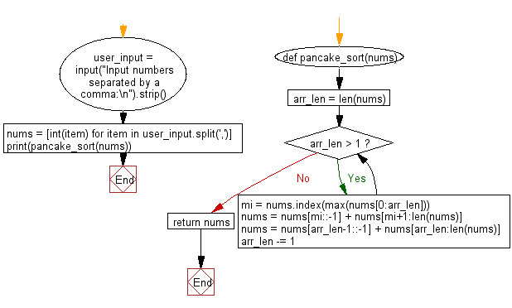

**Referencing**

w3resource. 2020. *Python Data Structures And Algorithms: Search And Sorting - W3resource*. [online] Available at: <https://www.w3resource.com/python-exercises/data-structures-and-algorithms/> [Accessed 10 March 2020].

**Appendix**