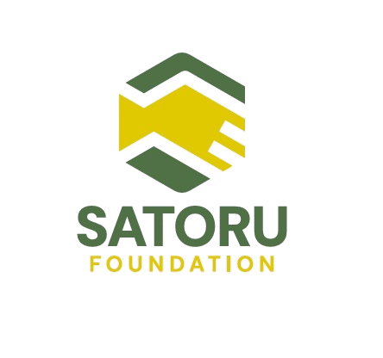
“So… you won’t come see us anymore?”
✦ How one moment became a movement
She said it softly.
Like she didn’t want to ask but needed to.
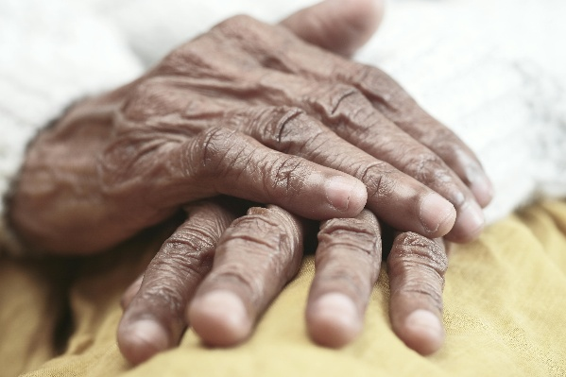
They were the last few days of the field visit. Our founder was just another Psychology researcher, wrapping up another interview thinking there’s only 2 days left to wrap up the field research. And yet, this question, simple, raw, and soaked in quiet ache became the start of everything.
It wasn’t a policy paper.
It wasn’t a funding pitch.
It was a tear on his shoulder…
…and the realization that being old in India often means being unseen.
This is where the Satoru Foundation began.
From Music Therapy to the Silence of Aging
Before aging, there was music.
Our founder’s earliest research focused on how music could treat depression.
Sound, emotion, the brain, it all fascinated him.
few of his friends suggested him to Work on something that was more like him, close to his heart.
That’s how he discovered the field of aging.
It wasn’t glamorous. It wasn’t trending. But it spoke to something deeper something emotional, human, urgent.
And that’s what pulled him in.
200 Homes, 100 Days, 1 Sentence That Changed Everything
In 2023, he went on a field visit to understand how India’s older adults really live, not in theory, but in reality.
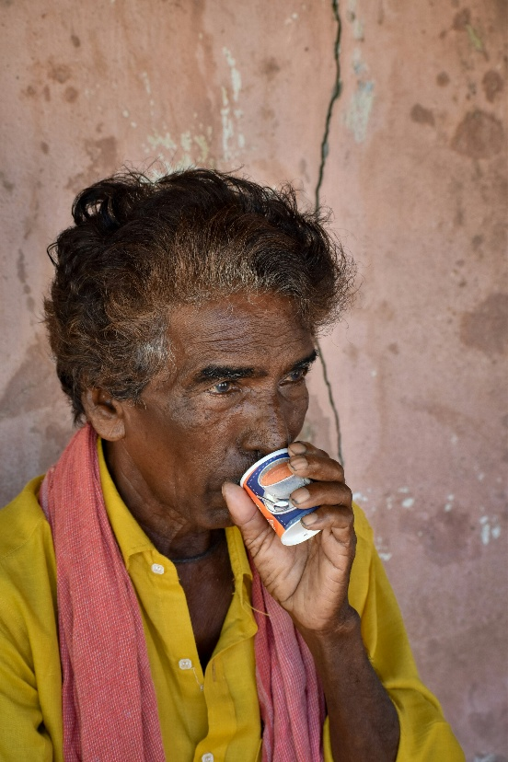
He knocked on doors.
Sat with people.
Drank tea with them.
Asked questions no one had asked in years.
He met over 200 elderly people in the span of 100 days spread across 8 districts in Andhra Pradesh & Telangana, but it was one sentence, on one day, that stayed.
An older woman gently asked him:
“So… you won’t come to see us anymore?”
He didn’t have an answer.
Because he wasn’t just seeing loneliness.
He was becoming part of it.
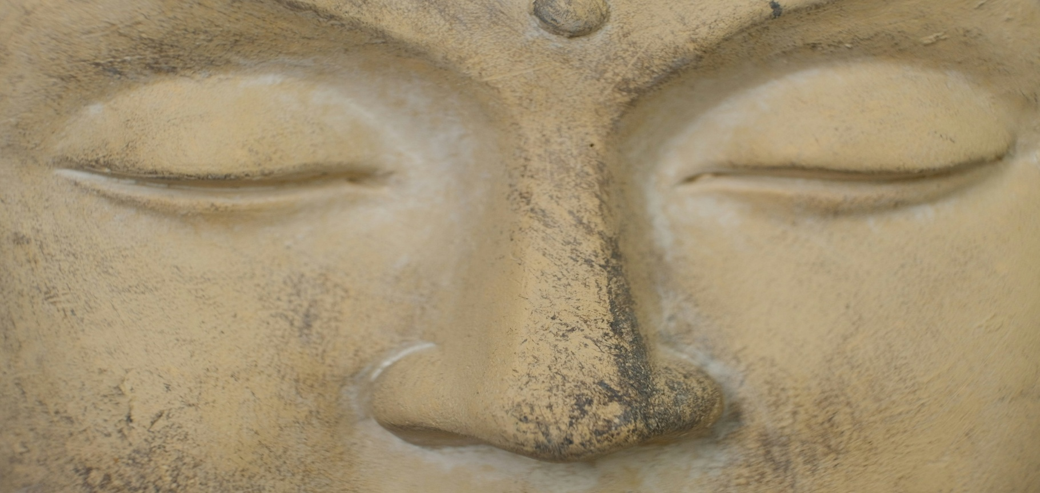
That day, research ended. Responsibility began.
Why
“Satoru”?
When it came time to name the foundation, we had options. Dozens. But something felt off.
Everything sounded clinical, distant,
We didn’t want a name that defined elders by their vulnerabilities. We wanted something that reflected their wisdom, dignity, and quiet strength.
Then came “Satoru” a Japanese word rooted in Buddhist tradition.
It means “to understand,” “to awaken,” or “to reach enlightenment.”
Satoru isn’t about helping the helpless.
It’s about restoring purpose through faith.
It’s about recognizing the strength that already lives inside those we serve.
A Logo That Speaks Without Words
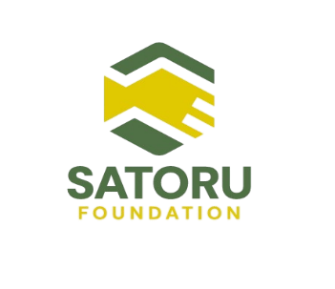

If you look closely at our logo, you’ll see three hands — one above, one below, and one gently held in the centre.
They represent our promise:
We are here. We are holding space.
We are the presence that says, you are not alone.
That is what we carry with us into every home, every conversation, every quiet moment of care.
Demographics Change, So Does Family
As India’s birth rate declines and economic structures evolve, the demographic fabric of our society is changing, fast.
The rise of nuclear families, migration to urban centres, and a shift toward individualism have deeply affected how we care for older adults.
Senior citizens are often left out — not just from conversations, but from homes.
Especially in cities, where speed has replaced slowness and connection has become a luxury.
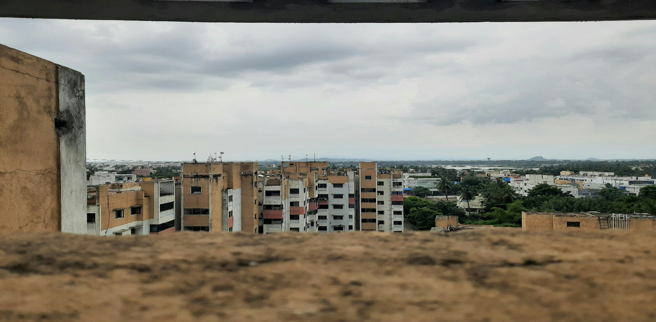
This is not just a cultural concern.
It’s a social emergency.
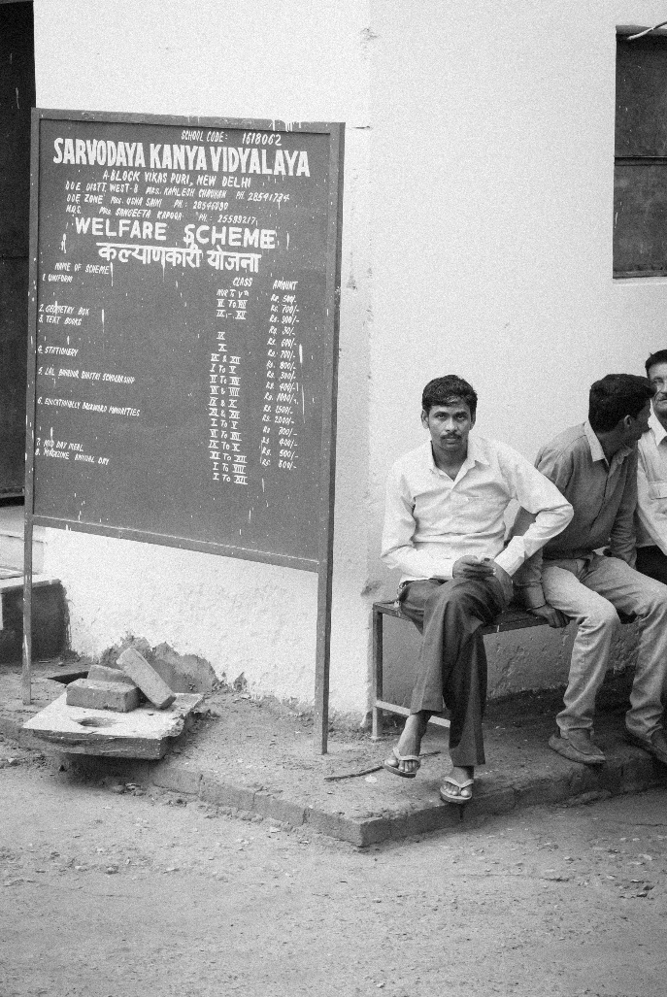
The
Real
Problem? It’s Not Policy. 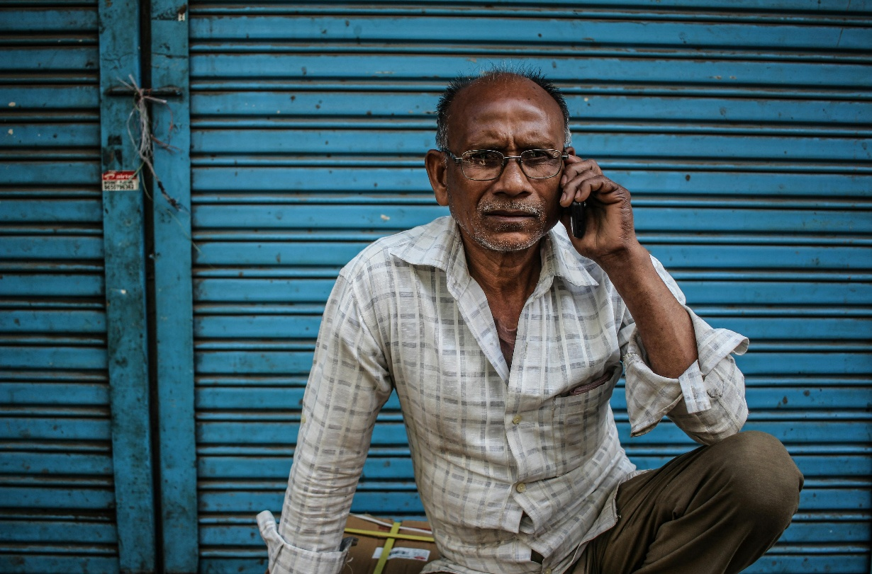
It’s Presence.
India has policies.
Schemes for senior citizens. Pension systems. Legal rights. Health cards.
But here’s the truth:
Most elders don’t even know what they’re entitled to.
They don’t know what exists.
They don’t know how to access it.
And most tragically… they don’t know who to ask.
What they need isn’t just help.
They need someone to show up.
That’s why Satoru foundation was born.
Not to invent new systems but to activate forgotten ones.
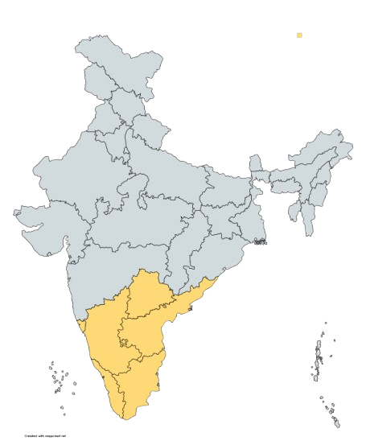
Why
the
South?
Why
Now?
Most of the work in the aging sector in India is focused in the North and even that is limited.
But in South India the silence is louder. The research, thinner. The loneliness, deeper.
In India, for every 100 kilometres, there’s a new dialect, a new culture, a new way of living.
That makes field research harder but the need more urgent.
That’s why we started here.
Where we could understand not just language but silence.
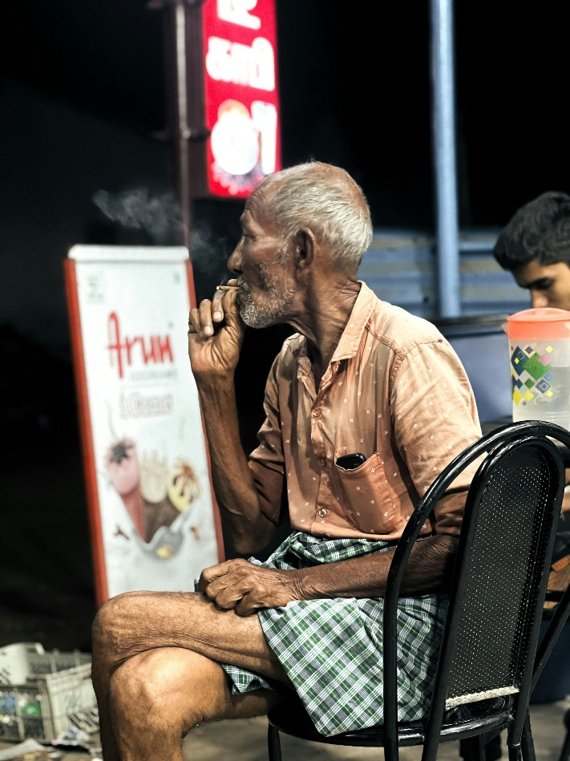
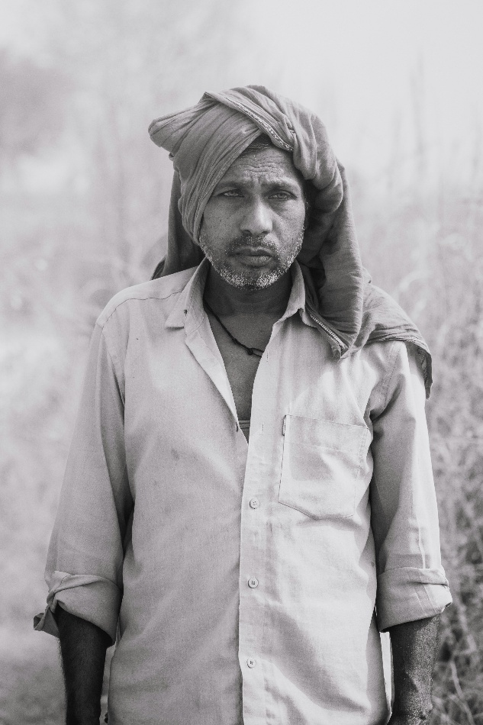
Aging Isn’t a Poor Person’s Problem. It’s a Human One.
Aging makes no distinctions — titles, income, or address don’t change its course.
We’ve met:
A school teacher who doesn’t know how to use UPI
A widow afraid of losing her home because she never taught her legal rights
A retired officer who hasn’t spoken to his son in weeks and won’t say why
Loneliness is classless.
And dignity isn’t a luxury.
At Satoru, we focus on all elderly individuals across all cultures, communities, and classes not because they’re the only ones suffering, but because they’re the ones least supported.
What We’re Building - One Moment at a Time
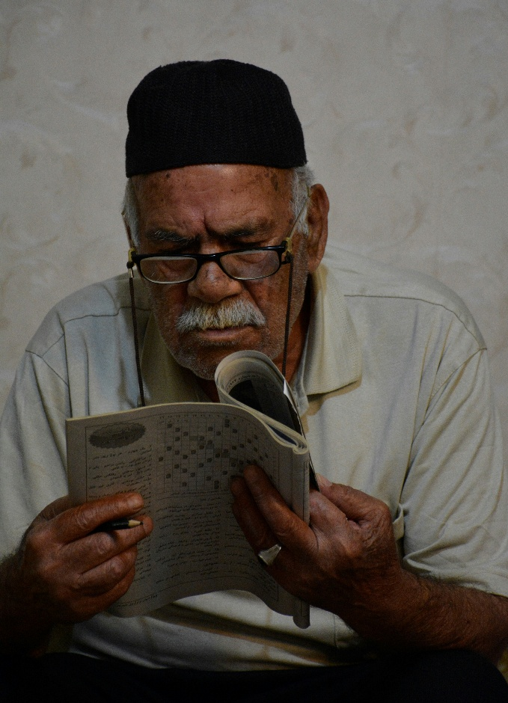
We’re not a massive organisation,
We’re a small, growing team. Built with heart, humanity, and honesty.
Our work is about:
Health & wellness
Legal awareness
Digital literacy
Dignity
One of our first projects, Madavi, studies the day-to-day emotional patterns of older adults through diaries, conversations, and time spent with them, not away from them.
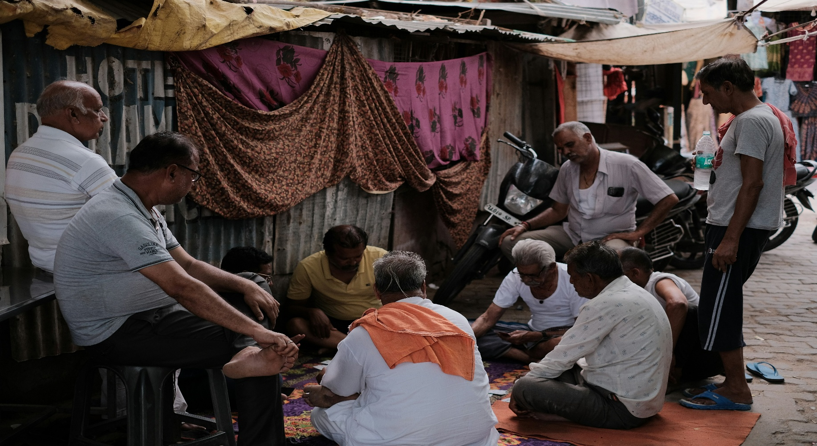
We believe stories are data.
Tears are indicators.
And smiles are worth Noticing too.
If You’ve Ever Wondered What Growing Old Feels Like…
Maybe you’ve seen it in your own family.
A grandparent fading into silence.
A parent saying “I’m fine” — when you know they aren’t.
Or maybe… you're afraid of growing old yourself.
If that fear feels too big, you’re not alone.
We’re building Satoru for people like you, too.
People who care. People who wonder. People who want to do something even if it’s just reading this far.
This isn’t just a blog.
It’s the beginning of a space that sees people for who they were… and who they still are.
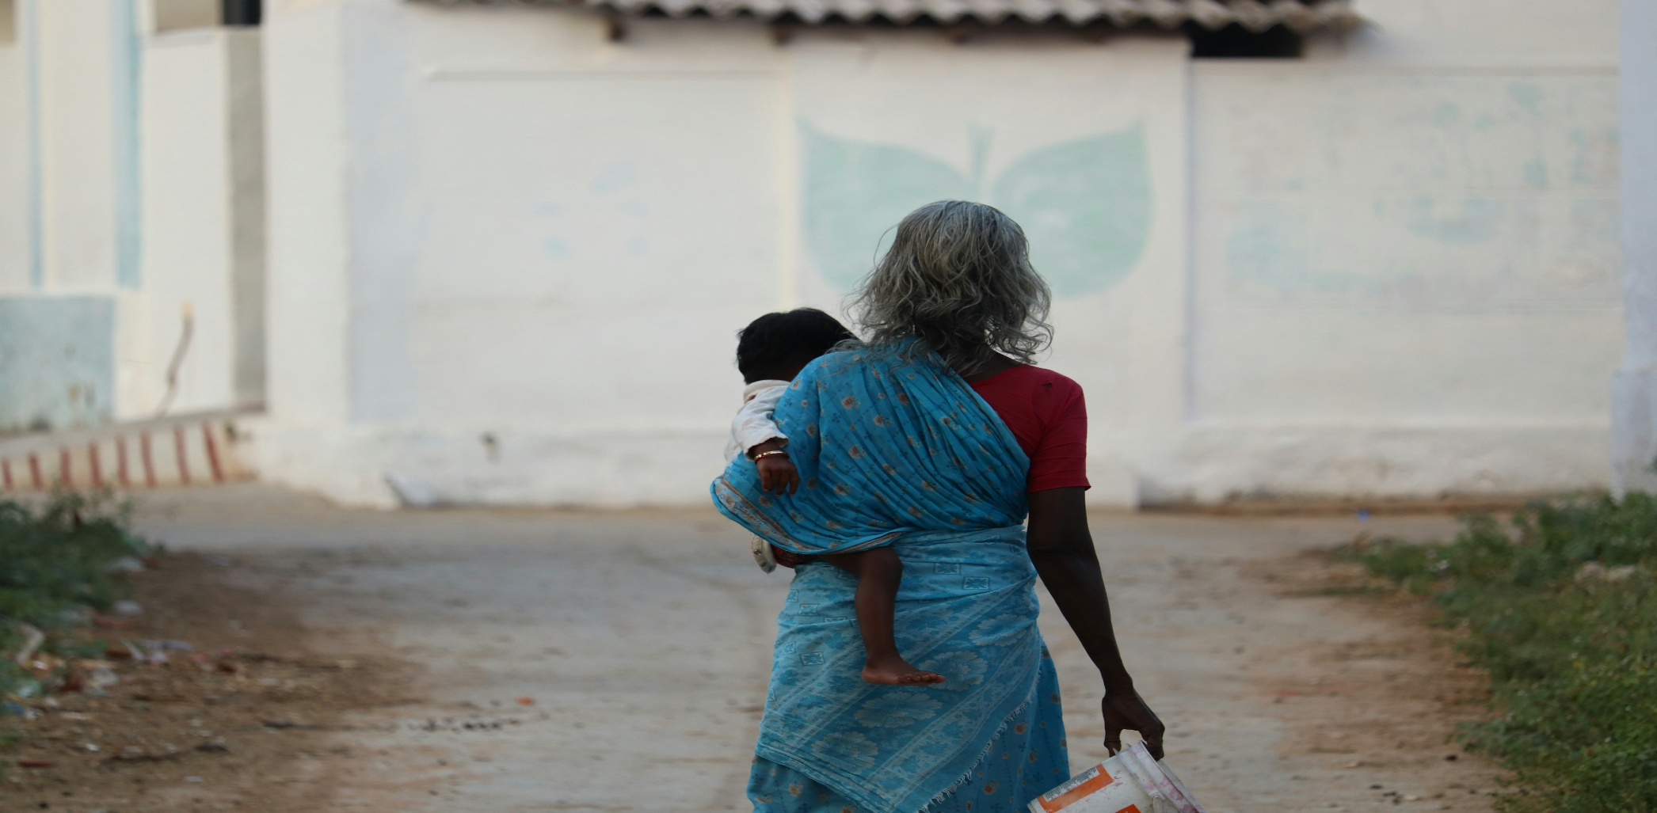
Final Word: The Tear That Built a Foundation
The Satoru Foundation didn’t begin in an office.
It began on a doorstep.
With a woman who didn’t want to be forgotten…
And a man who promised he wouldn’t forget.
We’re here because that promise matters.
And because someday, someone you love or maybe even you will grow old too.
And when that happens, we want to make sure the world still feels kind.

