>>How to **Login the HIVE** in the Cloudera

Command:- Hive

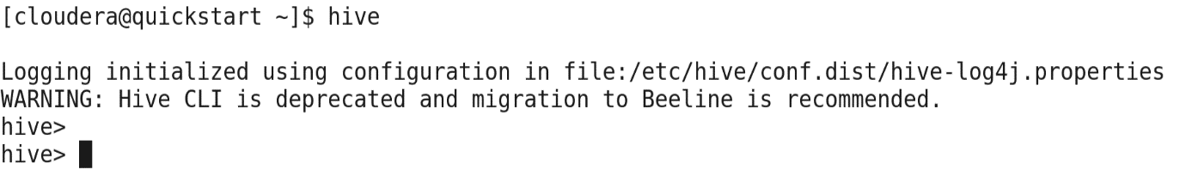

>>Each command in the Hive is terminated by the Semi-Colon (;)

>>**Show Databases**

Command:-show databases;

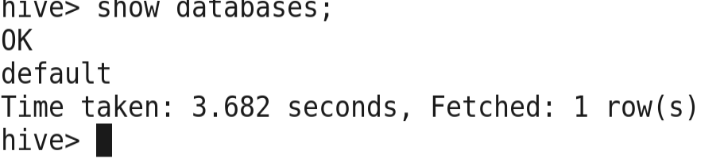

>>Now **create the Databases** in the Hive.

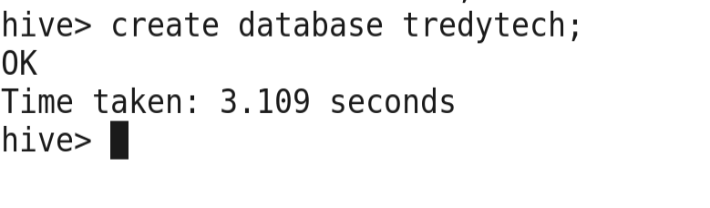

>>show databases in the Hive

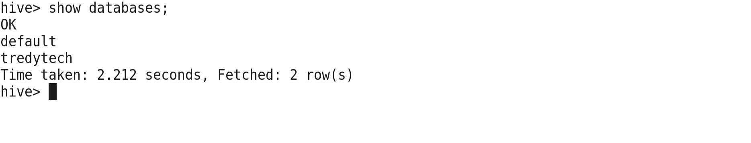

>>Use Tredytech;

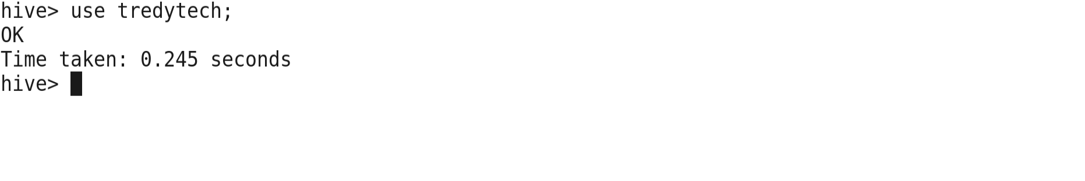

>>Create a Table customers in the Tredytech Database

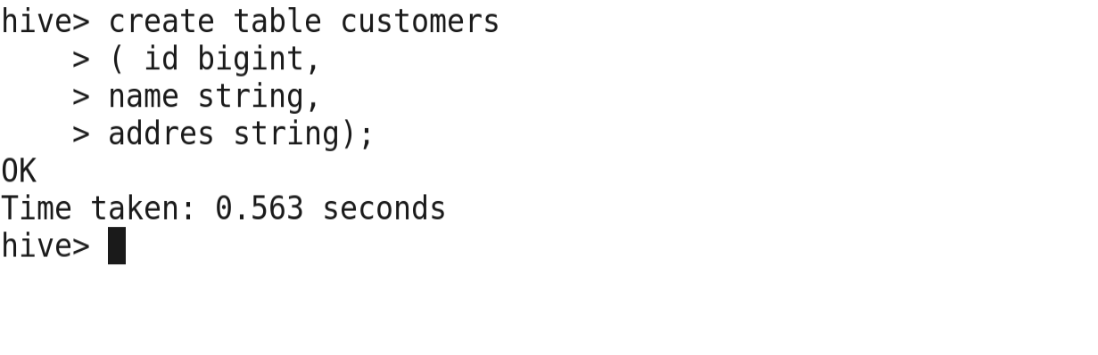

>>Describe all the **detail of the table**

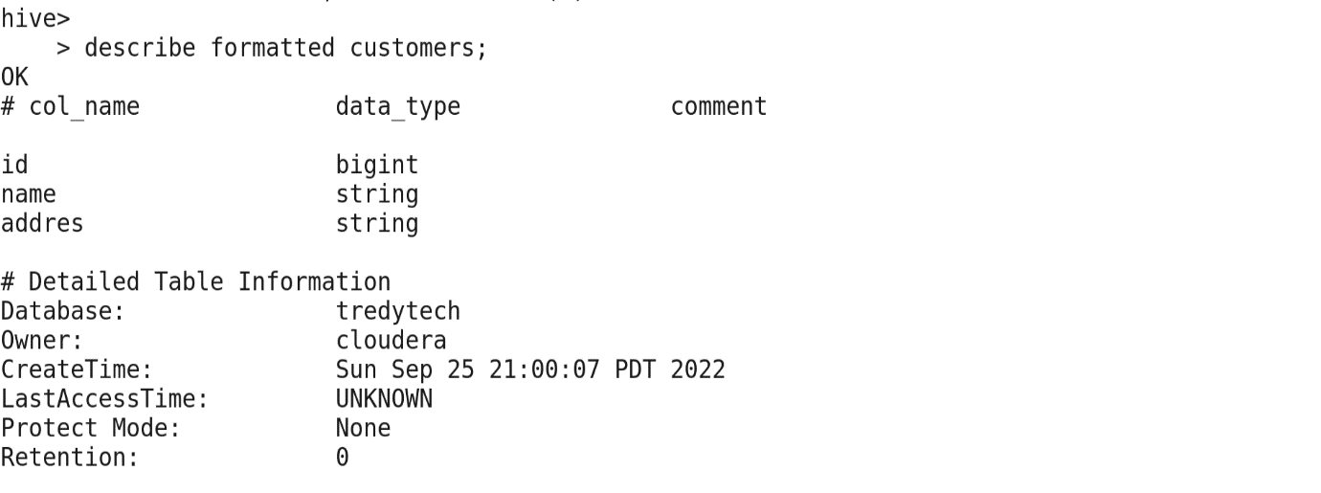

>>Insert the value in the Table.

Command:- insert value into customer(111, ”Rahul”, ”Osai”);

>>Show the detail of the table

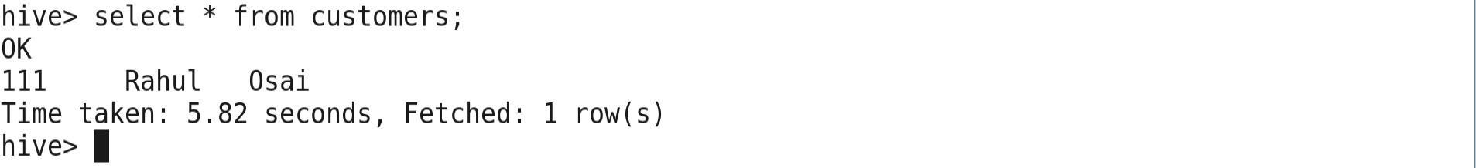

**Note:-** Insert are not Performatte in to Hive; Hive is the Transactional System.

>>Insert Multiple Records into Hive

Command:-



>>Show Values of the Table.

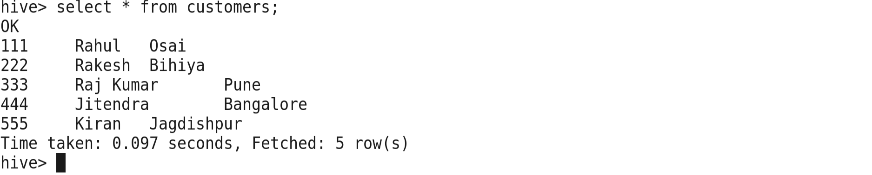

>>Data Stored in the Hive

1. Data:- Data is stored into HDFS

(Default Location is:- /user/hive/warehouse)

-HDFS not support updation

1. Schema (Metadata) metadata is stored into databases; because metadata frequently updated, quick access is required.

>>**Data kept in the directory**

**Path of the Database**

/user/hive/warehouse/ tredytech.db

**Path of the Table**

/user/hive/warehouse/tredytech.db/customers

>>Now open another Terminal and Go into the Hadoop and Check the Path or Directory of the table.

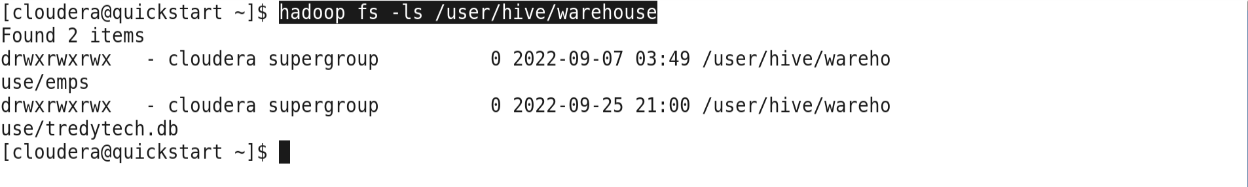

>>Now inside into Database of Hive



>>Now inside into table of Hive

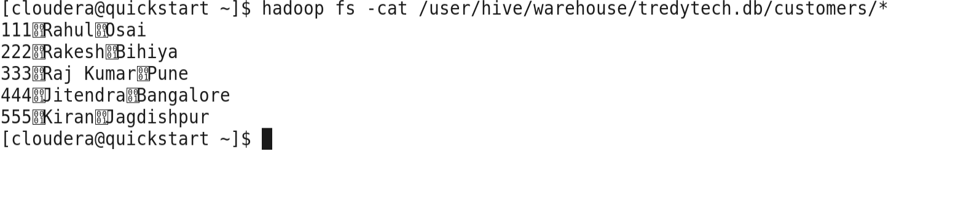

>>Check the all Query in the Hive

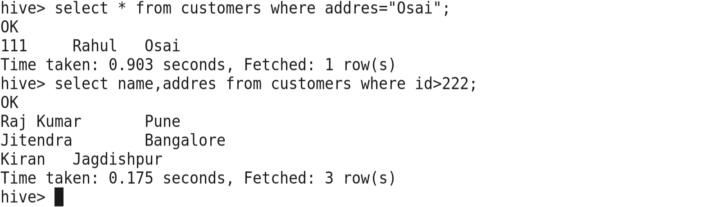

>>**Order by** check the data of the table.

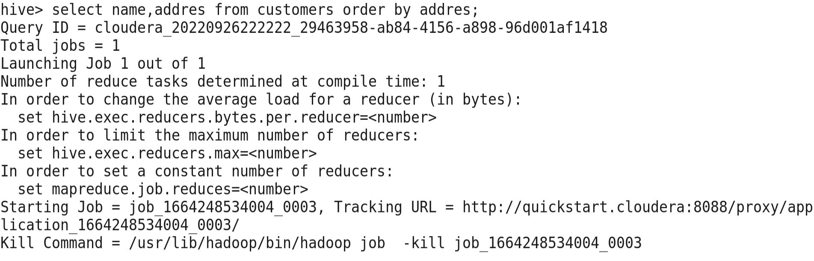

>>Now **Exit** from Hive



>>Now create the table **not exists** statement used

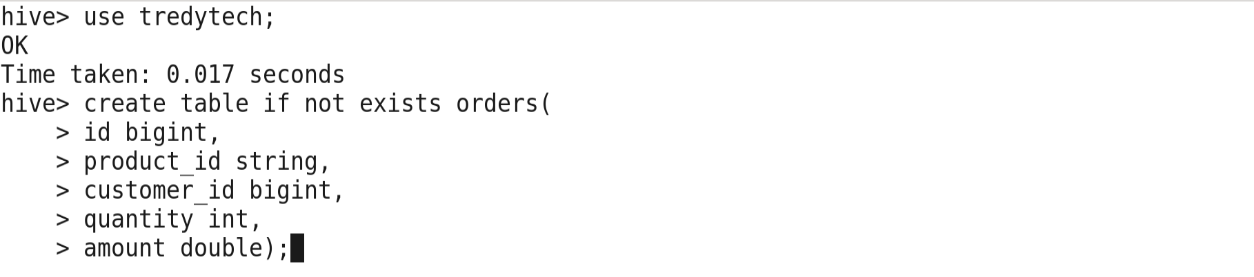

>>If the table of the Same Name does not exists create the Table of the above table.

**What are the Different Ways of the connect to the Hive**

1. Hive

2. Hue( Hadoop user Experience)

3. Beeline

>>Now Open the Browser in Cloudera and click on the navigation in which **hue UI** click on it and Give the password **Cloudera** and Username is **Cloudera**

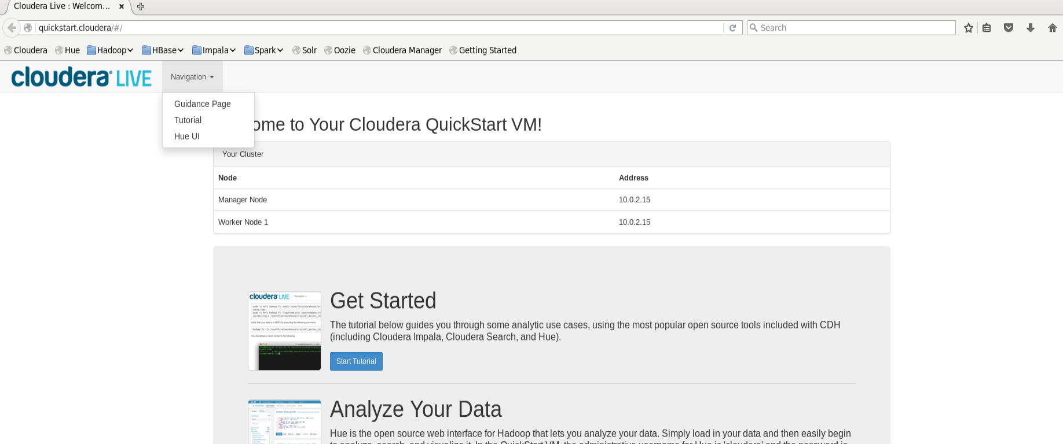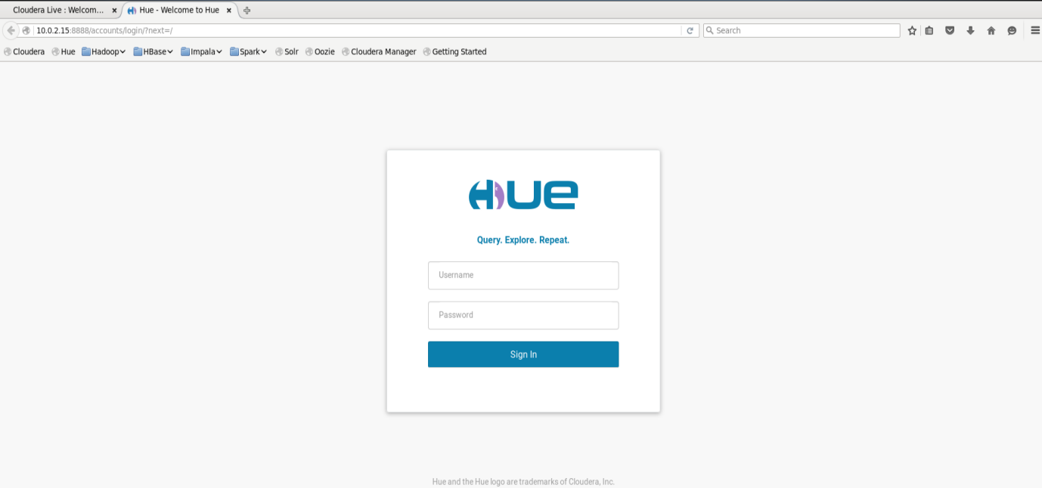

>>Now it will connect

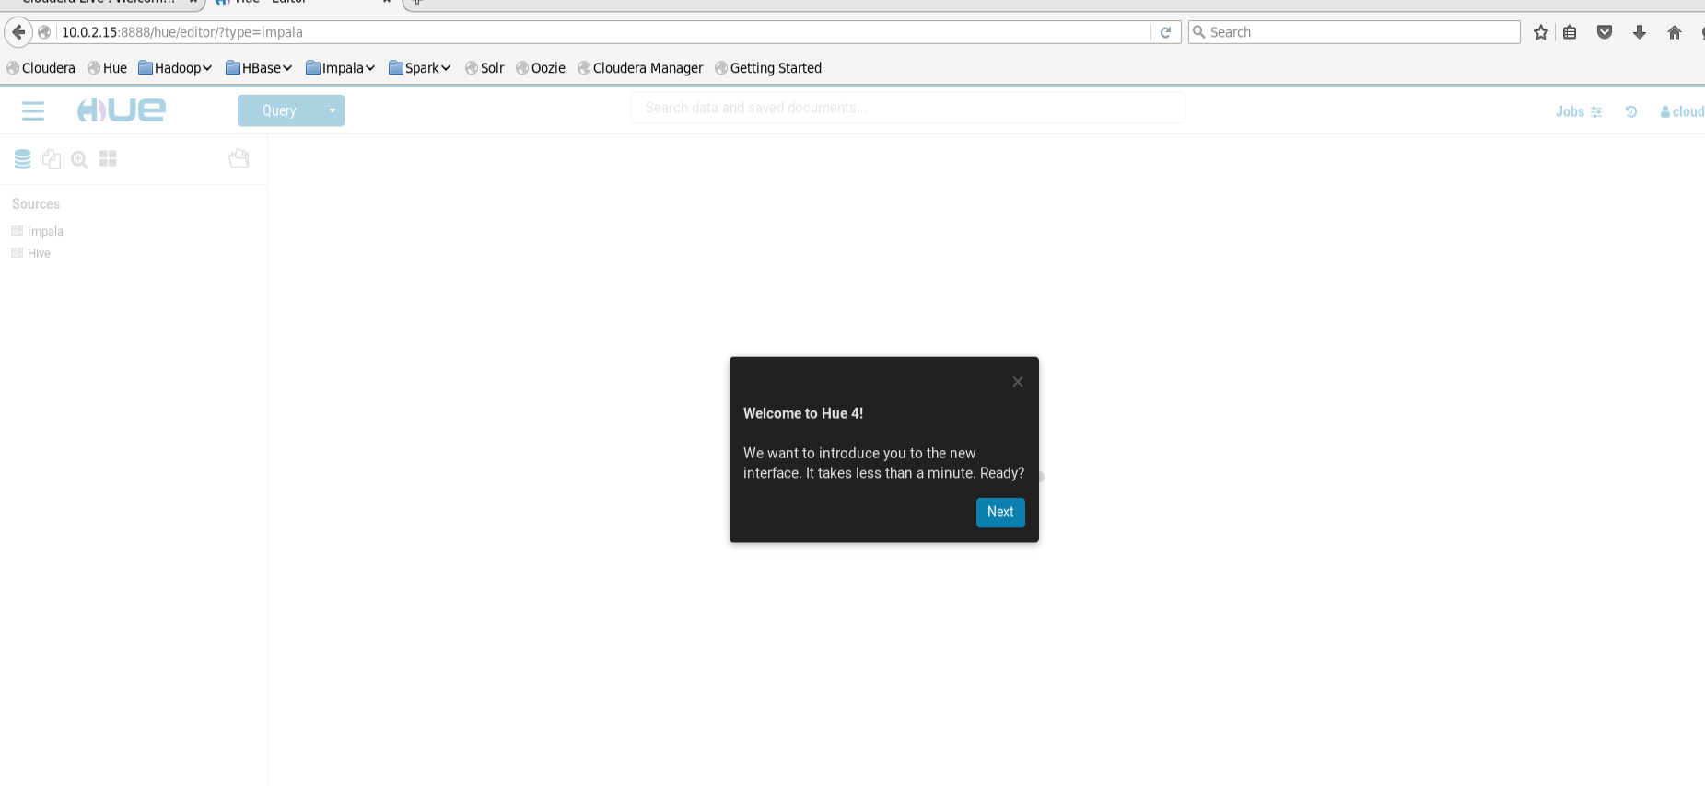

>>click on **Query** and the **editor** and click on the **Hive**

And now got the **Hive dashboard** and Default got the **previous database** in which table.

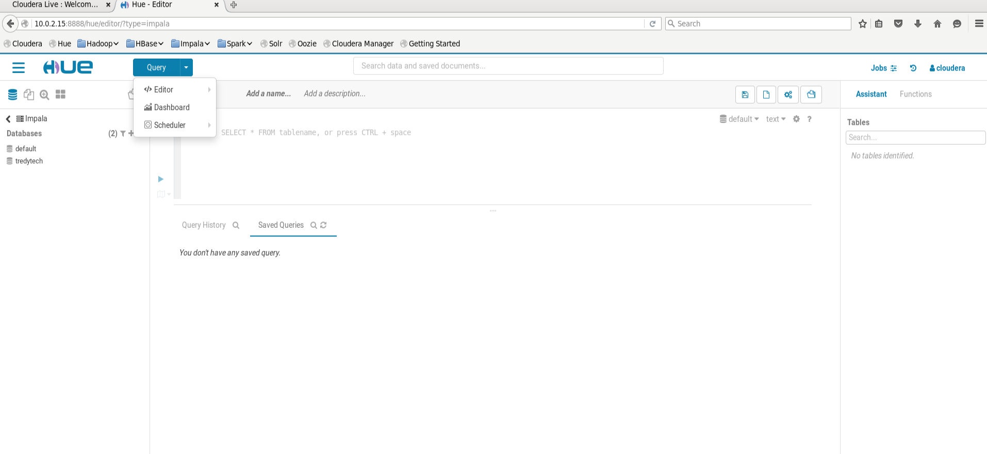

>>How to work with **Hue UI and** Result Area of HUE UI

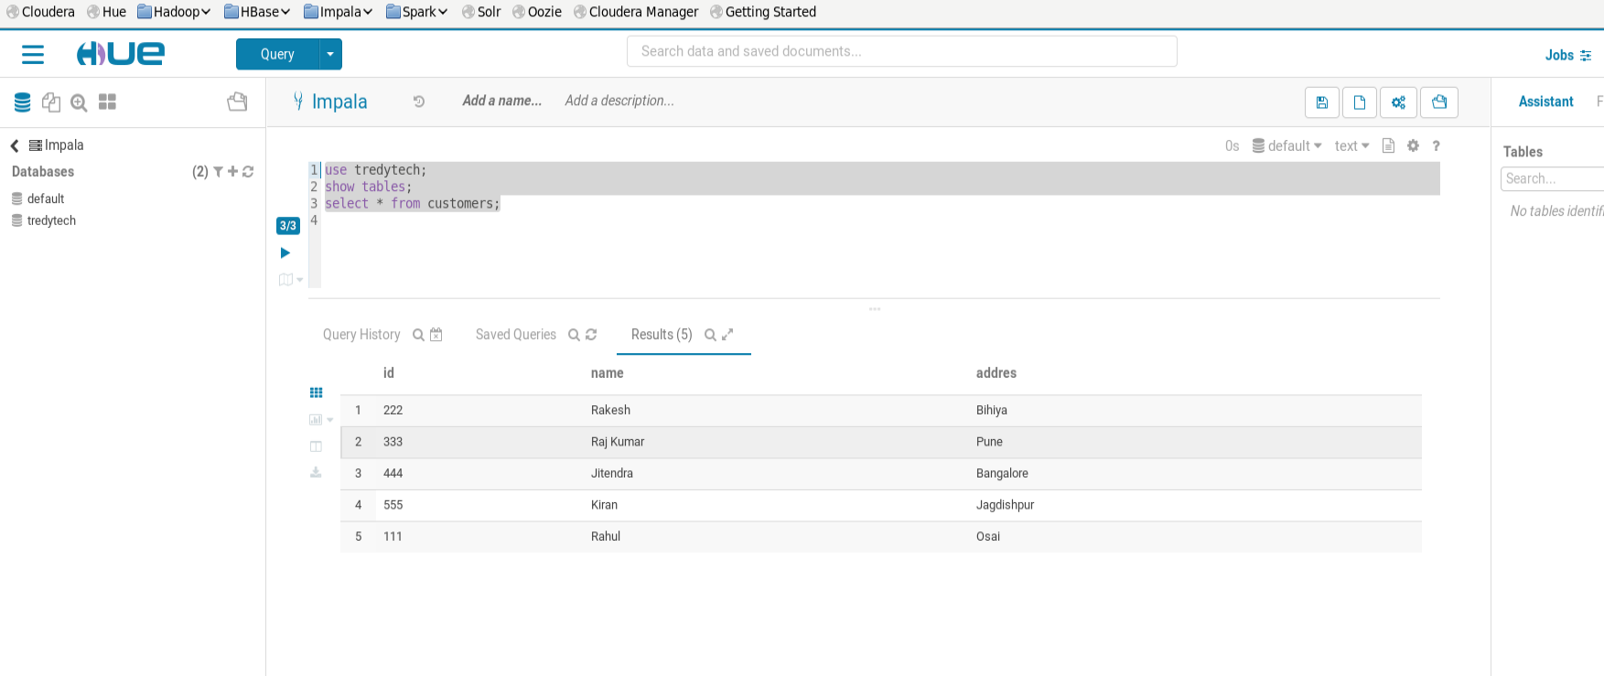

**Connect Hive with Beeline**

>>Beeline (connect Hive with Beeline is most preferred Choice)

>>Beeline is give better view and most secured.

>>Now connect Hive with beeline

**Command:-**

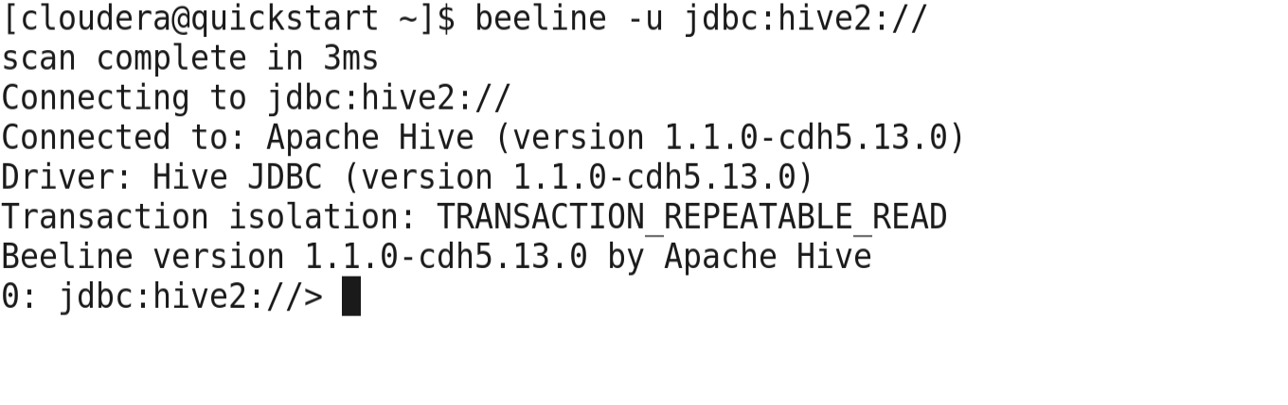

>>Show database in the beeline which are connect with the Hive;

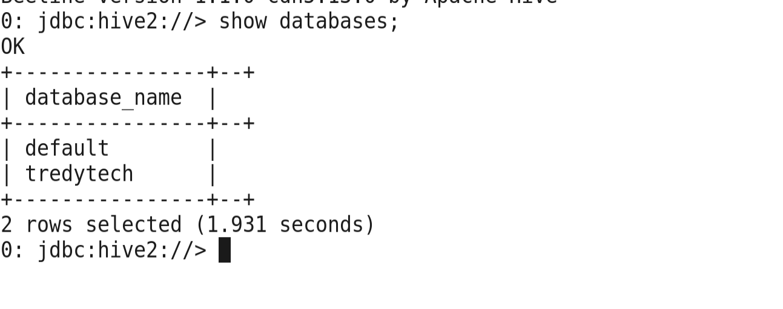

>>Now show **customer** table in the Tredytech database of the Hive **.**

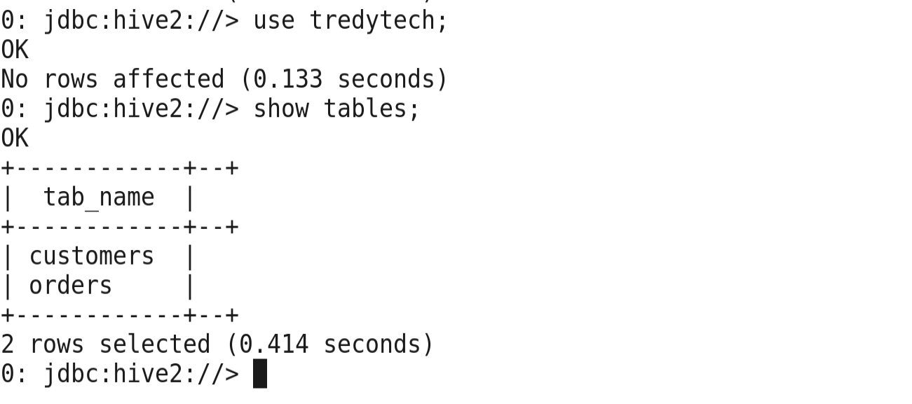

>> show the data of the customers table.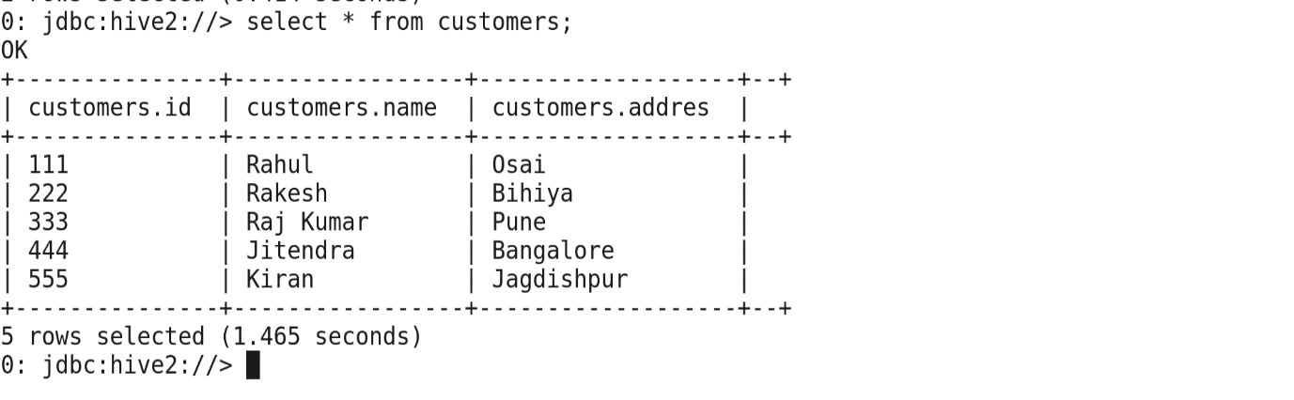

>>Describe the table

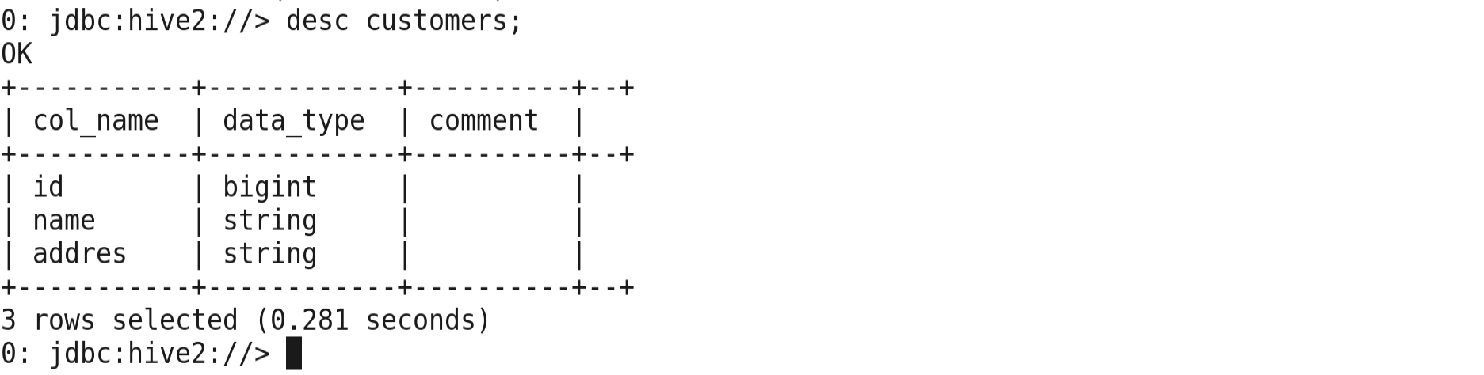

>>Now **exit from beeline**

**!q**

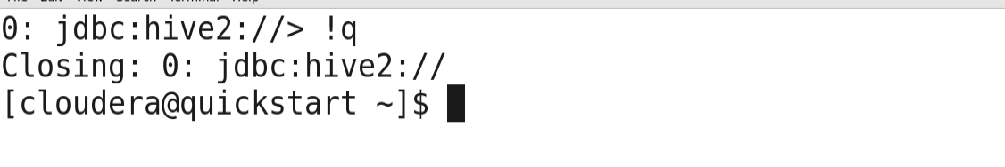

>>**Now create a file from gedit. Mysqlquries.hql**

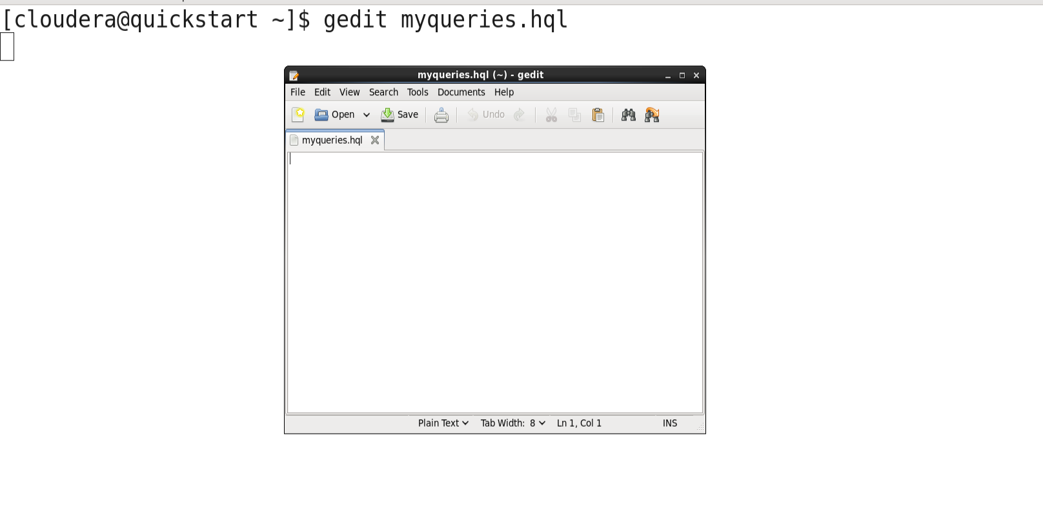

>>Now write the Multiple Query and then save it.

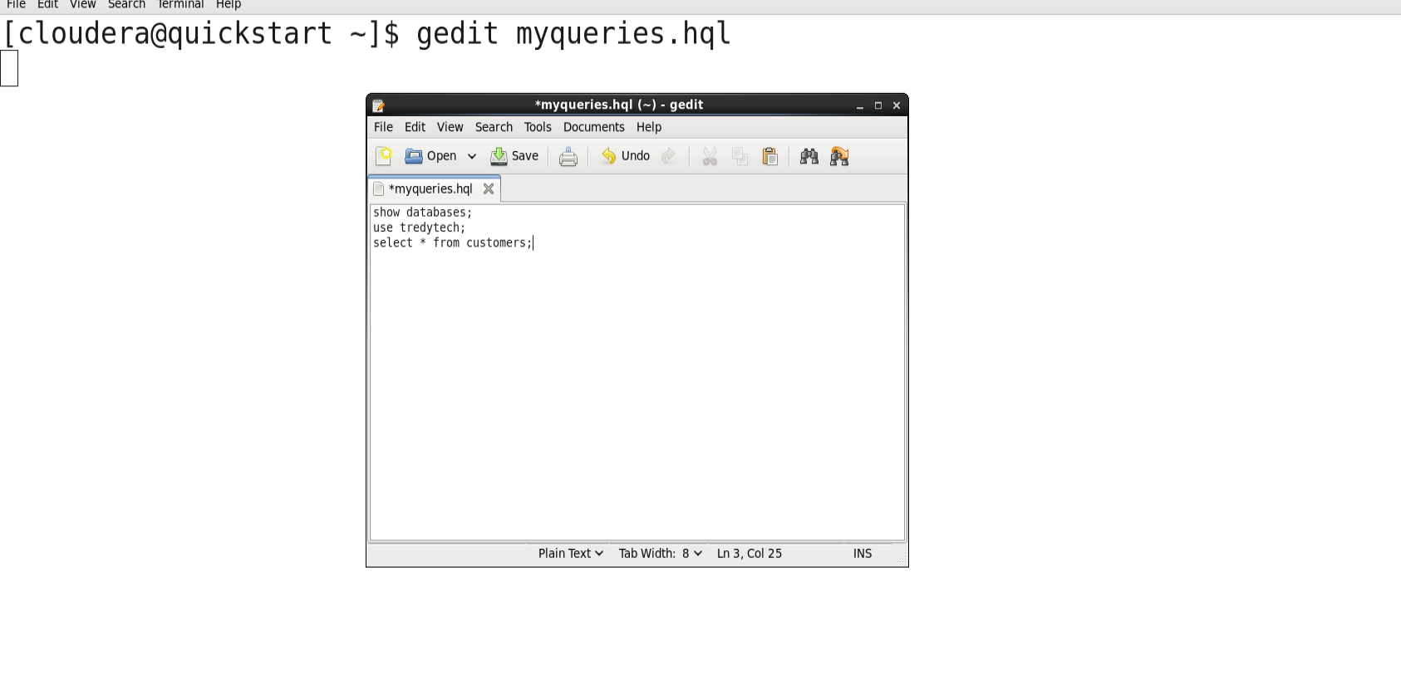

>>See the data which are written in the gedit file in the Hadoop(HDFS)

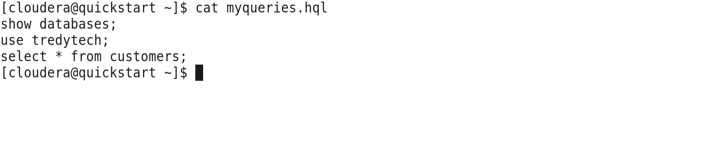

>>Now run the script in the beeline source code



