**Sub Queries in Hive**

>>Now create a table

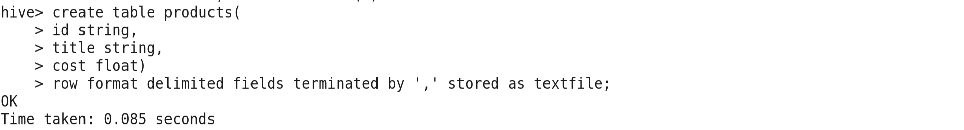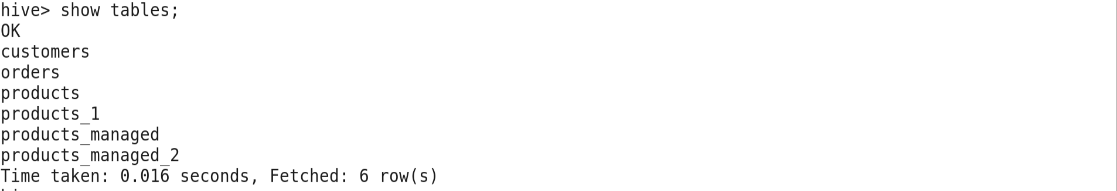

>>Now load the Data into Products table

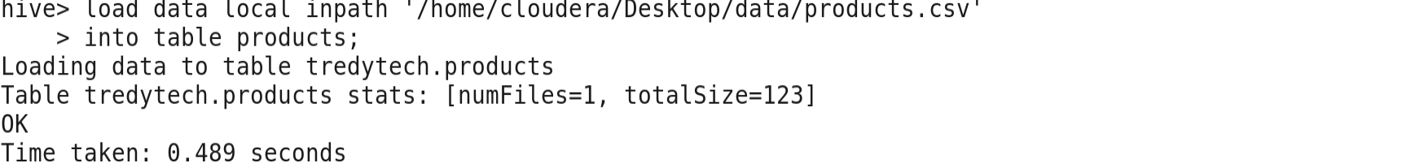

>>Check the Data of the Table

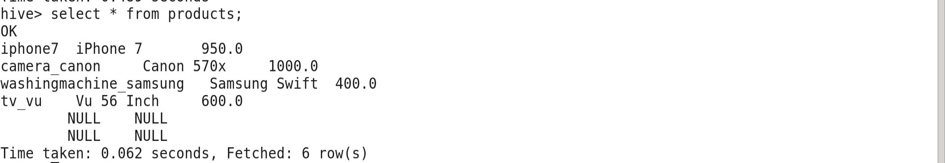

>>Create another table **freshproducts** Inside the Tredytech databases

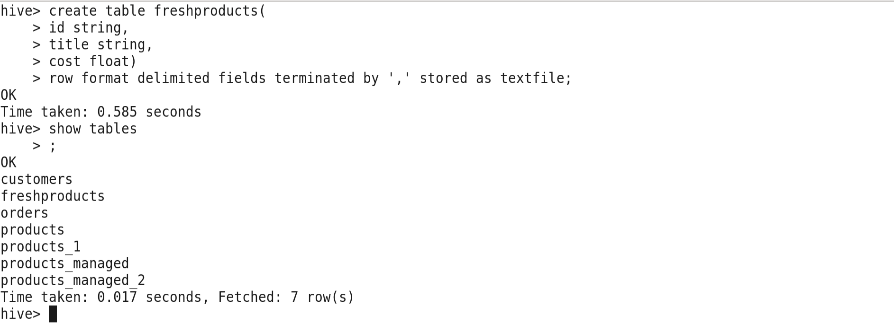

>>Now load the data into freshproducts table. Of the freshproducts.csv

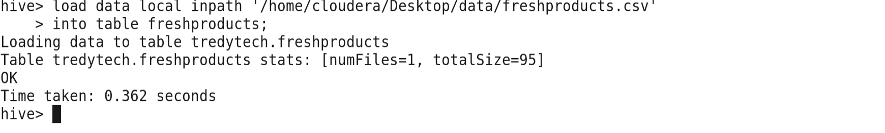

>>Display the Records of the freshproducts table

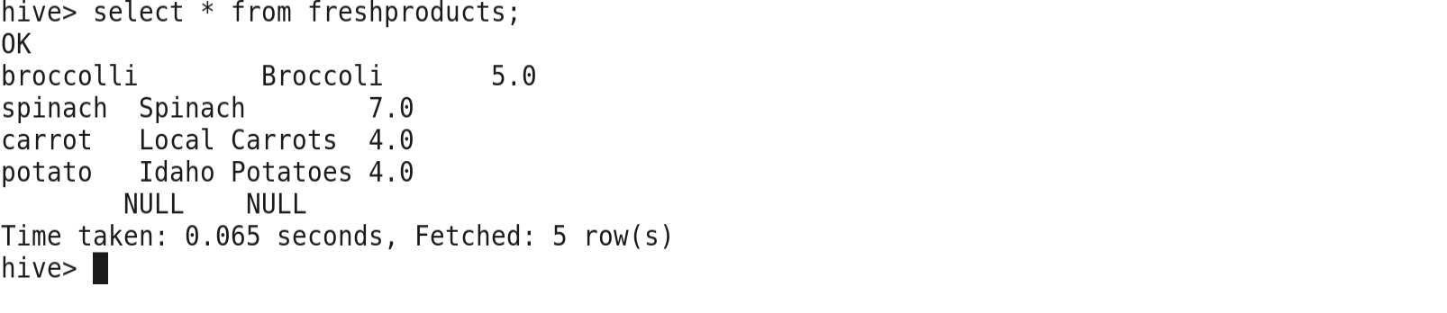

>> Now using the **From Sub queries**

Display records **using the Sub queries** using **from** clause

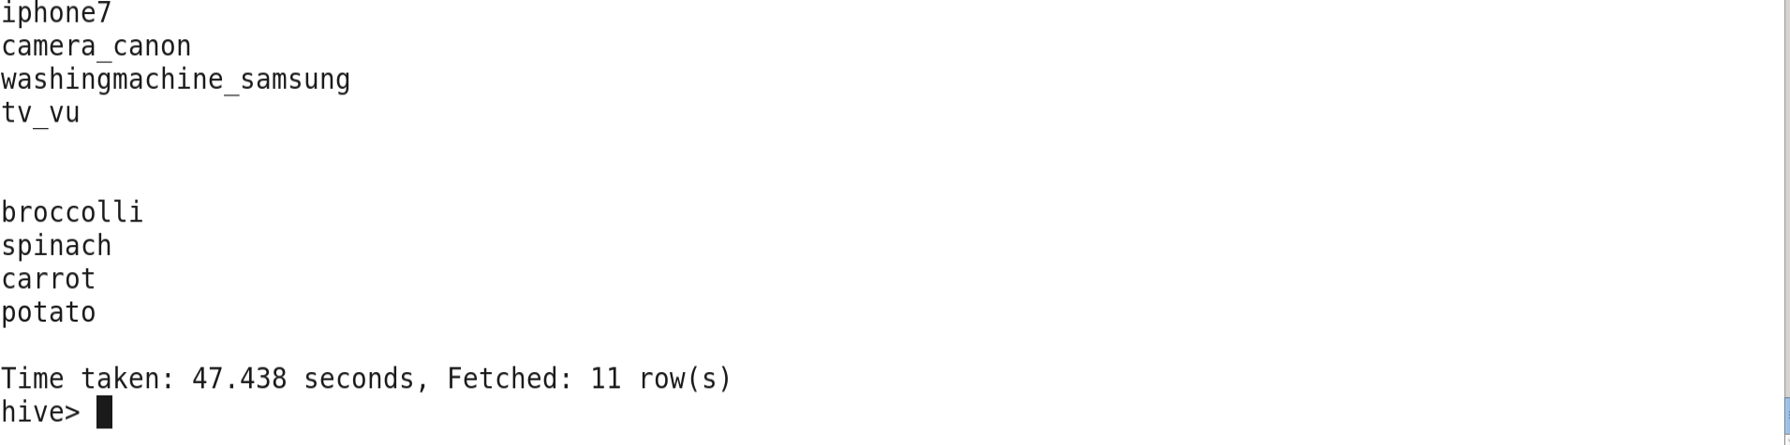

**Sub-queries in Where Clause in Hive**

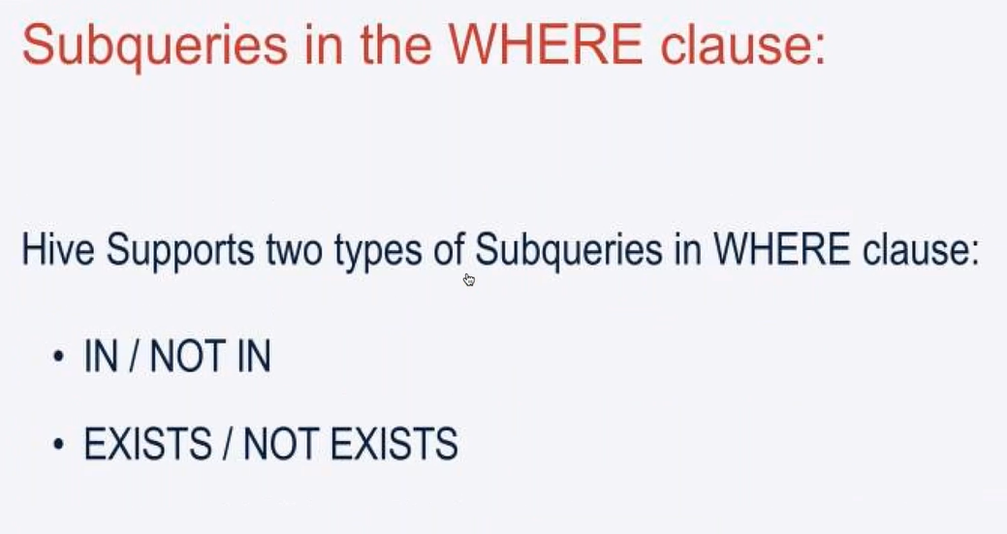

>>Run a query use the where clause

>>Subquery with **IN** clause within Where clause



output

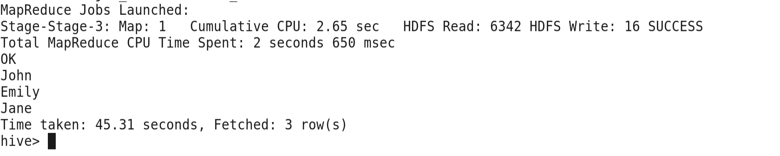

>> Subquery with **NOT IN** clause within Where clause



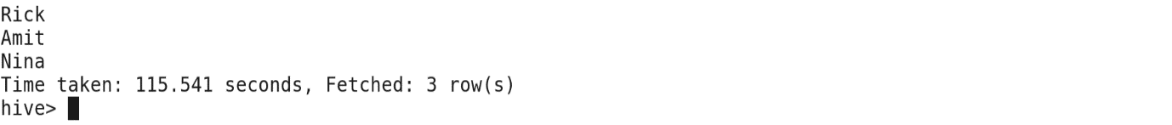

**Subqueries with Exist and Not Exist in where clause.**

>>Query for the **Exists** clause.

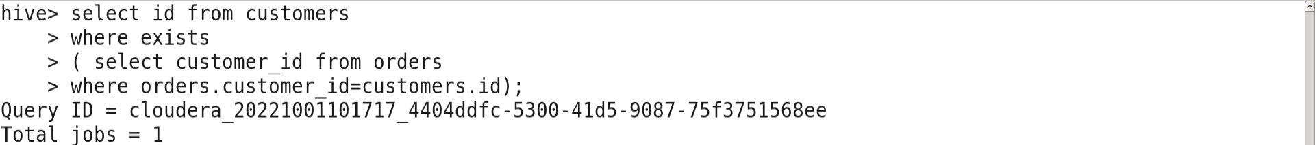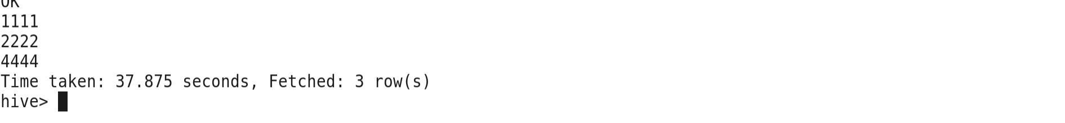

>> Query for the **Not Exists** clause.



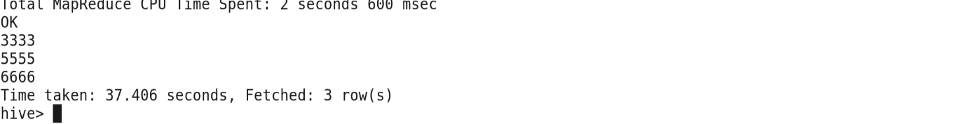

**View in Hive**

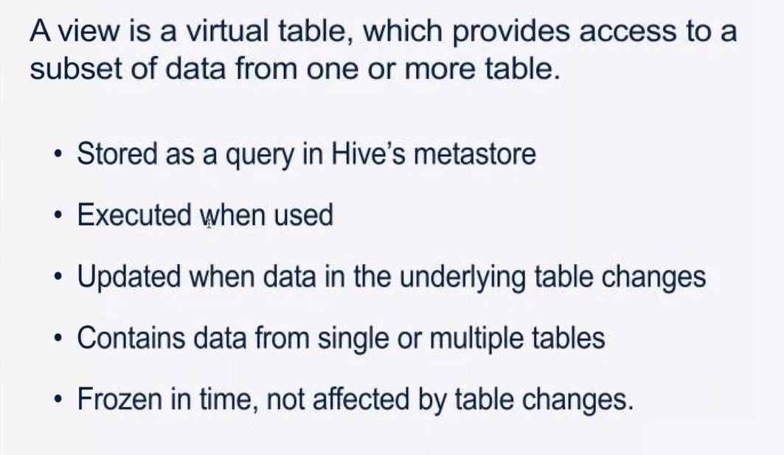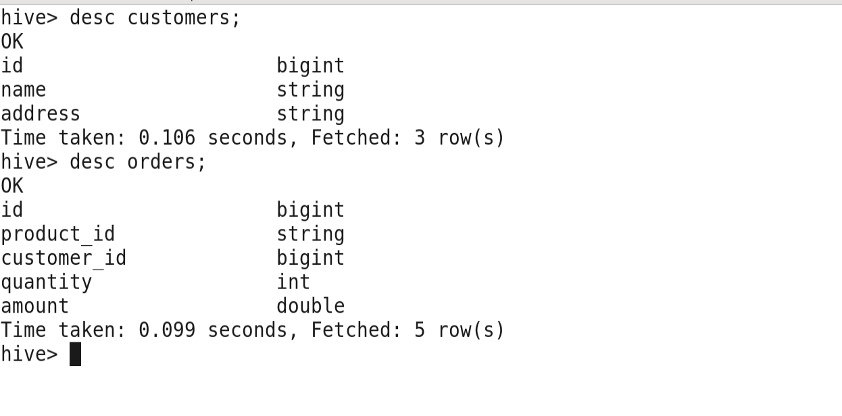

>>Create View in Tredytech database in the Hive.

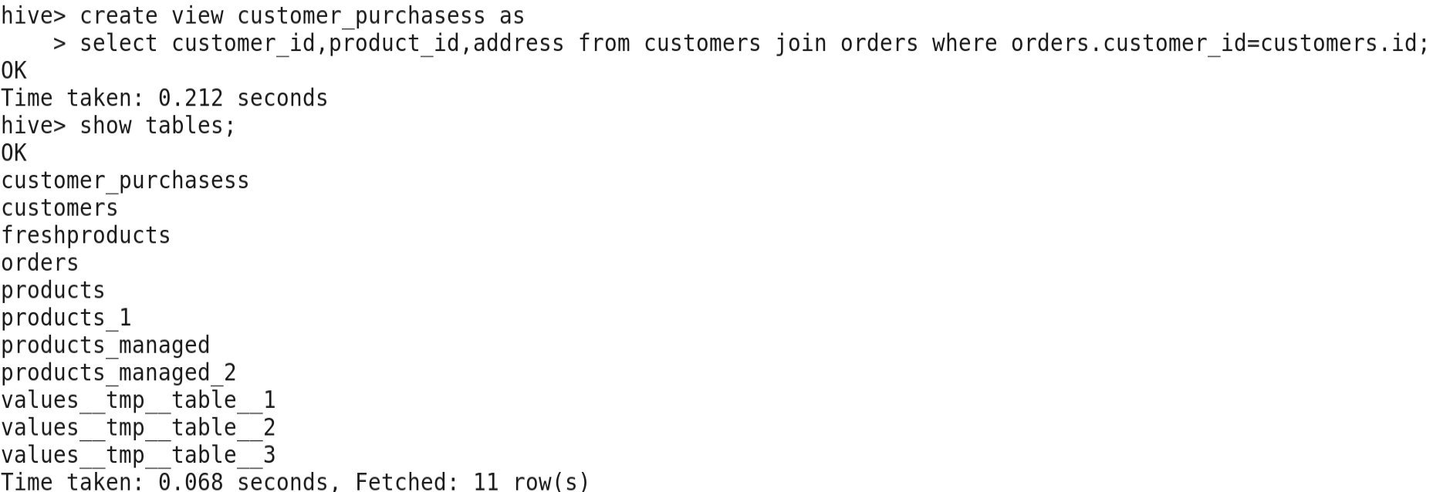

>> describe the view

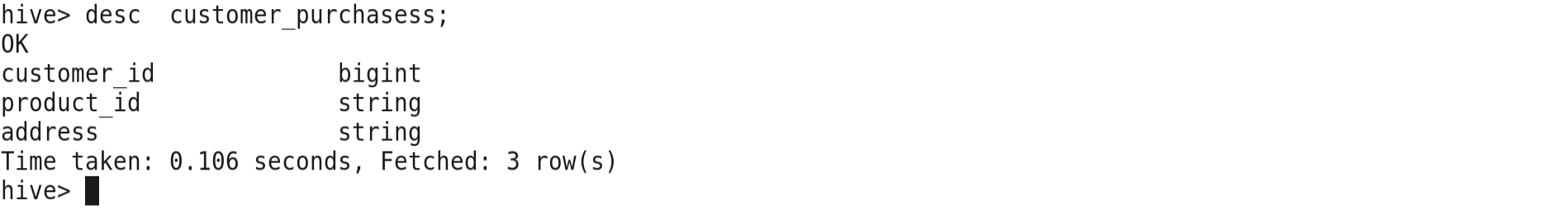

Data types are taken from original Table

>>Select the view

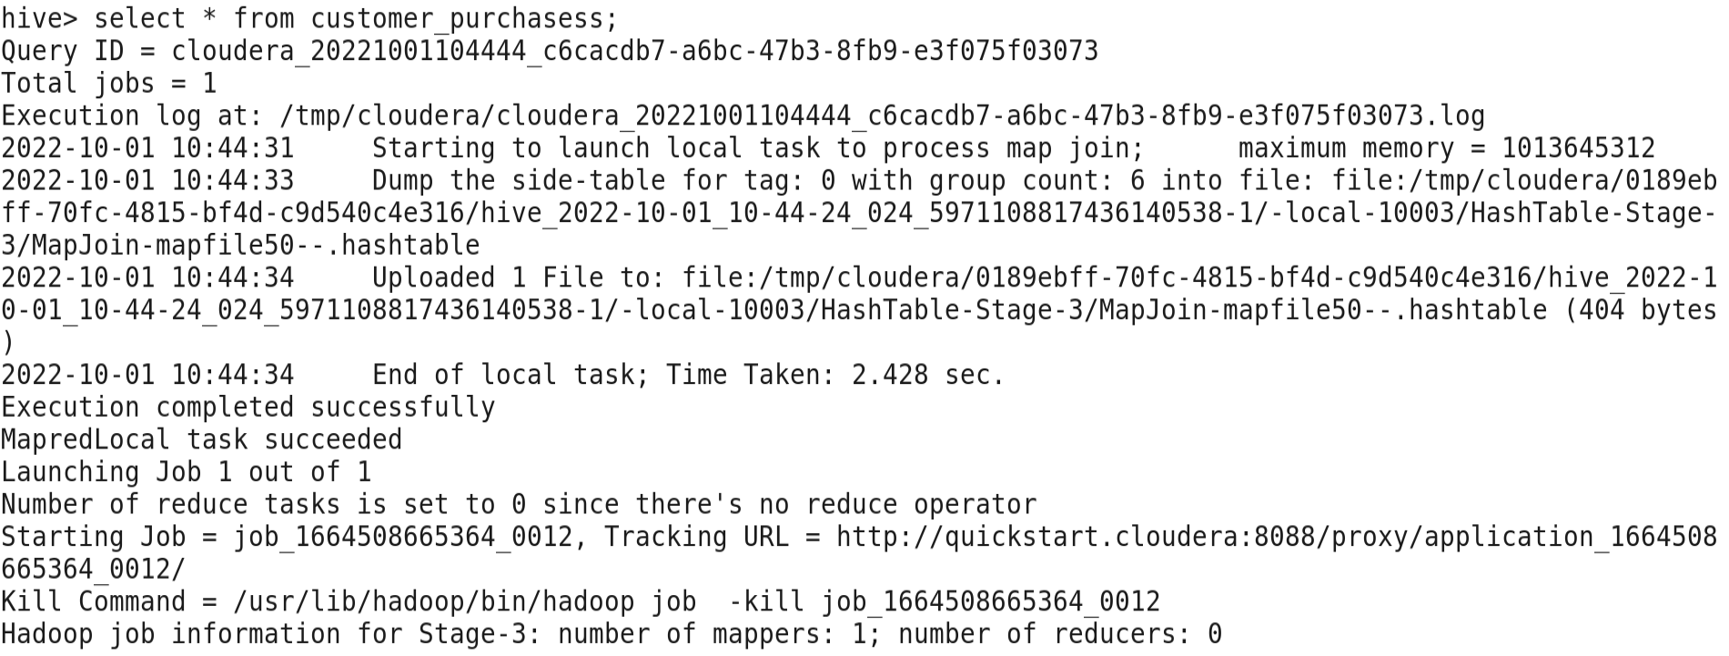

>>output of the view

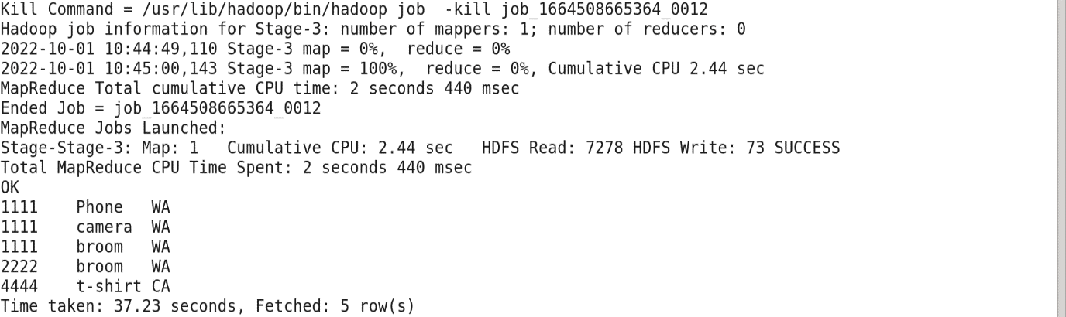

**Index in Hive**

