**Explode and Lateral View**

>>The System define function in Hive fall in 3 Categories.

1. UDF(User define Function)

:-One Line as Input and One Line as Output

Ex: - Length,

1. UDAF(User define Aggregate Function)

:-Multiple Input Line and One Output Row

Ex: - Max, Min, Sum

1. UDTF(User define Table Function)

: - One Input and Multiple Output

Ex: - Explode Function (array put in one line or Multiple Line)

**Explode Functions**

>>User define table generating Functions

>>create a table with an Array Function.

>>Now create a table (author_details) in Tredytech Databases;

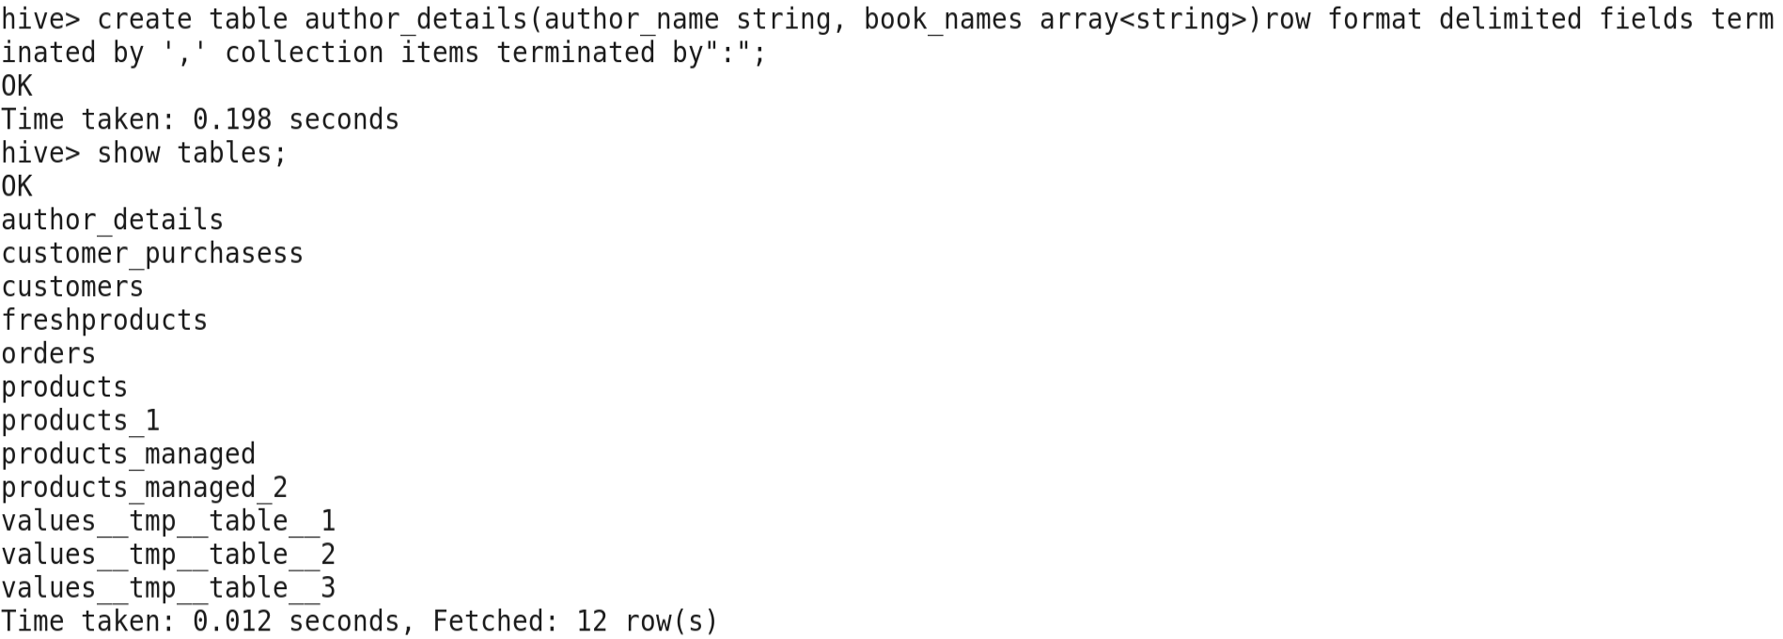

>>Load data into the authors detail table of the author.csv file

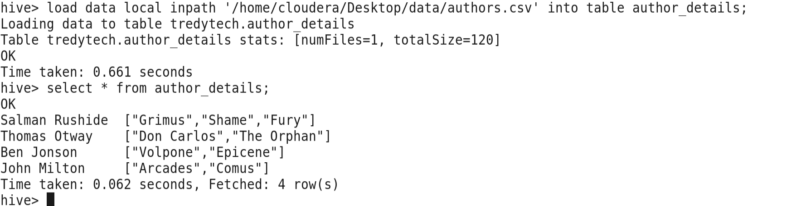

>>Now **Explode column** to for book details



