**Complex Data type in Hive**

>>Complex data type means holds more than a single value

Ex:- Array

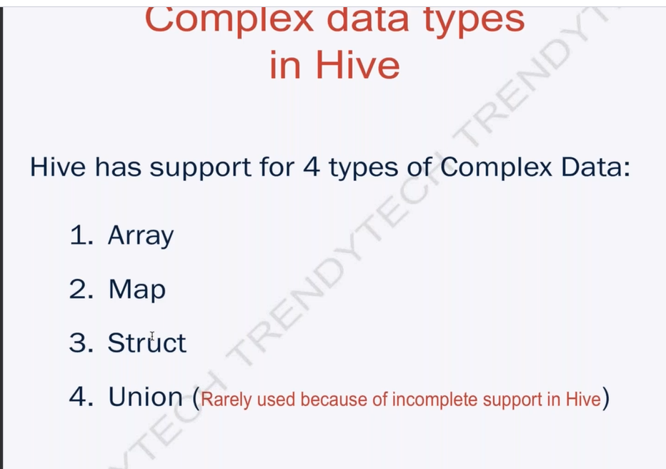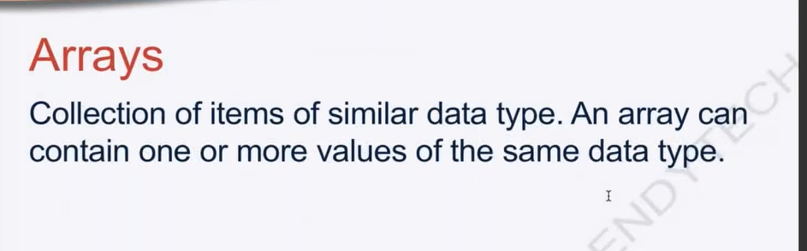

Array contain the Homogenous type of Data

>>Now create a table of the mobile-phones.

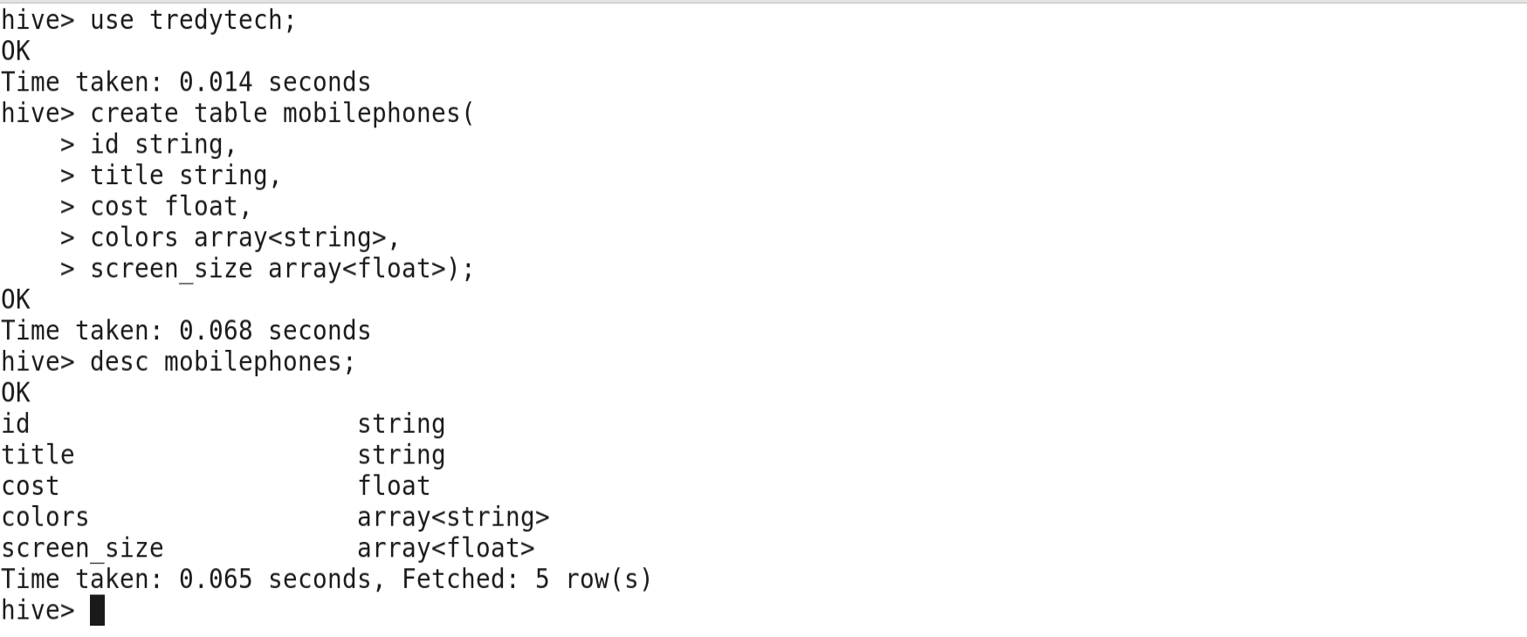

>>Insert data into to the mobilephones table

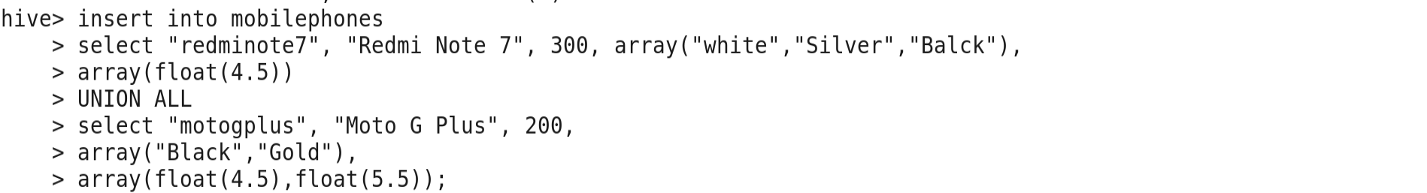

>>Display data from mobilephones table

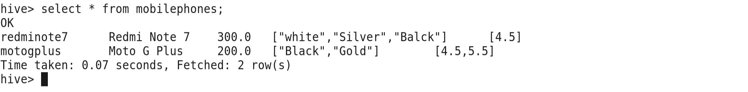

>>Display id and colors of the mobilephone table

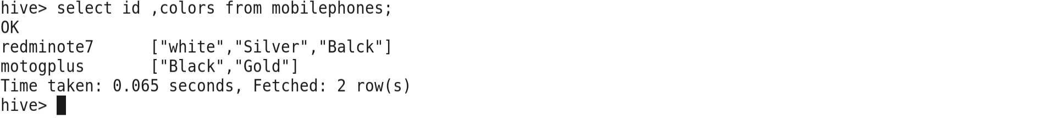

>>Display id and colors [0] of the column One

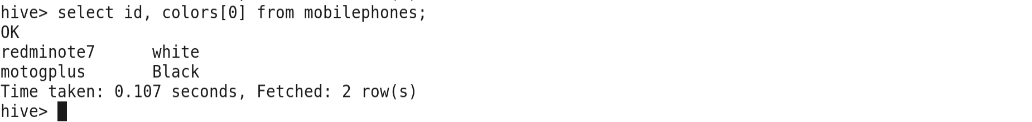

>>**Now create a New Table mobileophones_new**

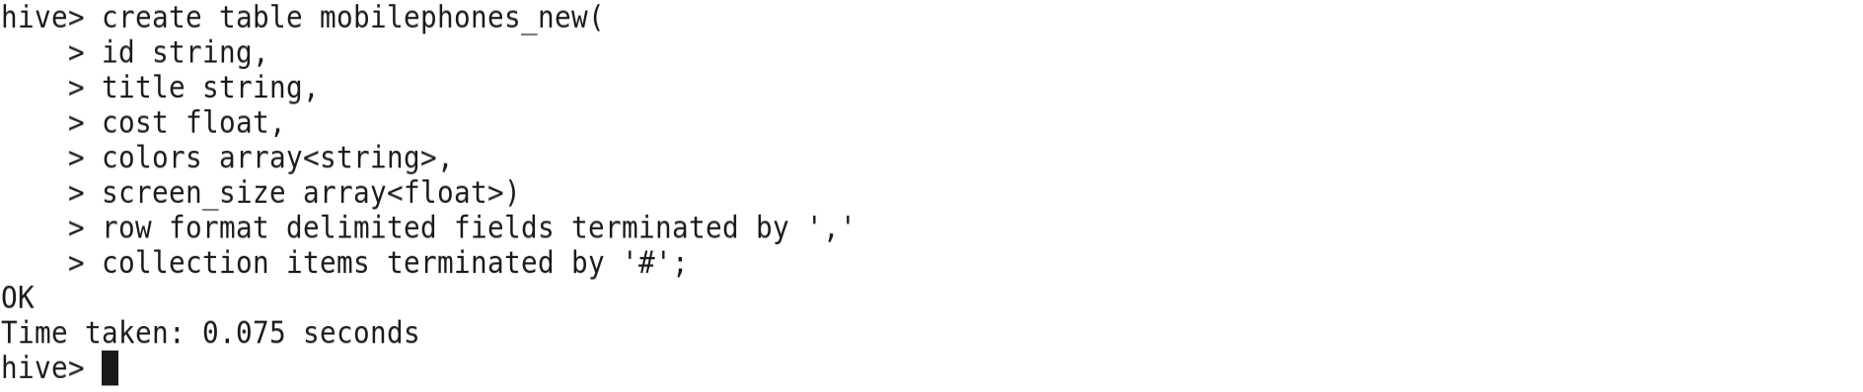

>>load data into the new table mobilephones_new from mobilephones_new.csv file



>>Display all Records of the array Element of Mobilephones_new

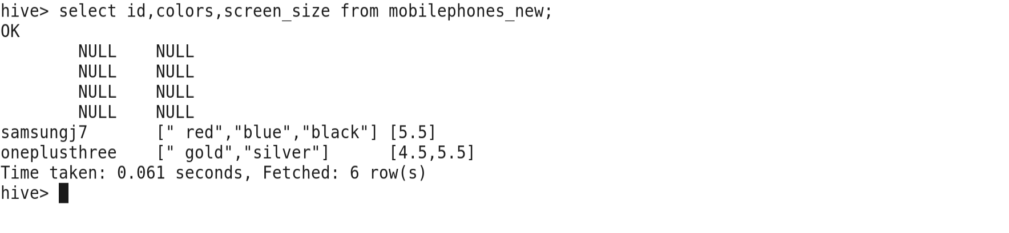

>>Display Records of 1st column Element of mobilephones_new

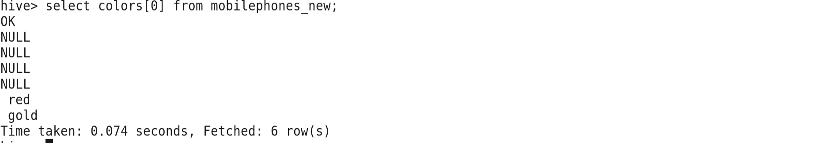

**Map**

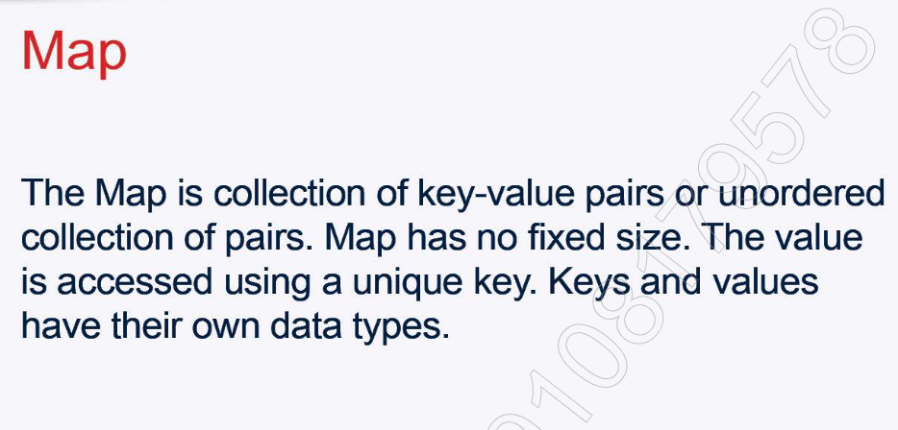

**Key Value**

Roll_no Name

1. Shilpi
2. Sushant

>>Now Create a Map New Table Mobilephones;

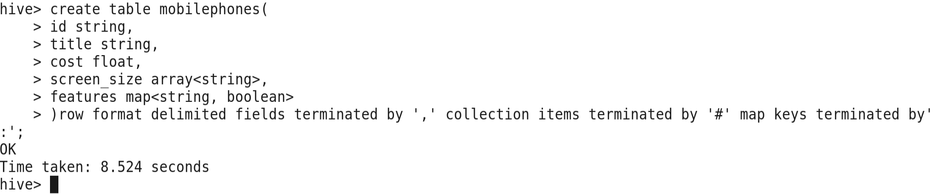

>>First of the Edit the mobilephones_new.csv file and Load into the mobilephones table of the map.

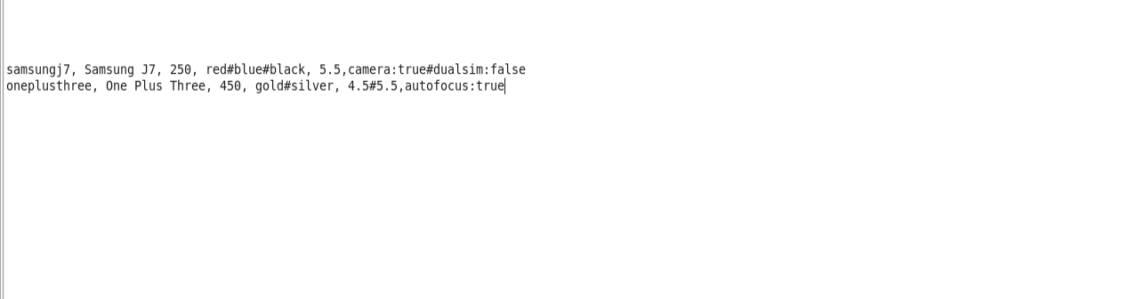

>>Load data into the Table

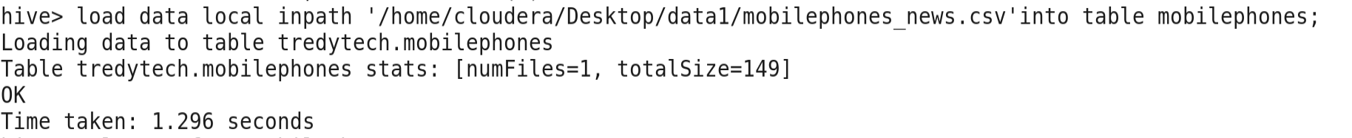

>>Check the all the data of the Tables of Map

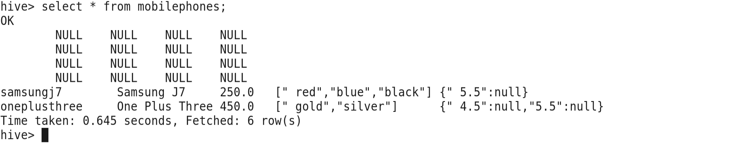

>> Select some features of the table.

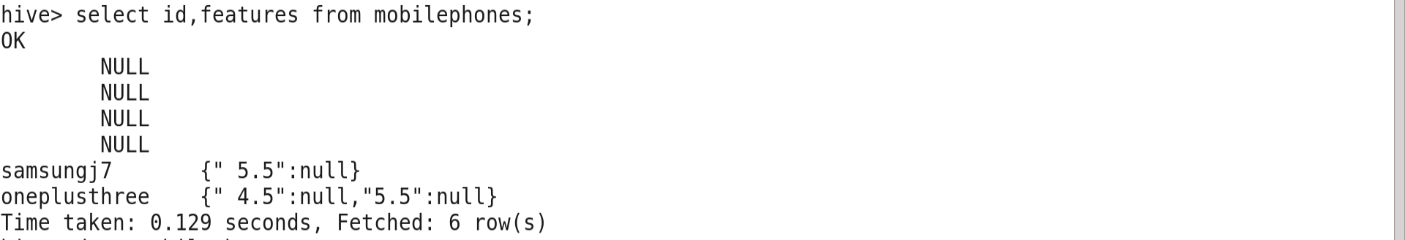

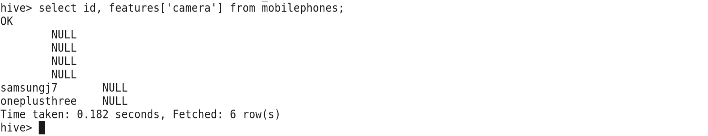

**Struct**

>>

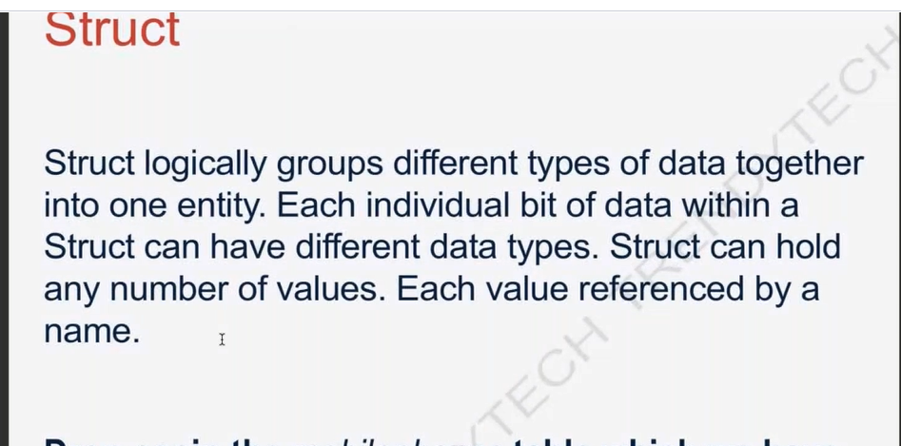

Ex:-

Student Struct

Student_id 101

Student_marks 001

Student_roll_no 404

>>First of all drop the Previous table of Mobilephones of the Map

>>**Create a new table Mobilephones with different Struct Data Types.**

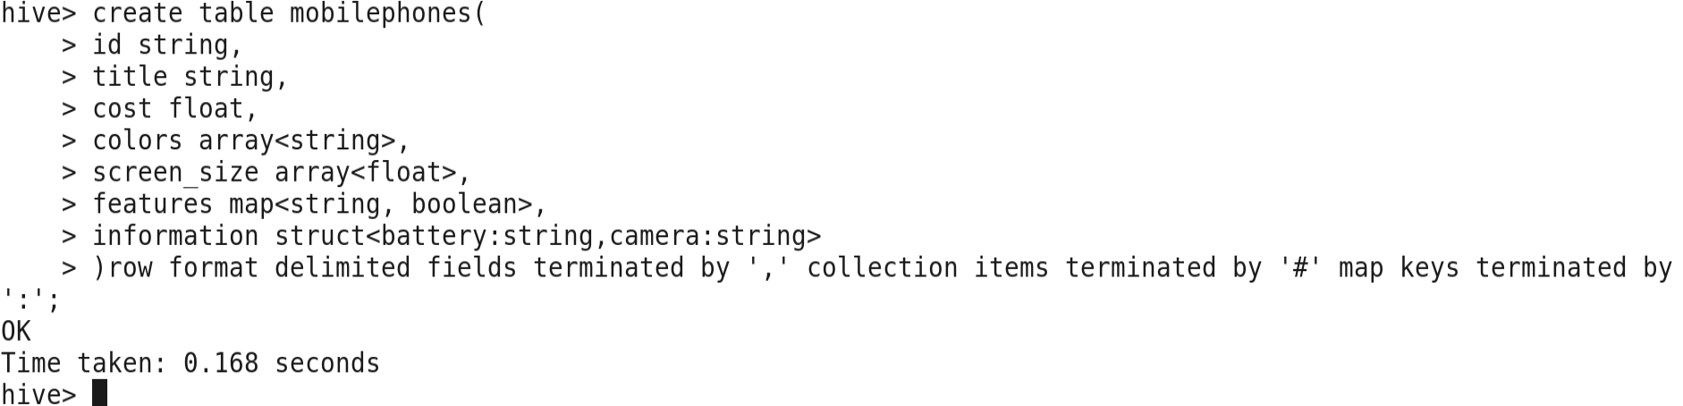

>>desc table of Struct Table

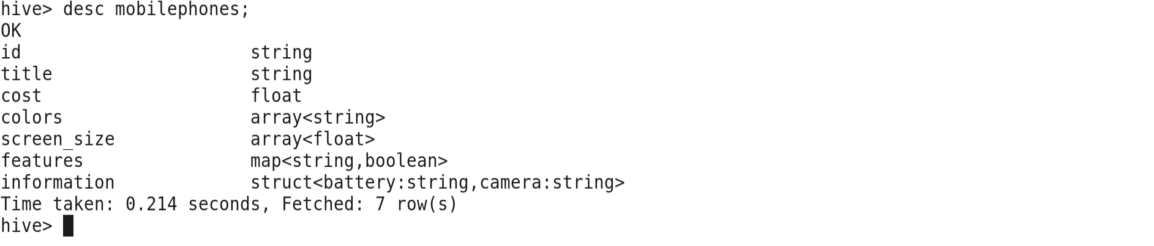

>>Load data into the Mobilephones table of Struct

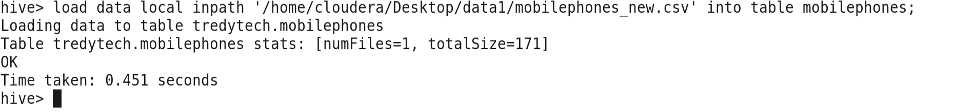

>>select from the table of the struct .

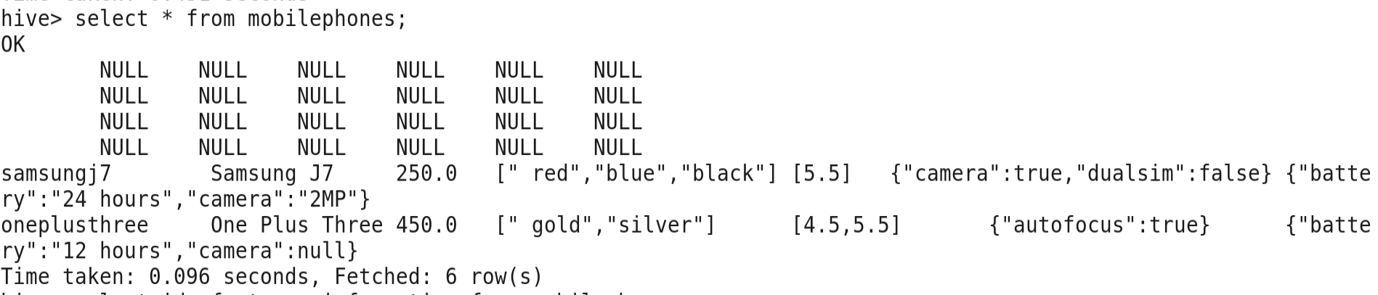

>>select some items of the Struct Table.

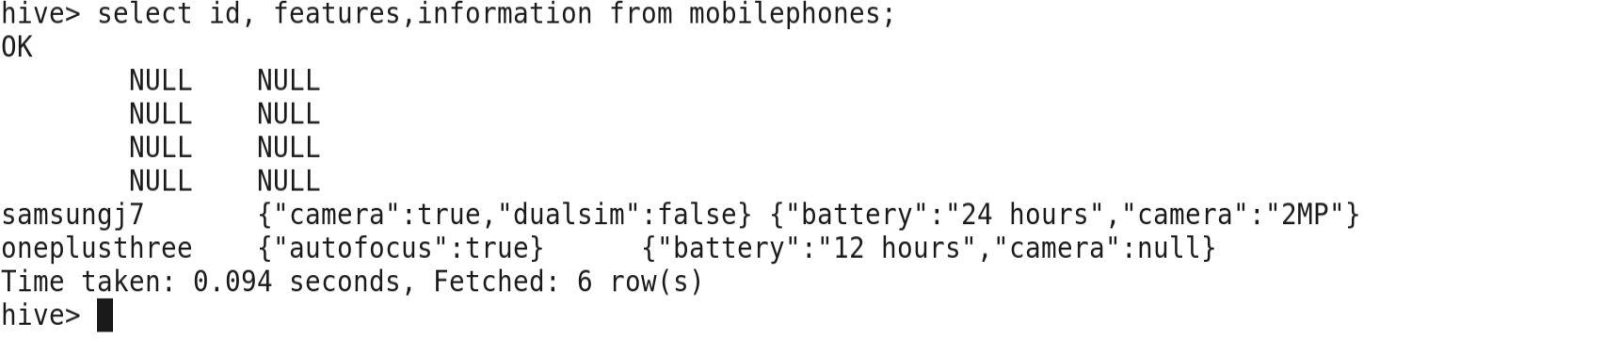

>>Some Items

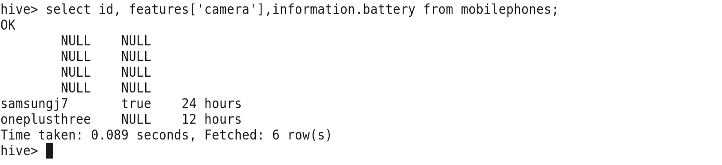

**UDF (User define Function)**

>>When user define function are not fit for our needs.

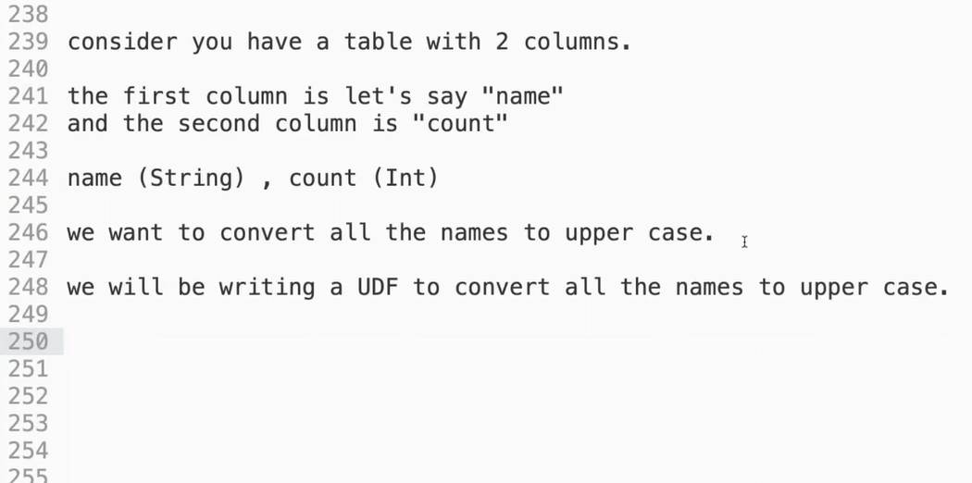

>>We need to write the Java Code for the convert the UDF function in Upper Case.

>>First of all open the Eclipse

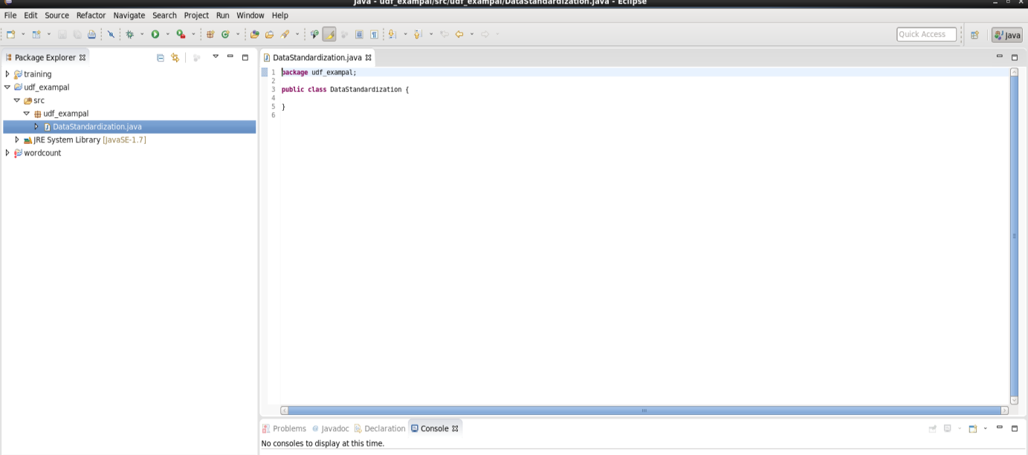

>>Write code in the Eclipse

Package udf_example;

import org.apache.hadoop.hive.ql.exec.UDF;

public class DataStandardization extends UDF

{

public String evaluate (String input)

{

if (input==null)

{

return null;

}

return (input.toString ().toUpperCase());

}

}

>>Now Download the jar file in the Eclipse for Resolve the error in the code.

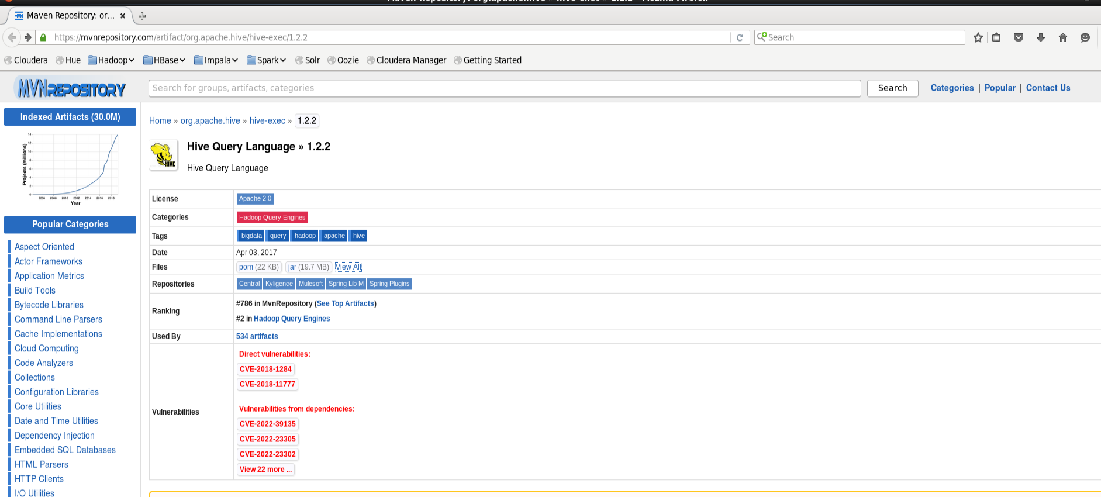

>>Now Download the jar file and Add into the Eclipse file.

>>Now create a table of the UDF



>>Load the data of the Sample.txt into Sample_table.

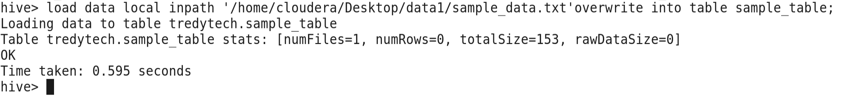

>>Now create a jar file

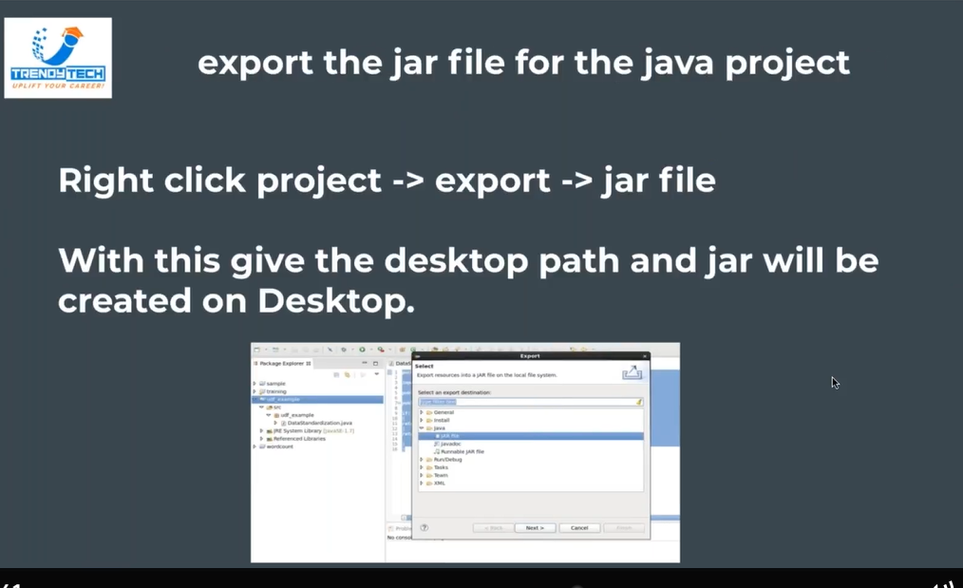

>>Now add the Jar file into the Hive from Desktop of the Cloudera.



>>Now create a temporary Function

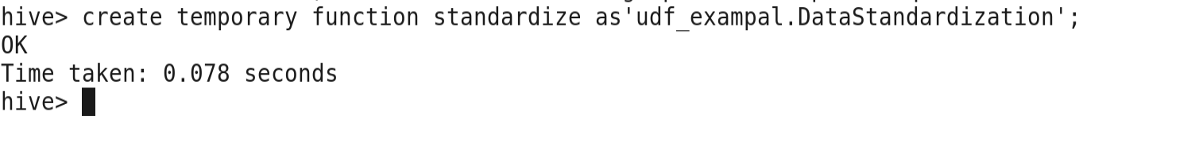

>>Now we are all set, try calling this UDF on a column in a table

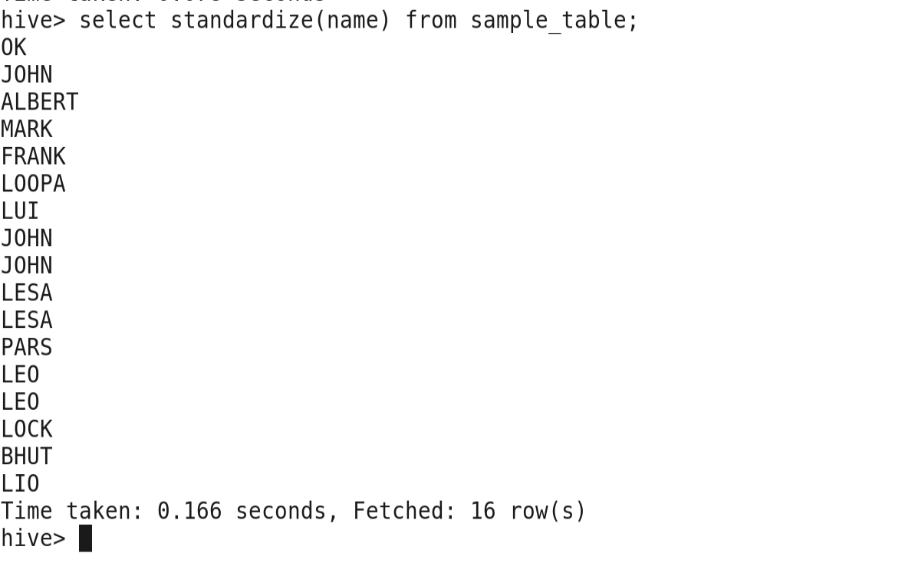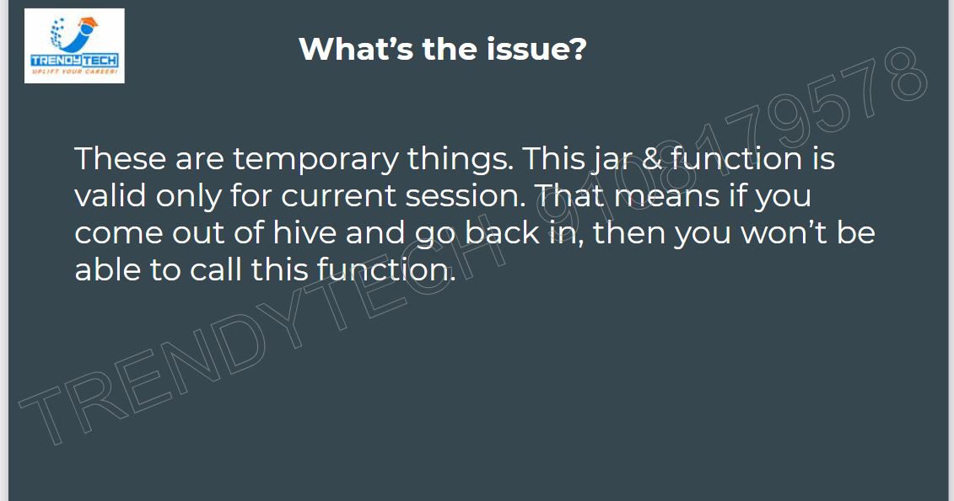

>> To make sure things are permanent, we need to first of all move the jar to HDFS

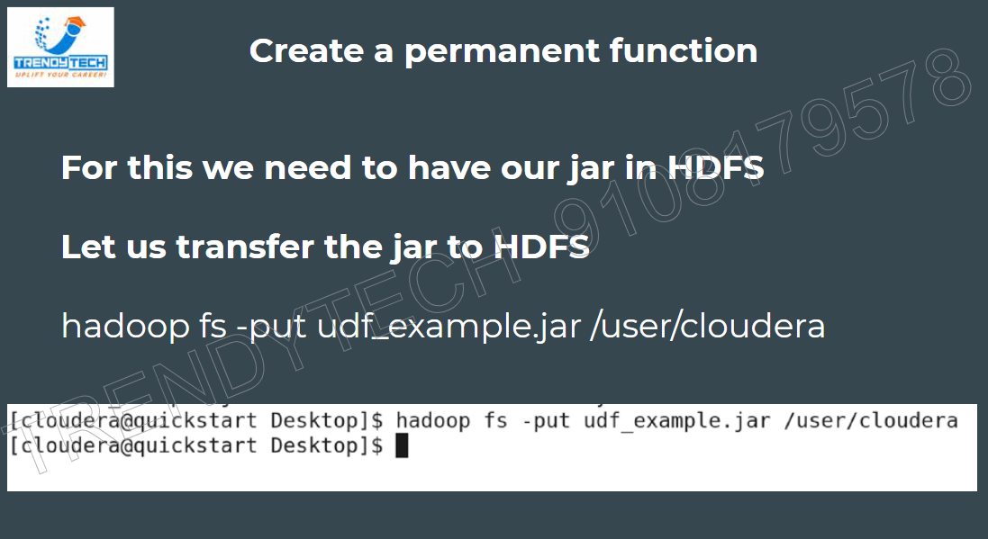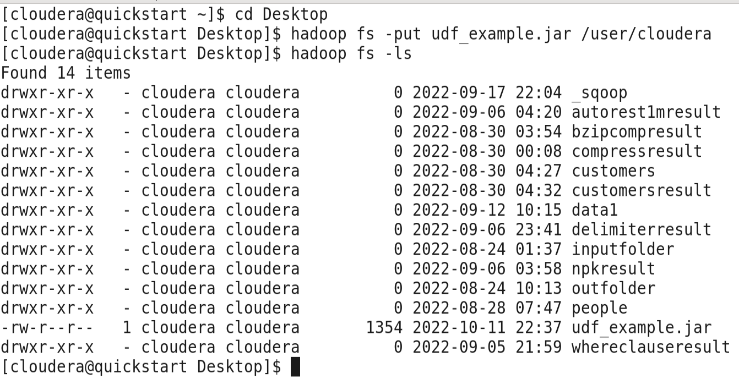

>> Then we need to define a permanent function not a Temporary one.

>>Now we have to create a Permanent function in Hive.

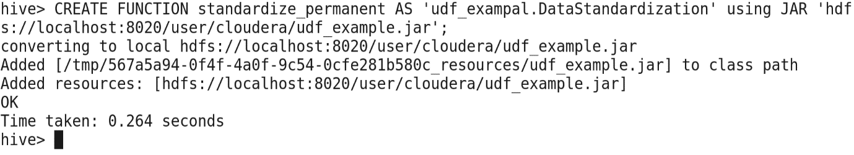

>>Now trying calling the Permanent Function table

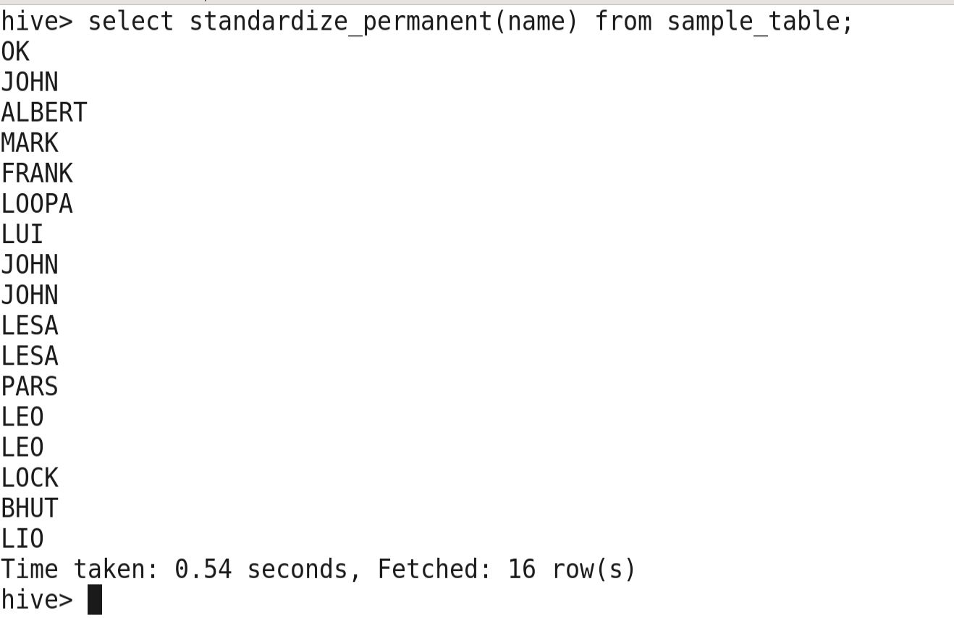

>>When we exits from the Hive then we use the Same Permanent Function