Project Report

School Management System

Company-. **Metallurgical & Engineering Consultants (India) Limited (**MECON), Ranchi.

6/26/2013

Prepared By:

Anirban, Shubham Rastogi,Md. Shahjada

Qualification: Pursuing B.Tech (CSE)

College: KIIT University

**Acknowledgements**

I would like to express my gratitude to my advisor Mr. M.Thanga Pandian for his guidance, support and his continuous enthusiasm and encouragement throughout the project. I am also very grateful and extend my sincere thanks to all the staff members of the department of Information Technology of MECON Ltd. for their cooperation.

Finally many thanks to friends, who have helped and given me suggestions, supports and corrections throughout the project.

**Table of Contents**

**1. Introduction**

**1.1 Abstract**

**1.2 Problem Statement**

**1.3 Objective**

**1.3.1 General Objective**

**1.3.2 Specific Objective**

**2. System Analysis**

**2.1 Functional Requirements**

**2.2 Non-Functional Requirements**

**2.3 Analysis Model**

**2.3.1 Use Case Diagram**

**2.3.2 Data Flow Diagram**

**3. System Design**

**3.1 Design Goals**

**3.1.1 Performance Criteria**

**3.1.2 Dependability**

**3.1.3 Maintenance**

**3.1.4 End User Criteria**

**3.2 Architecture of the System**

**3.3 Subsystem Decomposition**

**3.4 Hardware/Software Mapping**

**3.5 Persistent Data Management**

**3.5.1 Mapping**

**3.5.2 Relationship among tables**

**4. Implementation**

**4.1 Programming Tool**

**4.2 The SMS prototype**

**4.3 Test Cases**

**5. Conclusion and Recommendations 5.1 Conclusion 5.2 Recommendations**

**Introduction**

* 1. **ABSTRACT:**

This project work automates school management system. In the system a web based application is developed.

The application takes most of the activities such as student registering, faculty registering, staff registering. The web application facilitates attendance recording by the homeroom teachers, to view status of students by their parents and to view reports by school officials. It also facilitates report card generation and attendance report generation.

It has been observed that the system successfully registers students, facilitates attendance recording by the home room teachers and generates various reports such as report card. It has also been shown that the system facilitates to view the status of students by their parents using the Internet.

* 1. **PROBLEM STATEMENT:**

To help promote students achievement and success, schools must have access to complete, accurate, and timely information about students. One of the benefits of automated SMS is that the student record system will simplify retrieval of required information and is a great instrument for school improvement by taking measures from the information acquired. Despite the use of automated SMS, many schools are nowadays using paper based documentation system for performing various tasks which wastes manpower and much time unnecessarily that does not utilize the current technology.

Transcripts of students are prepared manually by the record officer and teachers. Report cards are produced by the teachers. Attendance of students is recorded by the teachers. In order to control absentees and know the number of days that a student has been absent from the school during the school days the attendance officer has to collect the attendance slips from the corresponding teachers and compile it which is also a time taking process. In addition to that retrieving records of students who have graduated couple of years ago has been a difficult task and the manual system also has difficulty of producing different reports which are required by the stakeholders such as teachers, administrators or officials.

Teachers may want to associate a student with his parent or emergency persons for disciplinary measures which need searching of the students record in the record office. It has been difficult to search a record from thousands of such records and observed that students can take any person claiming that he/she is their parent or emergency person which creates problem in control of students.

Due to the inefficiency of the current manual system, the need arises to automate SMS in order to efficiently handle students’ attendance, to produce transcript, report cards and the various reports satisfying users and customers.

* 1. **Objective:**

The general and specific objectives of the project are described below:

**1.3.1 General Objective**

The general objective of the project is to automate the SMS.

**1.3.2 Specific Objective**

In order to attain the general objective, the following list of specific objectives is set:

* To develop an online/offline application system.
* To develop an online registration system.
* To facilitate attendance record keeping.
* To facilitate various report generation.
* To allow students, teachers, parents and school officials to view reports on students.

**System Analysis**

**2.1 Functional Requirements:**

The functional requirements of the system are:

* Registration (i) Student

(ii) Faculty

(iii) Staff

* Record attendance of students.
* Records grades of students
* Generate various reports (Eg: attendance and grade report)

**2.2 Non Functional Requirements**

Security requirements are important factors in this system as classified data will be stored in the database. User validation will be done during login to insure that the user is valid and that the user only has access to his or her permission data. General users will only have access through the user interface.

The system will have consistent interface formats and button sets for all forms in the application, will have a form based interface for all data entry and viewing formats, and will generate reports that are formatted in a table and that should look like the existing manual report formats for user friendliness.

The system will be easily maintained by the developer or other authorized trained person and it shall respond as fast as possible in generating report and producing the timetable.

**2.3 Analysis Model**

To produce a model of the system which is correct, complete and consistent we need to construct the analysis model which focuses on structuring and formalizing the requirements of the system. Analysis model contains three models: functional and dynamic models. The functional model can be described by use case diagrams. Dynamic model can also be described in terms of sequence, state chart and activity diagrams. For the purpose of this project we have described the analysis model in terms of the functional model and dynamic models using use case and sequence diagrams.

**2.3.1 Use case Diagram**

Use cases of the system are identified to be “RegisterStudent”, “ClassAllotment”, “RegisterFaculty”, “UpdateRecord”, “Course&ClassAllotment”, “RegisterStaff”, “RoleAllotment”, “RecordMarks”, “RecordAttendance”, “GenerateTranscript”, “GenerateAttendanceReport”, “GenerateGradeReport” and “ViewReport”.

The diagram depicted in Figure 2.1 shows the use case diagram of the system.



Figure 2.1: Use Case Diagram

**2.3.2 Data Flow Diagram:**

* **Level 0 DFD:**



Figure 2.2: Level-0 Data Flow Diagram

* **Level 1 DFD:**



Figure 2.3: Level-1 Data Flow Diagram

**Data Dictionary:**

***Application details:*** First Name + Middle Name + Last Name + DOB + Gender + Phone Number + Address + Postal Code + Email ID + Nationality + Blood Group + Guardian [First Name + Middle Name + Last Name] + Class in Which Applicant Wants Admission

***App no :*** String

***Reg No.:*** String

***Password:*** String

***Academic Year:*** Integer

***Attendance Report:*** String

***Grade Report:*** String

***Class:*** Integer

***Section:*** Char

***Student Details:*** First Name + Middle Name + Last Name + DOB + Gender + Phone Number + Address + Postal Code + Email ID + Nationality + Blood Group + Year of Joining + House

***Query:*** String

***Output:*** String

***First Name:*** String

***Middle Name:*** String

***Last Name:*** String

***Address:*** String

***Nationality:*** String

***Postal Code:*** Decimal

***Phone Number:*** Decimal

***Blood Group:*** String

***DOB:*** Date

***Year Of Joining:*** Date

***House:*** String

***Email ID:*** String

***Class in Which applicant want admission:*** Decimal

***Gender:*** String

**System Design**

In the previous chapter we have identified the functional and non-functional requirements of the system and produced the analysis model. The following are discussed in this chapter: design goals, system architecture, system decomposition, deployment and database design.

**3.1 Design Goals**

Design goals describe the qualities of the system that developers should optimize. Such goals are normally derived from the non-functional requirements of the system.

Design goals are grouped into four categories. These are:

• Performance

• Dependability

• Maintenance

• End User Criteria

**3.1.1 Performance Criteria**

The part of the system to be used for the record office should have a fast response time (real time) with maximum throughput. Furthermore, the system should not be taking up too much space in memory. The record officer has chosen fast response time over throughput and hence the system should try to be more interactive.

**3.1.2 Dependability**

The school needs the system to be highly dependable as it is expected to be used by non-IT professionals. The system should be robust and fault tolerant. Furthermore, as the system is handling sensitive data of the school, high emphasis should be given with regards to security, as there are subsystems to be accessed through web.

**3.1.3 Maintenance**

The system should be easily extensible to add new functionalities at a later stage. It should also be easily modifiable to make changes to the features and functionalities.

**3.1.4 End User Criteria**

**Usability:** Usability is the extent to which a product can be used by specified users to achieve specified goals with effectiveness, efficiency and satisfaction in a specified context of use. From the end users’ perspective the system should be designed in such a way that it is easy to learn and use, efficient and having few errors if any.

Trade-off is inevitable in trying to achieve a particular design goal. One best case is the issue of security versus response time. Checking User-Id and Password before a member can enter to the SMS creates response time problem/overhead. The other case is the issue of response time versus quality.

**3.2 Architecture of the System**

The proposed system is expected to replace the existing manual system by an automated system in all facets. It is mainly based on the system Analysis document.

The architecture used for the system is a 3 tier Client/Server Architecture where a client can use Internet browsers to access the online report provided by the system anywhere using the Internet. Figure 3.1 shows the architecture of the proposed system.

The data tier maintains the applications data such as student data, teacher data, etc. It stores these data in a relational database management system (RDBMS).

The middle tier (web/application server) implements the business logic, controller logic and presentation logic to control the interaction between the application’s clients and data. The controller logic processes client requests such as requests to view student’s result, to record attendance or to retrieve data from the database. Business rules enforced by the business logic dictate how clients can and cannot access application data and how applications process data.

The client tier is the applications user interface containing data entry forms and client side applications. It displays data to the user. Users interact directly with the application through user interface. The client tier interacts with the web/application server to make requests and to retrieve data from the database. It then displays to the user the data retrieved from the server.



Figure 3.1 Architecture of the System

**3.3 Subsystem Decomposition**

Subsystem decompositions will help reduce the complexity of the system. The subsystems can be considered as packages holding related classes/objects. The SMS under consideration is decomposed into subsystems as shown in Figure 3.2. These subsystems are further decomposed into other subsystems. The major subsystems identified are “Registration”,“Login”,“Attendance”,“GradeReport”, “Transcript” and “Report” subsystems.

Users are classified in to roles. The “Login” subsystem authenticates a user to grant access based on the role of the user. The “Registration” subsystem registers a student, faculty or staff. It allows recording the detail information of the person including parental and emergency person.

“Transcript” and “GradeReport” subsystems are used to generate transcript and report card respectively. The “Timetable” subsystem generates a timetable, which involves allocating a time slot to a subject teacher for a class of students.

The “Attendance” subsystem facilitates recording absent students on the school day by the teacher to control absentees and to report to parents and the administrator to take corrective measures. The “Report” subsystem generates reports to parents and school officials in order to facilitate viewing students’ status and course achievement online.

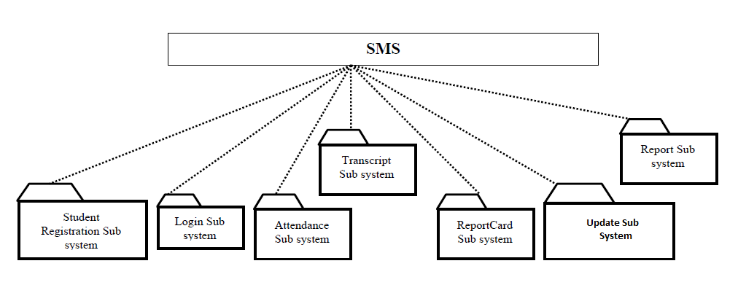

Figure 3.2 Layered Representation of the System

**3.4 Hardware/Software Mapping**

One of the major tasks in system design deals with hardware/software mapping which deals with which components would be part in which hardware and so on. It consists of web based system used by teachers to record attendance. The web based system also assists parents and officials to get or view status and report on students’ achievement and progress. The system assists the record officer to generate transcript and report cards. So the web based part is expected to run on a networked environment on different Operating System platforms. The client/server architecture of the system enables different clients to connect to the server remotely through Internet connection.

The system has two nodes such as the ***Web server*** and ***Clients.*** These nodes are shown as UML Deployment diagrams in Figure 5.4. The nodes can represent specific instances (workstations) or a class of computers (web server), which is a virtual machine. The applications of the system will run on the web server connected to the database server by ado.net

The following figure shows the deployment diagram of the system.

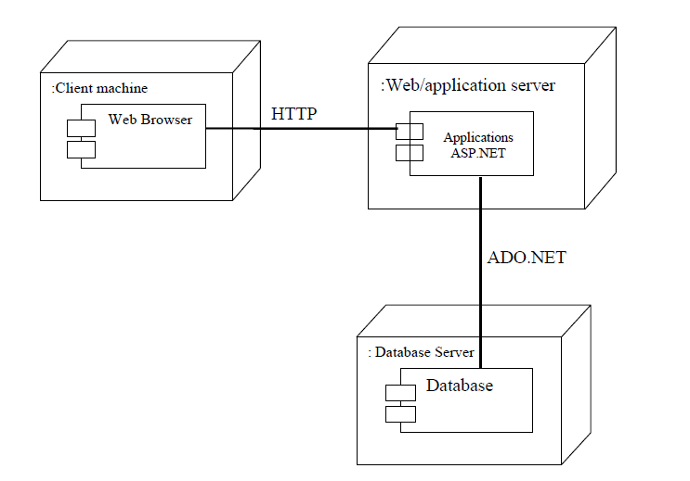

Fig 3.3 Deployment Diagram of the System*.*

For the web application users merely need to start their browsers and enter the URL of the application Web site. The server hosting the Web site is responsible for allocating all the resources the Web application requires.

**3.5 Persistent Data Management**

Persistent data management deals with how the persistent data (file, database, etc.) are stored and managed and it outlives a single execution of the system. Information related to student basic information, student’s attendance and grade mark, the timetable produced and other related information are persistent data and hence stored on a database management system. This allows all the programs that operate on the SMS data to do consistently. Moreover, storing data in a database enables the system to perform complex queries on a large data set.

The schools register students every year in thousands per grade level. For complex queries over attributes and large dataset Microsoft SQL Server is implemented, which is a Relational Database Management System.

**3.5.1 Mapping**

In order to store information persistently we map objects into tables and the attributes into fields to the specific table based on the objects found on the system. Therefore, we identified the major tables that will be implemented on the selected DBMS.

**3.5.2 Relationships among Tables**

This part is to describe and show the necessary relationships among the tables, which are selected to store the data persistently in the system. Generally there are three types of relationships in a relational database system. These are one-to-one, one-to-many and many-to-many relationships. The system under consideration has one-to-many and many-to-many relationships.

Student and Class_Student tables have many-to-many relationships. One of the aims in a database system is to reduce redundancy and for that purpose many-to-many relationship has to be reduced to one-to-one relationship. The Student and Grade and the Course and Grade have one-to-many relationship by using the Grade table as the associate table.

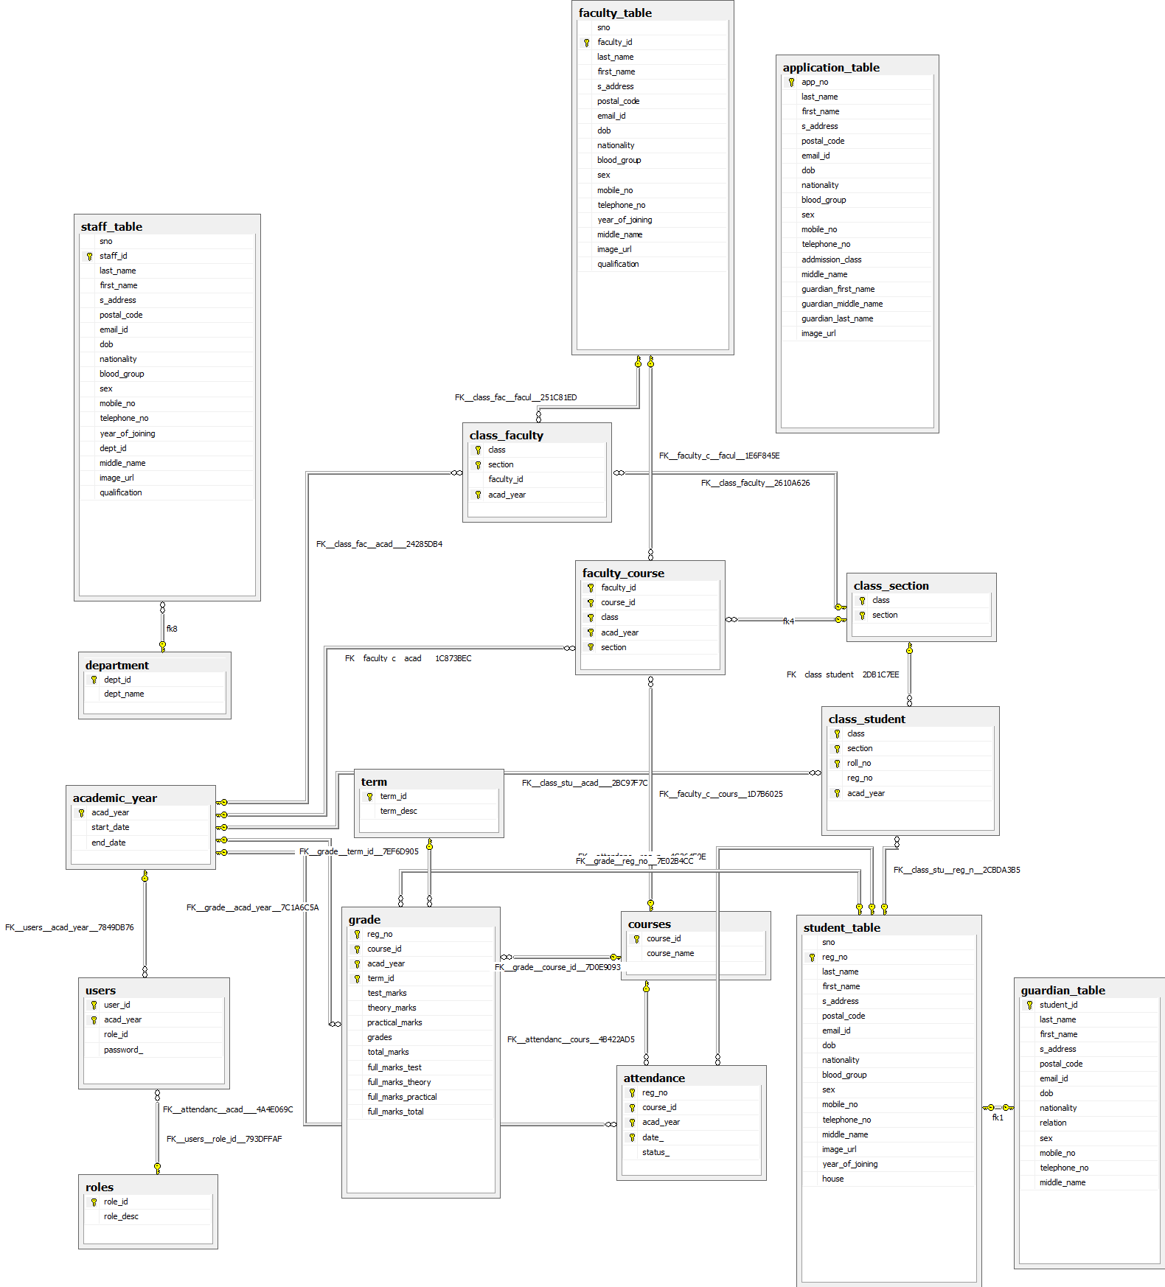

Figure 3.4 Relationship Diagram of the Table

**Implementation**

In this chapter, the tools used in developing the prototype and the developed system are described.

**4.1 Programming Tool**

The system has a web application is developed using Active Server Pages (ASP .NET 4.0). The application is developed using C#, which is one of the development languages in .NET.

**4.2 The SMS Prototype**

Here, the implemented system is described. How the user interacts with the system and some of the results of interaction with the system along with the screen shots are described.

When a user starts the application, a login screen is displayed as shown in to authenticate the user. The main window displays menus and sub menus based on the role of the user that has logged in.

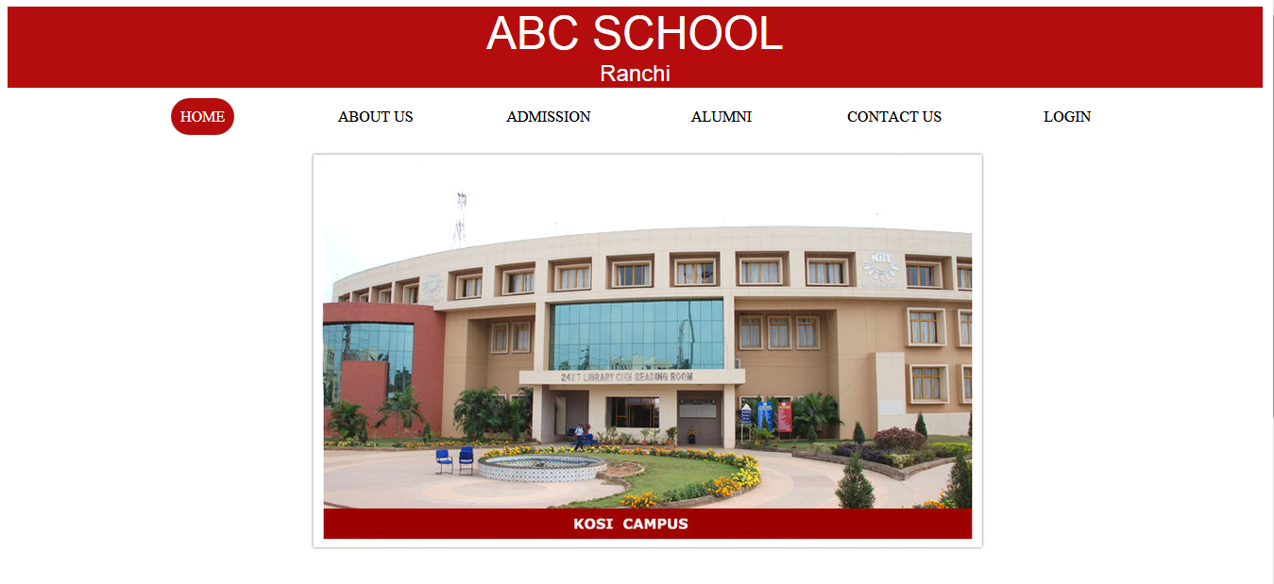

Home Page

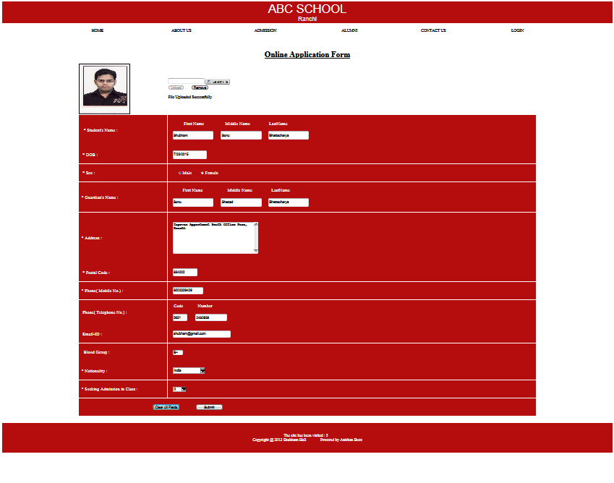

Online Applicant Registration

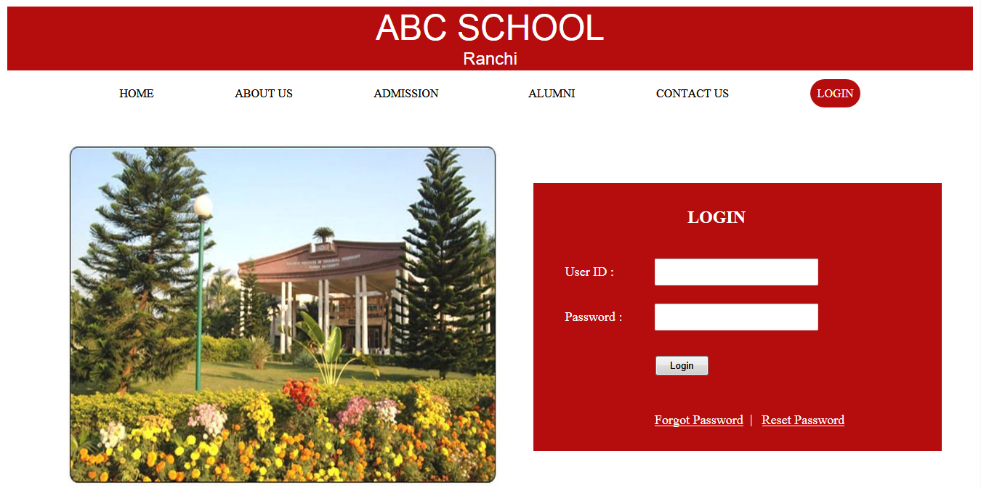

Login Page

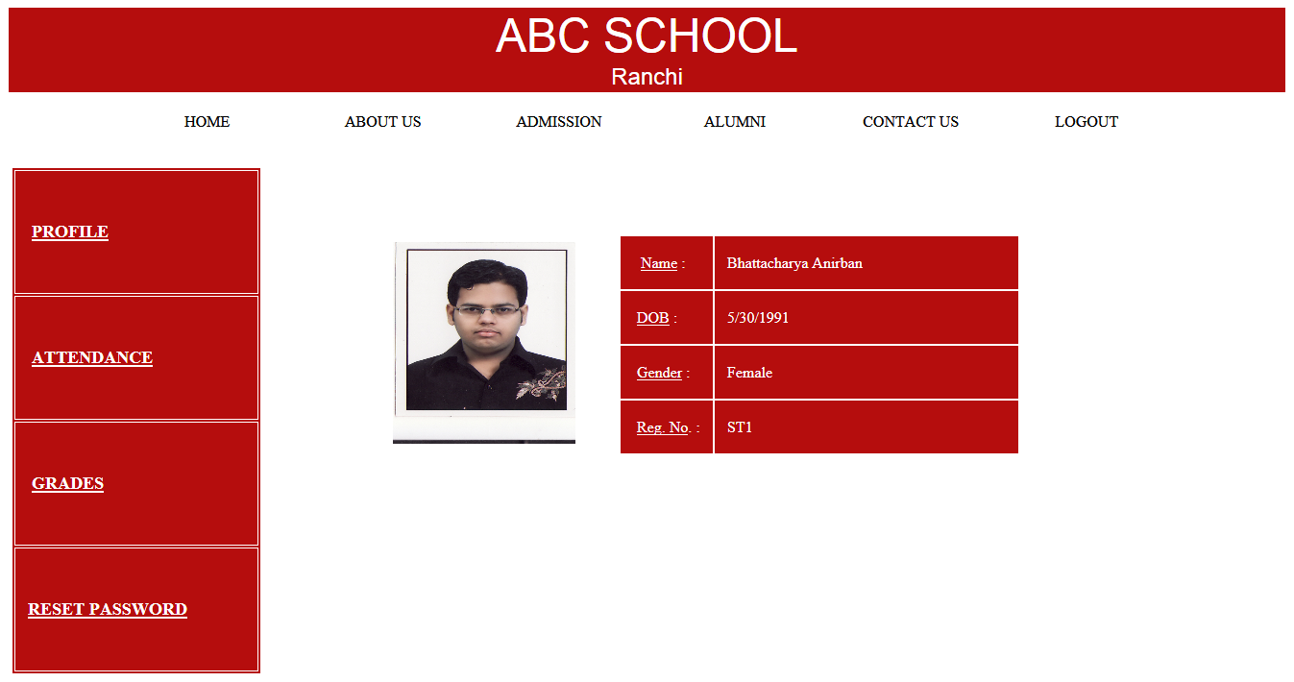

Profile Page

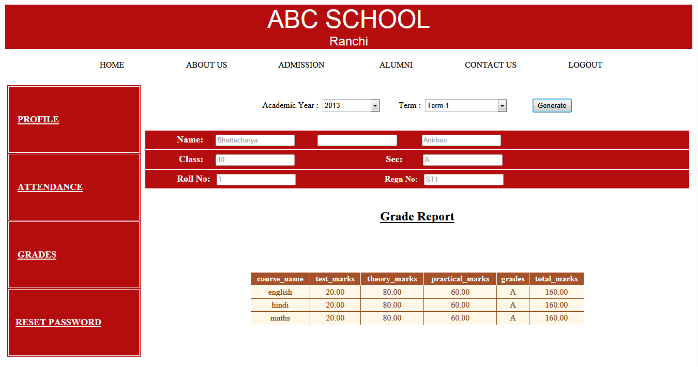

Grade Report Viewed By Student

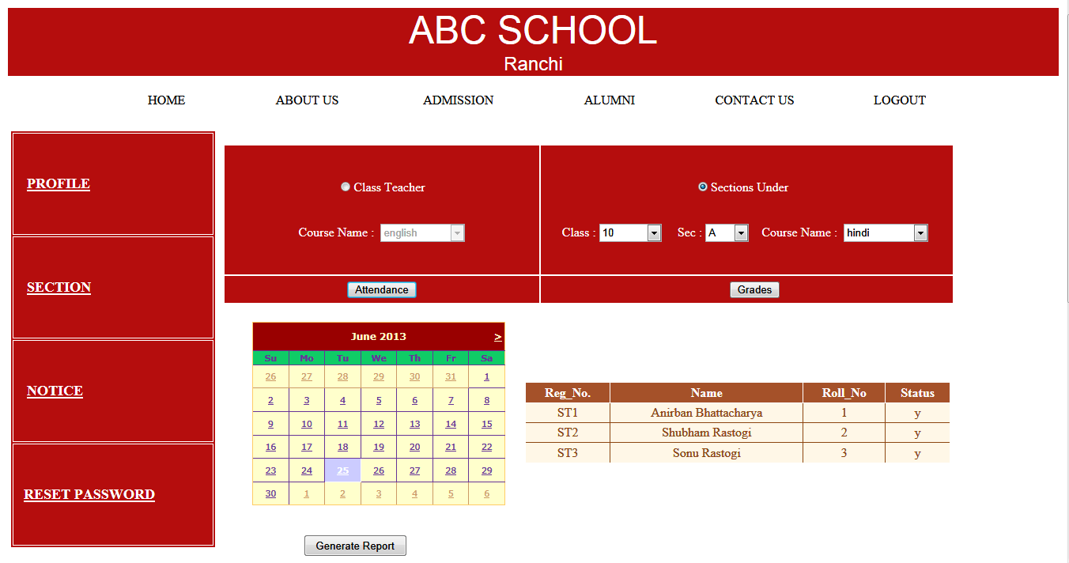

Attendance Report Viewed By Faculty

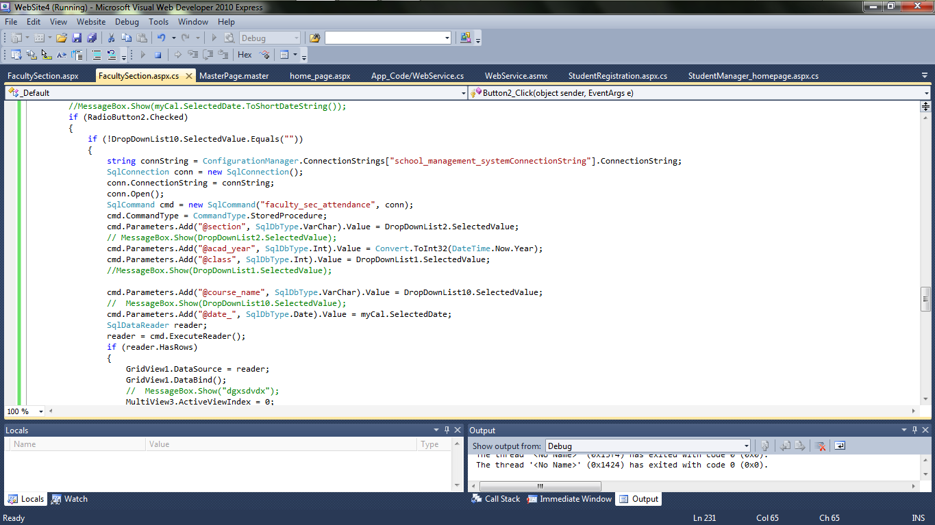

Visual Studio Code Page

**Test Cases**

|  |  |  |  |  |
| --- | --- | --- | --- | --- |
| **TEST CASE NAME** | **TEST PROCEDURE** | **PRE-CONDITION** | **EXPECTED RESULT** | **REFERENCE TO DETAILED DESIGN** |
| Login_blank | Both username and password field left blank | None | Errormsg():Enter data in both fields.(-ve test case) | user_table |
| Login_nousername | Username left blank | None | Errormsg():Enter username. (-ve test case) | user_table |
| Login_nopassword | Password left blank | None | Errormsg():Enter password.(-ve test case) | user_table |
| Login_valid | Valid data in both fields | None | Redirected to the respective user homepage(+ve case) | user_table |
| Login_invalid | Invalid data in both fields | None | Errormsg():  Invalid username and password(-ve case) | user_table |
| Course_notselected | No item selected in the course dropdown list | Must be logged in as a faculty | Errormsg():  Course name not selected(-ve test case) | faculty_course & courses |
| Term_notselected | No item selected in the term dropdown list | Must be logged in as a faculty(or student) for faculty section page(or student page) | Errormsg():  Term name not selected(-ve test case) | term & grade table |
| Term & course selected | Term & course selected in dropdown list | Must be logged in as a faculty(or student) for faculty section page(or student page) | Grade and attendance report generated | term,grade,course,faculty_course,course,attendance,class_student |

**Conclusion and Recommendations**

**5.1 Conclusion**

In this project, we developed an automated school management system that facilitates the various activities taking place at schools.

The system developed in the project consists of web application. The web application facilitates attendance recording by the teachers and to view reports, to view status of students by students, teachers and parents.

The prototype has been tested with manually inputted data. It has been shown that the system effectively registers students along with parental information, easily retrieves information about a student and generates the required reports such as transcript, grade report and attendance report. Furthermore it has been shown that the web application helps attendance recording by the teacher and parents can view the status of their children using the Internet.

**5.2 Recommendations**

To enhance the efficiency of the system, in the following we have listed some recommendations and future works.

As education is central to development there should be a good facility to make stakeholders participate in school improvement programs and decision making. To facilitate easy information access to such bodies the web application could be further enhanced by incorporating additional reports required by Education Bureaus. Such facilities will increase participants in decision making at educational activities and students achievement.