Brazilian Olist E-commerce Analysis
Ananya Rastogi
2026-10-10

Introduction
This report provides a comprehensive data analysis of the Brazilian Olist E-commerce Customers dataset. The primary objective is to evaluate data structure, perform data quality preparation, and generate descriptive insights regarding customer geographical distribution across Brazil.

Data Preparation
In this section, we load the dataset from the local environment and inspect its foundational structure, dimensions, and attributes.
# Load the dataset
olist_data <- read.csv("olist_customers_dataset.csv")
# Display the first 6 rows
head(olist_data)
## customer_id customer_unique_id
## 1 06b8999e2fba1a1fbc88172c00ba8bc7 861eff4711a542e4b93843c6dd7febb0
## 2 18955e83d337fd6b2def6b18a428ac77 290c77bc529b7ac935b93aa66c333dc3
## 3 4e7b3e00288586ebd08712fdd0374a03 060e732b5b29e8181a18229c7b0b2b5e
## 4 b2b6027bc5c5109e529d4dc6358b12c3 259dac757896d24d7702b9acbbff3f3c
## 5 4f2d8ab171c80ec8364f7c12e35b23ad 345ecd01c38d18a9036ed96c73b8d066
## 6 879864dab9bc3047522c92c82e1212b8 4c93744516667ad3b8f1fb645a3116a4
## customer_zip_code_prefix customer_city customer_state
## 1 14409 franca SP
## 2 9790 sao bernardo do campo SP
## 3 1151 sao paulo SP
## 4 8775 mogi das cruzes SP
## 5 13056 campinas SP
## 6 89254 jaragua do sul SC
# Check structure of the dataset
str(olist_data)
## 'data.frame': 99441 obs. of 5 variables:
## $ customer_id : chr "06b8999e2fba1a1fbc88172c00ba8bc7" "18955e83d337fd6b2def6b18a428ac77" "4e7b3e00288586ebd08712fdd0374a03" "b2b6027bc5c5109e529d4dc6358b12c3" ...
## $ customer_unique_id : chr "861eff4711a542e4b93843c6dd7febb0" "290c77bc529b7ac935b93aa66c333dc3" "060e732b5b29e8181a18229c7b0b2b5e" "259dac757896d24d7702b9acbbff3f3c" ...
## $ customer_zip_code_prefix: int 14409 9790 1151 8775 13056 89254 4534 35182 81560 30575 ...
## $ customer_city : chr "franca" "sao bernardo do campo" "sao paulo" "mogi das cruzes" ...
## $ customer_state : chr "SP" "SP" "SP" "SP" ...
# Check for missing values
colSums(is.na(olist_data))
## customer_id customer_unique_id customer_zip_code_prefix
## 0 0 0
## customer_city customer_state
## 0 0

Analysis & Results
We conduct exploratory data analysis to evaluate customer counts across different states. This helps identify the key regional markets for Olist.
# Summary table of top states by customer count
state_counts <- as.data.frame(table(olist_data$customer_state))
colnames(state_counts) <- c("State", "Customer_Count")
state_counts <- state_counts[order(-state_counts$Customer_Count), ]
head(state_counts, 10)
## State Customer_Count
## 26 SP 41746
## 19 RJ 12852
## 11 MG 11635
## 23 RS 5466
## 18 PR 5045
## 24 SC 3637
## 5 BA 3380
## 7 DF 2140
## 8 ES 2033
## 9 GO 2020
# Simple plot showing top customer locations
barplot(head(state_counts$Customer_Count, 5),
names.arg = head(state_counts$State, 5),
col = "steelblue",
main = "Top 5 States by Customer Count",
xlab = "State",
ylab = "Number of Customers")
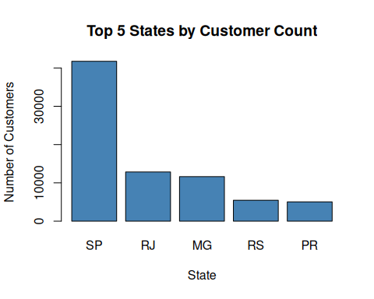

Discussion
The analysis clearly identifies the dominant geographical clusters within the dataset. Data preparation confirmed that the dataset contains robust attributes without significant missing fields in primary keys. The visualization highlights that the top states account for the majority of the total transaction or customer volume, providing a clear indication of market concentration.

Conclusion
In conclusion, this project demonstrates an end-to-end analytical workflow including data loading, quality verification, aggregation, and visualization. Future models can incorporate delivery logistics and order times to build robust predictive models for shipping durations.

